SWOT ANALYSIS
SWOT Analysis stands for:
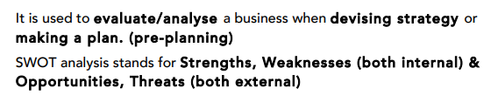
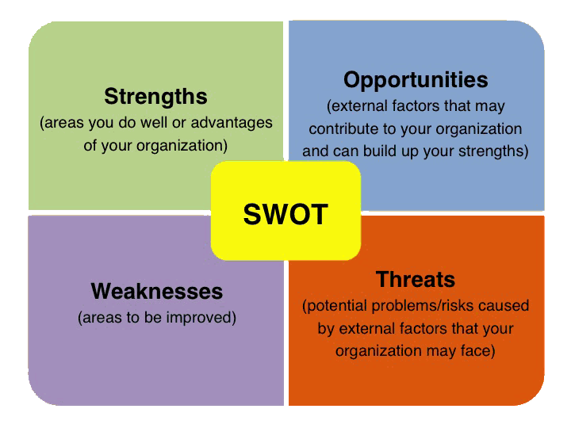

Sample: Conduct a SWOT Analysis for a business of your choice.
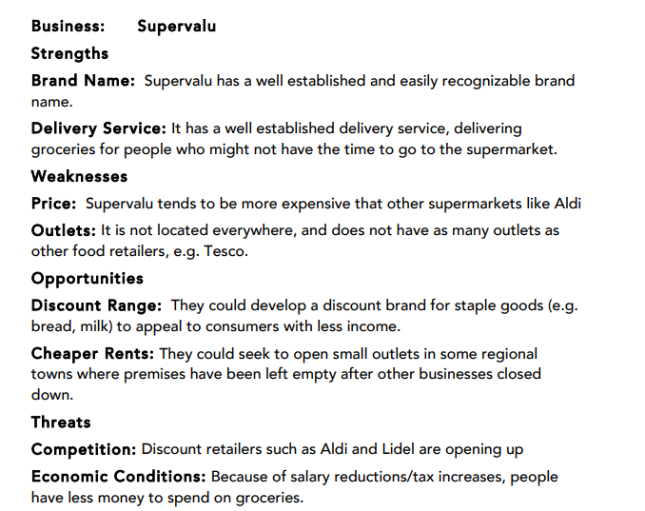

Task 1: As a class, we are going to look at conducting a SWOT Analysis for Starbucks. We must include at least two of each of the Strengths, Weaknesses, Opportunities, and Threats for this brand that we are all familiar with.
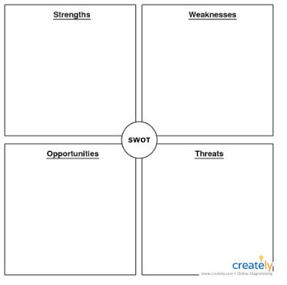

Task 2: With a partner, please have a go at conducting a SWOT Analysis for a brand that has been selected for you by your teacher.

Task 3: You should now be looking at conducting a similar SWOT Analysis of your chosen idea(s) for your mini-company project. This will be very beneficial in helping you plan for the next steps of your project.

