Rapid Revision: Leaving Cert Tax
Ainm:
1.
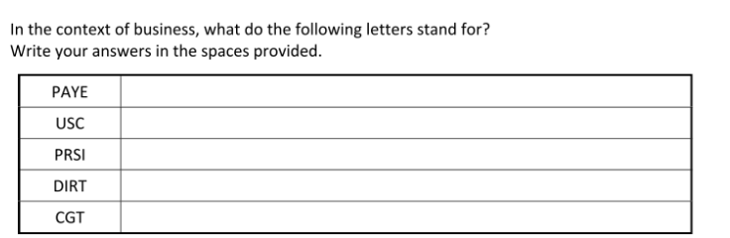
2. Circle the correct term from the sentences below:
- PAYE/USC is an example of a progressive/regressive tax as the more you earn the more you pay
- VAT is an example of a progressive/regressive tax meaning everyone pays the same regardless of income levels
- Direct taxes are taxes on income/expenditure- e.g. PAYE/USC
- Indirect taxes are taxes on income/expenditure- e.g. VAT
- Tax credits increase/reduce PAYE paid

3. Match the key terms to their definitions below:
- Capital Gains Tax | - This is the percentage of taxes paid by individuals which can be different- e.g. PAYE
- Capital Acquisition Tax | - Tax on certain products such as alcohol and tobacco
- Excise Duties | - Collect taxes on behalf of the Irish government
- Value Added Tax | - This is tax on the goods imported from outside of the EU
- Corporation Tax | - Employers must pay a percentage of the employee’s wages as their contribution to the cost of this insurance. Employers see this as an additional tax on them which increases the cost of employing staff
- Local Property Tax | - Tax paid by the self-employed. They are responsible for calculating their own tax bill,
- Customs Duty | - Tax if a person earns income from the sale of an asset such as shares or property (other than the home).
- Commercial Rates | - Tax paid of gifts and inheritance. The amount of tax you pay depends on who gave you the gift or inheritance and how much it is worth.
- Self-Assessment Income Tax | - Tax paid on the land/property owned by the business. They pay it to their local council every year. The amount paid is based on the value of the business premises
- Pay Related Social Insurance | - The tax on goods and services when a consumer buys goods. The tax is collected by the business and paid to the government
- Revenue Commission | - Self- Assessed tax paid by households on their home- only paid by households and not businesses
- Tax Rates | - This is the tax paid on the profits that a business makes

4.
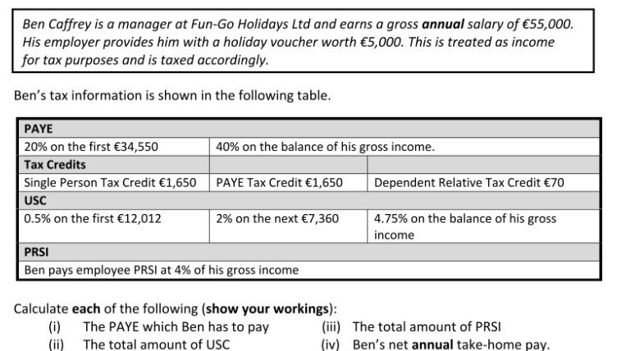
 | € | € | €

Workings

