Taxation in Ireland
Taxation is the process of the government collecting money from individuals and businesses to pay for public services.
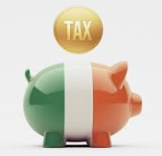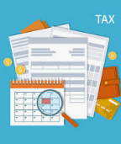
A fair tax system should have the following principles:
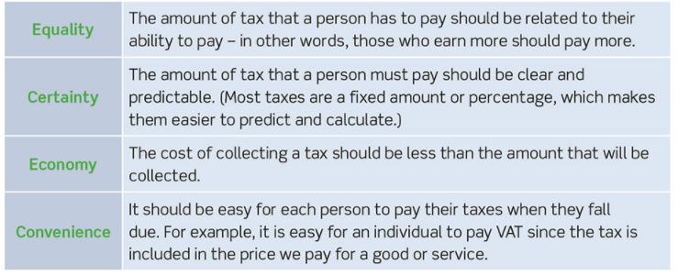
It is important to be aware that when collecting tax revenue, paying tax should not be a disincentive. Very high taxes could lead to growth in the black economy and the effect this would also have on businesses, workers refuse to do necessary overtime, or businesses not locating in Ireland as corporation tax will be too high.
In Ireland, taxes are collected by the Revenue Commission on behalf of the government.
Revenue’s main aims are:
- Collect taxes
- Collect duties on Imports
- Provide information on tax issues
1. Collect Taxes
Taxes collected by the government can either be direct, (taxes on income),or indirect, (taxes on expenditure).
Direct Taxes in Ireland- we will have covered these before.
Income Tax
This is PAYE, and is deducted from income. There is both a higher and lower (standard) rate depending on what you earn. In 2021, the standard rate is 20% and the higher rate is 40%.
PRSI
Paying PRSI can entitle you to certain social welfare benefits. The law makes it that your employer also pays a PRSI contribution on you working.
USC
USC was an emergency tax brought in by the government during the recession. It is paid by all employees with rates dependent on income.
Corporation Tax
This is the tax a company pays on its profits. In Ireland, the rate is 12.5% which makes it one of the most competitive in the world and why so many companies such as Facebook and Google choose Ireland as a European base.
DIRT
This is a tax on the interest on your savings. In 2021, this rate is 33%.
Indirect Taxes in Ireland- we will have covered these before
VAT
This is a tax paid on goods and services. The standard rate for consumers in Ireland is 21%. Every consumer pays the same rate regardless of income (Regressive tax).
There are different VAT rates in Ireland, for example the tourism and hospitality sectors pay 9%.
Motor TAX
This is a tax people must pay on their cars. Factors such as engine size and fuel emissions determine the amount.
Excise Duty
This is a tax on cigarettes, alcohol etc….
Customs Duty
This is a tax on imports coming into the country. There is free movement of goods and services bought from other EU countries, but with Brexit there are changes to buying goods from the UK.

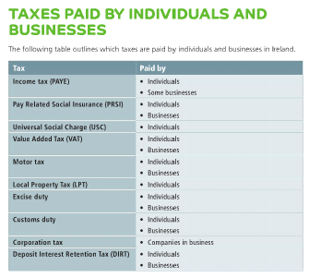
Self-Assessment Tax
Self-employed people pay income tax through self-assessment. This means that they calculate how much tax they owe, and fill in a tax return form which is sent to the Revenue Commission.

The effect of Covid 19 on Tax and Expenditure
The Covid 19 pandemic has significantly impacted people’s ability to earn income and pay taxes to the Irish government. On March 13th 2020, the Irish government brought in a Pandemic Unemployment Payment (PUP) to help workers who may have lost their job as a result of the pandemic. This money was paid to people in replace of their wage/salary if they lost their job by the Irish government.
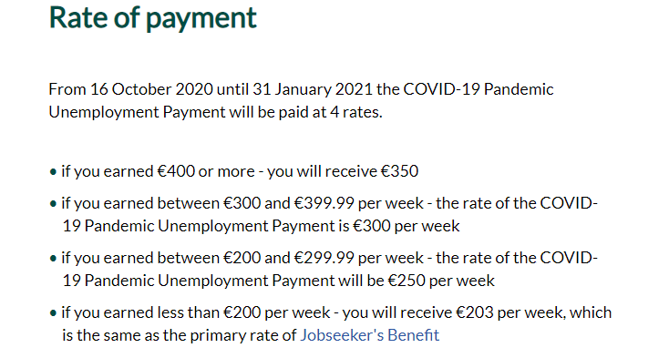
The Irish government spent over €4 billion in 2020 on the PUP.
What effect do you think this had on the government’s income and expenditure in 2020?
The Purpose of Taxation
Financial
Tax can be used to raise revenue for the government to run the country such as taxes being put into essential services like Health and Education.
Our government plays a key role, for example giving tax breaks to Irish companies to promote Irish goods and services and taxing imports to make them more expensive
The government can also encourage people to buy more goods and services by lowering tax rates such as Income Tax, DIRT etc… This will encourage people to spend more money and contribute towards economic growth
VAT rates on industries such as the tourism industry has led to more visitors coming to Ireland and spending money in this economy
Social
Money collected from taxes can be redistributed to society to do good. The homeless, people who are on disabilities or people who are unemployed now have a source of revenue through social welfare.
Taxing items such cars with heavy fuel emissions can also benefit society as they are less harmful to the environment.
The government can provide money to local authorities that can be used to improve local areas such as to build parks, libraries etc...
Improve people’s health- cigarettes and sugar tax…
Legal
A percentage of taxes collected are used to fund the legal system in Ireland, such as the Guards and Irish Prison Service. This helps keep law and order in the country and discourage anti-social behaviour.
Some taxes in Ireland must also be paid by all citizens, such as Motor Tax, and it is illegal to drive a car and not pay it.
Tax evasion is illegal, and people can be prosecuted for this.
Ethical
The Irish system of collecting taxes is to collect money and redistribute it to other parts of society. People who earn more pay more tax.
Money from taxes can be used to support the poorer parts of the economy and contribute to taxes such as Child Benefit

