Taxation in Ireland
The Household Taxes and Calculating Net Pay
Taxation is the process of the government collecting money from individuals and businesses to pay for public services.
In Ireland, taxes are collected by the Revenue Commission on behalf of the government.
Revenue’s main aims are:
- Collect taxes
- Collect duties on Imports
- Provide information on tax issues
Taxes collected by the government can either be direct, (taxes on income),or indirect, (taxes on expenditure).
In Ireland, some taxes are progressive, meaning that there are higher rates for people on more income (e.g. PAYE), and some taxes are regressive, meaning everybody pays the same regardless of income levels (e.g. VAT).
Household taxes
PAYE: Employees pay income tax on their wages under the Pay as You Earn System. Under this system, the employer calculates the PAYE tax payable by the employee. He then deducts the PAYE tax from the employee’s gross wage and pays it over to the revenue for her.
Self- Assessment Income Tax: Tax paid by the self -employed.
VAT: This is Value Added Tax and is the tax on goods and services when a consumer buys goods. The tax is collected by the business and paid to the government.
Motor Tax: Compulsory tax on car ownership paid to local Authority. In Meath it is the motor tax office in Navan.
Excise Duties: Tax on certain products such as alcohol and tobacco.
DIRT: This is Deposit Interest Retention Tax. When someone earns interest on money in the bank, the account holder pays this tax on that interest. The bank that holds the account must deduct the tax from the interest before paying the interest to the consumer.
Capital Gains Tax: Tax if a person earns income from the sale of an asset such as shares or property (other than the home). Tax must be paid on the return of this investment. It is your responsibility to calculate the CGT payable.
Capital Acquisition Tax: Tax paid of gifts and inheritance. The amount of tax you pay depends on who gave you the gift or inheritance and how much it is worth. However not all gifts and inheritance are subject to this tax. Married couples do not pay tax on gifts and inheritances received by each other.
Calculating Net Pay- We will be practicing questions in class.
Sample
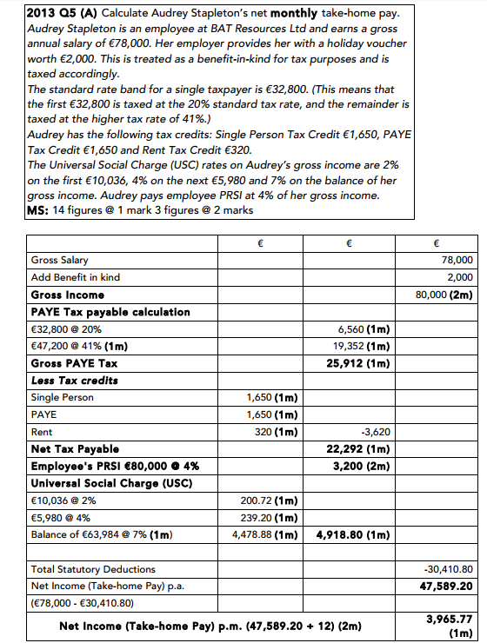
We will practice a number of tax working questions in class.

