The ABQ 2019

About the ABQ

1 | The Higher Level Leaving Certificate Business Paper consists of three sections.
2 | Section 2 which is the Applied Business Question (ABQ) is a compulsory question.
3 | The ABQ consists of a single practical Case Study Business Question – 80 marks are available, representing 20% of the total marks.
4 | The text and questions of the ABQ are based on three specified units of the syllabus, out of a total of seven units, which alternate (change) on an annual basis..

Methodology

- This section requires you to Name, Explain and Link for each point. A high level of synthesis (i.e. combining different elements into the one answer) must be established and should therefore be done when you are fresh. Evaluation may be also required.
- In answering the questions on the ABQ candidates must explain and make use of relevant knowledge / theory (and understanding) gained in the subject while studying the course in addition to the relevant links from the ABQ.
- Linking of points made in your answer with the text by relevant quotes / phrases / statements from the ABQ is essential. It is recommended that you present the link / quote in a different colour ink. A DIFFERENT / SEPARATE link is required for each point of theory made within each part of the ABQ. A link will not be awarded marks without having the relevant theory attached.
- Read the ABQ provided in full before reading the questions, then go back and highlight the relevant points / links in the text.
- Present your answers to each part of the question in point form and be sure to link or quote from the text of the ABQ in your answer, even if you are not specifically requested to do so.
- The methodology that must be used can be seen by looking at the structure of the sample answers shown below.

Sample ABQ’s Leaving Cert Business Units 1/2/3
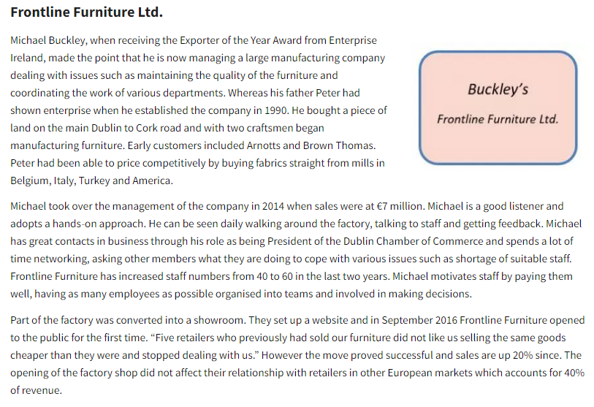
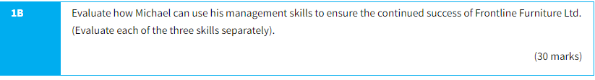
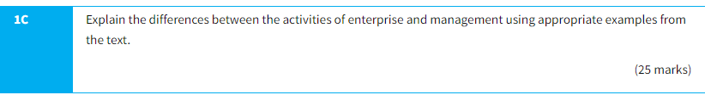

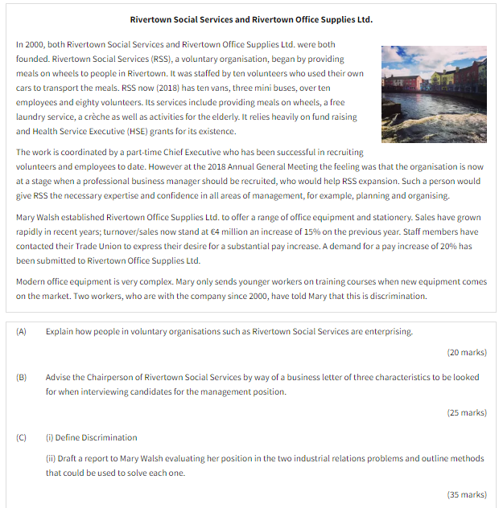

2009
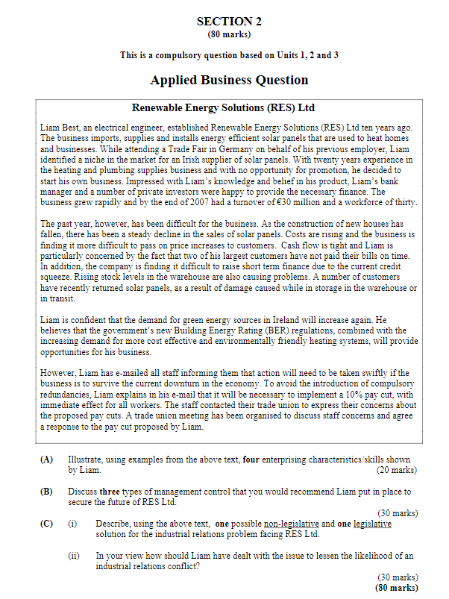

2014
