The Business Needs: New Ideas and Product Development
When starting a new business, an entrepreneur will need an idea to start up their new business that stands out from what is already out there, or an existing business may also need to generate a new idea for business growth and development.
These ideas can come from either internally (inside the business), or externally (outside the business).
Internal vs External Ways of Generating Business Ideas
Internal
1. Brainstorming: This involves people from different areas of the business who come together to generate a list of ideas on a given topic.
Companies like Google could have regular meetings between different members of teams e.g. sales, IT development etc.. to brainstorm new ideas.

2. Research and Development Department: The R&D department may work on discovering a new product or work on improving an existing product to extend its product life cycle.
Companies like Google spend billions each year on their R&D
3. Hobbies and Skills: An entrepreneur may turn their own hobbies or skills into the best business opportunity. They themselves may come up with a more unique production technique or finish to an already existing product/service, or have a passion in a particular field and develop this passion into an idea.
Brian Lee set up Chopped in 2012 based on his interest in health and fitness.
4. SWOT Analysis
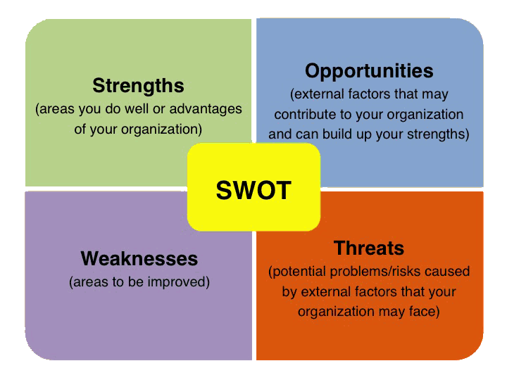
Strengths
- What am I good at?
- What am I interested in?
Weaknesses
- What am I not good at?
- What am I not interested in?
Opportunities
- What can I work on?
- Who do I know that could help me?
Threats
- What are the risks?
- What problems may arise?
Once you have completed the SWOT Analysis you should again try to use what you have found out to screen the best ideas and pick the one that you are most happy with.

Task: Conduct a SWOT Analysis of yourself in trying to come up with a new idea for a business.
5. Other internal ways: Suggestion Box, Intrapreneur (Facebook Like Button), Customer Feedback
External
- Competitors: A business could monitor close competitors and look at copying some of their product ideas, without copying them directly (patent)
Companies like Google constantly have to keep a close eye on the likes of Bing and Yahoo
- Trade Shows: Business would regularly attend trade shows such as the Dublin Web Summit to inspire them to make a new product for the domestic market or search for gaps in the market
Companies like Google travel all around the world to attend trade shows to see if there are opportunities for new products etc…
3. Other External Ways: Family/Friends, Media, Import Substitution, Business Alliances, Local Enterprise office

Development Process for a New Product/Service
- Idea Generation
- Product Screening
- Concept Development
- Feasibility Study
- Prototype Development
- Test Marketing
- Product Launch
We will be researching and examining examples of these stages in practice as part of our study in class.

