The European Union: Effects on Ireland and Brexit
The European Union and its member states
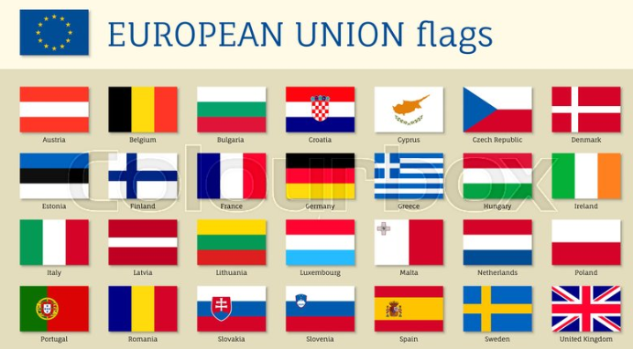

The European Union is a Trading Bloc of 27 countries operating in a single market meaning that there is free trade and movement of labour between the member states. (Remember, a trading bloc is a group of countries who agree to form a trade area for a common market and remove trade barriers in doing so).
Although each member is its own independent, sovereign country, they pool together to gain strength by numbers and give some control to EU institutions in order to support collective goals.
Of the 27 countries in the EU, only 19 use the Euro. The countries that use the Euro are called the Eurozone.
On your I-Pad, can you find the countries that are not in the Eurozone?
Some of the main goals of the EU include:
- Promote peace, its values and the well-being of its citizens
- A common currency
- Recognised qualifications in member states without needing further qualifications
- Free movement of people, money, and trade
- Offer freedom, security and justice without internal borders
- Highly competitive market economy with full employment and social progress, and environmental protection

The EU has established a number of institutions to look after the running of it. The most important are:
The European Commission
The European Commission is the executive body of the EU. It is the body responsible for proposing and drafting EU Laws and putting them into effect when they are passed. A really well known example of this would be the GDPR laws in Europe. They are also in charge of monitoring the EU’s budget
The European Council
The European Council meetings are summit meetings held regularly by each of the EU Heads of State. The council will discuss proposals from the European Commission and decide whether to pass them into law or not.
The European Parliament
Members of the European Parliament are the only ones to be elected by the citizens of the EU. Amongst their jobs, they debate and approve new European Laws and approve the EU Budget
The European Central Bank
As we have previously learned, the ECB is in charge of setting the monetary policy of the EU. It is in charge of interest rates and the supply of the euro

Ireland and the EU
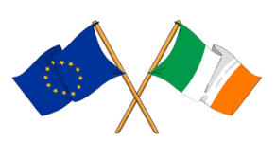
Ireland officially joined the EU on January 1st 1973. The following are a list of challenges and benefits of Ireland’s EU Membership:
Economic Benefits
- Access to larger markets (445 million people across 27 countries)
- Foreign direct investment (FDI) into Ireland- e.g. Facebook/Google, over 30 billion euro has come into Ireland
- Structural funding and rural development- Ireland has received billions of funding to help national development
- Financial assistance in times of crisis- Ireland received three year financial assistance programme in 2010, and in 2014 became the fastest growing economy in the EU- what will happen in 2020 with the Covid 19 crisis?
- Workers from other EU countries can work here and pay taxes

Economic Challenges
- Loss of control- some EU laws have to be followed
- Increased competition- e.g. Lidl and Aldi have become well-known brands
- More competition for jobseekers- have to compete with jobseekers from all over Europe
- Varying social benefits in EU countries- some move to Ireland as our Child Benefit and Jobseekers allowance is quite high
- Not being able to trade freely with the UK when it leaves the EU

Social Benefits
- Job creation and job opportunities- an estimated 700,000 jobs have been created in Ireland due to EU Membership
- Freedom of movement- Irish people can move, work, and study across the EU
- Improved working rights- e.g. Unfair Dismissals Act was introduced in Ireland after we joined
- Greater consumer rights- misleading advertising and unfair commercial practices have been banned in the EU since 2005

Social Challenges
- Many different languages- in 2019, it will be important for students to learn at least one new language, however we are fortunate to speak English
- Migration of skilled labour- qualified people leaving Ireland to seek employment, or coming back to Ireland which puts a demand on housing market
- Brexit influence?

Brexit
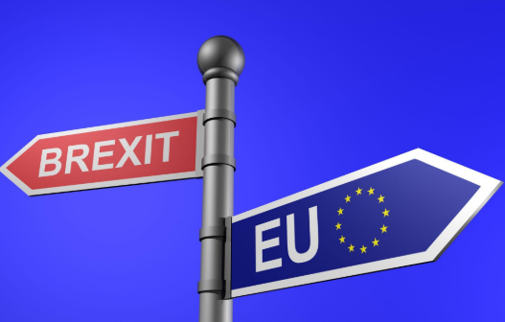
In June 2016, the UK voted to leave the EU and this is officially to come into effect in January 2020. This is known as Brexit. 48% of people voted to stay, while 52% of people voted to leave.
The UK formally left the European Union on January 31st 2020
The effect of Brexit on Ireland
- Reduction in the value of sterling (Irish exports become more expensive, imports become cheaper). Possible reduction of trade between Ireland and the UK- Ireland is heavily reliant on the UK as one of our main export partners, Irish products may become more expensive and people may not buy as many products/services as a result

- Restriction of movement of Irish people into and out of the UK- think of passport control in the airport, the difficulty of Irish people securing employment in the UK

- Border controls in Northern Ireland*- The backstop issue

- Downturn in the UK economy, which will affect Ireland’s economy- the potential loss of jobs for Irish people in UK businesses, and the need to return home. Where will these people live/work?

- More foreign direct investment in Ireland- businesses will come to Ireland as they can no longer trade freely while operating in the UK. Ireland’s corporation tax will prove highly attractive to these businesses

