The Management of Change

The Process of Change
All businesses at some stage may need to change. For example, the government banned smoking in 2004 and so pubs had to cope with this. Many now have outdoor seated areas to cope with this change.
Facebook aquired Instagram and made numerous changes to its design to compete with Snapchat and TikTok.
Business’s had to change and adapt to Covid 19.
Change is all around businesses and they must be able to adapt to this to be successful.

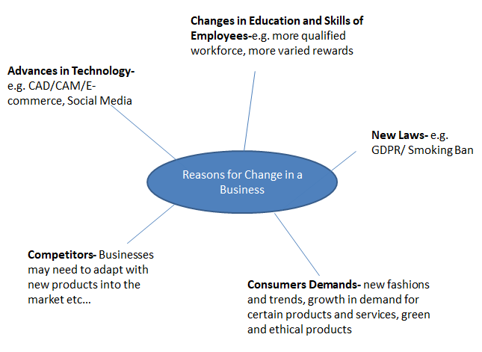
However, not all workers welcome change, and there can be a resistance to change in the workplace based on some of the following reasons:
- Fear of losing their jobs – technology replacing people, making skills obsolete
- Fear of losing power
- Fear of failure- employees cannot cope with new technology etc…
- Laziness
- Redundancy- some employees may feel the changes may bring abiut redundancies
Therefore, businesses come up with the following strategies to try and manage change:
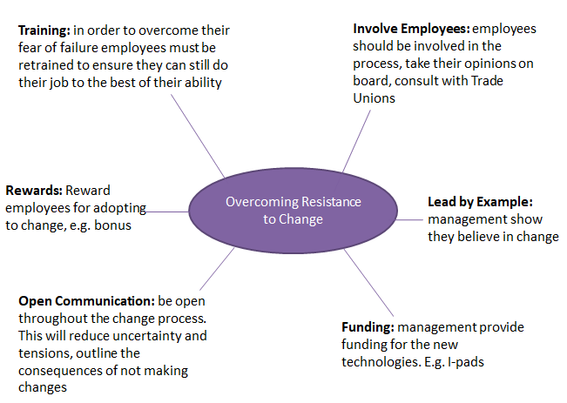
***The following are the main Strategies for Managing Change in a business***
- Move from controller to facilitator
- Employee Empowerment
- Job rotation/Job enlargement/Job enrichment
- Total Quality Management
- Team work
- Quality Circles
AND
The impact of technology
Change from controller to facilitator
The Controller manager would typically give orders and expect them to be followed without question. There is very little control given to workers and the manager makes all the decisions.
The Facilitator manager works with employees. They give direction, provide support and advice, and is comfortable delegating or empowering their workers to complete tasks. They place real trust in the hands of workers.
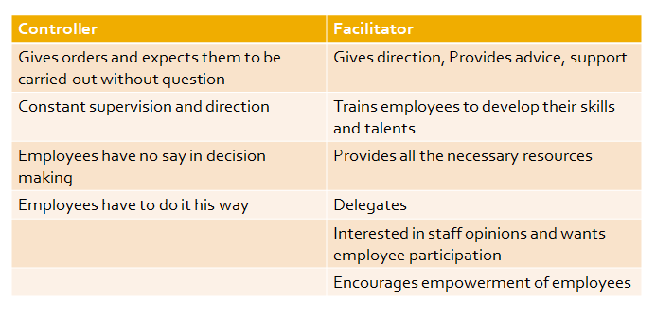
All these factors contributed to a significant change in management that can still be seen in operation today. The old authoritarian style of management that used to exist does not work in business any more. Because employees will no longer put up with always being told exactly what to do with no freedom, Irish managers have had to change the way they deal with workers. They have changed from the old style controller to more of a facilitator style of management.
vs.
Nowadays, a facilitator is more like a coach who trains and developes the employees with strategies such as empowerment and teamwork, encouraging and rewarding workers for work done.
The objective of a controller was autocratic- catch where the employee went wrong and teach them not to do that again. It is very much Theory X v Theory Y.
Facilitator Managers operate a theory Y management style.
Facilitator Management: The approach recognises that employees will contribute more of their talent and abilities to the firm if they are given:
- Encouragement and Responsibility
- Training
- Advice and Support
- Recognition and Reward
Employee Empowerment
Employee Empowerment means placing real power, which includes decision-making and full responsibility in the hands of workers where it is most effective, i.e. as close as possible to the customer.
Workers who deal with the organisation’s customers every day are given great influence over the operation of the enterprise. Decision-making and control is in the hands of workers who use their skills and knowledge in the interests of the organisation.
Benefits
Improved Decision Making
Decision-making and control is in the hands of employees who use their greater skills and knowledge for the benefit of the business. Decisions can be made quicker and without having to constantly refer to a superior for their input, disrupting their work and slowing down decisions
Improved Customer Experience
Employees become more responsive to the needs of customers as they come up with solutions to solve issues as they arise. If a customer has a query or problem, the employee has the power to deal with it there and then. There is no waiting for managers which will lead to more satisfied customers who feel valued and cared for, rather than stock answers on behalf of the business
Employee Motivation
Employee’s morale and motivation increase- they are part of the team. This will mean that productivity and output will increase and less potential for absenteeism as they feel valued in the organisation. They also have the opportunity to learn and develop their own skill set which may benefit them in the future when looking for promotional opportunities
Challenges
Increased chances of mistakes
If empowerment is introduced without adequate training for employees then mistakes can be made. Staff may make errors without management knowing about them, which could damage the reputation of the business with customers.
Unsuitable Staff
Some employee’s e.g. part time students may be unhappy with the extra responsibility and/or lack of training and their stress levels may increase. This can cause de-motivation among employees as they feel under too much pressure in their position
Job Rotation/Enlargement/Enrichment
Job rotation is the process of moving employees around an organisation so that they can develop and gain experience in different jobs. This adds to their skills profile as well as benefiting the organisation with fresh ideas that may be generated and reducing boredom or lack of motivation amongst staff.
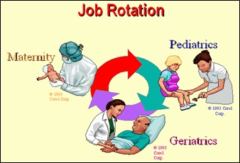
Job enlargement means giving people extra responsibility to make their job more challenging and interesting. Examples would include solo projects or becoming team leaders for a task.
Job enrichment is concerned with adding to responsibilities and giving the employee freedom to make choices. Examples could be not only becoming team leader of a project, but also allowing the employee the freedom to make all decisions about the project on behalf of the organisation.
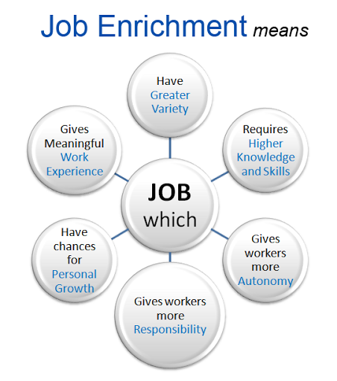
Total Quality Management
TQM is a management strategy designed to ensure 100% perfection and 100% customer satisfaction. It says that every person in the business is responsible for delivering quality to the customer. If a business follows the TQM principle, it will have perfect quality products. Quality assurance and Teamwork are essential to the TQM approach.
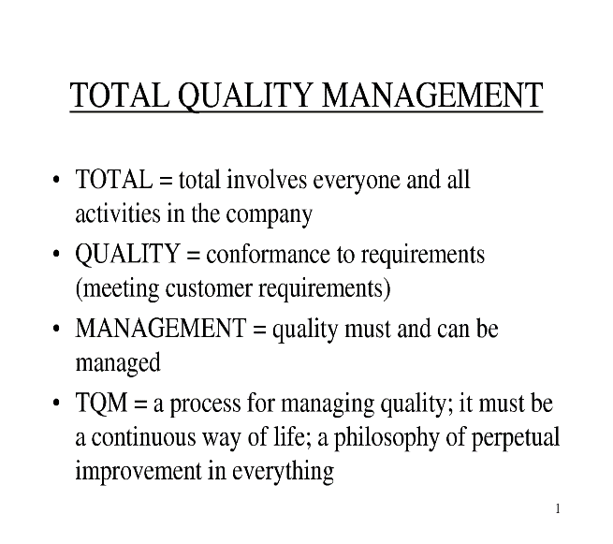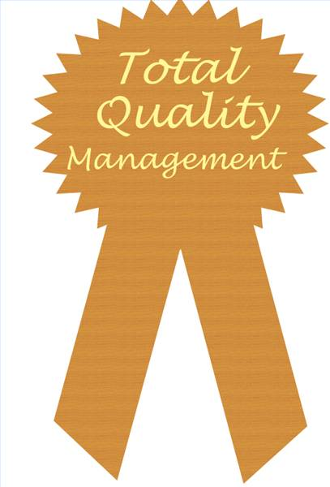

Benefits of TQM
Improved Quality
Continuous Improvement means the business tries each time to do better than the previous time when manufacturing products. A business using TQM will strive for ‘zero defects’ in production. The benefit is less products will be returned for a refund, reducing costs.
Increased Sales
The focus is on the customer, so a manufacturing business will conduct market research in to what the customer requires from their product. The benefit is that sales will increase as consumer satisfaction is improved. This will also prevent a firm producing lots of an unwanted goods as they will have checked what the consumer wants before production starts.
Job Satisfaction
Employees are empowered; allowing them to make decisions, increasing trust from management and allowing them satisfy esteem needs (Maslow). They also work in teams, increasing productivity and satisfaction. The benefit for the manufacturing business is that there would be more energized and productive staff, and lower staff turnover.
Meet Legal Requirements
Under the Sale of Goods and Supply of Services Act 1980, all products must be fit for purpose and of merchantable quality. The benefits to a manufacturing business are that TQM will help ensure standards are high enough so that they fulfill their legal requirements to consumers.
Attract workers
A business that implements a TQM approach can have a positive reputation in the market place and be an attractive place to work. This in turn can attract high calibre applicants to work in the business.
Problems of TQM
- TQM does not produce instant results as it is a long term strategy
- The role of managers and workers must be clearly defined
- Training must be on-going so that staff are provided with the skills needed to work in teams and managers learn how to cope with people who are empowered
- Time needs to be spent informing staff about the TQM approach and its implications for work practises, rewards and job control

Example of TQM in Guinness
Guinness's vision is to have the perfect pint, everywhere, every time This requires TQM at every stage in the production (making) and distributor (selling) chain.

Stage 1: Raw materials
Guinness only buys from the very best barley growers. It researches new types of barley, checks that its suppliers are growing the right type of barley and checks the quality of each barley harvest before buying it.
Stage 2: Manufacturing process
Guinness makes sure that its brewing process is the best quality by using trained “testers" and modern technology. Every day, trained testers undertake tests on dozens of samples of stout at regular stages in the brewing process to ensure that it is in peak condition for the customer. The tasters score the stout for its aroma, flavour and head quality, and they detect any hint of deviation from the normal.
Stage 3: In pubs
To ensure a perfect pint, Guinness has invested heavily in sales quality. It spent over €1 million developing the current Guinness tap. It is easy to operate and ensures that every pint is perfectly presented. The Guinness Quality Team regularly visits all the pubs in Ireland to check the quality of the pint and to advise the bar staff about delivering the perfect pint.

Team Work
"Talent wins games, but teamwork and intelligence wins championships." --Michael Jordan
Team work involves a group of people working co-operatively towards achieving a common goal. A team combines the various talents of its members, who work together in some way to produce better results for a business. A team will communicate and co-operate with each other over a period of time.

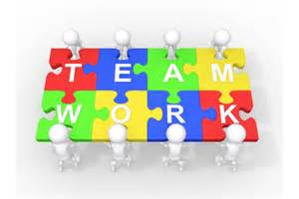

Teams go through 4 stages in their development:
- Forming
- Storming
- Norming
- Performing
.
- Forming
- Members of the team meet for the first time
- They are very polite to each other
- They discuss the jobs that they have to do together
- However, they do not reveal too much about themselves
- Storming
- As team members get to know each other a bit better, conflict occurs.
- Arguments arise as strong personalities emerge within the team
- Rows happen when team members vie for positions within the team, such as team leader
- Norming
- Team members resolve their conflicts, reach a consensus and start working together
- They agree on who the leader is, who has the power and each other’s roles.
- Team members start to trust each other
- They set ‘norms’ which are standards of behaviour and work that all team members must obey. If they do not obey them, they will be isolated from the team.
- Performing
- Team members pull together as one and focus on getting the job done.
- They cooperate with each other and work together as a unit.
- There is a strong sense of unity in the team.
Benefits of Teamwork
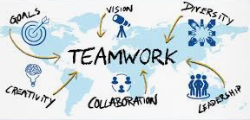
- The work is shared among individuals. People can see and appreciate other team member’s efforts. No one individual bears sole responsibility for a project/task

- Many hands make light work. Using teamwork can result in work being completed faster as different talents are utilised, there is less stress on one individual, responsibilities/duties are shared and there will be increased creativity in terms of how to complete a project efficiently.

- Speeds up the decision making process as staff no longer have to go through the chain of command to the top of the organisation for approval before making decisions. Workers from different departments work together as part of teams. This helps reduce internal barriers and makes work more meaningful

- Pressure and responsibility on certain employees falls as a result of teamwork, this can increase morale and motivation to achieve results and cut down on stress and absenteeism

Quality Circles
A quality circle is a volunteer group composed of workers, usually under the leadership of their supervisor, who are trained to identify, analyze and solve work-related problems and present their solutions to management in order to improve the performance of the organization, and motivate and enrich the work of employees.
The purpose is to let people who come into contact and deals with the issues regularly are the ones who solve it. The members of a Quality Circle may be from different sections of a business and operate at different levels.

The Impact of Technology on Change
How Technology Changes the Role of Managers
1. Marketing
Managers can now use the Internet to advertise their products to consumers throughout the world on the business's own website or on famous websites such as Facebook. This helps managers to reach customers who may not look at traditional advertising media such as newspapers or TV . Furthermore, the business can engage in e-commerce. It can use the Internet to sell its products all over the world without setting up shops anywhere.
2. Decision-making
Managers can use ICT to help them make better and faster decisions. They can download information in seconds from the Internet about any topic and use this to help them make a decision.
3. Production
Managers can use Computer Aided Design (CAD). This is computer software that is used to design new products for the business. Instead of drawing up designs by hand and manually building prototypes to test them, the computer can design and test the new product. This means that products can be designed and made much quickly and cheaply. This enables a business to respond rapidly to market changes by helping it to bring new products to the market quickly.
Managers can use Computer Aided Manufacture (CAM). This is computer software that controls the machines in the factory. It switches them on and off and tells them exactly what to make and to make any adjustments needed to ensure perfect products are made. This means that the machines can run 24 hours a day without making mistakes. This enables the business to mass-produce enough products to sell all over the world.
4. Redundancies
New technology can replace the employees in the business. This reduces a manager's span of control, as there are fewer employees to supervise. This frees up the manager to spend time on other aspects of running the business. Ryanair and Aer Lingus managers no longer have to supervise reservations clerks as they have all been replaced by online booking.
5. Employee Retention and Motivation
Managers can use modern technology to motivate and keep employees. The Internet enables teleworking, which means that employees can work from home. Their work is sent to their home computer and they complete it at home. This reduces the time and money employees spend commuting and also may suit employees with children. Therefore, it can be a very effective way to retain employees.
Impact of Technology on Personnel
1. Changing Nature of Jobs
New technology can change a worker's job by possibly making it easier or by enabling him to do more work or totally changing the way he carries out his duties. Bus drivers can drive and collect fares through computerised technology on the bus.
2. New Types of Jobs
New technology creates opportunities for employees to work in new areas, such as computer programming and website design. A major employment opportunity for workers is in the area of designing computer games.
3. Redundancies
New technology can now do the work that was done in the past by employees This allows the business to make these employees redundant. Therefore the employee loses his job and becomes unemployed as a result of new technology. This leads to a drop in his standard of living. For example, many of the Aer Lingus employees who worked in its ticket offices around the country were made redundant when the Internet allowed Aer Lingus to sell tickets online.
4. Teleworking
ICT enables certain employees to work from home. The employee's home computer is linked to the office computer. The office emails work for the employee to do. He completes it in his own home and emails it back to the office. In this way, the costs and hassle of commuting are eliminated or reduced.
Impact of Technology on Business Costs
Increased Costs
- New technology can increase a business's costs. It costs a lot of money to buy the technology – the hardware and the software. It also costs money to maintain the hardware.

- Employees have to be taught how to operate the new technology. Whether the business trains them in house or by sending them on courses, this training can cost a lot of money.
Reduced Costs
- New technology can reduce a business's costs. CAM uses computers to monitor the tools and machines used in the factory and to make any adjustments needed to ensure perfect products are made. This reduces the money the business spends on giving refunds and repairing faulty products.
- Fewer workers are needed because machines and technology now do the jobs that employees once did. For example, EDI means that a business no longer needs workers to process basic stock purchasing and invoicing. This leads to a reduced wage bill for the business.
Impact of Technology on Business Opportunities
1. Design
Modern technology can be used to design, test and manufacture new products more quickly and cheaply than before. This enables a business to respond rapidly to market changes by helping it to bring new products to the market quickly.
2. International Trade
The Internet enables businesses to sell their products anywhere without setting up shops all over the world (e-commerce). The business advertises its products on its website and any customer in any part of the world can view the website and order products from it, paying by credit card. For example, Dell does not have any shops. They use their website www.dell.com to sell computers all over the world.
3. Direct Marketing
A database is a computer program that stores, organises and manages information entered by a person. A business can use a database to store information about its customers, such as their names, e-mail addresses, previous purchases and so on. The business can then use this information to target customers with tempting offers it knows will appeal to them and thus increase sales.
4. New Products
New technology gives entrepreneurs the opportunity to develop brand new products. For example, successful entrepreneurs have exploited the features of the Apple iPhone to develop many different apps for customers to buy for their iPhone.

Business Opportunities For Managers
Production: Some new products owe their existence and success to technology e.g. reserving seats on airlines and making hotel reservations from any part of the world at any time. Businesses also use CAD (Computer Aided Design) and CAD (Computer Aided Manufacturing) which saves money and problems by having computers assist in producing products

Marketing: Many businesses now use the internet to market their goods and services. By creating a website a large number of potential customers can be reached at minimal cost/e-marketing/e-selling
Decision- Making: information on businesses, people, countries, products, in the world at the touch of a button. Leads to more informed decision making

Communications: Management & staff can be equipped with laptops, mobile phones and e-mail links which enable instant communication leading to increased business efficiency/global communications
Spans of control can be widened. Ability to monitor larger groups or groups which are geographically apart

Impact of Technology on Staff
Tele-Working: With the use of broadband it is not necessary for employees to work together in the same building. This leads to savings on office costs and allows a business to hold on to staff that may prefer to work from home

Training: In many occupations the training of workers can be done by or with the help of computers and the different software packages available

Redundancies: fewer employees needed due to technology. Some skills or industries are becoming obsolete.

New opportunities: new types of jobs have been created, such as web developers and computer programmers

Impact on Business Costs

Capital Costs: There is huge capital costs associated with technology development. There is an increased risk to the enterprise because costly equipment has to be bought prior to selling the goods and creating cash flow e.g. robotics for example, is a very expensive process involving a very complex production line.

Labour Costs: Changing technology reduces the number of workers required, e.g. using robotic equipment instead of people in automated production facilities. The emphasis is on quality and a far higher level of skill is required of the personnel. Multi-skilling (where people have a wide variety of job skills) is common in technologically advanced enterprises, and can reduce costs as fewer staff is required

Training Costs: Decision-making at all levels, from top management down, is helped. Communications between the functions in the enterprise and between the people in the enterprise are improved. Training costs in the organisation must increase to help the process

R&D Costs: Modern technology increases the speed of innovation and therefore shortens the life cycle of products, requiring new products or new developments/applications of old products. The associated research and development costs can be daunting. More personnel are required in this area.

