The Process of Managing Change
Task: Can you think of any examples of change for a business in the last 10 years? How has this business managed this process?
All businesses at some stage may need to change. If we examine the situations with businesses, schools, hospitals etc.. as a result of Covid 19, there have been a number of changes businesses have had to adapt to.
There are other reasons for change, for example Facebook aquired Instagram and made numerous changes to its design to compete with Snapchat. The Smoking Ban was introduced in Ireland in 2004, what affect does that have on pubs? The plastic bag levy, anti- discrimination laws etc…
Change is all around businesses and they must be able to adapt to this to be successful.
Some of the main reasons for change are outlined below:

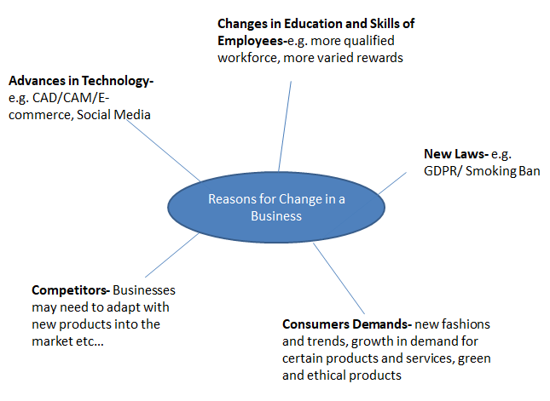

However, not all workers welcome change, and there can be a resistance to change in the workplace based on some of the following reasons:
- Fear of losing their jobs – technology replacing people, making skills obsolete
- Fear of losing power
- Fear of failure- employees cannot cope with new technology etc…
- Laziness
- Redundancy- some employees may feel the changes may bring abiut redundancies
Therefore, businesses come up with the following strategies to try and manage change:
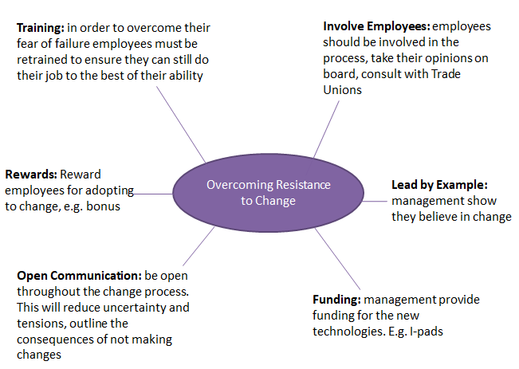
Task
- Research 5-10 examples of change in the business world over the past few years using real life businesses in your answers.
- Do you think overcoming resistance to change is linked to motivation? Explain your answer.

