The Wise Consumer
A CONSUMER is somebody who buys a good for their own personal use- Example-buying a new pair of Chinos in TopShop
A TRADER is somebody who buys goods and then resells them. Example- TopShop buys Chinos from the supplier and then sells them onto the customer
Task: Using your I-Pad- Find 5 more examples with pictures of items you would purchase for your own use as a consumer.
Before buying goods/services- as a consumer you should ask yourself the following questions:
- Do I need it: Is it really important?
- Can I afford it: How will it affect my budget?
- Is it value for money?
- Have you checked prices elsewhere?
- Don’t impulse buy
- Get a receipt as proof of purchase.

Do I really need it?
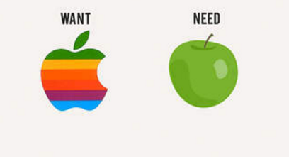
Think back to our needs and wants. Sometimes we can mix these up and it is really important as wise consumers that we remember this point.
Spending too much on our wants will mean that we may not have enough money to satisfy our needs and we may run into debt.
Can I afford it: How will it affect my budget?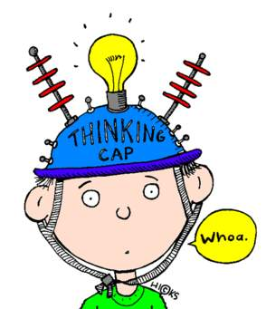
If you decide to buy something you must know how much it is going to cost and stick to a budget for it. It is really important to not spend more than you can afford- if you spend more than you can afford you will run into debt.
Is it value for money?
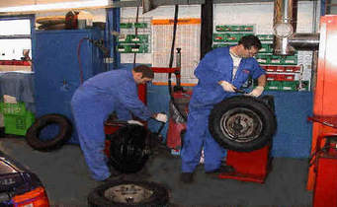
Think back to False Economies from our Expenditure Chapter. The wise consumer knows that just because an item is cheaper doesn’t mean it is better value for money.
Example
Chris needs a new set of tyres for his car. One set are €250 and will last 20,000 km. The more expensive set are €300 but will last 30,000 km. Which set should Chris buy and why?
Unit Pricing
The unit price is the price of the single amount of something. This is useful to calculate when you are shopping and comparing prices of items that come in different sizes.
The formula you use is:
Unit Price = $\frac{Price}{Quantity}$
Example 1
Boxes of Cookies come in the following packets:
- Small Box (500 grams) cost €3.00
- Medium Box (700 grams) cost €4.90
- Large Box (1kg) cost €5.50
Calculate which box is the best value for money.

Example 2
Boxes of Cereal come in the following packets:
Small Box (250 grams) cost €2.50
Medium Box (300 grams) cost €3.00
Large Box (500kg) cost €4.00
Calculate which box is the best value for money.
Have you checked prices elsewhere?
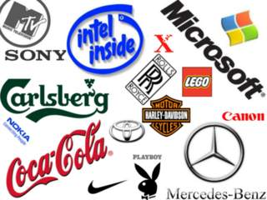
Whenever we need to buy goods and services, it is important to make sure that we shop around and don’t just buy in the first shop we visit. You would be amazed with the amount of money you can save by shopping around.
This can mean looking at different brands, walking into different shops and shopping online to find the best value.
Remember the brand test challenge that we did in class, notice how brand images can affect our choice when buying goods and services
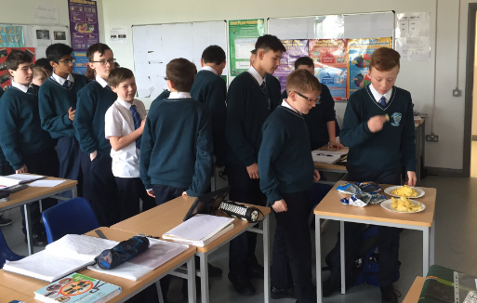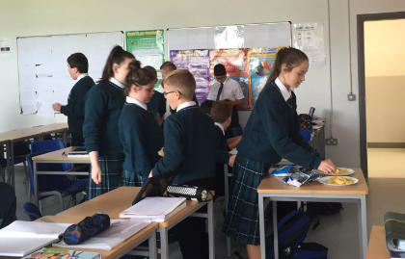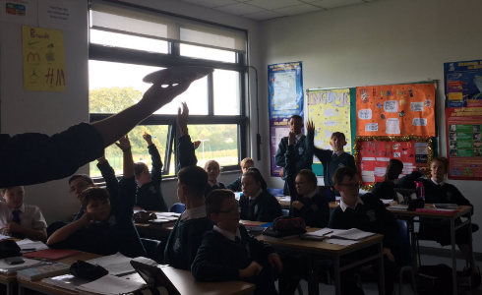
Some very expensive brands try to generate an exclusive image by getting people to spend a lot of money and choose their product over others. This is known as Conspicuous Consumption.
Think about the image people have when they wear expensive clothes. Businesses know people will choose their brand as the expensive brand will make them stand out over others and it appeals to people’s vanity.
The wise consumer is able to keep this in mind when buying products and services.
Don’t impulse buy
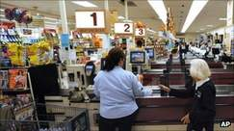
As we have seen in our Expenditure chapter, Impulse Buying is when we buy goods and services on the spur of the moment.
Shops deliberately place desirable goods close to the checkout in order to tempt us into making these purchases, and keep the most common goods such as bread and milk far away from each other in the hope we pick up other unplanned goods along the way
A wise consumer will be aware of this, and will also remember that just because something is on sale does not mean that we have to buy it
Shops will attempt to attract us to make impulse purchase with tactics such as:
- Loss Leaders: Attract customers into shop with low prices in the hope that they buy other profitable products- Example- €3 Chicken roll in the hope that you buy coke, sweets etc...as well
- Special Pricing: €9.99 sounds a lot better than €10. This sales tactic often fools people into buying goods and services that they would not normally buy for €10
- Below Cost Selling: Shops sell at a lower cost than they paid for it in the hope you will buy other things in store
Get a receipt as proof of purchase
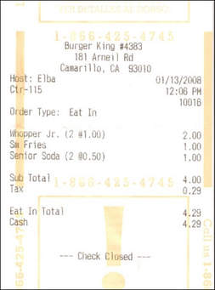
A receipt is a small piece of paper that you get after you have made a purchase and will contain:
- Name of the seller
- Date
- Description of the item purchased
- The price paid and change given
It is always good to keep a record of your receipts. If there was a problem with a good or service you bought your receipt would be your proof of purchase
Reviewing your receipts will help you monitor your spending and help prepare your personal accounts such as The Analysed Cash Book

Guarantees and Warranty
Guarantee: Promise from the manufacturer to offer a refund or replacement to consumers who have purchased faulty goods.
Warranty: Additional promise by a manufacturer or seller to repair damaged goods in a specified period of time.
Task: Log onto YouTube and find an advertisement for a car or computer product that offers a warranty or guarantee.

How can we understand Advertisements?
Advertisements are generally used by businesses to try and get us to buy their product or service
The two main types of advertising are:
Informative: Gives information about a product
https://youtu.be/BC7urUfk81Q
Persuasive: Tries to get us to buy a product over its competition
https://youtu.be/l8-Mr1Vf2iw?list=PL5F-BsyODxxcU9c8fnTn2JlX-d050xztH
Advertising Aims
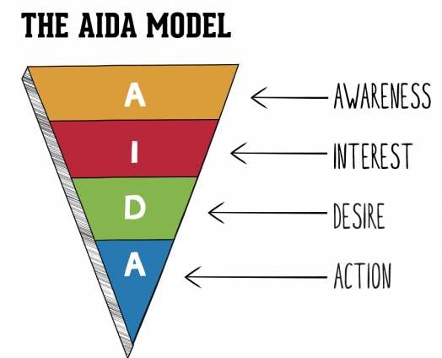
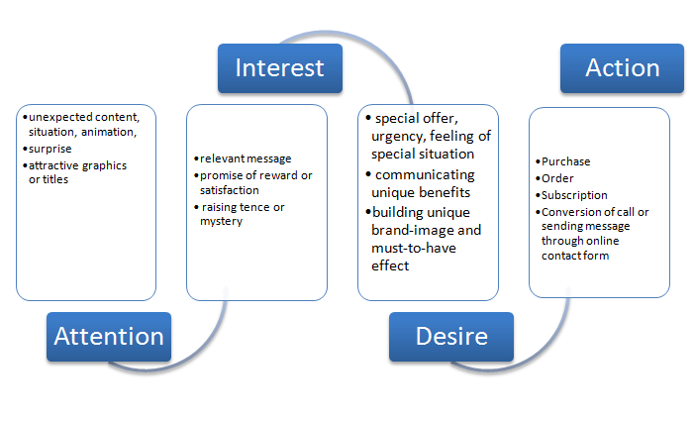
Task: Choose an advertisement from a magazine and use the AIDA model to analyse it.

How can we pay for our shopping?
Pay with our money
Cash: - using notes and coins. This is known as legal tender.
Debit Cards: - The chip and pin card. Safer than cash as these cards can be cancelled if stolen
Gift Cards: - This would be cards like a One4all voucher that can be used to buy products and services

Borrowed money
Loans:- Given by the bank, but you must be careful about interest rates
Hire Purchase:- Have use of the good immediately, but pay for it in instalments.
Credit Cards:- You must be careful about the interest rates and overdraft charges
Being smart shoppers online
- Use websites that you trust. Look at reviews, ask at home to review the website as well
- Secure Payment. Try use PayPal where possible
- Indirect Charges: Be aware of delivery charges, taxes, that can be added onto the cost of the good

