Management Skill: Leadership
Task: Research a figure in the business world where each type of leadership is evident.
Leadership is the ability to influence the behaviour and actions of others in the pursuit of certain goals through guidance, communication, and delegation. Example- a team captain. It is very difficult to lead alone, and the real power of an effective leader is to have the ability to have a positive impact on the actions and behaviour of others around you.
It is very important for a leader to delegate responsibility as it will be near impossible to get all work done by themselves. Delegation means the assignment of authority/power to another person. It is generally assigned from a manager to a subordinate, to undertake a specific work task or project. Example- delegate responsibility to your goalkeeping coach to work with the keepers while you sort out the rest of the team in football.
Benefits of Delegation
- Manager is not required to do all the work and has more time for strategic planning.
- Task/project may be completed to a higher standard due to the level of personal care
- Work gets done faster
- Accountability provided by delegation
- Increased employee motivation from job enrichment/ improved staff morale
- Good way to train employees for management
The following three leadership styles are generally used in business management:
- Autocratic
- Democratic
- Laissez-Faire (Free Reign)

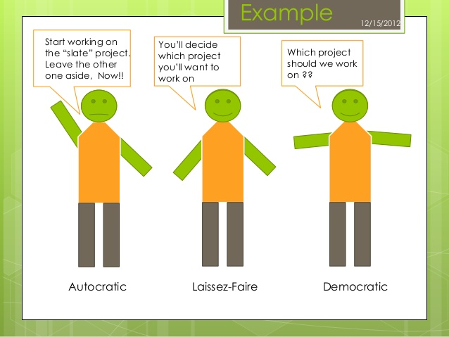

Autocratic Leader: My Way or the High Way
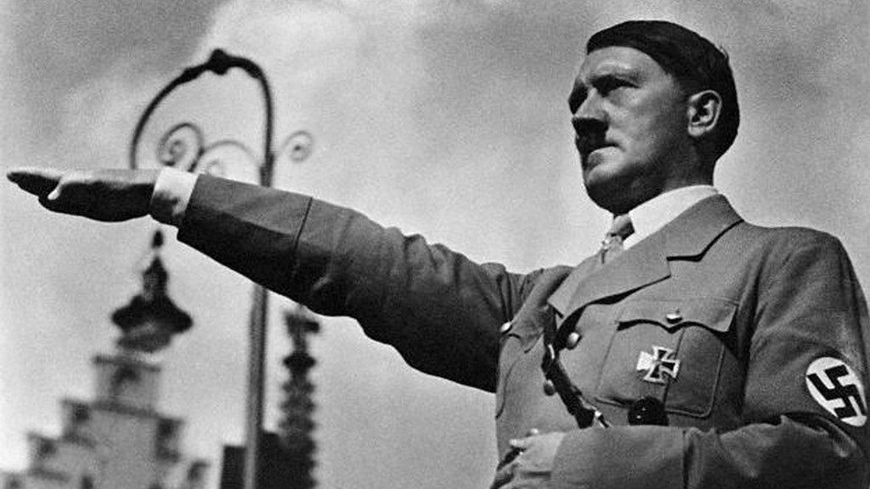
Autocratic Leadership is a leadership style characterized by individual control over all decisions and little input from group members. Autocratic leaders typically make choices based on their ideas and judgments and rarely accept advice from followers. They often motivate through fear and intimidation. Example: Hitler
There are very few examples of this leadership style today, although it does still exist. For example, in the army you would need to have autocratic leadership. Why?
Advantages | Disadvantages
Quick decisions are made- only one person in control which saves time | Frustration and low morale amongst staff- they are not being heard- output will also suffer
Provides strong motivation and job satisfaction to the leader who can dictate terms | Higher staff turnover- a lot of staff will not want to work under this management style where there voice is not heard
Good in routine situations where there is little scope for innovation | Work overload for the manager and time wasted on tasks others could complete

Democratic Leadership: Your opinion matters to me
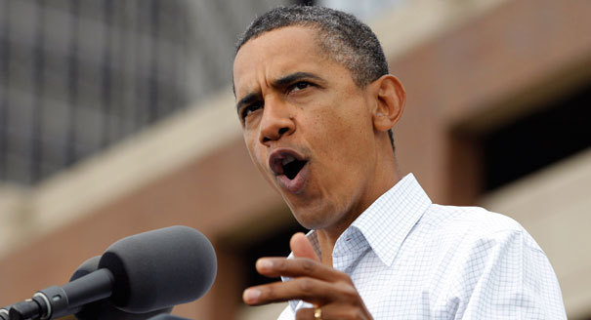
Advantages | Disadvantages
Because group members are encouraged to share their thoughts, democratic leadership can leader to better ideas and more creative solutions to problems | Slower Decision Making which can be a problem when a quick decision may be needed
Group members also feel more involved and committed to projects, making them more likely to be more motivated about the end results | Decisions can be overcomplicated as the views of too many people need to be taken into consideration  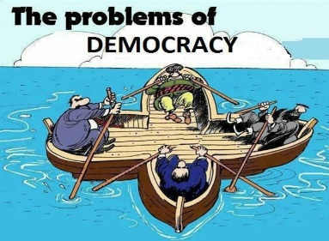
Improved Industrial Relations as employees are being listened to | The wrong decision may be reached in trying to keep certain people happy
Democratic Leadership is when workers take a more participative role in the decision-making process. Everyone is given the opportunity to participate, ideas are exchanged freely, and discussion is encouraged. While the democratic process tends to focus on group equality and the free flow of ideas, the lead of the group is still there to offer guidance and control. Democratic leadership tends to lead to higher staff morale and motivation. Example: Barack Obama

Laissez Faire Leadership (Free Reign)-Freedom to make choices
Laissez Faire Leadership is when leaders are hands-off and allow group members to make the decisions. Managers act as facilitators and provide targets and resources for the workers and then allow them to get on with the work themselves. Example: Warren Buffet
Warren Buffet is a well-known investor and businessman, who in 2008 was the richest man in the world.
Advantages | Disadvantages
High staff morale as people feel involved in the decision making process of a business | Not suitable for everyone-some people are not good at setting their own deadlines, managing their own projects and solving problems on their own
Ownership of decision making for staff will lead to decisions getting maid quicker | Not ideal in situations where group members lack the knowledge or experience they need to complete tasks and make decisions
Encourages intrapreneurship | Lack of control for managers- perhaps targets are not being met and regular meetings needed

