Your Consumer Responsibilities- Ethical Shopping
When buying goods and services, we make a choice about what type of business we give our money to.
If a person chooses to buy goods from an ethical business- one that behaves in a way that is fair to the environment, their customers, and their workers, then they are supporting this type of business with their purchase.
If a person chooses to buy goods from an unethical business- one that behaves in a way that they exploit their workers or pollutes the environment, then they are supporting that type of business when they purchase
Ethical Businesses- The Triple Bottom Line
Ethical business operates a triple bottom line- where they aim to make a profit, be fair to people, and protect the planet
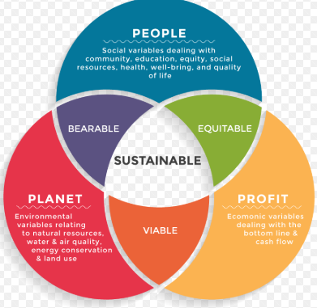
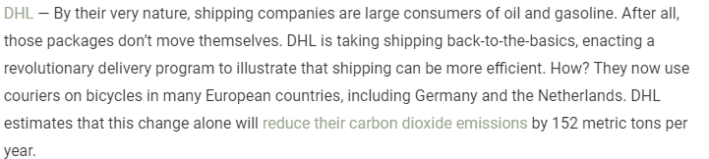
The Effects of our Shopping Choices
- The Environment
Online Shopping
Have you ever considered how far something bought online has to travel before it gets to your house? Think of the different types of transports and the pollution it creates
Pollution
The pollution of land, air, and sea from dumping and waste is a huge issue
Climate Change
Rising levels of carbon dioxide gas from pollution is causing the Earth’s climate to change- through consumers use of burning oil, gas etc..
- Labour Exploitation
Child Labour, poor working conditions, unfair wages. There are many companies who we buy from who adapt these strategies when making their products and services- does it matter to you?
- Animal Testing and habitat loss
Many cosmetic and cleaning products are tested on animals before consumers use them. Many natural habitats for animals are destroyed like forests to provide consumer goods and services
- Food Choices
Food that is not healthy is being purchased that contain lots of sugars, additives, and fats. This is creating huge health problems down the line
- Globalisation
A lot of large, multinational companies are locating in Ireland and forcing smaller, indigenous companies and family owned businesses to close down. These companies have no loyalty to Ireland and could move tomorrow. Which business do you shop in?

How can we be responsible?
- Be aware of your purchasing- When buying goods and services, understand the journey of these products/services. You can then choose an alternative product
- Read the labels- Labels provide key sources of information such as ingredients, company name, environmental impact etc..
- Know your values- This is a personal question- what is important to you
- Don’t make unnecessary purchases
- Advise others close to you on what you have learned

