Your Consumer Rights
Question
Have you ever saved up your money and bought something that you really wanted only for there to be something wrong with it when you went to use it?
There used to be very little protection for consumers (Caveat Emptor- Let the buyer beware), but now consumers have laws that look out for them.
Law Number 1
Sale of Goods and Supply of Services Act 1980
Under this act, the buyer has the right to assume:
- Seller must have title to the goods: This means that it must be yours to sell. I can sell my car because I OWN IT.
This is my car and so as a result, I would be able to sell it. If it was not my car, I would not be able to sell it as I would not have TITLE to this good.
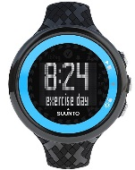
- Goods must be of merchantable quality: This means that the good must be able to do what it is supposed to. Example: If you buy a watch it should tell the time or if you buy an I-Phone it should be able to download apps.
This watch is a good of merchantable quality as it is telling the time like it is supposed to.
- Parts should be of merchantable quality: This means that the parts supplied during a service are of merchantable quality. Example would be a door handle should open a door. This is a part of the overall good.
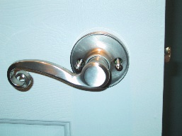
The part of the door handle on this door should be able to open the door if the good was to be of merchantable quality. If you pulled it and it did nothing it would not work and this would mean it is faulty.

- The goods are fit for purpose: Here you are relying on the seller’s knowledge about the product/service in that it will do what it is supposed to. For example, if you buy a car from a mechanic it should have an engine.
This car if sold by a car dealer would not be fit for the purpose of driving as there is no engine.

- Goods supplied as described: If you check a catalogue it should appear as described. For example if you saw an I-phone but received a Nokia 3310, the phone was not as described.
You would not want to pick out an I-Phone but then receive a 3310 as this good would then not be as described.
You would not want to pick out an I-Phone but then receive a 3310 as this good would then not be as described.

- Service must be carried out by suitably qualified people. This means that you have the right to assume that a person doing the work for you is qualified at their job. Example: Mechanic fixing your car.
A mechanic fixing your car should be suitably qualified to do so.

Note
All shops are required by law to protect their customers. They are responsible for any issues with any goods or services that they sell- even if it is the manufacturers fault.
Illegal shop signs
It is illegal for shops to display sign that give impressions that your rights are not being met.
Which of the following is a legal shop sign?
(a)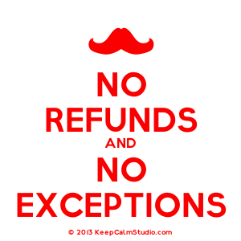
(b)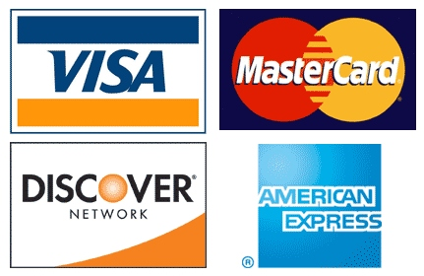

(c)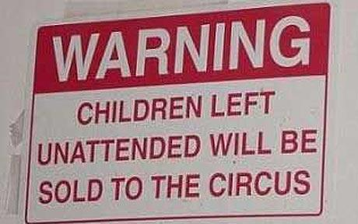

However, the retailer is not responsible if:
- The consumer breaks the good themselves
- If the problem of the good was pointed out to you before purchasing it
- You simply change your mind
Making Complaints
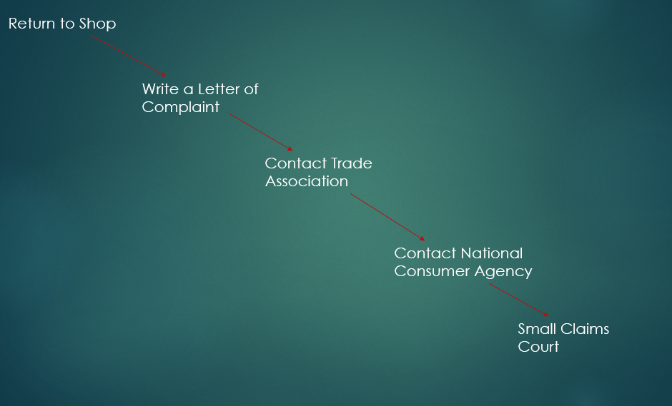
Letter of Complaint
Structure of Letter of Complaint
- Your Address
(Skip line)
(2) Date

(3) Company Address

(Skip line)
(4) Dear Sir/ Madam
(5) The Facts
(6) What’s your complaint?
(7) Your legal requirements: Note, this will always say ‘Under the Sale of Goods and Supply of Services Act 1980’...And is the only part not included in the question
(8) What you want done about it
(9) Sign off

Example
On 01/09/2014, Tom Jones, of 52 High Bridge Navan purchased a new fridge model XYZ from Fridge and Freezers Ltd, 24 Close Road, Dublin 15 for €600. After 2 weeks Tom found that the fridge would not close properly and the settings would always return to default. Tom was unhappy that the product was not fit for purpose or of merchantable quality and wanted either a refund or replacement immediately. Imagine you are Tom and write the letter of complaint dated September 20th 2014
- (Your Address)
52 High Bridge
Navan
Co. Meath
2. (Date)
20/09/2014
3. (Their address)
Fridge and Freezers Ltd
24 Close Road
Dublin 15
- (Salutation)
Dear Sir/Madam
5. On 01/09/2014 I bought a new fridge model XYZ from your store for €600. I enclose a copy of the reciept (the product purchased as given in the question).
6. (What went wrong- This is in the question).After two weeks I found that the fridge would not close properly and the settings would always return to default. 7. (Legal Requirements) The fridge is not of merchantable quality which is a legal requirement under the Sale of Goods and Supply of Services Act 1980.
8.(What you want done about it). I would like a refund or replacement product immediately.
9. (Sign off)
Regards
Tom Jones
However, If the Letter of Complaint doesn’t work...
Contact the National Consumer Agency, which was set up in 2007 to enforce consumer laws and protect the interests and welfare of consumers
If this doesn’t work, contact the:
Small Claims Court: Cheap, fast and easy way for consumers to solve disputes. No solicitors involved and deal with complaints regarding purchases or poor quality service. The maximum case can be worth €2000
Consumer Rights
With the resolution of a genuine complaint, a consumer is entitled to:
REFUND
REPAIR
REPLACE

How are Consumers Protected from Unfair Advertising and Promotion Tactics by Businesses?
Law Number 2
The Consumer Protection Act 2007
- It set up the National Consumer Agency in 2007 who enforce consumer laws and protect the interests and welfare of consumers. Later changed to CCPC in 2014. See below.

- It made illegal the establishment of pyramid schemes. Example – a chain letter. Pyramid schemes are unsustainable. A person will be asked to pay money into a scheme, but instead of getting a product or service, they can only get other people to join the scheme

- Illegal to make false claims about goods/services/prices

- Goods Example: Saying a product is 1kg when it is 1g
- Services Example: A service is available nationwide when it’s not
- Prices Example: Used to be a higher price when it never was

- Brings into Law EU Directives on Unfair/Misleading/Aggressive business practices
Examples would be false claims that would lead customers to buy a product or forcing you to buy a product against your will
Consumer Organisations
Small Claims Court: Cheap, fast and easy way for consumers to solve disputes. No solicitors involved and deal with complaints regarding purchases or poor quality service. The maximum case can be worth €2000
Competition and Consumer Protection Commission: The Competition and Consumer Protection Commission (CCPC) was set up by the government to promote fair competition between businesses and protect the interests of consumers by:
- Giving information and advice to the public
- Provide information and advice to businesses
- Enforce consumer laws
- Names and shames businesses that break these consumer laws
Trade Association: Represents firms that sell a particular product. Consumers can complain to these trade associations if they have a problem with a product. Example: - The Society of Irish Motor Industry.

Ombudsman: The ombudsman is a representative of the people and will investigate complaints made by members of the public, e.g. The Financial Services ombudsman- who specialises in resolving claims against banks, insurance companies, credit unions, and other financial institutions
Consumer Association of Ireland: A private, non profit organisation set up to promote the interests of consumers. They run advice services and highlight issues and problems for consumers
Advertising Standards Authority of Ireland: Promotes fair advertising and promotion. If you have a complaint about an advertisement you can contact them

