Business, Government, and the Economy

What is an economy?
An economy is an entire network of producers, distributors, and consumers of goods and services in a local, regional, or national community.
In 2008, Ireland’s economy went into a recession meaning that our economy was in decline. However, in more recent years, the Irish economy has grown again and in 2018 grew by 7.8% in comparison to 2017. We would call this Economic Growth- meaning we are producing more goods and services than the year before. This is extremely positive for an economy, as it means that there is more disposable income, more employment, more demand for goods and services, and a higher standard of living.
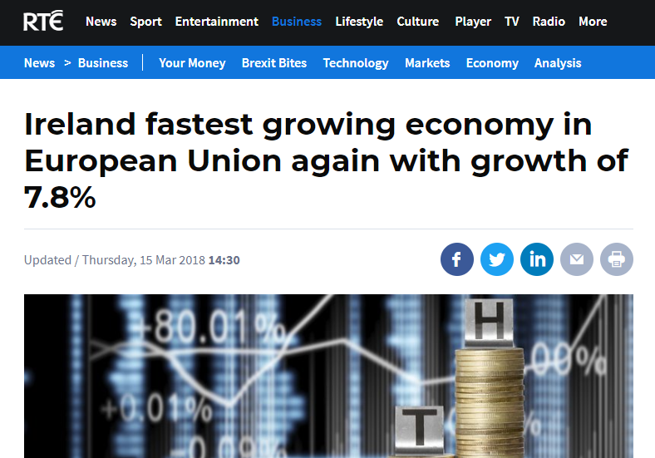
https://www.rte.ie/news/business/2018/0315/947638-cso-gdp-figures/

It is clear that the Covid 19 pandemic has had a significant impact on economies around the world. Ireland however had seen a rise in economic growth in 2020 and 2021.
Factors such as rising costs for consumers due to factors such as rapid levels of inflation, the war in Ukraine, and Brexit are factors which are having an impact on economic growth forecasts today. This uncertainty as we have seen in previous chapters will have a knock on effect for the Irish economy.

Economic Systems
As countries have developed over time, they devise different economic systems in organising their economic activities.
These economic systems include:
- What goods and services will the country produce?
- How will the goods and services be produced?
- Who is the benefit from the production of these goods and services?
Over time three systems have evolved:
- Free Market Economy 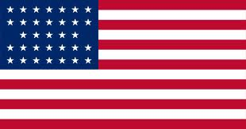
- All resources are owned by private sectors or by companies and used for their benefit only. The entrepreneurs are motivated by profit. The government plays a limited role in this type of economy. The free enterprise system allows any individual or group of people to start and operate a business with minimal government regulation or interference.
- Free enterprise systems are run on the basis of consumer sovereignty, which means that consumers are the ones that drive demand and the products and services that are sold. Businesses that cannot satisfy this demand will close down, and ones that can may expand
- A free enterprise economy is the most efficient and cost-effective way of doing business. There is less waste in the use of natural resources because everything is driven by consumer demand.
- The biggest drawback is that free markets create wealth gaps between what rich and poor people can afford, for example education
- Though free enterprise economies run on their own with little government intervention, the government will intervene if antitrust laws are violated or when natural resources are limited.
2. Centrally Planned Economies (communism) 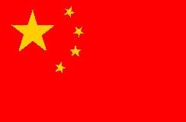
- All resources are publicly owned by the government on behalf of all citizens. The government controls all of the economy. There is no private sector
- The wealth and equality is divided among the people in which no man is richer and no man is poorer. No one is left behind
- Mixed Economies 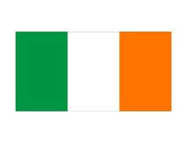
Mixed economies allow most of the major economic decisions to be made by the private sector, but the government intervenes to ensure the supply of essential goods to everybody. It is the most popular government system
- In a typical mixed economy, the government may run such things as the postal service, rail lines, libraries, and in some cases, the health care service. Even in industries which are not owned or run by the government, its influence is very noticeable in the form of taxes and regulations like wage controls. –Minimum wages.

We have seen above that Ireland operates a Mixed Economy. The state of the Irish Economy can be judged using a number of headings: (Relevant statistics year by year needed to support answers)
- Inflation
- Interest Rates
- Exchange Rates
- Unemployment
- Tax Rates
Inflation
It is the increase in the general level of the price of goods and services over a period of time. It is the increase in the standard of living in a country from one year to the next.
The official measurement for inflation is called the Consumer Price Index.
The Consumer Price Index or CPI measures the overall change in the prices of goods and services that people typically buy over time. It does this by collecting approximately 53,000 prices every month and comparing these to the corresponding prices from the previous month.
The formula for the CPI is
Increase/Year 1 price x 100/1

Inflation in Ireland 2022
In the Leaving Cert Exam in 2021, the question was about inflation hitting a 10 year low. In 2022, inflation has soared, not just in Ireland but worldwide.
In 2022, prices in Ireland rose an estimated 9.6 per cent in the year to July 2022, higher than the euro zone average of 8.6%. This is a 40 year high for the Irish economy.
Petrol and Diesel prices have increased significantly, as well as the cost of everyday goods in supermarkets. The cost of electricity was up 40.9% and natural gas was up 61%. The cost of heating your home with oil was up a huge 115.4%.
The shocking increase in prices is mostly driven by surging fuel and energy costs globally, due to the war in Ukraine, as well as rising food prices and sanctions on Russia seeing a drop in exports.
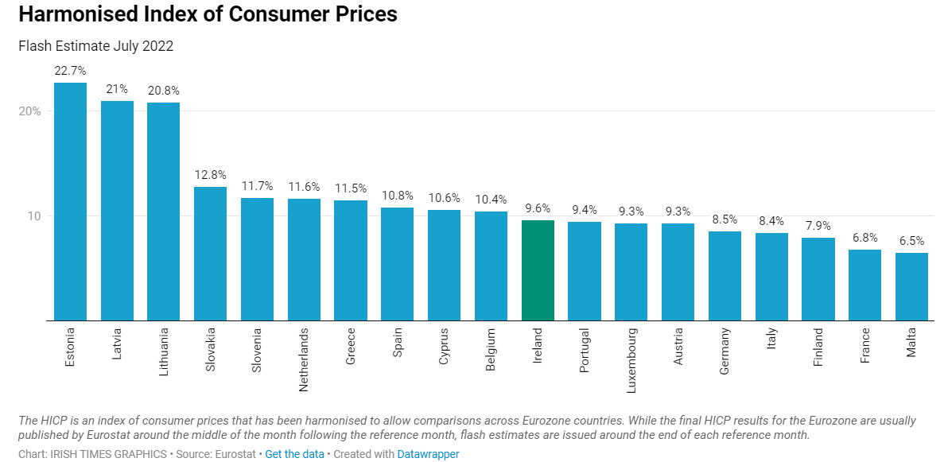
High levels of inflation lead to:
- Irish products being more difficult to sell abroad/at home due to the costs of producing them
- Reduction in profits of Irish firms- consumers buying less goods due to the costs which impact the sales for firms
- Industrial relations problems, employees will look for pay increases to meet the higher prices. If there is less money available for consumers to buy goods and an employer does not provide these pay increases, it could lead to strikes
- Reduction in buying power for consumers as the cost of living increases
- The cost of borrowing increases- European Central Bank have already increased interest rates this year as a result of inflation

Interest Rates
Interest Rates can be categorised on money borrowed or money saved.
Money Borrowed: The cost paid by a borrower to a lender for the use of borrowed money expressed as a % of amount borrowed. These interest rates are set by the ECB. In July 2022, ECB announced increased interest rates on mortgages across the EU.
Money Saved: The reward for money saved/invested over a period of time expressed as a % of amount invested.
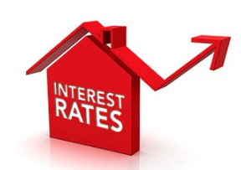
Low Levels of Interest Rates lead to:
- More borrowing as it is cheaper to borrow meaning more spending by consumers
- Mortgage repayments are cheaper so there is more disposable income for consumers
- Low interest rates means investment encouraged, as the return on savings is low which will help entrepreneurs seek the investment they need
High Interest Rates lead to:
- Less business expansion as the cost of borrowing becomes more expensive
- Business loan repayments increase meaning costs and prices may go up and profits may go down
- Mortgage repayments increase meaning consumers have less money to spend in an economy
Exchange Rates
The exchange rate is the price of one currency in terms of another currency. Exchange rates are not fixed and can fluctuate. For Ireland, we use the euro and it will tell you how much of the foreign currency you will get for that euro.
Example: Irish business sells Irish chocolates for €20 a box. If it sells this box in America, it must convert to US Dollars.
If €1 = $1.20, then 20 x 1.20 = $24 per box
If the exchange rate goes up or down, this could affect demand for this product.
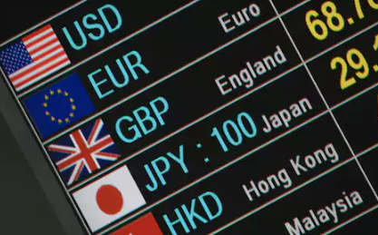
High Exchange Rate leads to:
- Irish exports being more expensive/competitive, which is bad for Irish businesses as sales and profits will decrease due to this increase
- Imported raw materials become cheaper
Lower Exchange Rates lead to:
- Goods exported abroad become cheaper and therefore easier to sell
- Imported raw materials will become dearer
Unemployment
The rate of unemployment is the percentage of the labour force that is not working. The government will always try to keep the unemployment rate as low as possible.
In Ireland, the Live Register and the Quarterly National Household Survey measures unemployment. The Live Register counts the number of people who sign on for social welfare, and the Quarterly National Household Survey is outlined below. 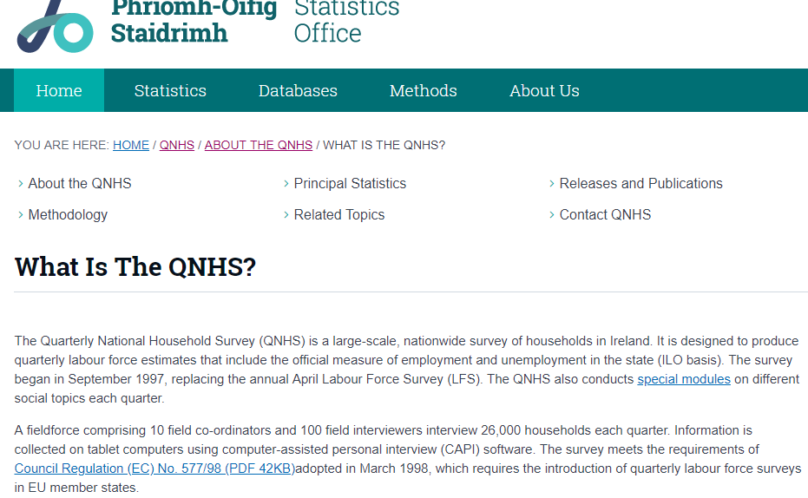
High unemployment leads to: (Opposite for employment growth)
- More money being given by the government to people for social welfare benefits. This will mean higher taxes in an economy to afford this, which means less profits for businesses due to this cost increase
- Wage costs decrease for businesses, as there is more demand for work and so businesses can pay people less to work for them
- Lower spending by consumers as there is less disposable income in an economy. This will force a business to compete for customers, there may be less demand and less sales for a business
- Emigration of skilled labour leaves the economy
The rate of unemployment in Ireland in 2019 was 4.8%. In April 2015 it was 9.9%. Ireland’s unemployment rate shot up to 28.2% at the end of April 2020 including- those receiving emergency jobless benefits due to the coronavirus pandemic
In October 2021 the unemployment rate fell to 7.9% and in May 2022 was 4.7%.
2018 Question 2 B
Benefits
• Increased income for employees will increase consumption spending/higher standard of living
• Increased taxation revenue for the government will lead to an improvement in public services or assist in paying of national debt/Reduction in Social Welfare as there is less unemployment.
• Increased confidence and local pride will mean more vibrant communities
• May attract foreign direct investment as the reputation of ‘Ireland.inc’ improves.
• Increase in the level of construction activity (very labour intensive activity): increased income will lead to more home buying and renovation. Business premises will also need to be built.
• Improved infrastructure will need to be provided to facilitate the increase in employment (improved DART, Luas Cross City and Metro system )
• Political Stability/greater social cohesion. Generally the electorate becomes more settled when employment levels are high.
• Less emigration as more employment is available in Ireland/fall in “brain drain”.
Challenges
• A skills shortage may exist as some skills are in high demand (e.g. programmers, chefs, hospitality service)/Difficulty finding workers to fill vacancies.
• Pressure may be put on housing stock resulting in a rise in rents and a lack of suitable accommodation in critical areas.
• The lack of affordable accommodation may also reduce the attractiveness of Ireland as a location for multinational companies.
• Improvements in infrastructure take a long time to occur. A commuter culture may be created where employees are forced to travel long distances to get to work.
• A commuting culture may create ‘commuter towns’ where residents are only present in the area in the evening. This can limit the development of community activities such as GAA Clubs and tidy towns committees as residents spend less time at home.
• High consumption spending leads to inflation which in turn causes wage demands affecting business competitiveness.
• In an effort to curb wage claims new contractual arrangements may reduce the quality of life of employees in low skilled jobs. (Part time employment, Zero hours contracts/the “gig economy”).
• Immigration may increase as people come to Ireland seeking employment. This may result in cultural conflict.
• In times where the increase in employment takes place in large cities, rural communities can fall into decline as residents leave the area to take employment in urban areas.
Tax Rates (Fiscal Policy)
Fiscal Policy means using taxation to achieve the government’s aims. Planned in the Current and Capital Budget and made law in the Finance Act.
Taxation is the payment that must be paid to the government to run the country. Lower levels of tax means there is more money in an economy for consumers and businesses, and high levels of tax means there is less money for consumers and businesses.
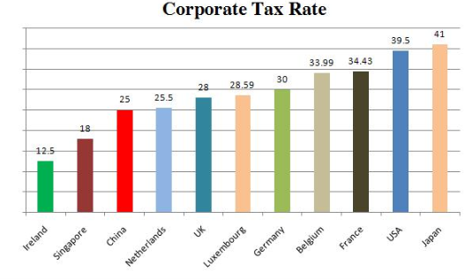
High Tax Rates lead to:
- High rates of taxes such as VAT and Excise Duties will increase the price of goods and services and reduce demand for customers
- Ireland’s corporation tax is 12.5% which is very favourable in attracting FDI to Ireland. An increase in corporation tax may cause FDI to slow down and lead to a loss of jobs
- Higher employee payroll in PAYE, PRSI, and USC taken from employees’ wages leave them with less disposable income. This will lead to lower sales and lower profits for businesses
- Increase in the black economy, which is the unregulated movement of goods and services such as cigarettes in an economy
Low Tax Rates lead to:
- More demand for products from consumers as taxes such as VAT and Excise duties fall meaning more profits for businesses
- A reduction in corporation tax would make the Irish economy an even more attractive economy for FDI
- More disposable income for consumers as PAYE, PRSI, USC rates fall
- Reduction in the black economy market- more taxes for government and sales for businesses

The Impact of Businesses on an Economy
Businesses can have both a positive and negative effect on the Irish economy
Positive Effects
- Businesses create employment, which in term contributes to the wealth of the Irish economy. With more people employed, there is more money being spent in an economy and more demand for the businesses goods and services
- Increase competitiveness, as more businesses are set up which gives consumers greater choice of products and services. This also means prices will remain low which has a positive effect in keeping inflation low
- Increases entrepreneurship and intrapreneurship, which in turn means that more businesses are being created and more ideas are being brought to the market
- Businesses buy goods and services from other businesses which obviously more businesses need to be created to act as suppliers
- Businesses contribute to paying taxes to an economy which increases government revenue to run the country
Negative Effects
- To increase profits, businesses will increase prices- there was uproar when Taylor Swift played two concerts in Croke Park and people could not afford tickets/hotels
- More pressure on infrastructure- successful businesses create more cars on the road. This can also have an impact on delivery of goods
- Competition mean some smaller indigenous firms cannot compete with larger multi nationals and so have to close down. This increases unemployment and social welfare payments and will have a negative effect on government spending in an economy
- Increased pollution- some businesses may not make environmental decisions to dispose of their waste. Development of Businesses also affects parking problems/litter problems and a distinct lack of green spaces in urban districts
- Increase in Child Labour around the world to meet the needs of Irish consumers
The Irish Governments role in encouraging and regulating businesses
Irish Government role in encouraging business:
Through decreases in taxation business activity is encouraged. A reduction in PAYE rates would increase spending power and stimulate demand for goods and services. A reduction in Corporation Tax may improve company profits, and the ability to fund future growth of the business. A reduction in VAT reduces cost of goods and services, stimulates demand and makes the Irish economy more competitive.
Through increases in State expenditure business activity is encouraged. The government could increase capital expenditure on infrastructure, schools, hospitals etc. This will create jobs and consumer demand.
Through a network of state agencies that give business advice, training and guidance, mentoring services and grant aid to facilitate growth and expansion.
Examples include:
- Fáilte Ireland (developing and promoting tourism)
- Enterprise Ireland (grant aid to indigenous industry, e.g. R&D and marketing) (See below)
- FÁS to be replaced by SOLAS (provides industrial training for workers)
- IDA Ireland (provides grant aid to attract FDI) (See below)
Through government planning -Forward planning reduces uncertainty for business. National wage agreements involving the social partners allow businesses to predict their future wage costs, as well as decreasing significantly the risk of industrial relations problems during the length of the agreement

State Agencies set up to develop the Irish Economy
Industrial Development Agency (IDA)
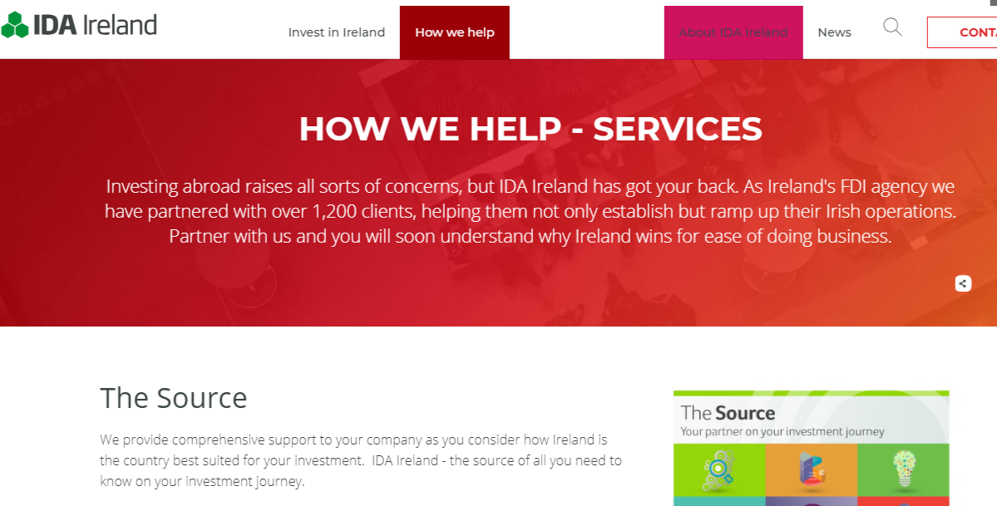
- IDA Ireland is responsible for the attraction and development of foreign direct investment in Ireland. Companies such as Google, Intel, Microsoft and Facebook etc. have all interacted with the IDA
- IDA Ireland provides information and statistics on key business sectors and locations within Ireland to help FDI’s make decisions
- IDA Ireland assists in setting up a business in Ireland and offers advice on property for international investors
- IDA Ireland introduces potential investors to local industry in Ireland, government, service providers and research institutions
- IDA Ireland builds links between international businesses and third level education, academic and research centres to ensure the necessary skills and research and development capabilities are in place

Enterprise Ireland
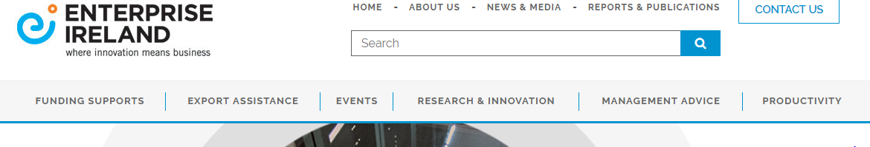
- Enterprise Ireland has the responsibility for developing Indigenous Irish industry with an export focus. It is focused on helping Irish-owned business with 10 or more employees seeking to deliver new export sales. The Irish software sector is one area that Enterprise Ireland supports
- Enterprise Ireland provides supports for both companies and researchers in Higher Education Institutes to develop new technologies and processes that will lead to job creation and increased exports
- Enterprise Ireland provides funding and supports for companies - from entrepreneurs with business propositions for a high potential start-up through to large companies expanding their activities and growing international sales.
- Enterprise Ireland provides international offices that can assist in the growth of exports by providing marketing services/connections and introductions to potential customers overseas.
- Enterprise Ireland provides a programme of trade missions, trade fairs and knowledge events to give clients the opportunity to connect with existing and new customers and increase sales in international markets and exchange ideas etc.
Irish Government role in regulating businesses
The government regulates business in order to protect the environment. It established the EPA (Environmental Protection Agency) whose role it is to protects the environment through its licensing, enforcement and monitoring of business activities.
The government regulates business in order to protect the consumer. The Sale of Goods and Supply of Services act 1980 gave rights to the consumer in relation to goods or services bought or hired. The Consumer Protection Act 2007 established the CCPC in 2014 to regulate business practices
The government regulates business in order to protect the employees in the workplace with legislation on unfair dismissal, equality and industrial relations. It established the Health and Safety Authority which works to create a national culture where all stakeholders commit to a safe and healthy workplace.
The government regulates business in order to protect the general public against misuse of information in manual or electronic format through the Data Protection Act of 2003. Data protection is the means by which the privacy rights of individuals are safeguarded in relation to the processing of their personal data.
How the Government Affects the Labour Force
- The Irish government is Ireland’s biggest employer with thousands of jobs in the public sector. These jobs are in the civil service (government departments such as revenue), state owned businesses (such as An Post), and public service (teachers, doctors etc...). Therefore the government helps increase the number of jobs in an economy
- The government investments in a country’s infrastructure leads to an increase of jobs in the construction industry. Increased infrastructure also leads to other businesses setting up here, increasing employment
- Short term training courses offered through further education (e.g. Solas) gives more people qualifications, skills, and expertise in the workforce
- Grants and incentives through Enterprise Ireland to indigenous firms, or IDA for foreign companies encourages businesses to set up here and create more jobs
- The existence of regulation such as Employment law, Health & Safety law, Competition law etc... A better regulatory environment encourages the growth and expansion of business leading to increases in the labour force
- The government sets rates for PAYE/PRSI/USC etc. These rates of tax may act as an incentive/disincentive to work. A low corporation tax rate of 12.5% encourages foreign direct investment, thereby increasing businesses in Ireland and increasing the labour force. Low personal taxation in the form of lower PAYE and lower tax on interest earned (DIRT) gives employees and consumers more disposable income, which increases the demand for the goods and services, thereby increasing the labour force
- The government has set the national minimum wage for workers.
National Minimum Wage
This is the legal minimum hourly payment to an employee set by government. In Ireland in 2022 it is €10.50.
If the government were to increase the national minimum wage:
• Profits of business may decrease due to higher costs.
• Increased costs may result in redundancies. The increased hourly rate of hiring employees may force the business to reduce staff numbers.
• Further Wage Claims. Other sections of the labour force may seek a pay rise in response to an increase in minimum wage, increasing costs.
• Increase prices may result in loss of trade. Increased wage costs are passed on to consumers as higher prices.
• FDI may not be attracted to Ireland. Higher wage costs will mean Ireland is not as competitive.

