Business Organisations

Please Note It’s the Business Textbook pg’s 372 and 373 will be very important with this chapter.
In this chapter, we will examine more closely the different types of businesses that operate in Ireland. We will have covered some of these briefly in Unit 5 Chapters ‘Business Start Ups’.
These main businesses are:
- Sole Trader
- Partnership
- Private Limited Company
- Public Limited Company
- Co-Operatives
- State-Owned Businesses
- Franchise
- Strategic Alliances
- Transnational/Multinational Corporations
- Indigenous Firms

Sole Traders
The Sole Trader owns and runs their own business. The Sole Trader is the one who makes all decisions and provides the money in their business
This type of ownership model is typical in small retail and service sectors. The owner has UNLIMITED LIABILITY!!
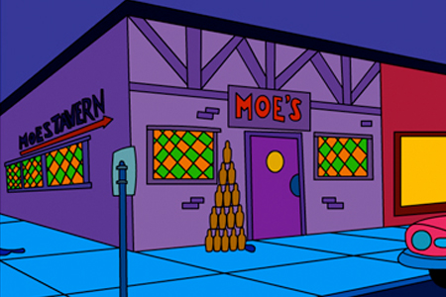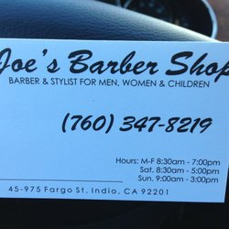

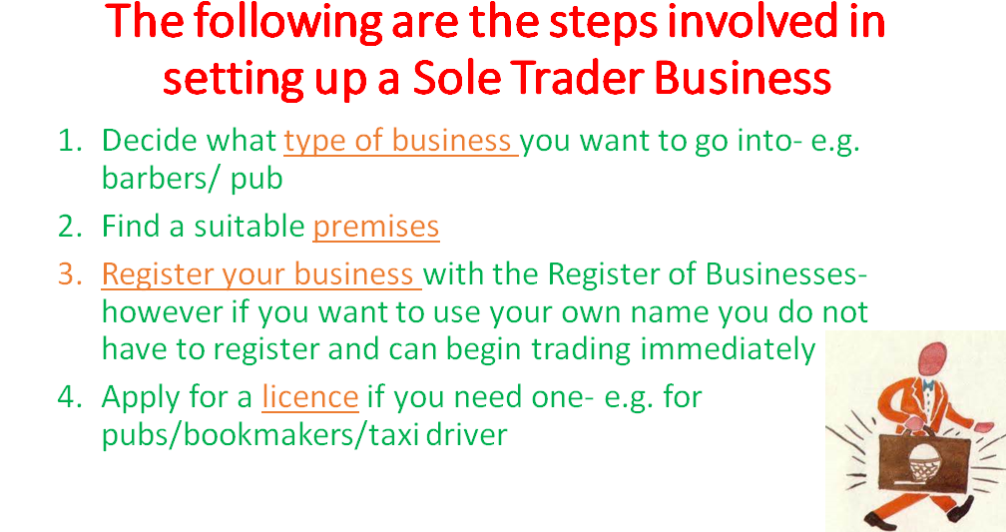
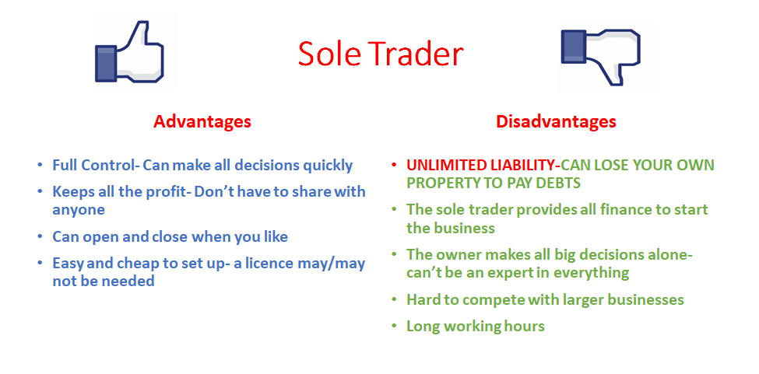
Partnerships
A partnership is a business where between 2 and 20 people come together to set it up and share control of the business. The owners have UNLIMITED LIABILITY!!
A set of rules and responsibilities for the company are agreed and written down in a partnership deed
The Deed of Partnership will include:
- How profits are to be shared
- How capital will be provided
- Duties and tasks of each person within the partnership
- Rules for new partners
- What happens if the business closes down/someone leaves
Partnerships are common in types of businesses such as private medical practices and solicitors
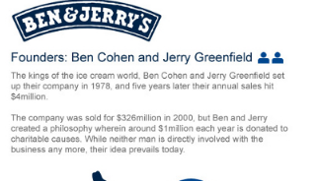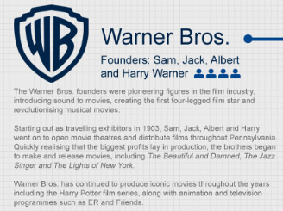
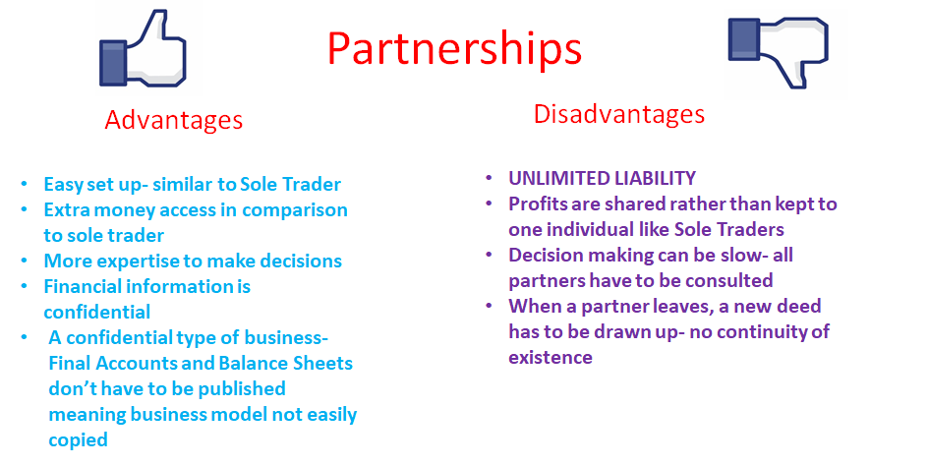
Private Limited Companies
In Private Limited Companies, you must be invited to purchase shares in this type of business.
The people who put money in are called shareholders. If the company makes a profit, shareholders receive a dividend.
The dividend received depends on the amount of shares you invest. 1 share = 1 vote, the more shares, the more votes.
Shareholders have LIMITED LIABILITY!
In Ireland, Private Limited Companies must be registered with the Companies Registration Office, and when satisfied are issued with a Certificate of Incorporation.

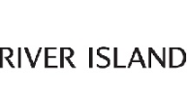
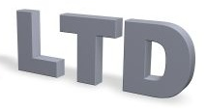
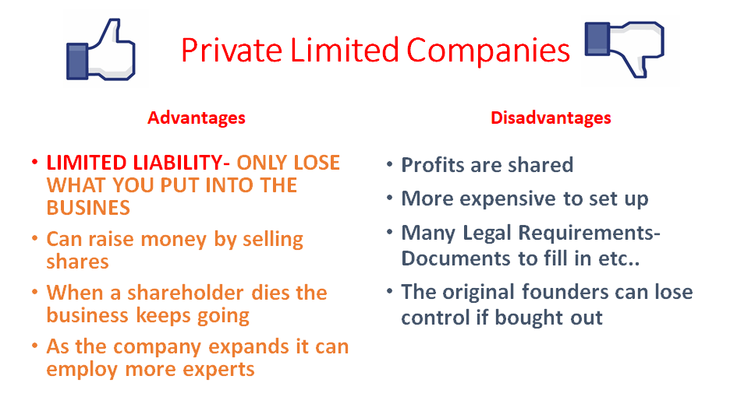
The rules and regulations of Private Limited Companies are set out in the Companies Act 2014. Under this act, there are different types of limited companies:
This table below outlines this:

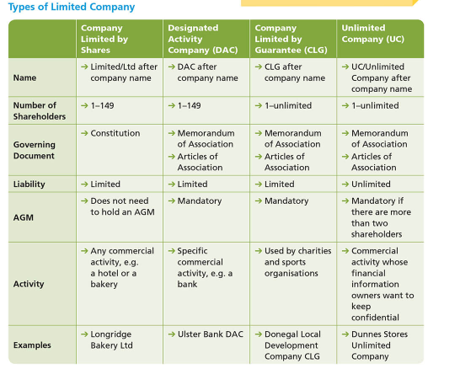
In 2022, a specific question on the different types of Private Limited Companies came up, lets complete the following question together on the board:
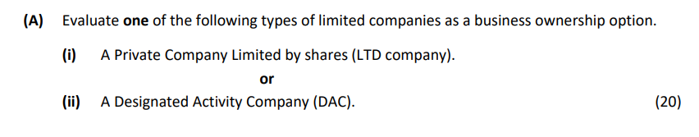

Exam Style Question- Changing Ownership Structure using Sole Traders and Private Limited Companies (Mock 2022)
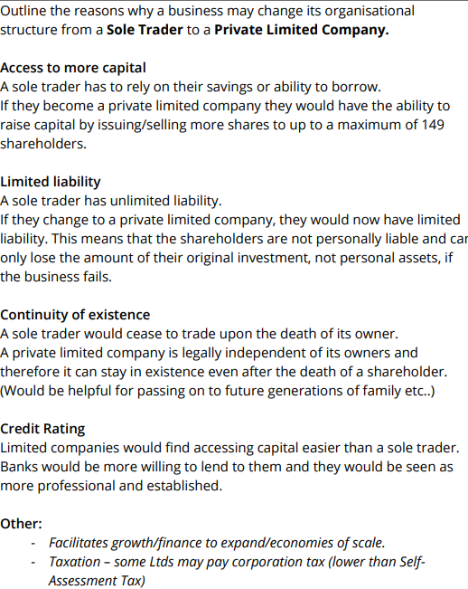
Public Limited Companies
A public limited company has 7+ shareholders and has directors who are voted by shareholders. These shareholders have LIMITED LIABILITY!!
They must follow many laws, rules, regulations- a lot more than Private Limited Companies. Shares can be bought and sold on the Stock Exchange and you do not have to be invited to purchase these shares. The name of the company will end with PLC.
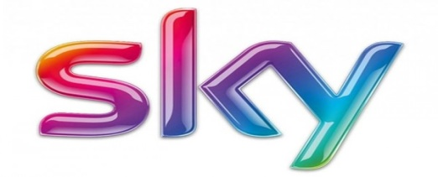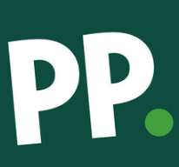
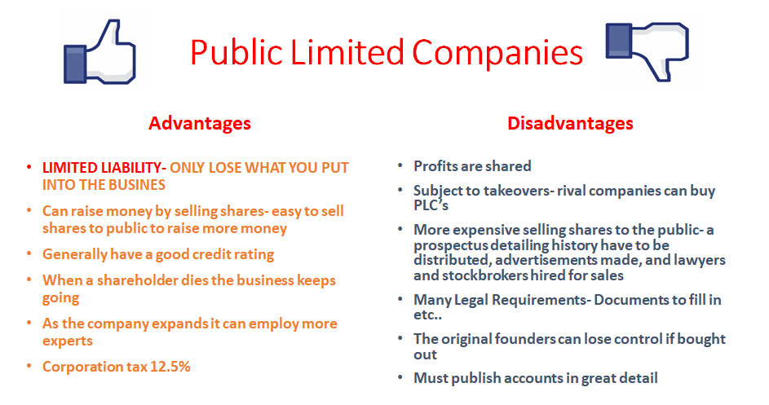

Co-Operatives
Co-operatives pool resources to achieve common goals, which as individuals they may not achieve alone. The people who set it up are called members and all profits go to the members. There must be at least 7 members and they apply to the Registrar of Friendly Societies to set up.
Co-operatives have LIMITED LIABILITY!!, and each member has one vote regardless of the amount of shares they own. They cannot sell shares or raise investment on the stock exchange.
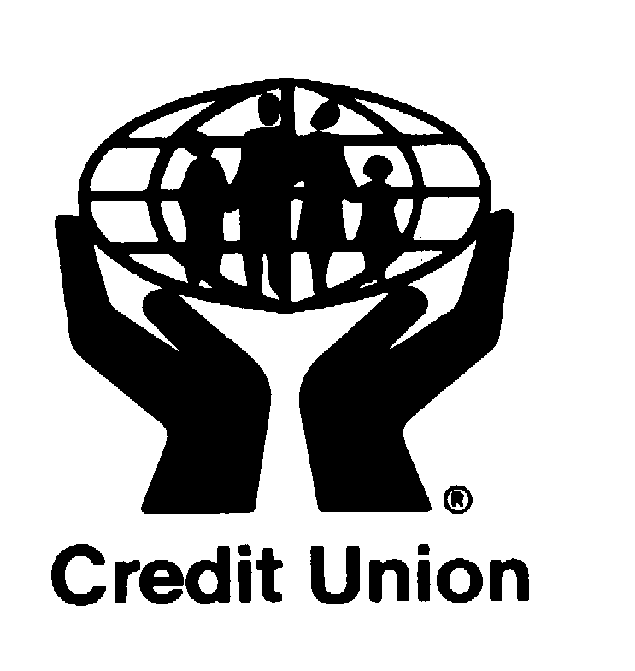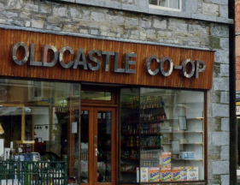
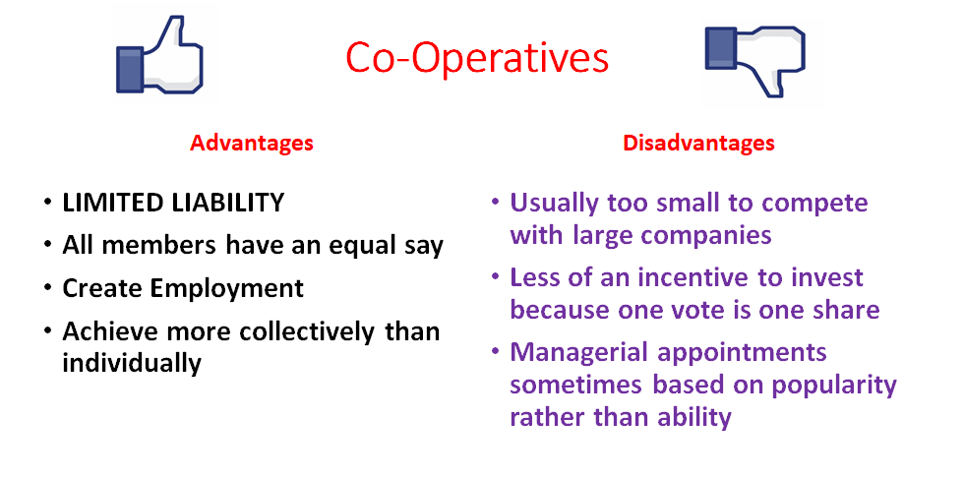
There are many different types of Co-Operatives that exist:
1- Producer co-ops
Here a group of people (i.e. farmers) contribute money, set up a factory, employ workers and managers, sell their products and share profits.
2- Worker co-ops
This is a co-op that is owned and controlled by the people who work in the business. The members pool their finance together and a start a business. Many of these type of co-ops suffer from lack of finance/lack of management skill. (e.g) furniture manufacture/house building
3- Credit Unions
This is a financial co-op owned and run by its members. Its principal activity is to encourage savings and provide loans at reasonable interest rates.
A board of directors elected by the members manages credit unions
State Owned Businesses
Formed by the Dáil and owned by the state with a board of directors appointed to run them.
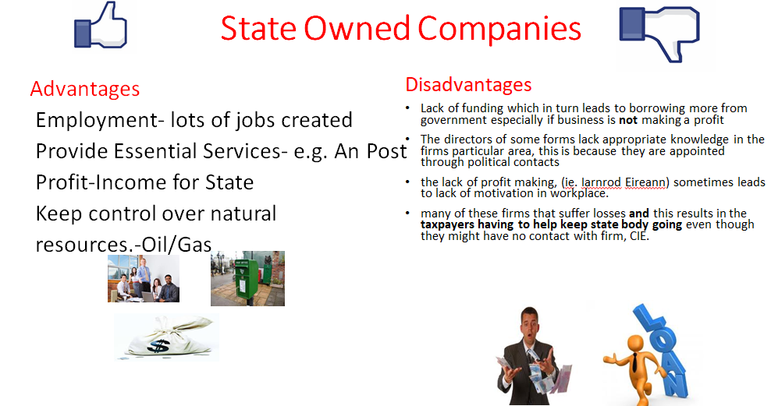
When a government sells a State- Owned Company it is called. Privatisation. Telecom Eireann was a semi- state business but shares were sold to the public and it became Eircom, and later Eir.
If the government takes over a company it is called Nationalisation.

Privatisation
Benefits:
Government Revenue: Selling of a state enterprise provides the government with a large sum of money e.g. Aer Lingus, AIB. The revenue can be used to build infrastructure/repay the national debt.
Efficiency: State owned enterprises are often perceived as being inefficient because they can rely on government funding and have little competition. Private firms are driven by a profit motive and should therefore be more efficiently run.
Access to Finance: Privatised companies are able to take out loans and shares and generally have greater access to sources of fi nance than state enterprise. This makes it easier to fund expansion, creating wealth and employment in the economy.
Industrial Relations: With greater job security employees in state enterprises are more likely to take part in industrial action in pursuit of pay claims, better working conditions etc. than those in the private sector.
Competition: The elimination of a state monopoly can lead to open market competition and can lead to greater choice and lower prices for consumers e.g. Eircom/Aer Lingus moving to private sector as option for consumers.
Opportunity to sell off loss making enterprises: Government financial commitments are reduced when an unprofitable state enterprise is privatised. E.g. They could sell Dublin Bus if it regularly recorded losses, removing the pressure on their budget to cover the losses.

Challenges
Loss of state assets: The state protects industries of strategic interest to the country e.g. transport network, the country’s energy supplies for industry and domestic purposes, water supply, communications systems, the economic infrastructure of the country.
Increased Unemployment: There may be a loss of jobs through rationalisation of services, leading to higher social welfare spending. Lack of social commitments. Non-profits making essential services may be discontinued by the private business in an effort to reduce costs e.g. the postal and telecommunications service, electricity, gas and water services to remote areas.
Loss of Control /Costs to state: The shares of privatised companies may end up with foreign investors/There may be high costs involved in preparing a company for privatisation.
Profit Motive/increased prices: Privatised companies must maximise returns to the shareholders and this could result in increased prices for consumers.
Franchises
Franchising is a business arrangement whereby one person (franchiser) sells the right to use their name, idea or business to others (franchisees) and allows them to set up an exact replica of that business.
A franchise is effectively a licence to produce and/or sell another well- known company’s products and use the company’s name in return for a fee
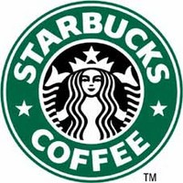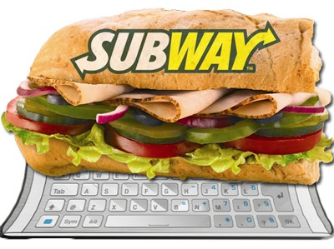

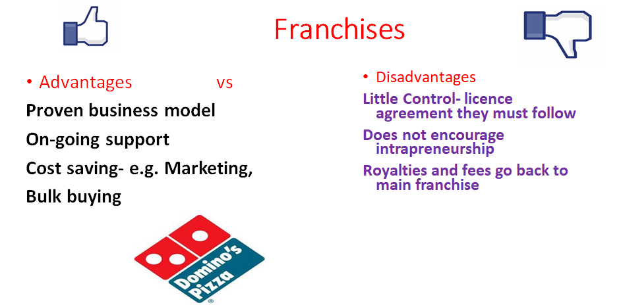
Alliances
This involves two or more firms combining their skills & resources in a particular line of activity. Alliances are popular because the companies co-operate with each other in relation to market information, new technology, human resources
SMART and Mercedes for SMART CAR
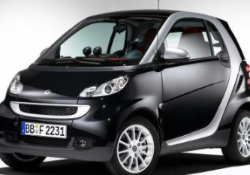
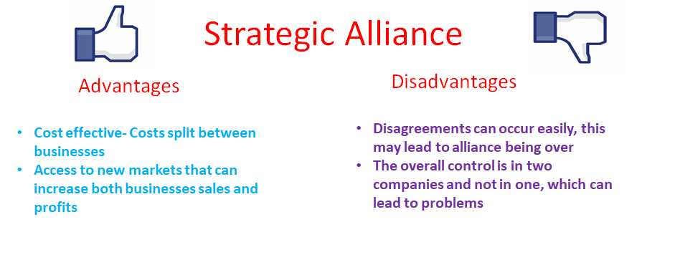
Transnational Companies
These businesses have their head office in one country and factories in other countries, i.e. IBM, Volkswagen, Siemens, Nestle, Intel, and Guinness. The head office controls the entire business, while these branches around the world carry out jobs.
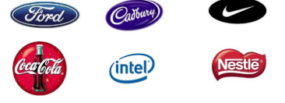
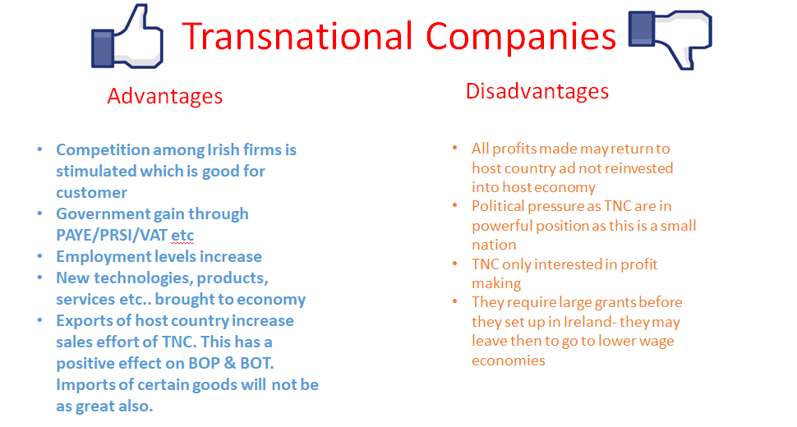
Indigenous Firms
These are firms founded in Ireland and owned by Irish people. Such businesses are being promoted by the Government so as to compete with foreign owned firms in this country.
Enterprise Ireland was set up by govt. in 1998 as the organisation responsible for setting to expand sales, exports and employment of Irish companies.

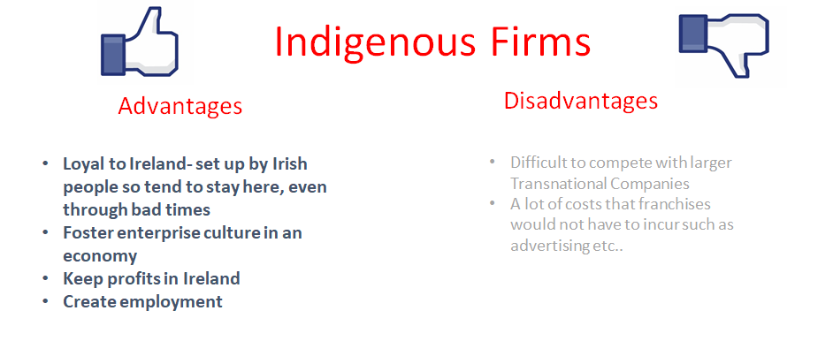
Recent Trends in Ownership Structures
- Privatisation of State-Owned businesses has been quite common over the years where businesses are selling state businesses to private owners to raise capital
- The increased popularity of franchises- e.g. Starbucks
- Co-operatives becoming Public Limited Companies- Kerry Co-Op is now Kerry PLC
- High Tech Transnational Companies setting up in Ireland, Irelands low corporation tax is very attractive
Why Change Ownership Structure
Less Risk: Changing from unlimited to limited liability reduces the level of risk for owners and investors which will be important for trying to attract investment
Raise Finance: The ability to raise more capital to expand may lead a sole trader to change their type of business, a private limited company, co-operative, or state-owned business may become a Public Limited Company to raise capital on the stock exchange
Additional Expertise: New experts can help move a business along or fill a gap needed to provide expertise in a certain area for business growth and development
Increase sales and profits: As a business gets bigger, it is natural to want to increase sales and profits and so changing the business structure may be the best chance of doing so

