- Cash Flow Management For The Household and Business
Cash Flow Forecasts for Households and businesses
Households generally use budgets to predict future incomes and future expenditures in order to have enough cash to cover costs. This budget includes the money the household expects to make (income) and payments (expenditure). There are three types of expenditure- Fixed, Irregular, Discretionary.
Businesses use cash flow forecasts to predict how much money a business will have in the future. It does this by subtracting expected future payments from expected future income. Money coming in is called receipts, and money going out is called payments. This cash flow forecast is an invaluable part of Financial Control- link back to Management Activities.
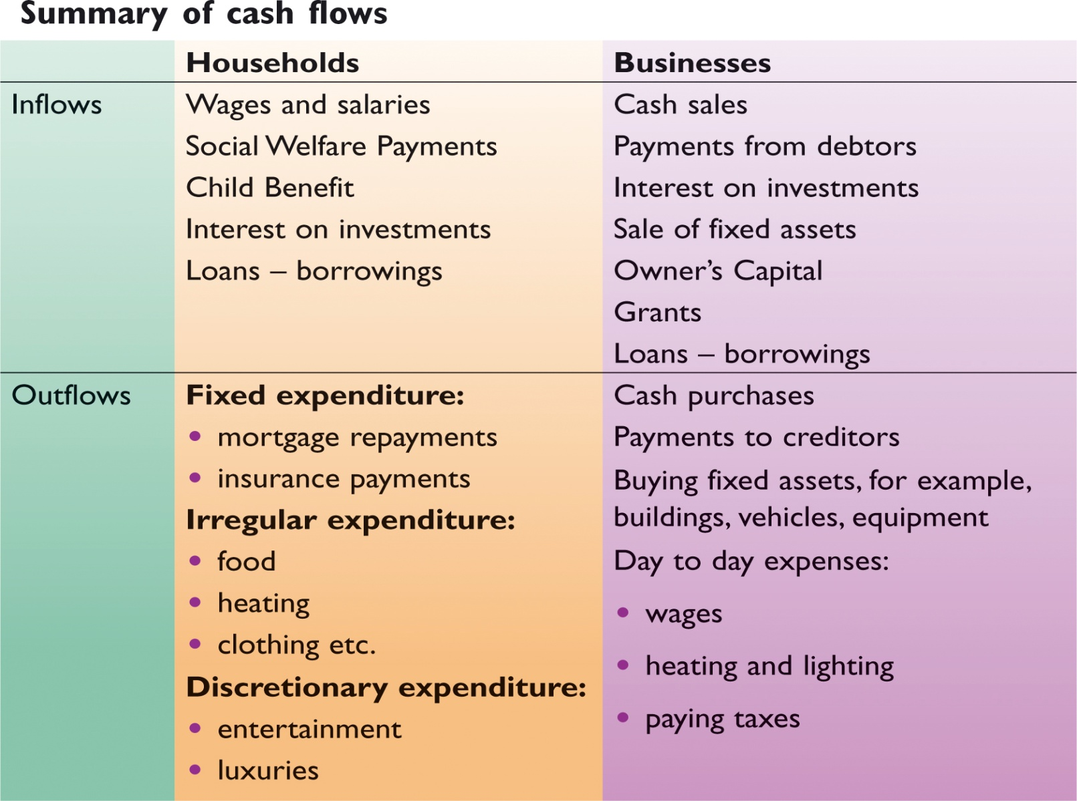
Why does a household/business need cash flow management?
- A cash flow forecast acts as a financial control mechanism that can be used to measure actual cash flow against planned cash flow encouraging a company or household to plan its finances sensibly and live within its means. Example for a business would be not to overtrade (e.g. buy/sell too much on credit).

- It helps avoid cash flow problems as costs are considered in advance, so they can ensure it has sufficient funds when the time comes.

- It lets us know in advance when there will be a deficit. This will give time to source short term finance such as a bank overdraft to deal with the deficit. This can ensure a household or business can pay its bills on time and will not go bankrupt/into debt.

- It lets us know in advance when there will be a surplus.
A business/household could then make plans to invest the money and gives them an opportunity to earn interest on this surplus as a form of capital.

- Identifies times when high expenditure may be needed (Christmas for the household/ excess supplies for a business) and therefore the opportunity to plan and set aside cash for such occasions. For the household a budget also shows the family exactly where money is going and highlights particular areas of overspending that can be cut back.

- It can set a target for where the cash flow situation should be in the future. The household/business can look at the cash flow forecast eventually and measure the forecast against actual performance.

- The cash flow forecast can be used as a tool in applying for a loan. This will show the bank that the books are appropriately in order.

Note: If you get asked a question asking you to give your advice as to how to make improvements on a firm’s cash position, look for:
- Avail of a short-term source of finance: Company X could arrange a bank overdraft facility with its bank to finance problem months where the business is running a deficit. The overdraft facility provides extra flexibility for Company X when it needs it most.
However, care should be taken because the rate of interest charged on a bank overdraft is high. Other short term sources could be considered such as trade credit (delaying payment to creditors/ seeking an extension period of credit from creditors).
- Adjust receipts: Its receipts could be increased by changing its marketing mix, e.g. lowering price to sell more, increasing the price depending on elasticities, designing new products or more effective promotion campaigns/reducing period of credit given to debtors/cash sales only.
- Adjust payments: The business could decrease its cash payments by sourcing cheaper suppliers, restructuring loan repayments or asking employees to take a wage decrease etc…
- Look to sell of an asset to raise capital. Company X could look to sell an asset such as a machine that is now obsolete to get an instant cash injection into the business

Sample Question: Cash Flow Forecast for Time Space Ltd for the following 3 months
 | October | November | December | Total
Total Receipts | 7000 | 7000 | 9000 | 23000
Total Payments | 6500 | 8000 | 12000 | 26500
Net Cash
Opening Cash | 100
Closing Cash
Questions to answer:
- Complete the cash flow forecast using the above figures.
- In which months has the business got a problem? Use your figures to explain your answer.
- Outline the reasons why a cash flow forecast would be prepared.
- What can we learn from this cash flow forecast and what actions can be put in place?

2. Business Finance
Sources of Finance
3 types:
- Short Term (0-1 years)
- Medium Term (1-5 years)
- Long Term (5 + years)
Short Term Finance | Medium Term Finance | Long Term Finance
Bank Overdraft | Medium Term Loan | Mortgage
Credit Card | Hire Purchase | Savings
Accrued Expenses | Leasing | Retained Earnings
Factoring |  | Equity Capital
Trade Credit |  | Grants
 |  | Debentures
 |  | Venture Capital

Short-Term Sources of Finance
Short Term Source of Finance | Business | Use | Household | Use | Collateral | Control | Cost
Bank Overdraft | YES | Wages/Salaries, Suppliers | YES | Holiday | NO | NO | YES
Credit Card | YES | Insurance | YES | New tv | NO | NO | Free if paid in full
Accrued Expenses | YES | Electricity | YES | Electricity | NO | NO | NO
*Factoring | YES | Bills- e.g. rent | *NO | xxx | NO | NO | YES
*Trade Credit | YES | Buying stock | *NO | xxx | NO | NO | Free if paid in full

1. Bank Overdraft (Business and Household)
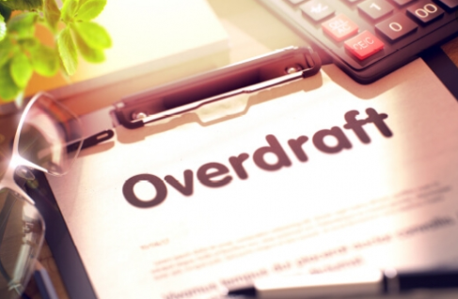
Bank Overdraft allows individuals to pay for things by writing cheques or using a debit card for any amount (up to an agreed limit), even though they don’t have enough money in their current account to cover these amounts. The bank pays whoever the individual owes.
Advantages
- Interest is paid only on the amount that the business/household is actually overdrawn, not on the full overdraft limit.
- No security is needed to get an overdraft, meaning businesses and households’ premises are not at risk if they can’t pay the overdraft back.
- For a business, the interest paid is tax deductible, which lowers the tax bill.
Disadvantages
- The rate of interest on overdraft is expensive
- The household/business must be overdraft free for at least 30 days in the year.
- The bank can ask the household/business to pay back the overdraft immediately.
- The bank imposes extra charges if the household/business goes over the limit.

2. Credit Cards (Business and Household)
Credit Cards allow households to purchase goods and services on credit. The credit card company pays the cost of the purchase and the household pays the credit card company back at a later date.
Advantages
- No interest is charged if the household pays its bill in full on time
- It is safer than carrying cash around because a stolen credit card can be cancelled, so no money will be lost.
Disadvantages
- If the household doesn’t pay its credit card bill full on time, it must pay interest at a very high rate.
- The household must pay a government tax for every credit card it has.

3. Accrued Expenses (Household and Business)
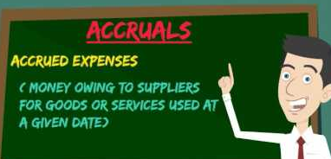
- Accruals are services which we have the use of now but which we pay for later, eg. telephone, electricity, or gas bills. It is essentially the delaying of the payment of bills to free up money to spend on other items.

- No extra costs are attached to these expenses however you would need to be careful not to overdo this as the supplier may cut off the services until you pay.

Advantages
- No interest is charged
- No security is needed, meaning the household/business does not have to give the supplier the deeds to its valuable assets to secure the finances, meaning their premises and assets won’t be at risk if they cannot pay the service provider back.

Disadvantages
- If the household/business takes too long to pay its bill, it will be cut off, meaning no service for a time and the household/business may have to pay a reconnection fee.
- Accrued Expenses are only suitable financing for certain purchases such as utility services.
- Damage to reputation in the market if consistently used

4. Factoring (Business Only)
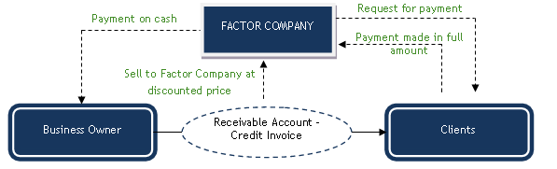

Factoring involves businesses selling their debtors to a third party for cash at a discount and gets money up front right now rather than waiting for debtors to pay up.
Factoring with recourse means that the business must reimburse the third party if any debtors it sold doesn’t pay back.
Factoring without recourse means the business doesn’t have to reimburse the third party if debtors it sold doesn’t pay back.

Advantages
- No security needed meaning the business is not at risk of losing its premises or assets if the debtors don’t pay the bank
- The entrepreneur’s ownership over her business is not affected since the business does not have to give the bank any of its shares to avail of factoring.
- Access to finance immediately

Disadvantages
- It is an expensive form of finance because the third party charges a high fee for the service.
- It can only be used by businesses that sell a lot of goods on credit or have a lot of debtors.
- Reputation damage, supplier may not like dealing with factoring company

5. Trade Credit (Business Only)
(Creditors-BUY NOW PAY LATER)
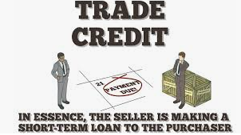

Trade Credit means a supplier allows the business to buy stock from it now without having to pay for it now. After a while, the supplier sends the business a bill showing how much it owes for the stock bought and sets out a deadline for payment.
Advantages
- It’s a free source of finance since no interest is charged.
- If interest is charged, it’s tax deductible, lowering the tax bill
- No security is needed so the business’ premises are not at risk if they can’t pay the supplier back.
- The entrepreneur’s control over her business is not affected.
Disadvantages
- If a business deliberately keeps its suppliers waiting for their money all the time, it’s called ‘leaning on the trade’ and will result in the business losing its credit rating, thus finding it hard to get credit in the future
- If the business pays its bills late, it loses out on any cash discounts that the supplier offers for early payment.
Sample Question
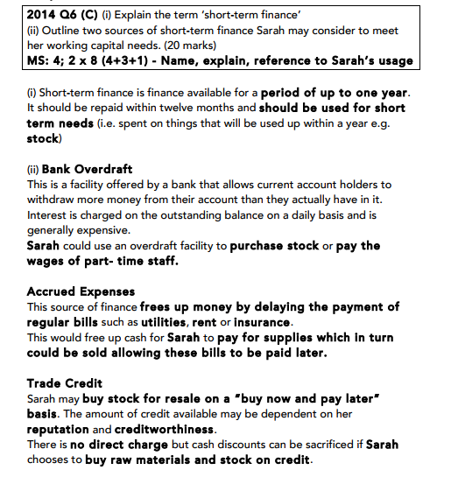
Medium Term Sources of Finance
Medium Term Source of Finance | Business | Use | Household | Use | Collateral | Control | Cost
Medium Term Loan | YES | Delivery Van | YES | Car | Dependent on amount borrowed | NO | YES
Hire Purchase | YES | Machine | YES | New bathroom | NO | NO | YES
Leasing | YES | Company Car/ Premises | YES | Apartment | NO | NO | YES

1. Medium Term Loan (Business and Household)
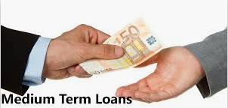
Here, a borrower takes out a loan from a financial institution and repays it with interest over an agreed period of time. The interest repayments can be fixed or variable and it is important for the household or business to shop around for the best rate
The higher the risk category of the borrower, the higher the interest rate charged, the bank will check the banking record of the customer to ensure they are reliable.

Advantages
- The rate of interest charged is usually cheaper than HP.
- The interest paid is tax deductible, which lowers the tax bill.
- The entrepreneur’s control over the business is not affected.
Disadvantages
- Security is normally required to get a medium-term loan. The business has to give the bank the deeds to its valuable assets to secure the finance. Therefore, the bank will take some of the business’ assets if the business cannot pay the loan.
- If the ECB increases interest rates and the business’ loan is variable, monthly repayments will increase.

2. Hire Purchase (Business and Household)
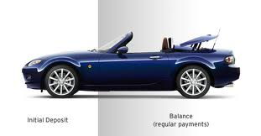
This is a form of credit which allows customers to have immediate use of goods while paying for them over an agreed period of time in instalments. The customer pays an initial deposit and then instalments. The customer only owns the asset when the last instalment has been paid.
It is used to buy assets such as motor vehicles, equipment, etc. It carries a high rate of interest and is thus an expensive form of finance
There are strict conditions attached to Hire Purchase which are set down in a written contract for the customer

Advantages
- No security is needed since the asset being purchased is the security itself. No premises or assets can be lost if the household/business can’t pay the hire purchase company back.
- For businesses, the hire purchase interest they pay is tax deductible
- For businesses, the entrepreneur’s ownership over the business is not affected.
Disadvantages
- It’s an expensive form of finance since the interest charged is normally high
- If the household/business cannot pay back the instalments, the asset will be repossessed by the company
- The household/business pays interest on the initial sum borrowed and there is no reduction for instalments repaid.

3. Leasing (Business and Household)
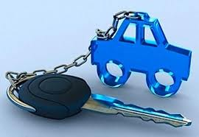
Leasing is like renting. The asset acquired is at all times owned by the lessor who rents it to the lessee over an agreed period of time in return for regular payments. Ownership thus never passes to the person renting it (the lessee). Leasing is cheaper than hire purchase as no change of ownership is involved
A lease agreement involves the payment of a deposit and a number of fixed deposits being paid (the number of which is agreed in advance. At the end of the agreement the asset is returned to the seller
Advantages
- No security is needed, meaning that the household/business won’t be at risk of losing their premises or house if they can't pay the leasing company back.
- The household/business can always have up-to-date equipment. It simply hands back the asset at the end of lease and signs a new lease agreement for a brand new asset.
- Businesses’ lease payments are tax deductible, which reduces the tax bill.
- The entrepreneur’s ownership over the business is not affected by the leasing agreement.
Disadvantages
- If the household/business cannot afford the lease payments, the asset will be repossessed
- If the household/business rents for a long time, it may have spent so much renting the asset that it would have been cheaper to buy it.
Long Term Sources of Finance
Long Term Source of Finance | Business | Use | Household | Use | Collateral | Control | Cost
Mortgage | NO | xxx | YES | Buying a home | YES | NO | YES
Savings | NO | xxx | YES | Buying an asset | NO | NO | NO
Retained Earnings | YES | Pay off loans | NO | Electricity | NO | NO | NO
Equity Capital | YES | Expansion | NO | xxx | NO | YES | NO
Grants | YES | Set up a new business | NO | xxx | NO | NO | NO
Debenture | YES | Buy new premises | NO | xxx | YES | NO | YES
Venture Capital | YES | Expansion | NO | xxx | NO | YES | NO

1. Mortgage (Household)
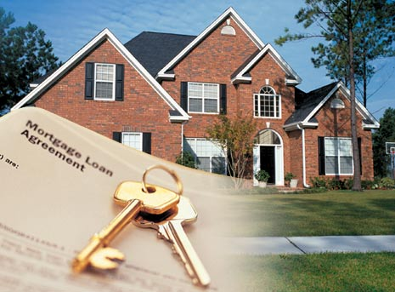
Mortgages are long term loans (20-35 years) used by households to buy their home. The loan is secured on the house. If the family can’t repay the mortgage, the bank will repossess their house.
The household makes monthly repayments to pay back the mortgage. There is a fixed and a variable rate mortgage.

Advantages
- The government makes a contribution towards the family’ monthly repayments, making it easier to afford a mortgage.
- The interest rate on a mortgage is the cheapest rate on any loan.
Disadvantages

- If the family cannot afford their monthly repayments, they will lose their home.

- Savings (Household)
Savings is money the household has not spent but saved for the future. A household will usually put their savings in a financial institution to earn interest, with the savings used to purchase assets like an extension to the house
Advantages
- No Collateral required
- No interest repayments
Disadvantages
- DIRT must be paid on interest earned
- Time consuming to build up and may not have enough to buy asset immediately
3. Retained Earnings (Business)
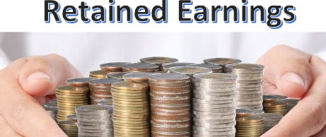
Retained Earnings are the profits that the business has saved up over the years, which it reinvests in the business and uses to finance the business into the future. They’re used to get major, expensive items that will last for more than 5 years.
Advantages
- There is no interest to be repaid
- No security is needed
- The entrepreneur’s ownership over the business is not affected
Disadvantages
- Retained earnings are not available to new businesses and it may take years to build them up.
- Businesses that save a lot of their profits and pay low dividends may have a bad relationship with shareholders.

4. Equity Capital (Business Only)
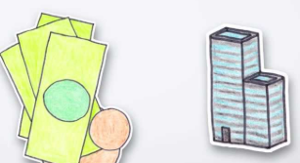
Equity Capital is obtained by selling some of the shares in the business to investors. The new investors then own part of the business and are entitled to vote at company meetings. They also are entitled to dividends ( part of the profits)
Advantages
- There is no interest to be repaid and dividends need only be paid at the director’s discretion, which all saves a lot of money
- No security is needed when selling shares in the business. The business does not have to give investors the deeds to its valuable assets to secure the capital.
- The money raised from investors is a permanent source of finance and doesn’t have to be repaid until the business closes down.
Disadvantages
- The entrepreneur must give some of the shares in the business to the new investors, which reduces her percentage ownership and her control over the business.
- Any dividends that the business pays are not tax deductible
- Organising the sale of shares is expensive. The business must pay for prospectuses to be printed, advertisements announcing the sale, stockbrokers to handle the sale and lawyers to draw up all the contracts and other legal documents.
5. Grants (Business Only)
Government grants are non-repayable amounts of money given to enterprises by state agencies which aid certain activities such as purchasing factories and machinery or train workers that help develop the business
These can come in the form of performance targets. E.g. a certain amount of money can be given to a company provided a specified number of people are employed. Failure to meet these targets can result in the demands for the grant to be repaid.
Advantages
- There is no interest to be repaid and the grant itself doesn’t have to be repaid.
- No security is needed
- The entrepreneur’s ownership over the business is not affected
Disadvantages
- The business will only get a grant subject to strict conditions. If the business breaks these, it will have to pay the money back to the government.
- The government gives the business only a percentage of the money it needs. The business still faces the problem of raising the long-term finance needed
6. Debentures (Business Only)
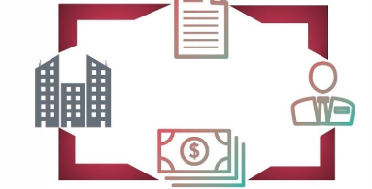
Debentures are long term loans used by businesses. The loan is secured on the business’ assets. If the company cannot repay the debenture, the bank will repossess its buildings or other valuable assets.
The company pays the interest on the loan every year but pays back the loan itself in one lump sum in the future. The rate of interest is fixed.
Advantages
- The interest is tax deductible for business, lowering the tax bill
- The entrepreneur’s ownership over the business is not affected
Disadvantages
- Security is required, so the bank will take the company’s buildings if the company can’t repay the loan.
- Debentures increase the company’s debt/equity ratio, which increases the company’s annual interest payments and its chances of going bankrupt and harder to get other loans.
7. Venture Capital (Business Only)
This is provided as start-up (seed) capital for new business enterprises and as development capital for existing businesses in which there is a higher than average degree of risk. The risk will be high but the possible returns on profit will also be high
The venture capital company will usually want to place members of its own staff on the board of directors to oversee the new firm’s progress.
Once the business becomes successful, the venture capital company sells its shares for a profit
Advantages
- Expertise and knowledge brought into business
- No interest payments
- Large amounts of finance available
Disadvantages
- Control is lost
- Profits must be shared
- All funds provided by the venture capital firm not always put in immediately

How Should the Source of Finance be selected? (Popular Exam Question)
Cost
Find the cheapest source of finance. Compare the APRs ( annual percentage rates) and choose the lowest.
The APR shows the total cost of borrowing expressed as a percentage of the amount borrowed. It includes interest charged by the lender and any other charges it imposes ( documentation fees). By law, all lender must show their APRs

Purpose of the Loan
Match the source of finance to the item you are buying. The loan should never take longer to repay than the life of the asset.
Use short term sources of finance to finance items the business/household will have for less than a year like an annual holiday or stock.
Use medium term sources of finance to finance items the business/household will keep for up to 5 years such as cars, computers, vans, furniture and equipment.
Use long term sources of finance to finance items that the business/household will use for longer than 5 years, such as houses, factories and shops.

Security
Would security be needed for the loan? If the loan cannot be repaid, the assets will be taken away. Lenders will only take valuable assets as collateral. Businesses/households should weigh up the advantages of a particular source of finance with the risk of losing their collateral.

Tax Implications
Will the source of finance offer a tax reduction ? Will it reduce the repayments and lower the cost of finance?
Debenture interest is tax deductible, dividends paid on equity are not tax deductible. The government pays some of the mortgage tax. Savings do not offer any tax relief.

Control (Businesses)
Will this source of finance require the owner giving away some of their shares in the business? This might reduce ownership in the business. Debenture Loans do not involve giving away shares but equity capital does. The business owner must balance her desire for capital with their desire to keep control over her business.

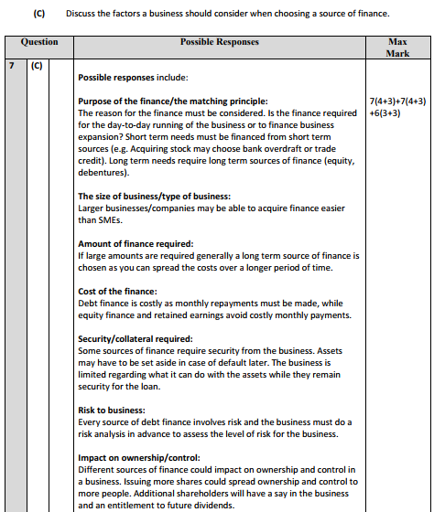

Banks Criteria for Loan Applications
Purpose of the loan | If it is productive and low risk, the bank will look more favourably on the loan.
Ability to repay | Examine the income- p60 for house/profits for business.
Security for the loan | Look at collateral- e.g. title deeds of property, share certificates in company.
Banking record | A good banking history will be looked upon favourably.
Credit rating | The bank may check a borrower’s credit rating with a reputable agency that specialises in this area. If the rating is good, the bank will advance the loan.
Business plan | Case of a business- growth potential will be looked upon favourably.
Own investment | A bank which is asked to loan money will be more assured if the person is investing a significant amount themselves.

Features of Current Accounts
Cheques are written documents that a current account holder fills in. It tells the bank to deduct the sum of money written on the cheque out of the account and pay it to the person named on the cheque.
Standing Orders are when the current account holder instructs the bank to take the same amount of money out of the account every period and pay it into the account of the person they name. They’re used to pay regular bills that are the same amount every month, such as mortgage or rent payments
Direct Debit is when the current account holder instructs the bank to take whatever sum of money it is told by a person she names and pay it into their account every period. The amount can change every time. It’s used to pay telephone bills, electricity, etc.
Paypath is a system whereby an employees’ net wages are paid directly into her bank account. The wages are transferred electronically from the employers account into theirs. It’s safer than being paid in cash and more convenient than receiving a cheque.
ATM Cards allow the current account holder to withdraw sums of money from her account using a machine in the wall of a bank. Withdrawals can be made 24 hours a day. A PIN is required to access the account.
Debit Cards allow current account holders to pay for things without the inconvenience of writing a cheque. The debit card can be scanned and the bank automatically takes the money from their account and deposits it in the shop’s account in a few days. Debit Cards take the money directly from your account while credit cards involve the bank paying the bill and you paying them back later.
Bank Statements are documents received from the bank showing all the transactions that took place on the account over a period together with the balance left in the account.
Cheques are written documents that a current account holder fills in. It tells the bank to deduct the sum of money written on the cheque out of the account and pay it to the person named on the cheque.
Standing Orders are when the current account holder instructs the bank to take the same amount of money out of the account every period and pay it into the account of the person they name. They’re used to pay regular bills that are the same amount every month, such as TV, insurance premiums and interest.

