Choosing Organisational Structures for Businesses
There are 4 main types of Organisation structure in a business. For the purpose of the Mini-Company Project, students will generally adapt a Functional Organisational Structure.
An outline of these structures and the advantages and disadvantages of each are included below.
- Functional structure.

Here, the organisation is divided into departments that specialise in a certain role with in the business, for example Sales, Marketing, Finance etc.… There is a clear chain of command as authority flows down and responsibility flows up.
Essentially, it is the most popular structure with departments organised on the basis of who does what. All staff who do the same job are put in the same department.
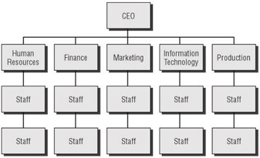
Advantages | Disadvantages
Employees see there is a promotional path in the firm | May only focus on department goals- not overall business
Allows employees to become experts in their department which improves productivity and efficiency | Communication can be slow between departments
Clear chain of command- people know who is in charge | Less chance for workers to gain broader experiences that may benefit the business

- Product Structure (music division, film division)

A product structure divides business operations on the basis of the products that it sells. For the mini-company, if a company decides to specialise in more than one product under a single brand name, one or more students could specialise in one of the products while other students specialises in another.
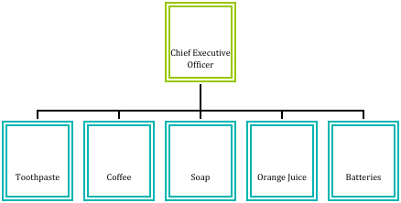
Advantages | Disadvantages
Focus is on consumer, so the producer can act faster to changes in consumer demand | Competition between departments may affect sales- look at car companies/beverages
The business is able to monitor the performance and profit of each unit and make production decisions such as to increase or decrease | Lack of diversity for workers, job can become routine and demotivating
Employees can develop expert knowledge which can be transferred when selling to consumers | Time efficiency- a lot of people end up doing the same job- think when you go into a store…

- Geographical structure. (branches in different countries)

This is where the business divisions are based in geographic locations, rather than the products produced. For the mini- company, this may be applicable if there is a focus on multiple locations, like in school, in the local Johnstown area, Navan town etc.…
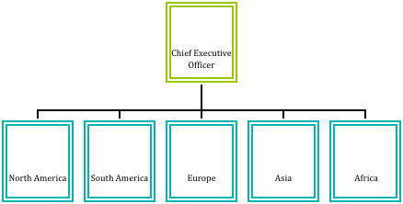

Advantages | Disadvantages
The managers know their market and so can make decisions that can be adapted to this market | Decisions by senior managements can affect different departments, for example cutting costs could affect certain regions more
Competition between each market can increase sales for the company | Greater difficulty in maintaining consistent company image across lots of areas
Needs of local consumers can be dealt with quickly, leading to increased loyalty and sales | Duplication of resources- same departments in different areas can increase costs

- Matrix or Team structure. (different departments work as a team for duration of project

A matrix type of organisational structure combines the traditional departments seen in functional structures with project teams. In a matrix structure, individuals work across teams and projects as well as within their own department or function.
It would involve experts in different fields working together on singular projects. It generally would not be seen this year.
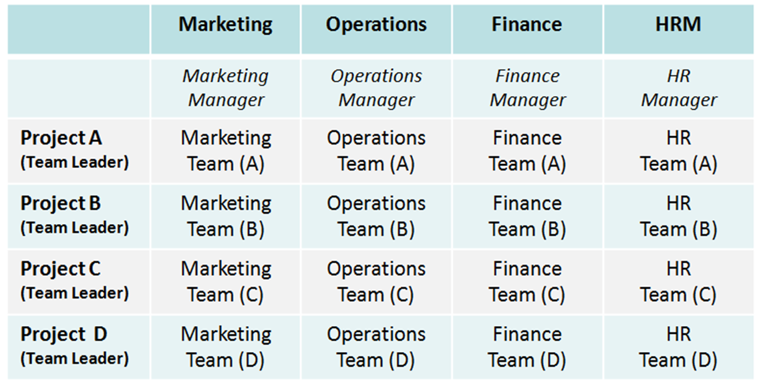
Advantages | Disadvantages
Increases employee motivation- they feel valued and part of the team | Extensive training may be needed at a cost to the business
Improves overall communication for the business as employees across departments work together | Confusion of the chain of command, there may be power struggles and conflict
Provides good training for future managers | Loss of control for senior managers

