Community Development

Community Development is the social and economic development of local areas and local communities through the efforts of its local people.
It involves people of the community coming together to achieve the desired goals and objectives through enterprise and self-reliance. Local people will identify the main problems in an area and develop plans to solve these problems. It is all about self-help, using teams from the community and grants from government bodies to do this.
Example of Community Development initiatives in Meath through Meath Partnership http://www.meathpartnership.ie/pages/home/
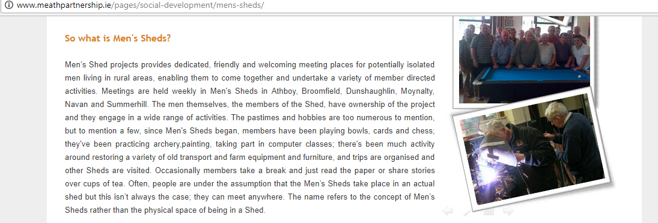
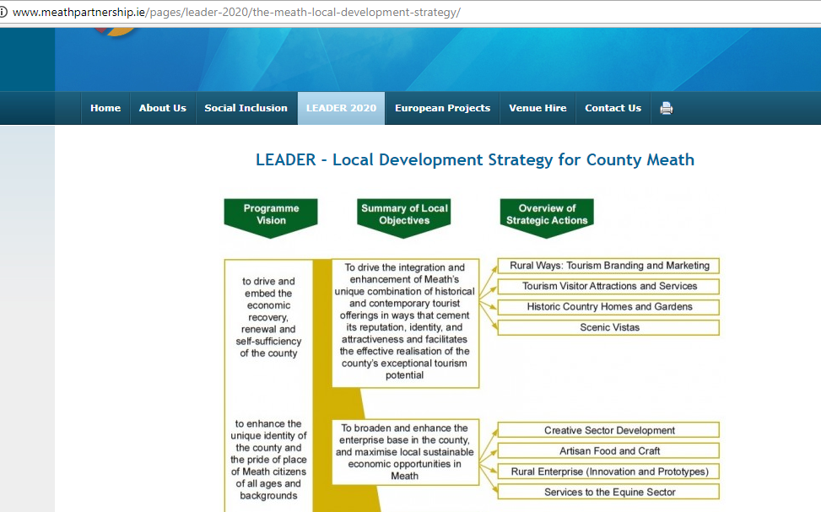
Other Examples of Community Development Projects
• Credit Unions.
• Skills training programmes
• Community resource centre
• Child care service
• Tidy Towns committee
• Developing tourism
The Benefits of Community Development
Increased employment and spending in a community
New businesses are set up and jobs are created for local people. This income generated is usually then spent in local shops also, which in turn can increase the standard of living in a community developing the local economy.
Spin off employment
The establishment of community initiatives and business enterprises in a local community brings an immediate increase in the levels of direct and indirect employment. This new employment sees an increase in demand for goods and services in the area. e.g. transport, education, entertainment etc. Community development has the spin off effect of increasing sales for other businesses in the area.
Government Income
Less people on social welfare and more people working paying taxes is of huge benefit to the government. This will increase the money governments will have to give local economies to improve and develop.
Enterprise Culture
Community Development initiatives can encourage other members of the community to pursue ideas. This can lead to more new initiatives or new businesses being established in the future. It can lead to a culture or generation of people taking the risk to set up new enterprises.
Increased community spirit
The increase in employment, choice, and other facilities will improve the standard of life in a local community. Local people will feel a sense of belonging to their area which in turn leads to a greater community spirit, and less anti-social behaviour.
Depopulation is prevented
People may be encouraged to remain in an area if facilities are available and opportunities to work and to enjoy leisure time are provided. Local communities thrive.

To develop business enterprise in a community the following is essential:
- People
- An Organisation
- Plan
- Finance

People- There needs to be meaningful participation from interested parties. It is best to hold a meeting trying to get a broad representation of people from the community who can volunteer their expertise and skills in different areas
An Organisation- Setting up a formal organisation of key people to oversee and run the operations of the community development initiative
A Plan- A key plan should be in place, it should be SMART and a SWOT analysis should also take place
Finance- With the above steps in place, the project will now need to raise money. This could be through fundraising etc..

Agencies that can help Community Development
Local Enterprise Office
LEO’S are state agencies responsible for assisting entrepreneurs who want to start up small/micro businesses (10 employees or fewer) and create employment in their county.
They help local community in the following way:
Support
Advice: They provide small group or one to one advice and mentoring from successful or experienced business people to help you develop your ideas
Networking: They will put you in contact with local people that could be of importance to your business such as local suppliers of produce that may be of interest to your business
Training: Provide skills and development workshops- such as Start Your Own Business Courses
Finance
They can provide grants such as feasibility grants up t €20,000 where the entrepreneur matches 50%, which helps the business when starting out
Leader Plus Programme
This is a programme set up jointly by the EU and Irish Government to help and assist enterprise in rural areas.
The aim for the Leader Programme 2014-2020 is to reduce poverty and promote social inclusion and economic development in rural areas through strategies such as increasing tourism and development of projects such as better water and broadband supply.
Leader gives advice on businesses to rural areas, as well as grants to assist in purchasing items such as machinery to operate.

Area Partnership Companies
Area Partnership Companies were set up to help disadvantaged people in urban areas, through grants, advice and mentoring, as well as workshop and training programmes.

