Conflict Resolution: The Consumer
Consumer conflicts: Can be solved in 2 ways:
1. Non-legislative methods
2. Legislative methods
What is a Consumer?
A consumer is somebody who buys a good for their own personal use- Example-buying a new pair of jeans for yourself in H&M.
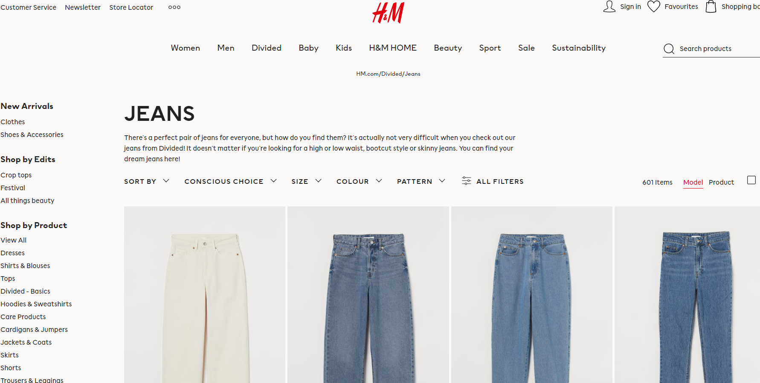

1. Non-Legislative Methods to solving Consumer Conflict
1. Meet and Negotiate
2. Letter of complaint
3. Third Party Assistance: Consumer’s Association of Ireland/European Consumer Centre Ireland
- Meet and Negotiate
Negotiation is when the consumer and retailer bargain and try to reason with one another.
What steps are involved in negotiating?
1. The consumer approaches the manager and makes a complaint. The consumer’s tone should be firm but polite
2. The consumer shows proof of the purchase they have made
3. The consumer and manager will continue to negotiate until a compromise has been me
- Letter of complaint
If the consumer is unhappy with how their face-to-face negotiating goes they should write a letter of complaint to the store. This is to be a formal letter outlining your issues and the redress you require.
- Third Party Assistance
Consumer’s Association of Ireland
You will then contact the Consumer Interest Group ‘The Consumer Association of Ireland’. This is an independent, not for profit organisation representing the views and interests of consumers.
Consumer Association of Ireland produce a monthly magazine called Consumer Choice to educate consumers about their rights and also provide a telephone service and website for more information.
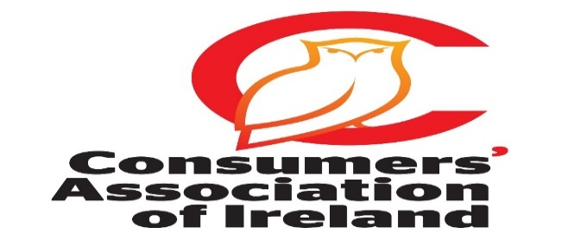
European Consumer Centre Ireland
The ECC Ireland helps consumers when buying goods from other EU countries.
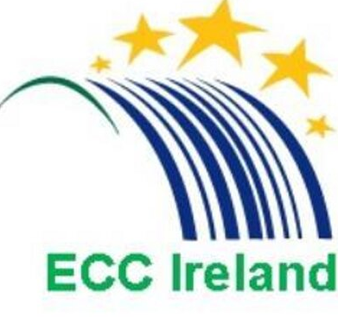
2. Legislative Ways of Solving Consumer Conflict
- Sale of Goods and Supply of Services Act 1980
- Consumer Protection Act 2007
- Competition and Consumer Protection Commission (CCPC)
- Ombudsman
- Small Claims Court
Act 1: Sale of Goods and Supply of Services Act 1980- Very Important!!
When consumers buy goods from a retailer, both parties have entered into a contract. The following are the conditions to this contract:
For Goods:
Under this act, the buyer has the right to assume:
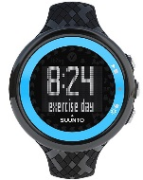
- Goods must be of merchantable quality: This means that the good must be of an acceptable standard, taking into account price and durability. Example: If you buy a watch it should not stop working after using it once.

- The goods are fit for purpose: This means that the good must do what you expect it to. Example: A freezer should freeze food 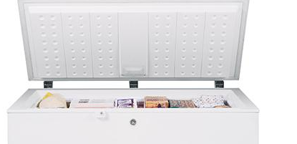

- Goods supplied as described: This means that the description of the good should match the packaging, catalogue, or description given by the sales person. Example: A silver I-phone X must be silver if selected by the consumer.

- Goods should match the sample: This means the sample shown to you by the seller should match the product purchased by the consumer. Example: A sample of curtain selected must match the sample delivered to the consumer.

For Services:
Under this act, the buyer has the right to assume:

- Parts should be of merchantable quality: This means that the parts supplied during a service are of merchantable quality. Example would be a door handle should open a door. This is a part of the overall good.
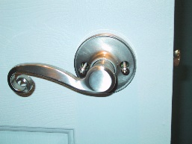
`
- Service must be carried out by suitably qualified people. This means that you have the right to assume that a person doing the work for you is qualified at their job. Example: Mechanic fixing your car, not your Business teacher.

- The service provider must take proper care and attention: When carrying out the work, a surgeon for example must take proper care when doing the procedure. If they do not, they would be legally liable. They cannot be watching Netflix while performing the procedure.

Other Provisions of the Act:
Rented/Leased/ Hire Purchased Goods: You are entitled to return such goods if they do not work- example rent a lawnmower from the local hardware store that doesn’t work
Second Hand Goods: They must be fit for the purpose they are sold but not fair for us to assume they should be brand new either. It is important to note if you buy from a private seller you are not covered- example a second hand video game from a friend.
Illegal shop signs:
It is an offence for the retailer to display signs that give the consumer the impression that they have no legal rights. E.g. ‘No Refunds on Sale Items’ Consumers’ rights under the act cannot be taken away or limited by signs such as ‘Credit Notes Only’, ‘No exchange on items’ etc. These signs are illegal and do not affect your statutory consumer rights
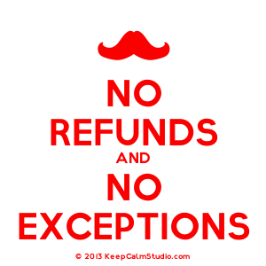
Inertia Selling/Unsolicited Goods: This is where goods are sent to a person who hasn’t ordered them and the seller later demands payment for them. This law makes this practice illegal.
The Act outlaws this practice and allows the consumer to keep the good free of charge after 30 days provided they have written to the seller asking them to collect the goods, or after six months, as long as the consumer has not prevented the seller from accessing them
Guarantees: Guarantees are seen as additional protection given to the consumer and they cannot limit the consumer’s rights under consumer law. The consumer can choose to have the goods fixed by the manufacturer or they can insist that the retailer deals with the complaint regardless of the guarantee.
The contract is between the seller and the buyer

Remedies for breach of the Act- Very Important!!
Please note that a consumer has no right to redress when the goods are not faulty, where they themselves damage the goods, or when they simply change their minds
Redress: Refund/ Repair/ Replacement
1. Refund
If a consumer buys a good that does not meet the standards set out by the Sales of Goods and Supply of Services Act they are entitle to a complete refund. This is one form of redress that is used to solve consumer conflicts.
Example: You pay for a guided tour of Rome through English. The guide cannot speak English and gives the tour in Italian. You are entitled to a refund.
2. Repair
If a consumer buys a faulty good in need of repair through no fault of their own they can ask for a repair.
Example: A dress with a faulty zip is returned to the seller and repaired for the consumer.
3. Replacement
If a consumer buys a faulty good they can ask for a working replacement. This form of redress is common, especially when the good cannot be easily repaired.
Example: You buy an iPad which stops working for no apparent reason. When you bring it to the Apple Store they say it cannot be repaired. You are entitled to a replacement iPad.
Evaluation of the Sale of Goods and Supply of Services Act 1980
I believe the ‘The Sale of Goods and Supply of Services Act 1980’ is very effective because it:
Informs consumers of their rights when purchasing and enables them to understand that they are entitled to a Refund/Repair/Replace if their rights are infringed upon. Consumers cannot be misled by retailers and they know that they are protected when purchasing goods and services.

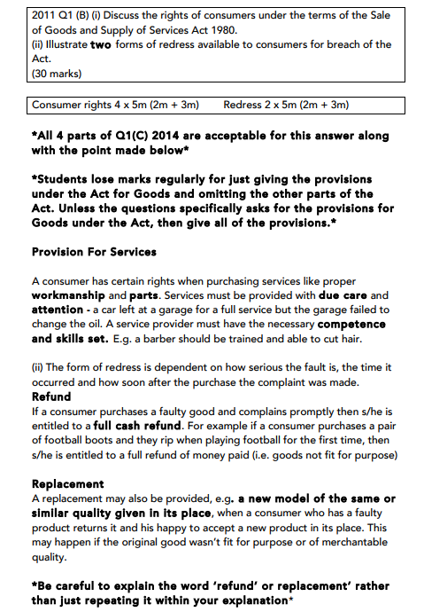

Act 2: The Consumer Protection Act 2007
The Consumer Protection Act 2007 sets out the following rules about:
- Aggressive business practices
- Claims about prices
- Prohibited practices
- Price Controls
- Misleading Descriptions

- Aggressive business practices
A business cannot force or threaten a consumer to buy a good/service. Example: A restaurant owner or chef cannot harass you until you come into their restaurant.
- Claims about prices
This means the price of certain goods must be displayed in a particular way.
1. Goods sold must be final price inclusive of VAT etc..
2. Grocery stores selling Fruit must provide weighing scales.
3. If a special offer price is only available for a limited period this must be clearly stated. - Example while stocks last/ ‘Must End Friday’
A wise consumer will always shop around to get the best price. The Latin phrase Caveat Emptor meaning ‘let the buyer beware’ as the buyer alone is responsible for checking the quality and suitability of goods before a purchase is made.
- Prohibited practices
Certain practices are banned under this law:
1. Making false claims about cures for illnesses.
2. Offering free prizes when it costs money to claim these prizes.
3. Running competitions when the top prize is not available
4. Claiming a business is closing down when it is not
5. Ban of Pyramid Schemes
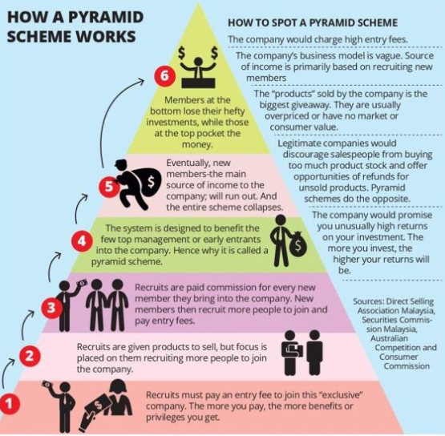
- Price Controls
In emergency situations the government can introduce a maximum price for a product. Example: Tickets for gigs cannot go over cost price to eliminate touting as a government policy.
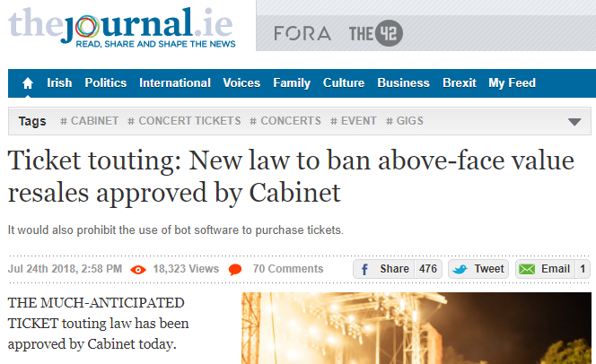

- Misleading Descriptions

Sellers cannot advertise in a way that deceives or misleads consumers.

1. About the product or service- the ingredients or materials used to make the good. A company saying their food is fat free when it’s not.
2. About usage/ history of 2nd hand goods, e.g. a car dealer changing the mileage on a car.
3. The country of origin of the good
4. The quantity or weight of the good
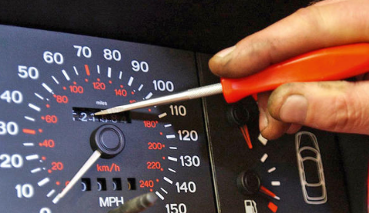
Evaluation of ‘The Consumer Protection Act 2007’
The Act benefits consumers as they must receive fair and accurate information from retailers about goods and services. This will ensure the consumer knows exactly what they are buying and at what price.

The Competition and Consumer Protection Commission (CCPC)
The CCPC is an independent body that enforces consumer protection and legislation in Ireland.
The CCPC operate the following functions:
- Inform consumer of their rights
- Investigate breaches of consumer laws
- Advise the Government
- Provide personal finance information and advice
- Enforce product safety regulations

- Inform consumers of their rights:
The CCPC provides consumers with information about their rights in relation to the purchase of goods and services, as well as financial services. They provide a website, a helpline, social media site and engage in radio and television advertising. They also produce a newsletter through a subscription service on their website.
- Enforces breaches of consumer laws:
The CCPC is the statutory body responsible for enforcing all consumer laws. They issue compliance notices, on the spot fines, prohibition notices and produce a Consumer Protection List of all businesses who have breached consumer law.
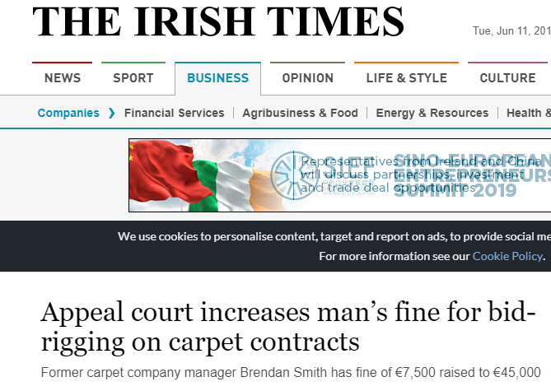
https://www.irishtimes.com/business/companies/appeal-court-increases-man-s-fine-for-bid-rigging-on-carpet-contracts-1.3537397

- Advise the Government:
The CCPC conducts research and identify areas where consumers need greater protection. It then informs the government about the impact these new laws would have on Irish consumers.
http://www.mondaq.com/ireland/x/751336/international+trade+investment/The+CCPC+Recommends+Grocery+Regulator

- Personal Finance Information and Education:
The CCPC provides financial information to consumers. They run campaigns and education programmes in offices and schools. The CCPC website has many tools for consumers to use to make more informed decisions. These include financial calculators, cost comparisons for various financial services, interactive quizzes etc. They also sponsor How to be Good with Money.

- Enforces Product Safety Regulation:
The CCPC share information about dangerous goods and ensure producers and retailers obey product safety regulations.
Credit: EDCO
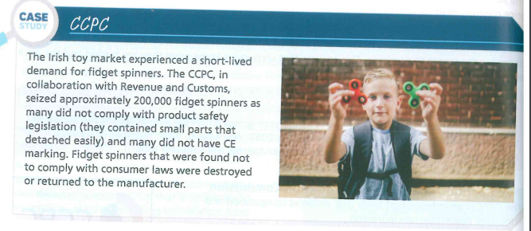

Evaluation
I feel that the CPPC is essential for Consumer Protection. Its provisions ensure that we as consumers have a body that looks out for our best interests in the market place and protects us in our dealings with the various stakeholders in business.
The Small Claims Court
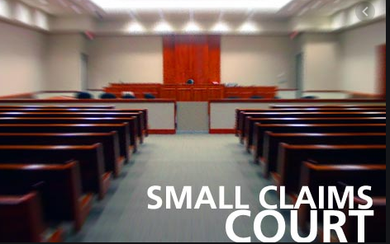
If a consumer and a retailer are unable to resolve a dispute the consumer might look to bring the retailer to The Small Claims Court.
It aims to sort out consumer claims quickly, cheaply and without a solicitor
- The small claims procedure doesn’t deal with debts, personal injuries or breaches of leasing agreements. It also does not deal with most claims about private rental properties.
- The largest amount a consumer can sue a retailer for is €2,000
- A special application form must be filled out along with a €25 fee
- This meeting is as informal as possible and private
- After listening to all the evidence the Registrar makes their ruling
- There is no need for a solicitor to be present- you can represent yourself
- It the Registrar is unable to solve the complaint, they will bring the case to the District Court for a hearing

Evaluation
The Small Claims Court is very effective for consumers as it provides a cheap and fast way to solve conflict between a consumer and a business. It is housed in the local District Court (there are 23 in Ireland) which means a consumer has a number of courts close to their vicinity that they can have their case heard.

The Ombudsman
Set up by The Ombudsman Act 1980, if a consumer has a problem with any of the 4 following public bodies they can make a complaint to The Ombudsman. Legally the ombudsman can investigate the following 4 institutions.
The Ombudsman operates as follows:
1. Complaint
The consumer makes a complaint to The Ombudsman, this must be done within one year of the incident. There is no fee for the services of The Ombudsman.
People complaint about Garda conduct during protest.
https://youtu.be/K3LTQGXTx4Y
2. Investigation
The ombudsman will investigate the complaint.
3. Recommendation
After considering all of the evidence The Ombudsman will make a recommendation.
• The recommendation/ findings are not legally binding.
• The public body doesn’t have to obey The Ombudsman.
• But if the public bodies don’t comply, The Ombudsman will include them in a report sent to Dáil Éireann every year.
Evaluation of ‘The Ombudsman’
The ombudsman is very effective because the service is provided free of charge. The Ombudsman also discourages bribery in public state bodies. The ombudsman is independent of the government.

