Conflicting Interests:
Industrial Relations

VS.
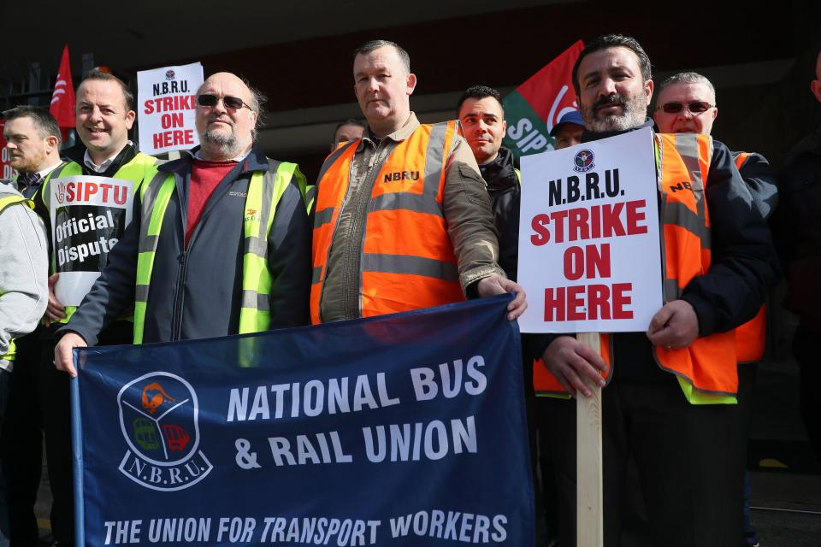
We will look at:
- What is Industrial Relations
- The importance of good Industrial Relations
- Why Industrial Relations are bad: Industrial Relations Disputes
- Types of Industrial Action
- Solving Industrial Disputes- Non Legislative and Legislative

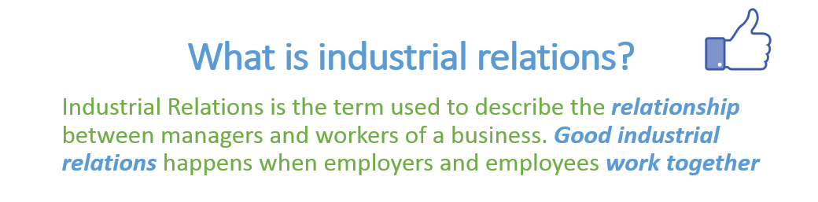
Maintaining good Industrial Relations can lead to the following:
1. Increased Morale and Productivity
Good industrial relations lead to happy workers. Happy workers with high morale are normally more productive than unhappy workers. Think of the jobs with great perks like working in Facebook
2. Less Absenteeism
When workers are happy in their job they are less likely to call in absent. A good employee/employer relationship is vital for this reason
3. Lower Staff Turnover
Staff turnover is the rate at which employees leave a business. Employing new workers is expensive because of high training costs. Good industrial relations result in decreased staff turnover. Think of when Máistir worked in his jobs when in college. There was always a high staff turnover and as a result people were not that motivated in their jobs
4. Customer Loyalty
When there is a good employee-employer relationship there is a smaller chance of constant industrial action. Customers don’t enjoy strikes and may take their business elsewhere
5. Encourages Investment
Shareholders are more likely to invest in a business that that has positive Industrial Relations and therefore it will be easier for a business to raise capital
When Industrial Relations go bad: Industrial Relations Disputes
The most common causes of Industrial Relations Disputes are:
- Pay and Working Conditions
- Discrimination
- Redundancy
- Promotion
- Demarcation

Pay and Working Conditions
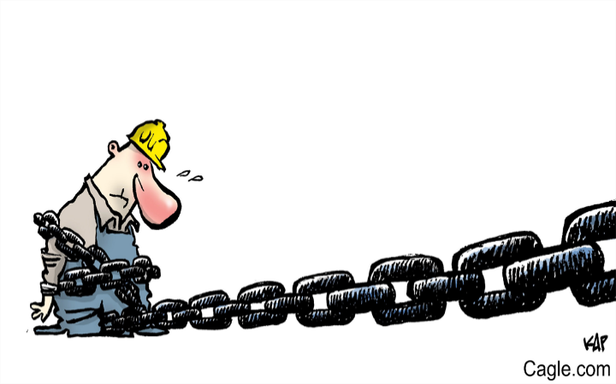
The Economic downturn will have seen many employees pay and working conditions change. In some cases this has been accepted but in others there have been noticeable disputes around this (Bus Eireann, Teachers, Ryanair pilots etc…)
There are 4 reasons an employee may ask for a pay increase:
1. Productivity Increase
If an employee is asked to work harder or produce more goods and services by a manager they make look for compensation in the form of a pay increase. This is known as a productivity claim.
2. Cost of Living Increase
Workers will often make a claim for a pay increase in an effort to keep up with general rising prices and inflation. This is known as a cost of living claim
3. Comparability Increase
This is where employees ask for a pay increase when they see workers from different business doing similar jobs but earning more. An example would be if workers in LIDL get a pay increase, then the workers in ALDI might seek the same.
4. Relativity Increase
Sometimes people’s jobs are linked with each other. If one person receives a pay increase then the other person may also seek one. An example of this would be if waiters receive a 5% increase in wage, then the bar staff may also look for a 5% increase to maintain the pay gap.
Discrimination
Examples of discrimination would be paying men more than women for doing the same job or not treating new staff fairly. Discrimination of workers is illegal under the Employment Equality Act 1998.
https://www.irishtimes.com/news/ireland/irish-news/hundreds-of-schools-closed-due-to-strike-action-over-pay-1.4160750

Redundancy
Redundancies happen when staff lose their jobs usually through cutbacks in a job. Trade Unions will try to ensure redundancies are voluntary. Sometimes staff can deem redundancies unfair and as such form a dispute against their employer.
https://www.irishtimes.com/business/retail-and-services/est%C3%A9e-lauder-staff-at-dublin-airport-plan-further-strike-action-1.4364734
Promotion
This is when somebody gets an upgraded position in the workplace, and can be a massive source of conflict in the workplace. Reasons can include seniority and experience lead to promotion but this may not always be the case. It can cause particular unrest in a job.
https://br.reuters.com/article/us-ryanair-unions-britain-idUSKCN1IU1ZK
Demarcation
This is a dispute about who does what in a particular job. You should only do the work you are qualified to do and not be asked to do duties that you are not supposed to do. For example if your teacher was constantly being asked to man the office reception as well as teach classes they might have a dispute with management over this.
Types of Industrial Action
Illegal
- Unofficial Strike
- Lightning/Wildcat Strike
Unofficial Strike
An unofficial strike is one where employees don’t hold a secret vote and/or don’t give their employer 7 days’ notice. The trade union doesn’t recognise unofficial strikes and will not pay workers strike pay
https://www.independent.ie/irish-news/threat-of-unofficial-strikes-across-all-ci-companies-35488688.html
Lightning/ Wildcat Strike
This is a sudden strike where no prior notice has been given. Employees literally walk out of the job. This sort of a strike is illegal in Ireland
https://www.thejournal.ie/wildcat-strike-could-happen-again-3316941-Mar2017/

Legal
- Official Strike
- All out Strike
- Work to rule
- Overtime ban
- Token Stoppage
Official Strike
An official strike is legal in Ireland. First employees must hold a secret vote. If 51% of people want to go on strike they give their employer 7 days ‘notice. The trade union instructs employees to cease working. They will pay workers strike pay.
All-out Strike
This is where every single employee in the business goes on strike. For an all-out strike to be legal the workers must get the approval of the Irish Congress of Trade Unions
https://www.thejournal.ie/inmo-strike-4325520-Nov2018/
Work to rule
This is where workers do the least amount of work possible under the terms of their employment contracts. An overtime ban or go slow may be part of “working to rule”.
https://www.rte.ie/news/education/2018/0918/994521-lecturers-at-wit-and-it-carlow-set-to-take-action/
4. Token Stoppage
Workers temporarily stop work for a short period of time. This is an attempt to get the employer to listen to the workers and solve industrial disputes
https://www.irishtimes.com/news/ireland/irish-news/dublin-bus-staff-to-hold-three-48-hour-stoppages-in-september-1.2772899
Overtime Ban
This is when employees refuse to do any overtime for the employer.
https://www.irishtimes.com/news/health/psychiatric-nurses-begin-overtime-ban-over-pay-1.3777250

Solving Industrial Disputes
Non-Legislative v Legislative
1. Non-Legislative
1. Negotiation
This is where an employer/ manager and representatives of the employee (trade union) sit down with one another. They will discuss the reason for the dispute and attempt to seek common ground and come to a solution. Any deal that is agreed is known as a “collective agreement”. This collective agreement holds no legal power.
The role of the Trade Union as part of negotiation:
An employee may chose to use their Trade Union to assist them in their negotiation. When employees begin work they enter into a contract with their employers. Over time it may be necessary to change the terms and conditions of a contract and both sides negotiate the changes. It is most common in these circumstances for the employees to be represented by a Trade Union.
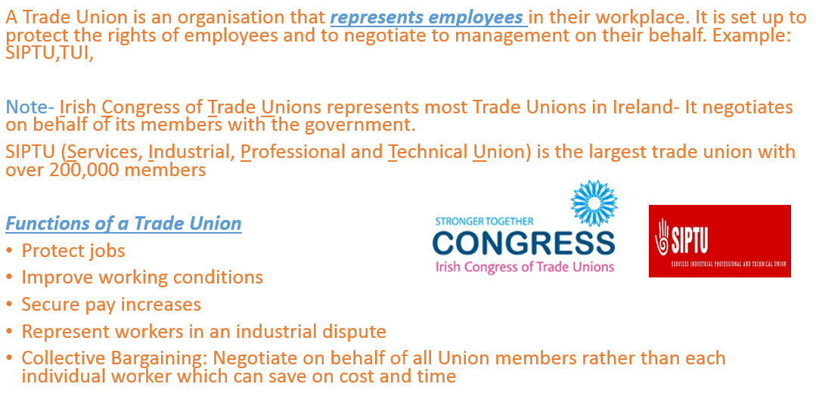
The Shop Steward
The elected staff representative for the Trade Union is known as the Shop Steward. The Shop Steward is the first 'port of call' if a member has any kind of difficulty or concern in their workplace. The Shop Steward also has other duties such as informing workers of any trade union updates, encouraging new memberships and service benefits in the workplace, organising meetings, and organising the votes for an industrial dispute on behalf of the union.

2. Conciliation: Unbiased third party
Conciliation aims to get the two sides in dispute to listen to each other’s points of view, to discuss the issues and negotiate an agreed settlement before the dispute grows into a serious one.
In the case of a conflict, e.g. of an industrial relations nature, it means the voluntary coming together of the parties to the dispute in the interest of resolving the conflict. Once the agreement is made it is not a legally binding one but its aim is to resolve the dispute without strike action.
They investigate both sides separately before they bring the two sides together and help them see each others point of view
They DO NOT make a decision. They merely help both sides to reach an agreement.
One of the main functions of the Workplace Relations Commission, a body set up under the Industrial Relations Act 1990, is to provide a conciliation service to help resolve industrial relations difficulties.
Consumer complaints: CAI, Trade Associations, Ombudsman
Employee complaints: WRC
3. Arbitration
Arbitration is where the settlement of a dispute (conflict) is sent before one or a group of independent (impartial/unbiased) persons for adjudication (settlement).
It is the final non legislative option. It is where both sides agree to allow a third party who is unbiased to make a decision that is legally binding.
The parties to the dispute agree in advance to the arbitration process and that the arbitration decision will be binding on them.
The main type of disputes dealt with by arbitration are ones that concern:
- The conditions of general contracts. e.g. travel agents with customers for holidays, building contracts for houses, etc.
- Industrial relations agreements between (employees) trade unions and employers.

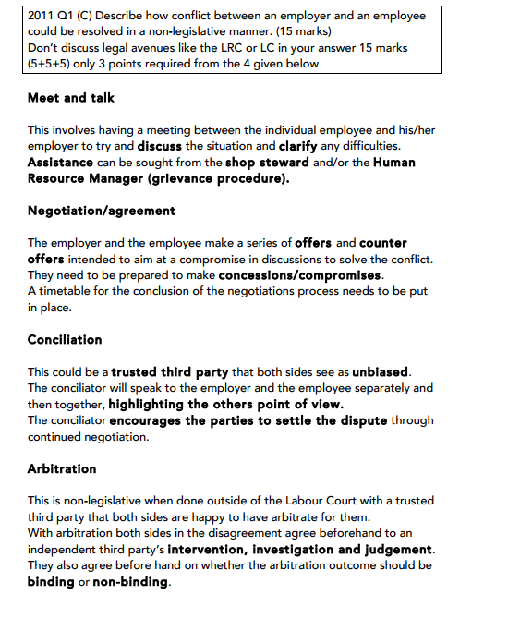

2. Legislative-Very Important!! Acts must be learned and evaluated
This is where industrial conflicts are solved by using Irish law.
There is a number of acts that are used as legislative methods of solving conflicts:
1. Industrial Relations Act, 1990.*
2. The Workplace Relations Commission.
3. The Labour Court.
4. Employment Equality Acts 1998-2015
5. Unfair Dismissals Act, 1977 & 2007.
1. The Industrial Relations Act 1990
The Industrial Relations Act 1990 was introduced to improve industrial relations in Ireland. The main features of the Act are:
1. Trade Dispute
A dispute must be legitimate, which is any dispute between employers and employees that relate to conditions of employment.
An example of a legitimate trade dispute would be pay and working conditions etc… (any from the list we have covered above). An ilegitimate trade dispute would be not liking your employer etc…
2. Secret Ballot
For official industrial action to be taken, a secret ballot must take place to vote on the action. If the majority of 51% or more vote in favour, then official industrial action can take place and the trade union will decide what form.
3. Notice
The employeed by law must give their employers 7 days notice that the industrial action will take place.
4. Picketing
Primary Picketing can take place at the employees workplace. Employees walk up and down outside with placards indicating that they are engaged in strike action.
(Secondary Picketing may also take place outside another employer if it is found that that employer is directly involved in their industrial dispute, e.g. sending over their workers to man the tills. It is illegal to do it if it does not impact directly on the dispute in question)
5. Immunity
The employer is not allowed to sue the trade union or workers for losses made by the business due to strike action provided that they have followed the steps in the dispute.
Evaluation of the Industrial Relations Act
Very effective as it puts into a law a legitimate trade dispute and protects workers in official disputes with their employers in the workplace.
2. Workplace Relations Commission
The Industrial Relations Act 1990 gave legal status to The Workplace Relations Commission. The Workplace Relations Commission was set up to promote and improve industrial relations in a timely and effective way and reduce the number of industrial conflicts brought to the Labour Court.
Functions of the Workplace Relations Commission
- Information
The WRC provides information on employment law and industrial relations to employers and employees through its website.
2. Advisory Service
The WRC works with businesses to build and maintain positive industrial relations in the workplace, often visiting businesses and provide workshops and training.
3. Conciliation service
The WRC employs an Industrial Relations Officer (I.R.O.) who provides a conciliation service. Their job is to try and solve any disputes between employers and employees and reach a mutually accepted agreement.
4. Mediation/Adjudication
The WRC offers a mediation service, and if successful it becomes legally binding. If it is unsuccessful, it is referred to an Adjudication Officer who will then hear both sides and give a recommendation. Decisions made by the AO can be appealed at the Labour Court.
5. Codes of Practice
The WRC consults with the ICTU and designs codes of practice. These codes of practice make it clear for employees/ employers what they should do in specific situations of industrial conflict
Evaluation of WRC
Despite the fact that the LRC’s agreements are often not legally binding they are still very effective because they have a Rights Commissioner who strives to resolve conflicts between employees and employers. The Rights
Commissioner achieves this through a private hearing where they hear both the employee and employers point of view. They give a recommendation as to how best solve any conflict.

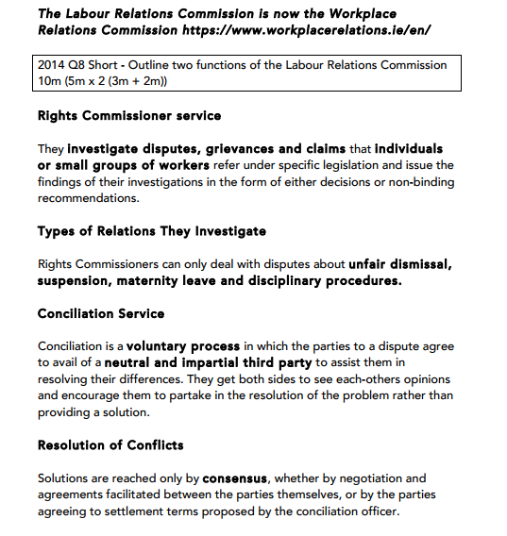

The Labour Court
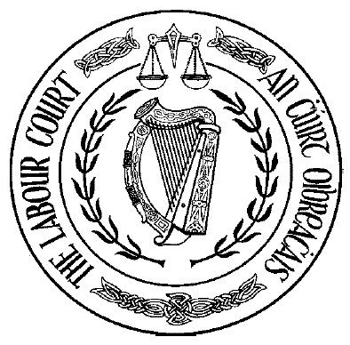
Why is it called the court of last resort?
Because disputes are referred to the labour court if:
1. The W.R.C. can’t resolve the dispute
2. A decision by the rights commissioner is appealed
3. A decision by the equality officer is appealed
Functions of the Labour Court
1. Investigate disputes
The Labour Court investigates disputes between employers and employees. It gives a non-legally binding recommendation to both parties. If neither side is happy with their recommendation they can appeal to the High Court.
2. Hear Appeals
If either party rejects the recommendation of the WRC, the case will be sent to the Labour Court. The Labour Court issues a binding judgement to the case.
3. Register Employment Regulation Orders
The Labour Court draws up an ERO to fix pay and working conditions for people in certain industries that become legally binding, e.g. window cleaners
4. Interpret Codes of Practice
The Labour Court interprets the Labour Relations Commissioner’s codes of practice. It will also investigate any breach of these codes of practice
5. Joint Labour Committees
Establishes Joint Labour Committees which produce employment regulation orders enforceable by law. They regulate industries where workers have no union, to discuss issues such as pay etc..
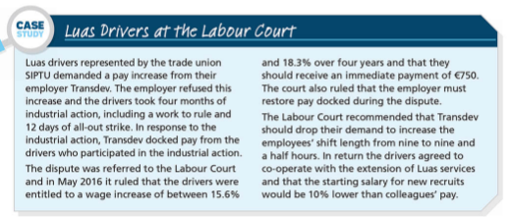
Evaluation of the Labour Court
Because the Labour Court is a court of last resort for solving industrial conflicts most employees and employers accept their recommendations. The Labour Court also has the respect of all parties in Industrial relations and the majority of their recommendations are accepted

4. The Employment Equality Acts 1998-2015
The Employment Equality Acts 1998-2015 outlines discrimination in the workplace to temporary, part-time, and full-time staff. It also applies to areas of employment such as pay and promotion.
**It defines discrimination as when one person is treated less favourable than another in a comparable situation. **
There are 9 grounds of discrimination, and they are:
- Age
- Gender
- Race
- Sexual Orientation
- Member of Travelling Community
- Religious Beliefs
- Marital Status
- Family Status
- Disability
The Act also set up the Equality Authority which was set up to ensure businesses treat their workers with respect and decides whether discrimination can be examined.
The Act gives the following functions:
1. Monitor the operation of employment legislation
2. Assists people with complaints
3. Advises employers and employees of their legal rights with regards to discrimination
Resolving complaints of Discrimination
Employees who feel they may have been discriminated against can either solve themselves or choose to contact the Director of Equality Tribunal who will use either legislative or non-legislative methods to resolve disputes under the Acts.
Non-Legislative
A Meeting with management is scheduled where the complaint is discussed. The employee may bring the shop steward with them. It will be hoped that the complaint is listened to and a solution can be brought forward there and then.
Legislative
If an employee cannot resolve the issue in the workplace, they can contact the WRC and request Mediation in order to get a third party involved to achieve a mutually agreeable solution. The solution is recorded in writing and becomes legally binding.
Unsuccessful mediation can be referred to an Adjudication Officer. They hear the case, and if discrimination is proved, they can reward damages such as financial compensation or take action against the employer.

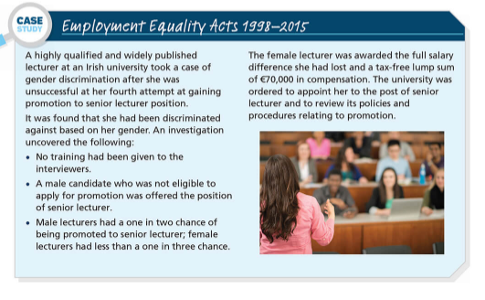
https://www.lawsociety.ie/gazette/top-stories/wrc-awards-2500-to-man-who-suffered-age-discrimination/
Evaluation
This act does a good job of protecting employees because there is a government backed official who’s RULING MUST BE OBEYED. It also clearly sets out the grounds for discrimination which clearly must be followed and provides employers and employees with advice and assistance if needed.

2015 Question

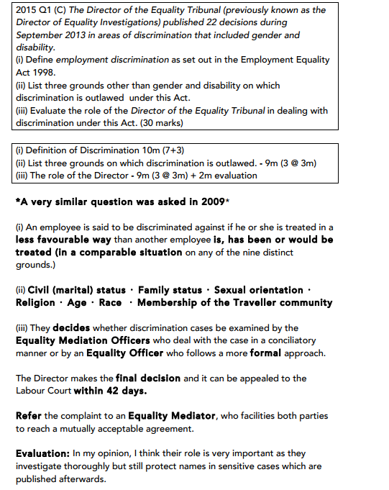

5. The Unfair Dismissals Acts 1977-2015
The Unfair Dismissals Acts were introduced to protect employees from being dismissed from the workplace for unfair reasons. The Acts refer to employees with 1 year + continuous employment with the same employer.
Under the Acts, all dismissals are deemed to be fair and the burden of proof lies with the employer.
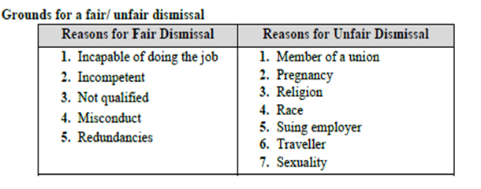
We have covered in The Employment Equality Acts 1998-2015 some of the reasons for unfair dismissal, but the following are reasons for fair dismissal in the workplace:
Incompetence: The emloyee does not perform their job to a resonal standard, e.g. continuous failure to reach targets
Redundancy: If a job is facing redundancies for genuine reasons, such as poor sales. The redundancy must be chosen fairly and cannot be forced on one person and not another for no reason
Not Qualified: If the employee does not have the relevant qualifications needed for the job
Misconduct: This is unacceptable behaviour by an employee in the workplace, and can range from high absentessism and persistant lateness to gross misconduct like theft or assault
Legal Reasons: An employee can be dismissed if their employment breaks the law, for example they do not have a valid work visa.
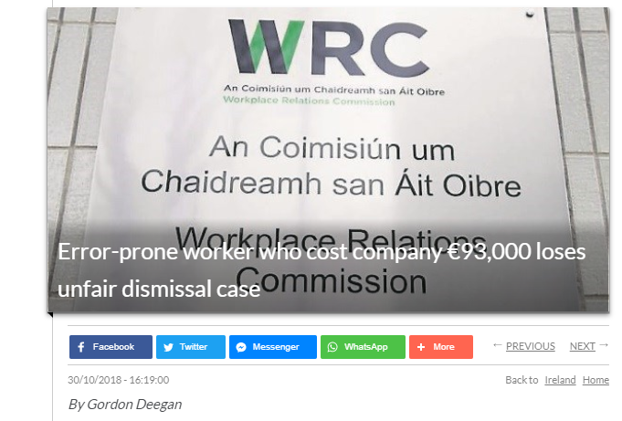
https://www.breakingnews.ie/ireland/error-prone-worker-who-cost-company-93000-loses-unfair-dismissal-case-882128.html
Procedure for fair dismissal
1. Counsel Employee- The employer notices the employee is underperforming and tries to work with them to solve the issue. A meeting is called where the problems are outlined and extra assistance is provided if needed, e.g. extra training.
2. Verbal Warning- Performance has not improved and a formal meeting is called where a verbal warning is given to an employee. The employer outlines a target that must be achieved.
3. First Written Warning- This is issued by the employer if performance shows no improvement.
4. Final Written Warning- If there has not been any significant improvement, a final written warning will be issued and if performance does not improve within a specified time frame, an employee will be suspended or dismissed.
5. Suspension- The employee may be suspened with or without pay until an investigation has concluded
6. Dismissal- The employee is removed from their job as performance is not up to standard, despite efforts of support and training
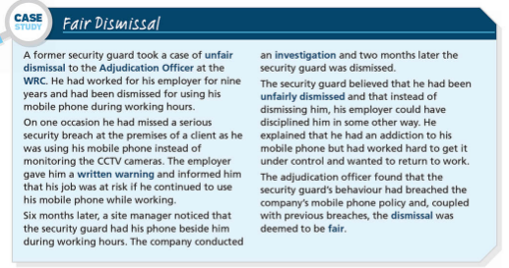

Redress for Unfair Dismissal
If an employee has found to be unfairly dismissed, the following are the options for redress:
1. Reinstatement
Here, the employee gets their old job back, they will also receive any back pay outstanding and is entitled to any improvements in conditions of employment when they were dismissed
2. Re-engagement
This means that the employee can get either their old job back, or a new position as approved by the WRC, but they are not entitled to back pay
3. Financial Compensation
This means the employee can get financial compensation up to two years salary if they have suffered a financial los due to dismissal, or up to four weeks salary if they have not suffered financial loss
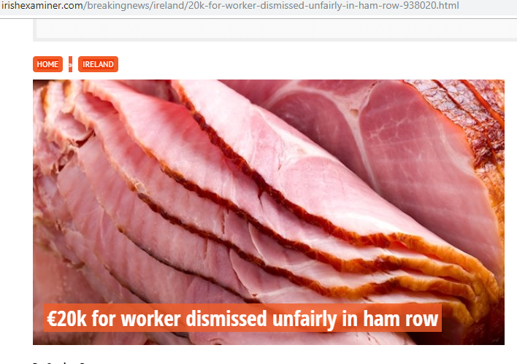
https://www.irishexaminer.com/breakingnews/ireland/20k-for-worker-dismissed-unfairly-in-ham-row-938020.html
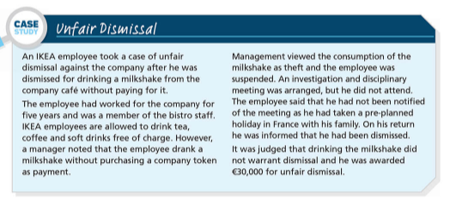
Constructive Dismissal
This occurs when an employee is forced to leave their job due to the employer’s behaviour and attitude towards them. The employee feels that their job is becoming so unbearable that they cannot remain in the job.
The burden of proof lies with the employee, and so they must show that their resignation was justified. They should have tried every possible way to solve the issue with their employer and document evidence of any concerns along the way.
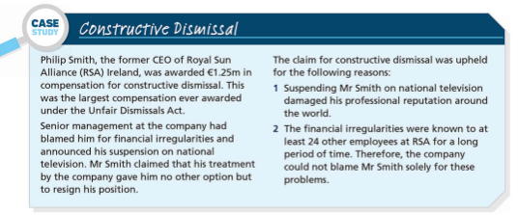
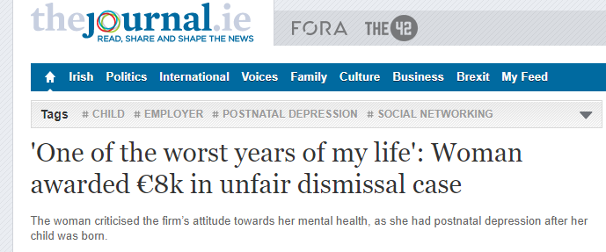
https://www.thejournal.ie/workplace-relations-commission-unfair-dismissal-case-4391676-Dec2018/

