Economic Systems and Economic Growth
Sectors of an economy
The main sectors in an economy are ‘Public’ and ‘Private’ sectors. As we have seen before, there are other sectors such as ‘Not for Profit’.
Public: These sectors of the economy are owned by the government. It is made up of local and national government and state owned businesses.
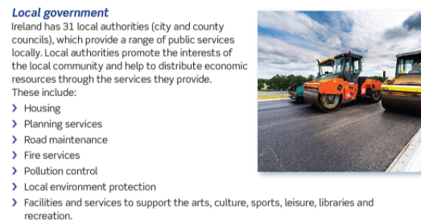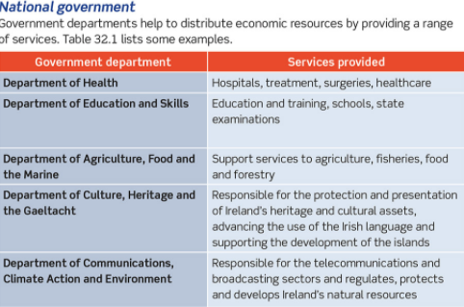
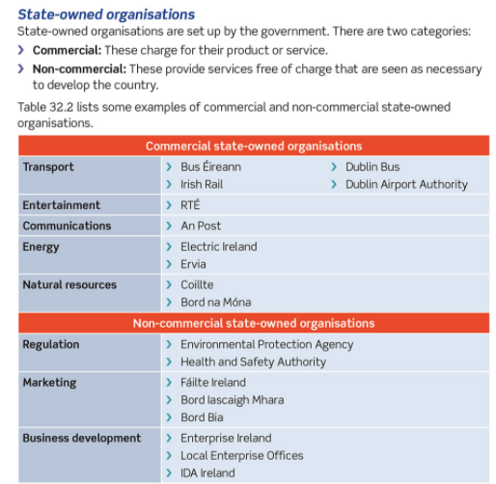
Private: These sectors of the economy are owned by individuals who aim to sell goods and services to make a profit
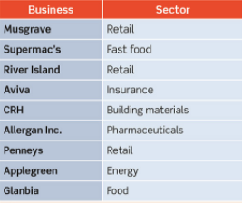
Voluntary/Social/Not for Profit: These are voluntary, social, and not for profit enterprises set up to benefit people in the community
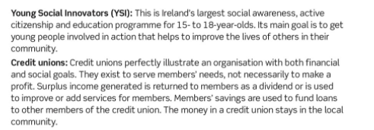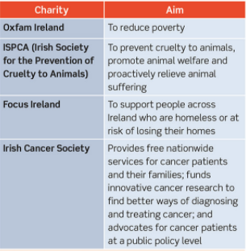
Economic Systems
As countries have developed over time, they devise different economic systems in organising their economic activities. An economic system is the method countries use to distribute economic resources and trade goods and services.
These economic systems include:
- What goods and services will the country produce?
- How will the goods and services be produced?
- Who is the benefit from the production of these goods and services?
Over time three systems have evolved:
- Free Market Economy 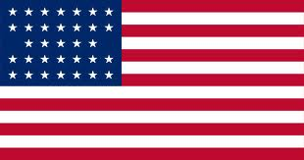
- All resources are owned by private sectors or by companies and used for their benefit only. The entrepreneurs are motivated by profit. The government plays a limited role in this type of economy. The free enterprise system allows any individual or group of people to start and operate a business with minimal government regulation or interference
- Free enterprise systems are run on the basis of consumer independence, which means that consumers are the ones that drive demand
Sample Answer: In a Free Enterprise (Capitalist) economy, consumers are the ones that drive demand. There is very little government involvement and the resources are owned by the private sector. The more successful a business is the more profit it will make. An example of a country is America.
2. Centrally Planned Economies (communism) 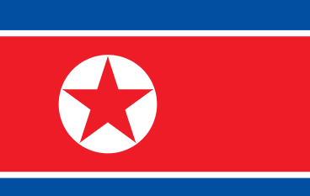
- All resources are publicly owned by the government on behalf of all citizens. The government controls all of the economy. They control all factors of production and make all decisions about what goods and services are to be produced. There is no private sector businesses owned by private individuals
Sample Answer: In a Centrally Planned economy all resources are publicly owned by the government on behalf of all citizens. The government controls all of the economy. An example of a country is North Korea.

Mixed Economies 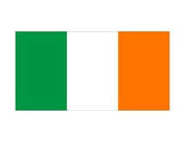
- Mixed economies allow most of the major economic decisions to be made by the private sector, but the government intervenes to ensure the supply of essential goods to everybody. It is the most popular government system
- In a typical mixed economy, the government may run such things as the postal service, rail lines, libraries, and in some cases, the health care service. Even in industries which are not owned or run by the government, its influence is very noticeable in the form of taxes and regulations like wage controls. –Minimum wages.
Sample Answer: In a Mixed Economy, there are a mix of both public and private sectors. Most of the major economic decisions to be made by the private sector, but the government intervene to ensure the supply of essential goods to everybody and set regulations such as the minimum wage. An example of a country is Ireland.

Each of the above economic systems operates in an economy where people or businesses buy goods and services. Economies can be small, like Navan, or big, like Ireland, The EU etc…
Unfortunately, no economy will have enough resources to satisfy all needs and wants, and so must allocate and use these resources effectively
How does an economy decide production?
What to produce? What is a country good at producing- what is Ireland good/bad at producing?
How to produce? What skills are needed, what people do we need? What factors of production do we require?
Who to produce it for? Who is the good for? Should everyone get an equal share?
How does an economy work?
Simple circular flow of income 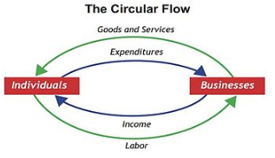
Money flows in a circle between businesses and households. Households work for wages, and that income us used to buy goods and services from that and other businesses.
Circular Flow of Income including the government
The government takes money out of the circular flow in an economy (leakage), as well as putting money into an economy (injection)
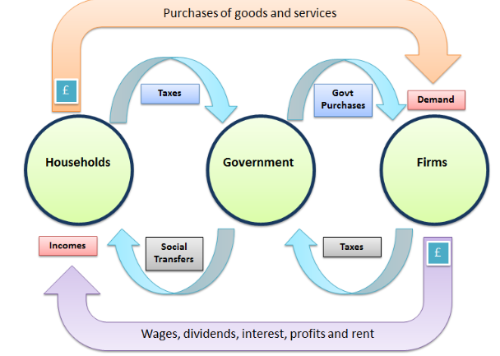

Economic Growth
As the economy grows, it generally moves through four stages. These stages are:
(Remember- Economic Growth is the production of more goods and services than the previous year. We use GDP/GNP to measure).
1. Boom
2. Recession
3. Slump
4. Recovery
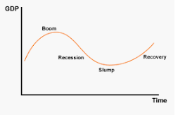
1. Boom
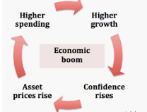
This is above average economic growth, where more revenue is generated by the government due to increased employment and public spending. Prices will rise to generate more profits for businesses and peoples standards of living increase.
2. Recession
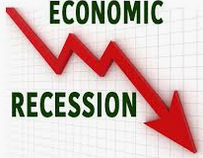
This is when economic growth falls below average. Unemployment rates rise, inflation decreases, consumer spending slows and businesses begin to close down. Less revenue is also generated from the government.
3. Slump
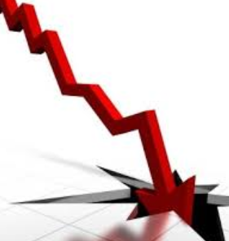
This is when the recession lasts a long period of time. Unemployment is high and inflation and spending is low over a prolonged period of time.
4. Recovery
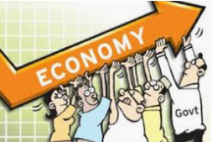
The economy starts to rise again. Employment begins to rise as well as consumer spending in an economy. More tax income is generated for the government also.

Ireland’s Economy- The Celtic Tiger Years and Bailout
The Irish economy in the 1980’s through the 1990’s was steadily increasing, to become one of the world’s most rapidly growing economies. Unemployment went down from 20% in the late 1980’s to 4% in 2007.
One of the main reasons Irelands’ economy grew so much was due to job creation. Having low tax rates, specifically in the corporate world, helped to attract many investors to Ireland. Ireland also began to offer free higher education to EU citizens- creating more jobs for EU citizens.
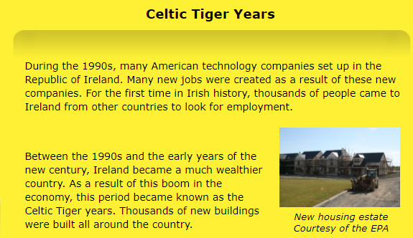
However, in the early 2000’s, the nature of the boom began to change, a housing bubble developed and businesses and households borrowed large sums to pay for them. In 2007, the housing market hit its peak and the bubble burst, leading to the financial markets collapsing. *See video on OneNote and article below*
https://www.irishtimes.com/business/economy/the-banking-crisis-ireland-s-lost-decade-in-10-charts-1.3644680
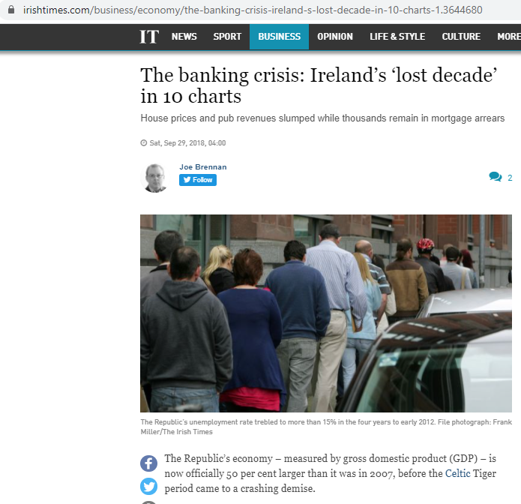
Banks cut lending and people could not afford to repay their loans. Unemployment rose significantly as people and businesses had huge debts they could not afford. This meant Ireland entered into a recession in 2008, and the Irish economy had to bail out the banks. *See video below*
https://www.rte.ie/archives/2018/0927/998454-government-bank-guarantee/
To save the Irish economy from collapse, the economy received nearly 70 billion euro from the EU and the International Monetary Fund (IMF) in 2010, which would have to be paid back with interest over the next few years. The government had to factor this into their tough budgets for years to come.
Taxes such as USC, job cuts, wage reductions, and increased taxes like VAT going up from 21% to 23% were introduced.
In September 2013, Ireland successfully exited the bailout program and began to show signs of recovery with an increase in employment, increase in exports, and more tax revenue generated in the economy.
The effect of Covid 19????
For 2020, the Irish government was forecasted to operating in a surplus, however the Covid 19 pandemic has seen the economy return to a recession, and it remains to be seen how the economy will recover. In 2020, the Irish economy recorded a deficit of around €21 billion.
How the economy responds to Covid is uncertain.
https://www.irishtimes.com/business/economy/how-well-will-the-irish-economy-recover-in-2021-1.4448271
