Enterprise and the Entrepreneur
An Entrepreneur is someone who spots a gap in the market, takes both a personal and financial risk, and sets up a business. They can either make a profit or a loss, depending on how successful their enterprise is. Eg. Mark Zuckerberg taking both a personal and financial risk to set up Facebook in 2004.
Enterprise is a person or group being innovative/creative/using their initiative, while taking on a risk (personal/financial risk) in order to achieve a goal or make a profit. E.g. Business Enterprise: Mark Zuckerburg taking the risk of setting up Facebook in 2004
So essentially, enterprise is the opportunity, and an entrepreneur is the person who takes the risk in setting this opportunity up.
Famous Entrepreneurs
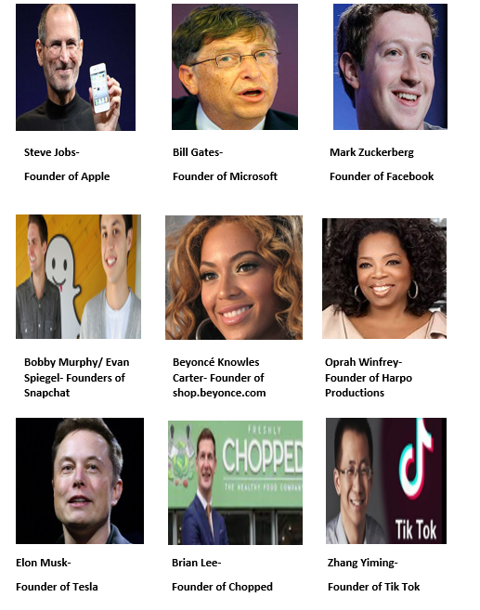
These above people are examples of an entrepreneurial talent for spotting a gap in the market and setting up an enterprise.
Types of Enterprises
There are three main types of Enterprise:
- Financial Enterprise
- Cultural Enterprise
- Social Enterprise

1. Commercial/Financial Enterprises
The most popular types of enterprises, these are goods and services set up to make a profit. Most are owned by entrepreneurs.
`
Financial Enterprises main purposes are to:
- Create employment
- Provide services to customers and businesses
- Generate taxes that can be used to run the country
- Generate economic growth

2. Social Enterprises
Not all enterprises that are set up are set up to make money. They were set up and sometimes have paid members but their goals are not to make profit, rather to help other people and society, such as the homeless or those in poverty. These are known as Social Enterprises.
They are not charities as they do not depend on donations, their income comes from selling goods and services, but any extra revenue generated is reinvested back into the business and the community.
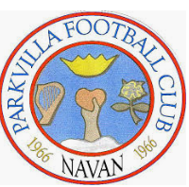
Social Enterprises main purposes are to:
- Create employment
- Provide much needed services to a community that are not being offered by the government or financial businesses
- Raise awareness of social issues
- Bring about change

3. Cultural Enterprises
Some businesses are set up to promote the arts and culture such as art galleries or music centres. Although the businesses make a profit, it is not their main aim. These are known as Cultural Enterprises.
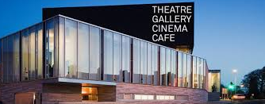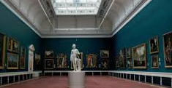
Cultural enterprises main purposes are to:
- Create employment
- Bring in revenue to a country through tourism
- Encourage Irish innovation
- Give people access to arts and culture

Why do people become Entrepreneurs?- Exam Q.
People often decide to become an entrepreneur for the following reasons:
Income: Potential to make a profit and support yourself financially- to potentially earn more than an employee wage
Independence: Be your own boss, work for yourself and make all key business decisions
Challenge: Some people get bored easily and like to challenge themselves to be successful
Creativity: They have the ability to constantly come up with new ideas
Redundancy: They have been laid off from work and need a source of income for themselves

The Importance of Enterprise in an Economy
- Enterprise creates jobs for local people and gives higher standard of living and quality of life
- It increases the production of goods and services in an economy and creates competition which is good for consumers
- It creates new breed of entrepreneurs, acting as a role model for others
- Government can use taxes to spend on education, hospitals etc.
- Not for Profit Enterprises provide many socially desirable places like Sports Clubs and charities
- Creates the need for other service providers like banks and Building Societies

Characteristics and Skills of Enterprising People-
Typical Exam Question
Below are some examples of skills/characteristics you may be familiar with
(*Note: You will need to know 5 and be able to State, Explain, and Example/Refer*)
- Risk Taker- Ability to take a chance
- Decisive- Ability to make decisions
- Networking- Ability to set up contacts
- Goal Setting- Ability to have a vision
- Creative/Innovative- Ability to come up with new ideas
- Realistic- Ability to use correct judgement on what’s possible
- Self-Confident/Inner Belief- Ability to back themselves and their concept
- Resilient- Ability to take a setback and keep going
- Proactive- Ability to keep moving and not stand still

Now we will examine a Case Study of Brian Lee and his business ‘Chopped’ and answer it from a LC Business perspective:

Intrapreneurship
This refers to an employee inside a business who engages in entrepreneurial activity/comes up with new ideas within/for the business in which she/he is employed. They take a personal but not a financial risk. Intrapreneurs come up with ways of reducing costs or ideas for new products that benefit a business.
e.g. A worker at Google came up with idea for Gmail. A worker at Google came up with the idea for Google Maps. A worker at Microsoft came up with the idea for the Xbox.
Examples of Intrapreneurship
- New ideas- e.g. a new sandwich on the menu in Subway selected by employees
- New production process- e.g. a tailor coming up with a cheaper way to make suits
- New work methods- a different way to chop meat in the deli

Ways to Promote Intrapreneurship
- Empowerment/employee participation encourages creativity as it allows employees greater freedom on how to do their job by placing real power, responsibility and authority in the hands of employees
- Create a culture within the organisation where it’s okay to make mistakes, employees are encouraged to think and work independently
- Financial rewards for effort and creativity. These rewards could involve a mixture of pay, incentives and benefits
- Teamwork encourages creativity among employees as it facilitates brain storming sessions as part of the product development process.
- Training program for employees and management, training them on the implementation of an intrapreneurial culture within a business

Benefits of Intrapreneurship
Increased Sales - New Products/Markets identified
Intrapreneurship results in new products/services being developed. Intrapreneurs are champions of change, looking for ways to grow and expand the business constantly, to improve the business process or product for the business in which they are employed.
New product and market development is very important to ensure the continued viability of any/all businesses. e.g. An employee at Sony came up with the idea for a games console which would become known as ‘The Playstation’. This increased Sony sales and profits.
Reduced Costs - Improved Efficiencies/ Increased Productivity
Various ideas introduced result in greater productivity in the business. Many new ideas and cost cutting measures introduced result in greater profitability in the business. e.g. An employee at Cadbury’s came up with a packaging improvement that reduced costs.
Increased Staff Morale and Increased Staff Motivation
More enjoyable workplace/nurturing of in-house talent to promote innovation. Where staff are offered the opportunity to be intrapreneurial they are generally more productive, happier and more fulfilled in their work.
There is greater motivation and improved industrial relations which saves time and money in the business. e.g. Facebook is one the world’s top employers. Facebook encourage intrapreneurship. An employee developed the idea for the ‘Like’ button- encouraging intrapreneurship leads to a happy and motivated staff.

Famous Examples of Intrapreneurship
Let’s first examine one of the most famous examples of intrapreneurship- Ken Kutaragi and the Playstation.
https://youtu.be/Y0kpYoGJE0k

Other modern examples of Intrapreneurhip
Amazon Prime- generates billions of dollars annually

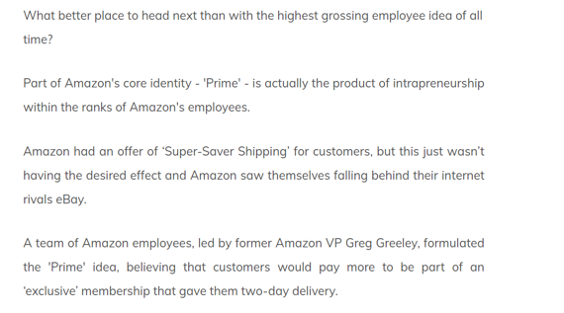
The Sticky Note- generate 1 billion dollars annually

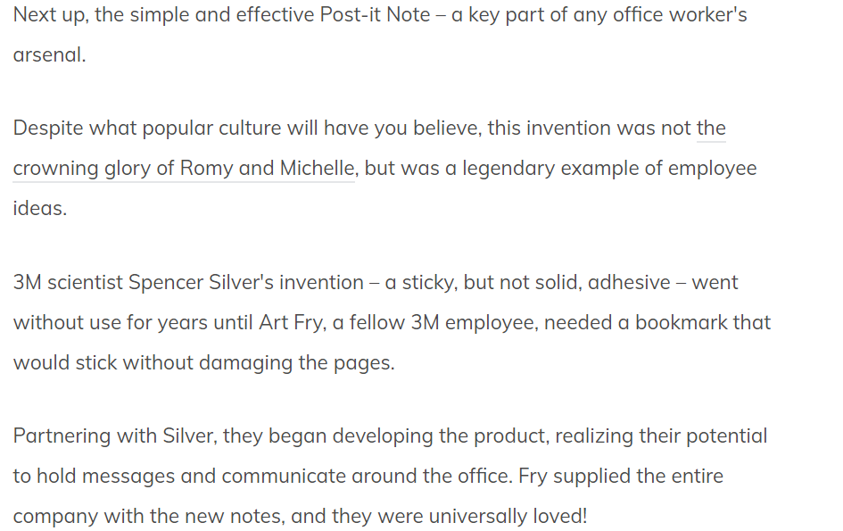

Apple- Swipe to unlock
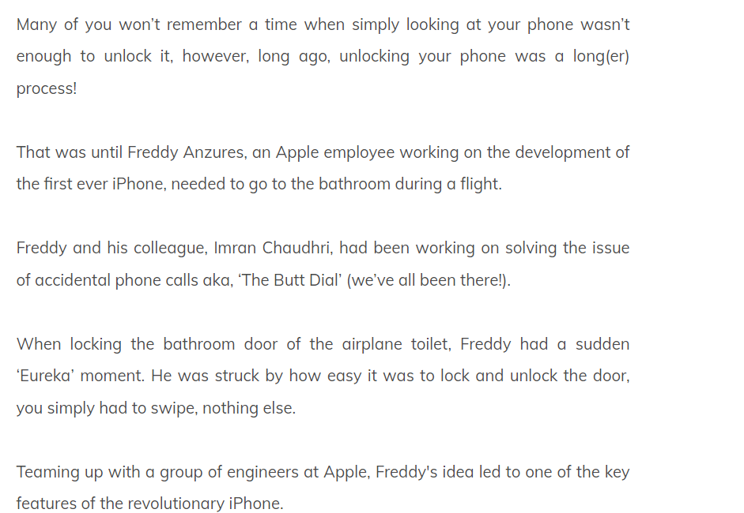

Legoland- Waiting with children in queues

