Expenditure
Expenditure is money that goes out of a household on or a business. It is what a household or business will spend their money on.
We must plan for what money we have to spend to make sure we have enough. Some expenses can happen weekly (groceries, while others monthly (rent/mortgage) or yearly (car tax)
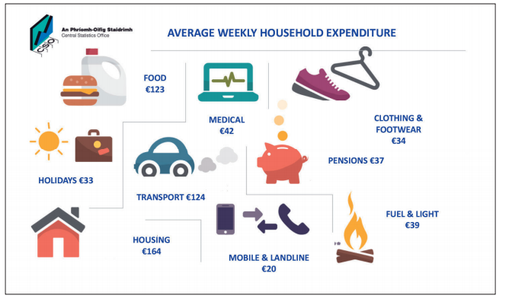
The 3 types of Expenditure
1. Fixed Expenditure
2. Irregular Expenditure
3. Discretionary Expenditure

1. Fixed Expenditure
This is expenditure that stays the same every month e.g. Rent, Mortgage, Loan Repayments, Milk bill
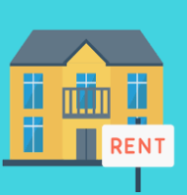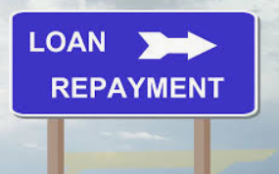

2. Irregular Expenditure
This is expenditure that changes every month depending on usage e.g. ESB, Telephone, Gas bills. For example, why will your light and heat be more expensive at Christmas than in the summer?
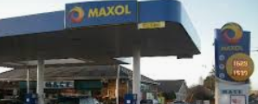

3. Discretionary Expenditure
This is expenditure on once off or luxury items e.g. holidays, personal apps, designer clothes, gig tickets, computer games. We should prioritise last after Fixed and Irregular.
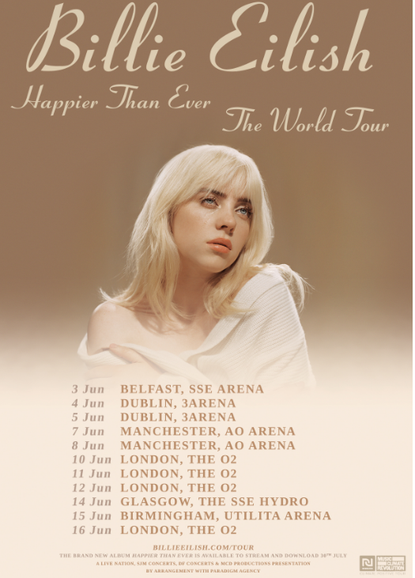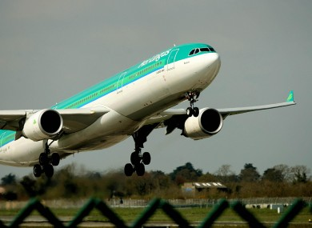
Activity: Based on what we have studied about the different types of expenditure, state whether the following expenses are Fixed, Irregular, or Discretionary.

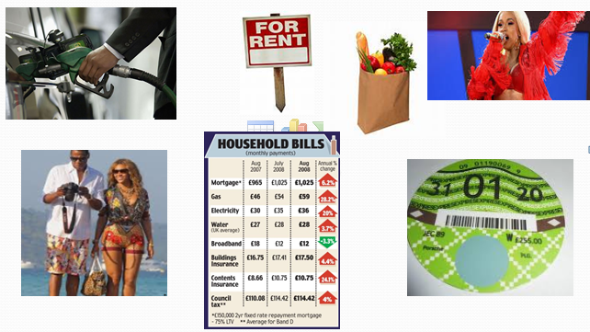
Categories of Expenditure
We can split the above expenditure into two categories: Current and Capital Expenditure
Current Expenditure: This is day-day spending. We will generally by these items for the short term. Examples include food, groceries, credit, Spotify subscription etc..
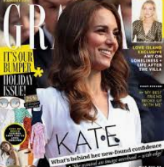
Capital Expenditure: This is spending for the long term such as buying a house or car. These items that we buy will last a long time.
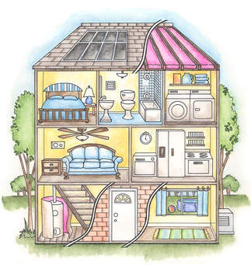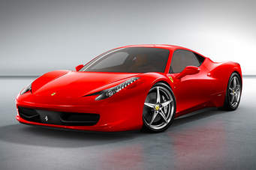
Important Considerations When Spending
Impulse Buying: This is when you buy goods that you did not plan too- buying on the spur of the moment. Example- You go into a shop to buy a paper and come out with a drink and bar of chocolate. You would need to be aware of how impulse buying can affect our budget for the future.
Ways to prevent yourself from impulse buying include bringing only the money you need with you for what you plan to buy or have a shopping list.
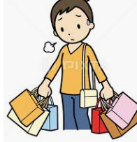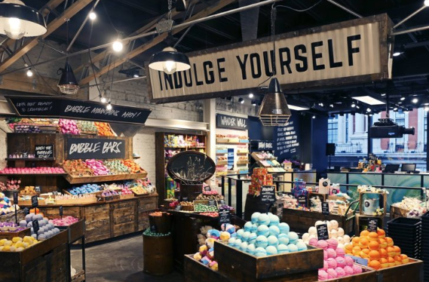

False Economies: This is when something in the short term appears to be cheaper, but in the long run turns out to be more expensive.
Example- you could buy a bigger 4 colour pen and keep it in your pencil case for 2euro, but instead you get cheaper pens for 0.35cent. You keep losing them and have to constantly replace them. It would have been cheaper to get the more expensive pen in the first place.
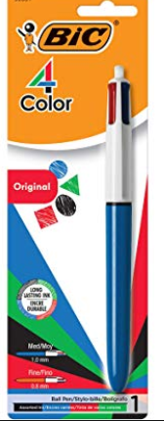
Financial and Opportunity Cost: Financial cost is the actual cost of the item you bought. E.g. Mars Bar for €1.
Opportunity Cost is the cost of missing out on the opportunity of having another item instead. It is the cost of the item you did not buy.
Unfortunately, unless we are very wealthy we cannot afford everything we want and so we must weigh up the opportunity cost of our spending.
Eg, you have a choice between a Mars and a Twix, they both cost €1 each but you only have €1, so you buy the Mars. The opportunity cost is the Twix
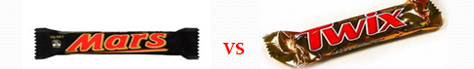

Planning for Expenditure
Similar to our income, we will be spending time examining our spending habits and why these are important in the future.
