Final Accounts 1: The Income Statement 1
All businesses, whether for profit or not for profit need to keep accounts in their business. At the end of each year, a business will show how they are performing using what is known as an Income Statement and a Statement of Financial Position. These accounts show whether the business is making a profit or a loss.
The Income Statement 1

All businesses are involved in some type of trade, i.e. they buy and sell goods or services. The trading account records all the details relating to these goods or services during the previous trading period. The purpose of the first part of the Income Statement is to find out whether a business has made a Gross Profit or a Gross Loss, before any expenses have been paid.
Key Terms:
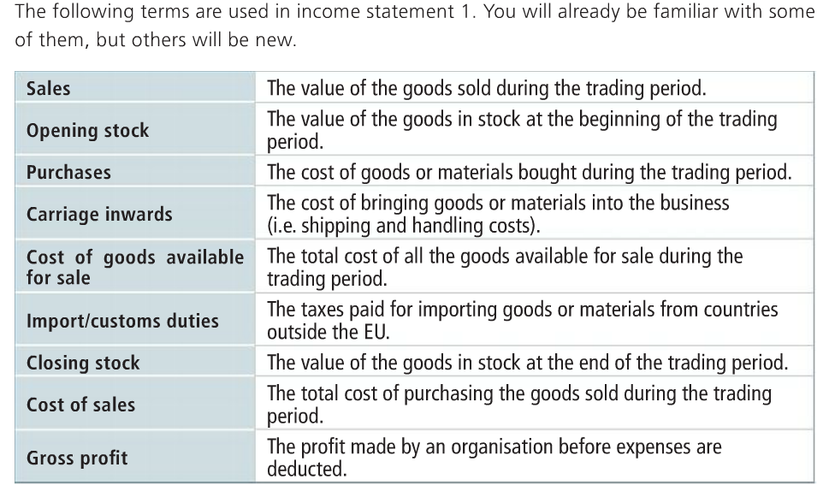

The layout for these accounts must be learned off by heart

Company Heading along the top
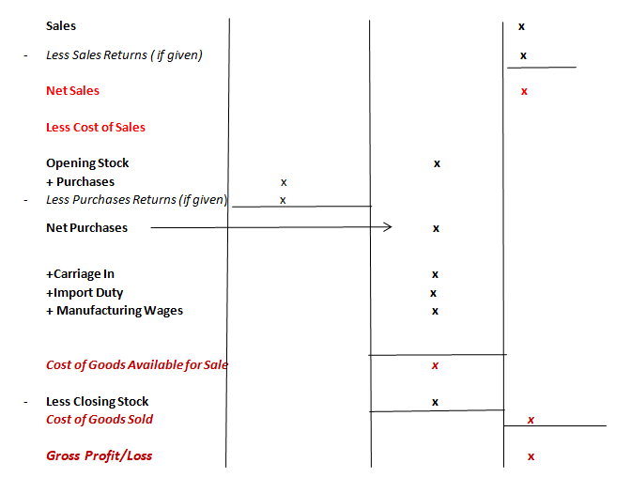

*Please note, generally only one or two of Carriage Inwards, Import Duties, or Manufacturing Wages will be given in a question.

Sample Trading Account/Income Statement 1

Trading Account for XYZ Ltd for Year Ended 31/12/2019
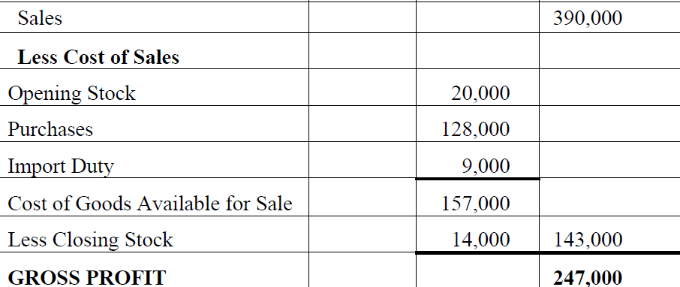
Practice Questions

Sales | 290,000
Sales Returns | 16,000
Opening Stock | 50,000
Purchases | 80,000
Carriage Inwards | 2,800
Import Duty – A duty or tax on goods | 200
Closing Stock | 18,600

Sales | 600,000
Sales Returns | 500,000
Opening Stock | 70,000
Purchases | 85,000
Carriage Inwards | 100
Customs Duty | 350
Closing Stock | 72,000

Sales | 204,000
Sales Returns | 2,000
Opening Stock | 13,000
Purchases | 96,000
Purchases Returns | 84,000
Carriage Inwards | 800
Manufacturing Wages- Wages for workers on purchased goods | 14,000
Closing Stock | 11,100

Sales | 170,000
Sales Returns | 150,000
Opening Stock | 111,000
Purchases | 90,000
Purchases Returns | 86,000
Carriage Inwards | 12,800
Manufacturing Wages | 18,450
Closing Stock | 111,100

Sales 290,000
- Sales Returns 16,000
Net Sales 274,000

Less Cost of Sales
Opening Stock 50,000
+Purchases ` 80,000
+Carriage In 2,800
+Import Duty 200

Cost of Goods Available for Sale 133,000

- Closing Stock 18,600
Cost of Goods 114,400

Gross Profit 159600

Sales 600,000
- Sales Returns 500,000
Net Sales 100,000

Less Cost of Sales
Opening Stock 70,000
+Purchases 85,000
+Carriage In 100
+Customs Duty 350

Cost of Goods Available for Sale 155,450

- Closing Stock 72,000
Cost of Goods 83,450

Gross Profit 16,550

Sales 204,000
- Sales Returns 2,000
Net Sales 202,000

Less Cost of Sales
Opening Stock 13,000
+Purchases 96,000
- Purchases Returns 84,000
Net Purchases 12,000
+Carriage In 800
+ Manufacturing Wages 14,000

Cost of Goods Available for Sale 39,800

- Closing Stock 11,100
Cost of Goods 28,700

Gross Profit 173,300

Sales 170,000
- Sales Returns 150,000
Net Sales 20,000

Less Cost of Sales
Opening Stock 111,000
+Purchases 90,000
- Purchases Returns 86,000
Net Purchases 4,000
+Carriage In 12,800
+ Manufacturing Wages 18,450

Cost of Goods Available for Sale 146,250

- Closing Stock 111,100
Cost of Goods 35,150

Gross Loss (15,150)

