Financial Service Providers
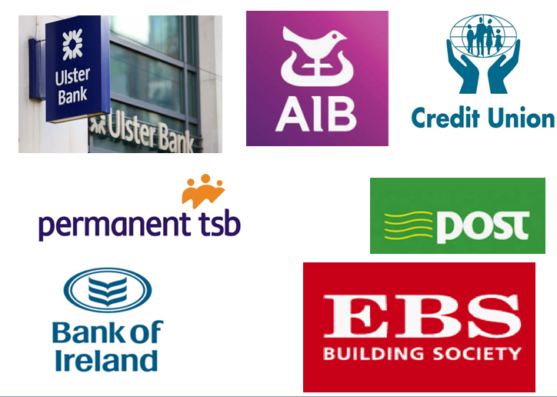
What is a Financial Services Institution?
A financial service institution manages money and offers services such as saving, taking out loans, and opening accounts to its customers.
The main types of financial institutions are:
- Commercial Banks- e.g. AIB/BOI
- Credit Unions
- Post Office
- Building Society
1. The Bank
Banks normally talk about two types of interest, that they give people with money in the bank and that they charge people who have loans from them
So banks borrow from savers and give them a lower rate of interest, than they charge those who have taken out loans from them
This is how they make some of their profits
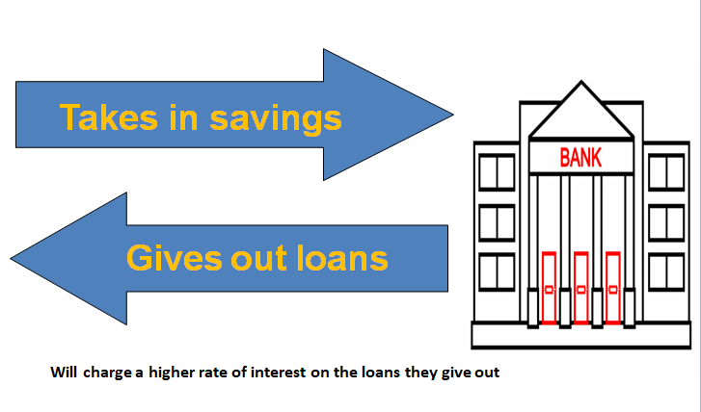
Opening a Bank Account
- You must complete an application Form- see workbook pg. 64
- Provide Proof of Identity- ID and Address
- Get a reference from somebody known to the bank- usually this will be another account holder/school
- Job Title- Employed/Unemployed
- Provide a sample signature
Each student in CNM will get the opportunity to open up their very own bank account this year!
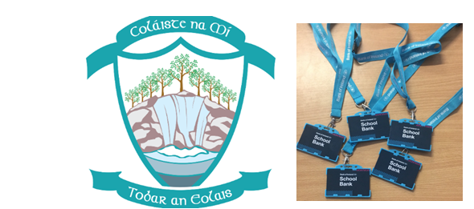

There are two main types of bank accounts:
Current account (DAY-DAY): This is your day-day account, where you can get paid wages electronically (PAYPATH), and use for spending with Debit Cards, Cheques, ATM transactions, Standing Orders and Direct Debits, Bank Drafts etc..
Deposit account (SAVINGS): This is a savings account. You get interest on money saved, and you pay Deposit Interest Retention Tax (DIRT) on your savings. There is no cheque book, debit card and you cannot use the hole in wall (ATM)
Withdrawing from a Current Account
- The Debit Card/Contactless Payments
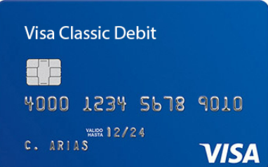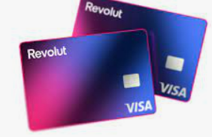
Chip and Pin- 4 digit number- NEVER SHARE WITH ANYONE!
Can be contactless up to €50- what are the advantages and disadvantages to using contactless payments?
Advantages
- Safer and need to carry physical cash with you
- Quicker/more convenient than going to an ATM to take out cash
- More time efficient in paying for goods and services
Disadvantages
- If card is stolen- can be used without a pin
- Hidden charges/costs
- Makes it easier to impulse buy
2. Cheques
Cheques are when we write a note to tell a shop to take a certain amount of money from our bank account.
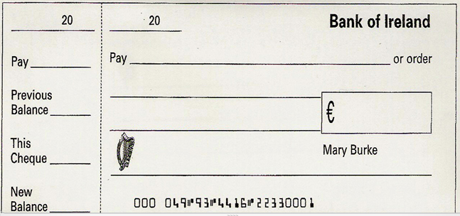
The person, who writes the cheque is the Drawer
The person to whom the cheque is written to is called the Payee
The bank that the drawer has their account in is called the Drawee
3. The ATM
Most banks now allow one to withdraw money 24 hours per day 365 days per year, using a machine placed outside the building
The machine is known as an ATM (Automated Teller Machine)
You can also pay bills electronically, buy phone credit, order statements etc...
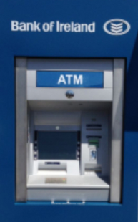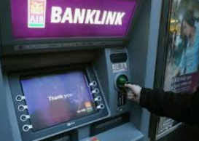

4. Direct Debits and Standing Orders
Standing Order: Asking the bank to pay a large fixed sum of money to a stated person- e.g. mortgage payments, rent payments. Payment interval cannot be changed.
Direct Debit: A current account holder gives permission to another person or business to withdraw variable/different amounts from their account. The time for payments can be changed and the payments are quick and efficient. Used for household bills like phone bills, gas etc…
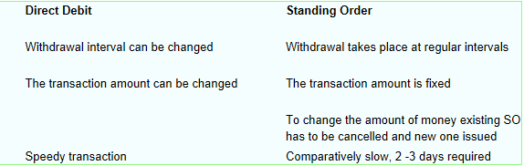
5. Bank Draft
We buy this cheque from the bank to pay large sums of money. Usually used to pay large sums of money where cheques are not acceptable. You may get a bank draft instead of paying in cash for items such as a new car
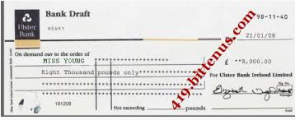
Borrowing from Commercial Banks
1. Bank Overdraft
A bank allows the account holder to withdraw/spend more money than they actually have in their current account. The account holder needs to be aware of interest payments for late repayments.
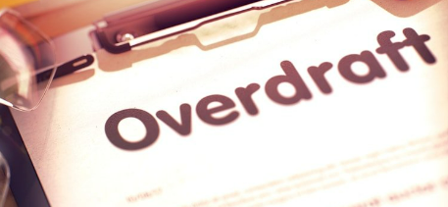
2. Credit Cards
Similar to Debit cards, but they differ as the money is not instantly paid from the account of the person paying for the good, instead the credit card company pay it within a few days
The credit card allows the buyer to spend more than is in their account up to an agreed limit with the credit card company
No interest is paid provided the full amount is paid within 28 days of the account statement being issued. If the full amount is not paid, a high amount of interest applies
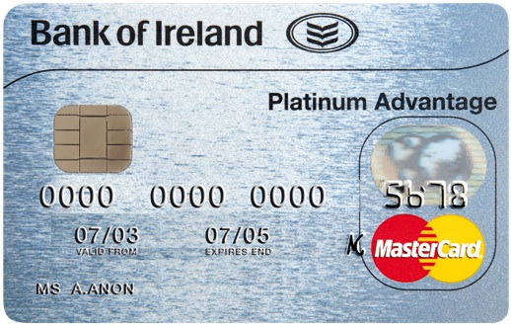
3. Loans
A loan is a sum of money that is borrowed by a customer from a bank and is repaid over a period of time. They can be short term (up to 1 year), medium term (1-5 years), or long term (5 years +)
The customer should shop around for the best interest rates. A mortgage is a typical example of a long term loan
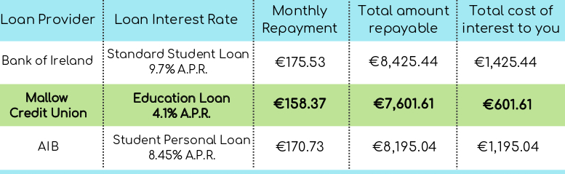
Sample Current Account Statement; look out for all of the different transactions
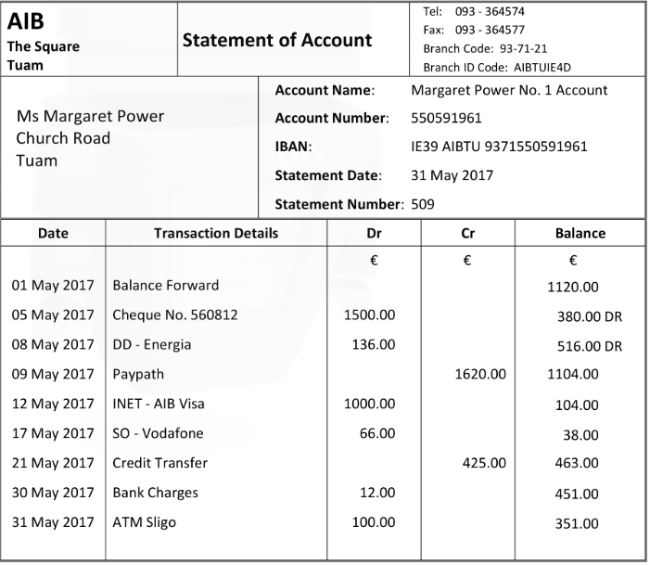
Other Services:
1. Online Banking
Can be accessed online 24/7, via the internet and can be used to
- Monitor accounts
- Search payment history
- Credit Transfers
- Get online bank statements
- Set up standing orders and direct debits
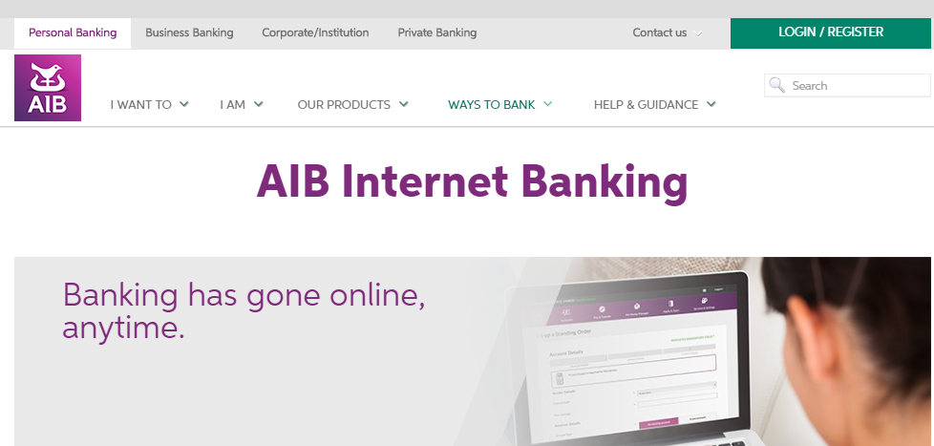
2. Foreign Exchange
Exchanging currencies in a bank
There is a ‘we buy, we sell’ rate that the bank operates

2. Credit Unions
Credit Unions are examples of cooperatives as they are owned and run by members
When a person puts money into the Credit Union, they become a member. Members receive a return on their shares at the end of the year
They are not for profit organisations, and offer services to members such as loans, savings, and insurance policies
3. An Post
An Post is owned by the government, and serve 1.7 million customers each week
In addition to postal services, they also provide a range of financial products including saving, foreign exchange, and transferring money
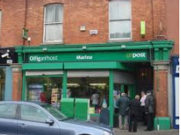

Regulating Financial Service Providers
The Central Bank in Ireland is responsible for looking after the interests of the financial services sector in Ireland
- They aim to:
- Regulate the financial service providers
- Protect consumers from financial service fraud
- Provide financial advice
The Future?
