Global Business

Global Businesses and Transnational Businesses
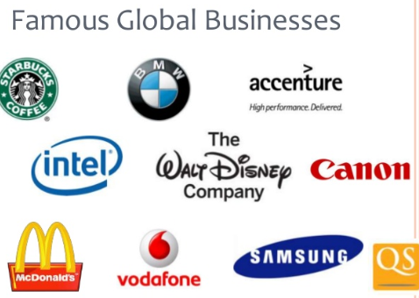
A global business sees the world as one giant market and production location. A global business provides the same, undifferentiated product worldwide. It uses a global marketing strategy, which involves the same or sometimes an adapted marketing mix (product, price, place, promotion) throughout the world to build a global brand. Examples of global businesses include Coca Cola, Dell, Nike, Toyota, Microsoft, Intel, HP, Google, and Nokia.
The Growth of Global Firms
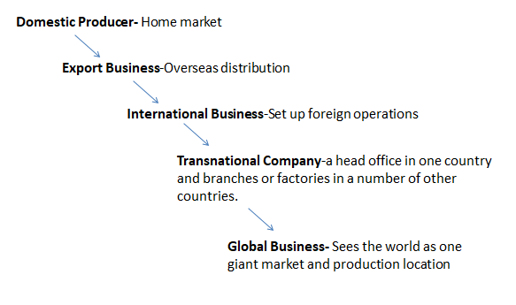
Reasons for Global Businesses
There are a number of reasons why there are so many global businesses operating today.
1. Increased Profits
Businesses become global to increase sales all over the world. This leads to higher profits. Also making enough products for the whole world leads to economies of scale for the business and lower costs
2. Technological advances in manufacturing
Technological developments such as Computer Aided Manufacturing (CAM)- meaning equipment can be computer controlled allowing firms to locate anywhere in the world, Computer Aided Design(CAD)- which revolutionises the design and testing process as products can be designed by computer quicker and more cheaply, and Computer Integrated Manufacturing (CIM)- which uses computers to control all parts of the production process from design to distribution
3. Development in Communications
Communication and transport advances have made it easier to run a global business. Video-conferencing enables managers to run a global business without having to travel. They can hold meetings with branches all over the world from their own devices
4. Deregulation
Deregulation by the World Trade Organisation has made a global business possible. Businesses can now enter markets previously denied to them thanks to freer world trade. For example, one of the biggest markets in the world, China, did not trade with the rest of the world until relatively recently
5. The Internet
The internet makes it a lot easier for a business to develop its brand. Websites such as Facebook allows a business to reach a global audience, and the building of websites enables them to advertise around the world
Global Marketing and The Marketing Mix
Global Marketing means selling the same product all over the world using the 4 P’s of the Marketing Mix. The Marketing Mix will either be Standardised or Adapted.
Standardised Marketing Mix
Standardised: (Undifferentiated approach to the 4 Ps/Consistent marketing mix). Global business, like Nike, and Levis, with successful brands, aim to take the same, undifferentiated approach worldwide and use a standardised marketing mix. All products are targeted at similar groups locally. This leads to lower company costs and increased profitability.
Adapted Marketing Mix
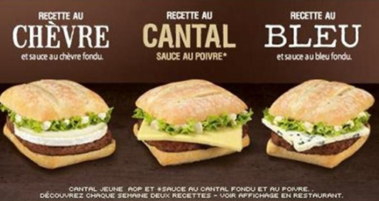
When certain elements of a marketing mix have to be changed to reflect local market needs- this is known as the Adapted Marketing Mix. A business must change some of the 4 P/s to reflect differences like language, cultures, or values in different markets.
Example- McDonald’s in France has adapted to the local tastes of its consumers. While McDonald’s maintains its overall brand image; logo, store layout, main menu items, the French brand of McDonald’s caters to the locals taste; it offers burgers with French cheeses. They also provided freshly baked baguettes for their McBaguette sandwiches.
The Global Marketing Mix
Global Product
This is a product that is sold throughout the world. Coca-Cola is an example of this. This is the one element of the global marketing mix that is most likely to stay the same all over the world.
To help with global recognition, most business will try to use the same brand name throughout the world to make it easier for customers to recognise when they travel around the world.
However, global businesses must take local needs and cultures into account if they want their product to succeed. For example- Mc Donald’s does not sell beef burgers in India, as the cow is considered sacred in Hindu Religion.
Global Price
The price that the company charges for its product may vary around the world. This is due to a number of factors including:
- The standard of living varies in different countries. Prices will normally be higher in wealthy countries because people can afford to pay more. Did you ever notice this on holiday?
- Taxes and tariffs may have to be paid. Countries that the global business exports to may add different taxes to its price
- Local rival firms charge different prices. The level of competition in the market will also determine the maximum price the global business can charge for its product in different countries
- Transport costs may be involved which raise the price of goods and services
Global Place
In global marketing, getting the product to customers all over the world can be a daunting process. Many global businesses rely on local agents and distributors to deliver their product for them.
A Global business will have to develop a global channel of distribution to ensure products get to consumers all over the world. They may try to use strategies such as use their website to distribute directly, form a strategic alliance with a local firm, or use local agents to sell products on their behalf
Global promotion
If a global business can use the same promotion methods all over the world, this will save it a lot of money.
Global companies sponsor global events such as the Olympic Games and the World Cup because sponsorship of these events reaches a truly global market.
However, it is not always possible to use the same promotion throughout the world. Promotion may change in different countries to take account of differences in language, culture and advertising laws. If global businesses do not take these differences into account when promoting their product, they may offend locals and lose their sales.
Example- KFC made Chinese consumers a bit apprehensive when "finger licking good" was translated as "eat your fingers off."

Importance of Global Marketing
Global marketing is important for businesses for the following reasons.
1. Economies of Scale
By selling the same product throughout the world, the global business can enjoy lower costs. It makes so many products to satisfy global demand that it enjoys massive economies of scale – the more products the business makes, the cheaper it becomes to make each one.
2. Expertise
Selling the same product all over the world requires makes it in huge quantities. The global business becomes an expert in making the product and, through practice, better than anyone else at making it. Furthermore, the global business can afford to invest in research and development on the product to make it the best in the world.
For example, the global business Sony is one of the best electrical goods manufacturers in the world.
3. Marketing Mix
Global businesses must realise that a truly standardised marketing mix is not possible. If local tastes are ignored, the global business will alienate local people and lose sales.
For example. Sales of Barbie dolls were low in Japan because the doll looked too Western. The company changed the doll to make her look more Japanese and sales increase rapidly.
4. Cultural Differences
Global businesses must consider cultural differences when advertising its global products. For example, ads shown in Western countries depicting women in a certain way might cause offense in some other countries. Furthermore, global business must be aware of the backlash against globalisation. Many people vehemently oppose the imposition of one culture

Effects of Globalisation on The Irish Economy
Positive
- Globalisation can be viewed as an opportunity for Irish businesses to sell goods and services abroad and grow and expand their operations. Companies get access to much wider markets E.g. Kerry Group and GlanBia Plc leading to economic growth for the Irish economy
- Globalisation impacts on the labour market within the Irish economy. Having experienced net emigration for decades, Ireland now has significant immigration as global companies located here try to fill high skill vacancies, for example in the technology sector, where there is a skill shortage
- Global companies located in Ireland are a significant source of employment. It is estimated that American global companies alone directly employ 115,000 people. Companies such as Dell, Microsoft, Google, Hibernian Aviva, Palm Inc., Facebook & Intel have all made significant contributions to the success of Ireland’s economy.
- Consumers get much wider variety of products to choose from and they get the product they want at more competitive prices/Increased domestic demand leading to economic growth in the Irish economy
- Greater economies of scale for Irish businesses which will reduce unit costs per products and increase business profits. This can lead to an increase in tax revenue for the economy
Negative
- The growth in Globalisation and global firms, with their quality produce at cheap prices, are a competitive challenge for Irish exporters. Irish exporting firms will have to become more efficient and invest in R&D in order to provide products with a unique selling point (USP) to survive the competitive threat from global firms.
- Globalisation can be viewed as a threat to the Irish economy because if Ireland is uncompetitive, its domestic industries will decline in the face of cheaper imports of goods and services produced globally
- Global Businesses send their profits home so the money they make in Ireland does not necessarily benefit the Irish economy
- Ireland is in the middle of a housing crisis, and with an increase in people coming to work for global businesses it is having a knock on effect on the housing market

Effects of Trade in Global Markets for Irish Businesses
Benefits
• Sales revenue increase. Ireland has a small population, Asia and Europe have large populations therefore selling to these areas could have a positive effect on sales and profits
• Greater Economies of Scale-cost benefits of large scale production/Producing and selling in bulk will reduce unit costs resulting in increased sales and profits
• Niche Markets can exist in different countries i.e. luxury Irish skincare products. Target certain markets
• The business may acquire ideas from other markets and existing competition.
Challenges
• Competition levels will be high so only the most efficient businesses will survive/ Intense international rivalry is far more challenging than competing in an indigenous market alone
• Price will have to take into account standard of living of market as well as if they operate inside or outside the EU. There may be extra costs such as transports costs or tariffs
• Social and cultural differences. Alterations may need to be made to products/marketing at extra cost
• Difficulty getting goods delivered in a fast and reliable manner can be an arduous task when operating across different regions of the world. Stock can be damaged and breakdowns in communication often hamper business success
• Challenging to create awareness of your brand on a global scale which in turn will allow for repeat purchasing, customer loyalty.
• Must have an online presence capable of dealing with international trade/ecommerce. Vulnerable to hacking

Transnational Businesses
Revision from Business Organisations
These businesses have their head office in one country and factories in other countries, i.e. IBM, Volkswagen, Siemens, Nestle, Intel, and Guinness. The head office controls the entire business, while these branches around the world carry out jobs.
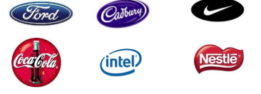
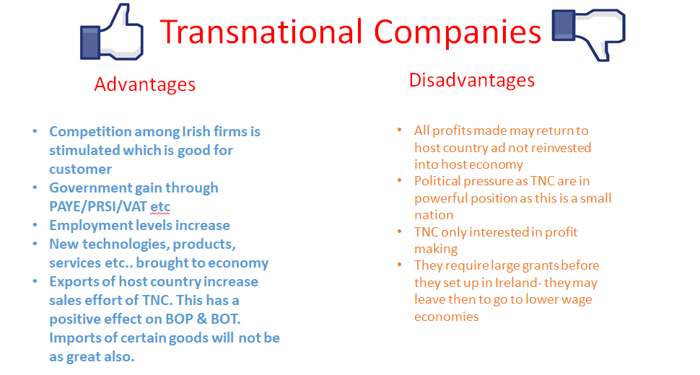
Note- question may also ask about multinational companies. Multinational companies (MNC’s) operate in more than one country and have a centralized management system. Transnational companies have many companies around the world but do not have a centralized management system. The notes below can be used for both.
There are many transnational companies today. The reasons for this include the following:
1. Spread Risk
Businesses expand into different countries to spread their risk. They don’t want to become too dependent on one market. For example, Dell (a US transnational) expanded into Europe. If there is a downturn in the US economy and sales of computers falls in the US, European sales may keep the businesses in profit.
2. Increase Profits and Sales
Businesses expand into different countries to increase their sales and profits. By expanding overseas, they can sell their products to many more customers than if they concentrated solely on their home market
3. Transport and Communication
Advances in transport and in communications technology have made it easier for businesses to run overseas branches. Video-conferencing enables managers to run a transnational business without having to travel. They can hold meetings with branches all over the world from their office
4. Overcoming Trade Barriers
Expansion into different countries is a way of overcoming trade barriers. Transnational companies that set up in Ireland have a major impact on the economy, mostly positive but there also can be some negative aspects to them
Advantages and Disadvantages of Transnational Companies
Advantages
1. Jobs
They create thousands of jobs in Ireland. This leads to lower unemployment in the country and a higher standard of living for Irish people. For example, Dell and Intel employ almost 10,000 people in their Irish plants
2. New Technology
They bring new technologies, new products and new management skills and ideas into Ireland. Dell and Intel bring the latest computer technology into Ireland and train their Irish employees in the latest computer skills
3. Competition
They bring competition into the Irish market. This is good for Irish consumers because it leads to lower prices and better quality. Lild and ALDI have increased competition in the grocery market, leading to lower prices for Irish consumers
4. Taxes
They pay a lot of tax to the Irish government on the profits they make in Ireland. This money can be uses by the government to improve Ireland’s economy through lower taxes and better infrastructure.
5. Buy Irish
They buy raw materials from Irish businesses, thus increasing the sales and profits of these indigenous businesses. Tesco Ireland buys a lot of Irish – produced food to sell in its stores
Disadvantages
1. They leave
They can close down with very little notice and leave Ireland in Ireland in order to move to countries where wages and other costs are lower
2. Too much power
Many are so big that they can put pressure on the government to give them their own way
3. Repatriate profit
They often repatriate most of their profits. This means that they send most of the profits they make in Ireland back home
4. Decisions taken abroad
Most decisions are taken by the lead head office abroad and they may not take Irish interests into account

Why Transnational Companies come to Ireland
Corporation Tax Rate
MNCs pay 12.5% corporation tax on their profits. For example in the UK it is 20%, This low rate of corporation tax is a key Government strategy in attracting FDI.
Spin off Presence
Global companies such as Intel, and Google have a major presence here and as a result it can be inferred that Ireland is a good place to do business and this international goodwill encourages other businesses to locate here. Internet companies such as Facebook, skype, eBay have followed Google
Work of IDA Ireland
IDA Ireland is responsible for the attraction and development of foreign direct investment in Ireland. Companies such as Apple, Microsoft and Facebook etc. have all interacted with the IDA and approximately 150,000 people are directly employed by foreign multinationals in Ireland
The availability of a highly skilled and well educated workforce
(MNCs) employ highly skilled graduates, right up to PhD level. Many of these graduates are engaged in R&D, an important area in multinational businesses. Google’s European headquarters are in Dublin.
The Euro and EU
The introduction of the single currency brought additional incentives for foreign investors to locate in Ireland, along with relative price stability. The euro has made life easier for MNC’s and travelling business executives trading or visiting in the euro zone area. The creation of the Single Market eliminated trade barriers within the EU, allowing for the free movement of goods, services, labour and capital between member states. (MNCs) located in Ireland have access to a huge EU market of over 500 million people
English Language
Ireland is an English speaking country and English is the international business language. In addition the growing number of people living in Ireland that speak different languages is a key factor in encouraging (MNCs) to locate here

