Human Resource Management

What is a Human Resource?
This is a term that refers to the people who work for an organisation
Human Resource Management is the process by which an organisation attracts, develops and rewards its workforce to ensure that the goals of the organisation are achieved as effectively and efficiently as possible. It is in essence related to people at work and all areas of responsibility that affects people at work.
So who is the Human Resource Manager?
The Human Resource Manager is responsible for, dedicated to, and concerned with the establishment and preservation of stable human relations in the organisation.
They attempt to:
- Improve communications
- Encourage flexible work practises
- Maximise the contribution made by the staff to the firm

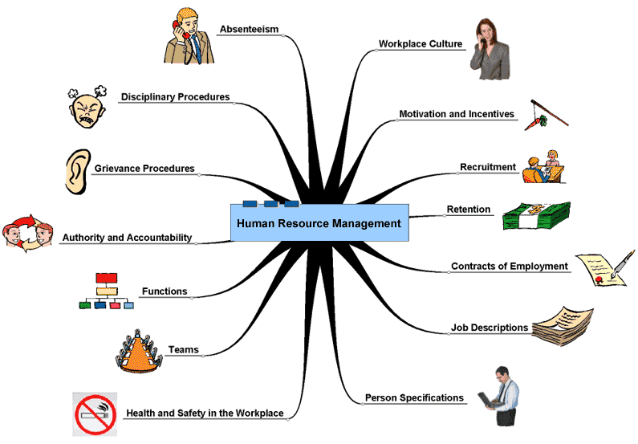
As a result of good Human Resource Management, a firm will have a committed, motivated, enthusiastic, productive workforce, who enjoy their work and work to the best of their ability. This improves productivity and profits for the firm.
***Functions of Human Resource Management***
- Manpower Planning
- Recruitment and Selection
- Induction, training and development
- Appraisal and Performance
- Rewards
- Monitoring Industrial Relations
Manpower Planning
This involves determining the human resources necessary for the future and preparing a plan so that the firm will have the right staff in the right quantity at the right time to meet the firm’s objectives. It should be flexible and adaptable.
To do this the Human Resource Manager must:
- Analyse Current Staff
- Make Future Manpower Forecasts
- Design and Incorporate a Training Plan
- Review the Training Plan
Analyse Current Staff
The Human Resource Manager must conduct an audit of the existing employees who work in the business (including numbers, age and skills) to see how many workers there are at present. They must also take into account those close to retirement age, ill, or thinking of leaving. An example would be that Ryanair has say 200 pilots at present, with 5 nearing retirement age.
Make Future Manpower Forecasts
The human resource manager must estimate how many employees and what skills the business will need in the future. Here, the organisation will compare what they have at present with what is needed for the future of the organisation An example would be if Ryanair as an airline plans to run 100 new flights a day from March.
Design and Incorporate a Training Plan
The plan is the action that will be put in place. If more recruits are needed, the business will source additional employees to meet the excess demand. They will need to recruit extra staff, however it is possible for a business to train existing staff, or in some cases make staff redundant if they have too many. An example would be Ryanair needing to recruit more staff to be ready for the new route either through training, promotion or external recruitment.
Review the Plan
The plan should be reviewed regularly, and if changes need to be made, it can be acted upon, such as the need to recruit more staff or increase turnover.
Benefits of Manpower Planning
Labour Turnover is Identified- If the figure is high; the manager can take steps to reduce it. Labour turnover can add significantly to the costs of a business due to the need to train new staff.
Correct Staff Inventory- Manpower Planning will ensure the business has the correct staff at the correct time to meet the needs of the business and its customers. If the business did not have the correct inventory of staff, customers may go elsewhere.
Training Needs Identified- Additional training needs for staff can be identified and acted on which can increase productivity and efficiency in the business.
Recruitment and Selection
This is the main role of the human resource manager. It is about making sure you get the right person to do the job. The job can be filled internally or externally.
Internal: Redeployment/Promotion.
Here the employee is familiar with the internal culture, policies, and work practices of the firm. Training and advertising costs are decreased as the job is advertised internally.
External: Recommendations, Training Centres, Employment Agencies, Unsolicited Applicants, Head Hunting, Advertising.
Here, the job is advertised externally. The new employee may have the skills and experience that the existing staff do not. This can bring a fresh perspective to the job, and avoid jealousy that may exist if the job was given internally.
Benefits of Internal Recruitment
Staff Morale: Morale improves as existing staff have greater variety and promotion opportunities- career progression can act as a motivator to strengthen employee commitment to the business.
Business Knowledge: Employees have existing knowledge of the business and how it operates; this will save a business time and expense in the cost of induction training.
Employees known to Management: The existing employees are known by management, there is evidence of work completed in the past and their skills and capabilities will have been on show before. This can only benefit in the selection of process.
Benefits of External Recruitment
Best Candidate: A wider range of candidates can be selected externally to the business. This will enable them to compare many more people which can assist in making sure the best candidate is selected.
New Ideas: External candidates can bring new ideas to a business. This can help increase productivity and efficiency that may only benefit the business in the future as these ideas can be shared and implemented.
No existing relationships: The external candidate will be from outside the business. This can reduce possible internal jealousy and conflict among existing members of staff who may feel they were overlooked and another work got the job.
The Recruitment and Selection Process
- Prepare a job description/personal specification
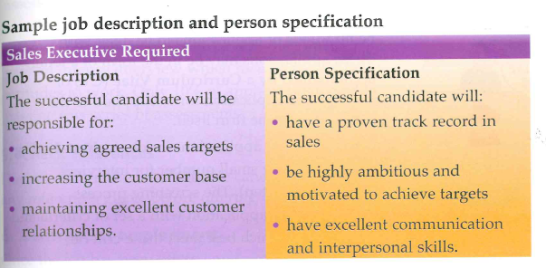
Job Description
A Job Description sets out the key responsibilities of the job and the tasks to be performed. It shows the jobs span of control and chain of command. It will also give out details such as the job title, salary, working hours, duties, and responsibilities for the successful candidate.
Person Specification
A Person Specification allows the business to define the kind of person they want working in a position and they use this as part of the job application. This lists the qualifications, skills, experience, and attributes the successful candidate must possess. The person specification will allow the HR Manager to compare candidates against each other and use it to try and get the best candidate to fill the role.

- Encourage suitable candidates to apply
This step is concerned with finding the appropriate applicants to apply for the position. Here, the HR Manager creates a job advertisement containing information such as qualifications required, main duties, and how to apply.
The business can do this in various ways such as internal advertising, personal recommendations, employment agencies, advertising online etc…
The business must obey the Employment Equality Act 1998 in order to give applicants equal opportunity in the application process
- Screen the applicants
This step is concerned with short-listing all applicants. The applicants may apply through CV and cover letter or application forms. The HR Manager will compare each applicant with a list of criteria and selects the applicants that best meet the criteria in preparation for an interview.
- Selection/Interview
The job interview is used to select the best candidate for a position. A job interview is a process in which a potential employee is evaluated by an employer for prospective employment in the company.
The process attempts to determine the candidate’s ability to do the job, get along with other employees, work in teams and contribute to the business. Interviews generally take the form of interview panels where a number of interviewers interview one candidate.
Panel Interviews
A Panel Interview is where the candidate is interviewed by a group of people rather than one individual. This is done to reduce the possibility of a single interviewer bias. It will also take into account more than one interviewer’s opinion in the interview process and also allow for the distribution of questions across the panel.
- References
These would be used to get another relevant opinion of the candidate and their potential suitability as a worker. The employer will check the references before offering the job. An example could be a former principal or boss of another job you have worked in.
- Job Offer and Contract of Employment
Once the employer is happy with the references and the job has been offered, a contract of employment is then drawn up. The employers has a legal entitlement to have a copy of this contract, specifying the terms and conditions of employment.

- Inform those who did not get the job
It is good practice to inform those who were unsuccessful in applying for the position either by phone or in writing and giving them the opportunity to receive feedback if required. This could be down to a number of reasons such as qualifications, experience, or suitability to the task at hand.
Training and Development
Training provides workers with the skills and expertise necessary for them to perform their jobs properly.
Some of the benefits of good training practices include:
- People learn more about an organisation i.e. how it works, why it works the way it does
- People learn additional skills, This enables them to progress in the organisation and attain promotion
- People are motivated to succeed and to fill vacant posts
- New people are attracted to the organisation knowing that they will receive training
- Morale amongst existing workforce is raised

The types of training:
Induction Training- Helps the new employees fit into the workplace by familiarising themselves with the organisation, policies and code of ethics, rules, and meeting their colleagues.
Examples of induction training could include a tour and induction pack.
On the Job Training- Practical training by doing the work under supervision and watching how experienced workers go about the task. Examples include work shadowing and demonstrations. It can be cheaper than formal training as done by existing employee and as a result can integrate a worker quickly which can also lead to increased productivity.
A business would need to ensure that the quality of training is adequate however, and that the best person is training the new recruit to the position.
Off the job training- This would be participation in courses external to the organisation such as up skilling or attending college. It can bring about high quality training and a chance for workers to meet and exchange best practice ideas with workers of other industries.
It may however be expensive for the business, and if the training takes place during work hours there may be a decrease in productivity.
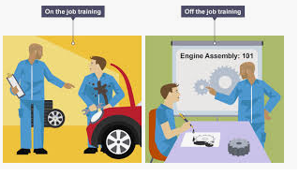
Development
Development involves not just the acquisition of skills, but also the growth and development of the person. As people develop and grow, they become confident enough to seek promotion, gain transfers into other areas of the business.
Development is a very important aspect of working life today. Development is needed so as individuals are equipped to cope with technological changes, cultural and social changes, new methodologies etc…
Development can be done internally through practices such as job rotation gaining experience in different aspects of the firm or externally through management courses or conferences.
The advantages and Disadvantages of Training and Development
Advantages | Disadvantages
Promotion opportunities | Financial cost for firm
Less Industrial Relations issues | Employees may receive training then leave (think of a lot of football club cases)
Boosts motivation by adding to employers self esteem | Other employees may feel resentful for not being chosen for the course
Develop new skills

Performance Appraisal
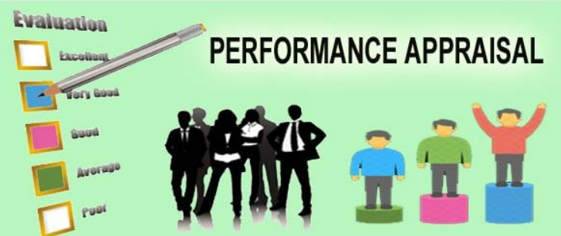
Performance Appraisal is the process of setting performance standards for each employee and then evaluating their performance over time usually done by their superior. It is a way of helping people in the organisation to maximise their performance. Workers who score well may be rewarded and those who score badly may need to be given more training.
Benefits of Performance Appraisal
Improves communication: As appraisals involve regular meetings between the employee and the manager, the relationship between the two should improve. These meetings give both a chance to talk to each other and sort out any problems that may exist, thus helping improve industrial relations practice in the workplace
Highlights staff reaching their potential: Employees who get an excellent performance appraisal are the ones who are suitable candidates for internal promotion. They have proved their potential at their current job and show potential for more responsibility
Gives information on staff and performance: Employees who score badly on their performance appraisal may need to be helped with more training. After the training, their performance should be evaluated again to see if they have improved. If not, the manager may have to consider sacking them
Helps decide on rewards: The results of the performance appraisal can be used to determine an employee’s pay rise or bonus. Employees who score well get a higher pay rise or bonus than those who score badly. Thus, performance appraisal motivates people
Other Points
Helps in the planning process: forecast bonuses/retraining costs
Overtime costs: May be reduced due to increased productivity during normal working hours
Delegation: A manager may be able to assign additional work to an employee who is performing well thus freeing up additional time

Rewards
Pay and rewards consist of incentives offered to employees for work done. They can be financial and non-financial.
Financial Rewards are when the employer gives the employee money as payment for work or some other gift that has a money value
Non- Financial Rewards are when the employer gives the employee inducements other than money or some gift that has a money value, as payment for work.
Financial rewards:
- Time Rate: With time rate, payments of a fixed amount per hour for a fixed number of hours per week are made to employees. If the employee works more than the fixed number of hours overtime is paid at different rates above the minimum e.g. time and a half or double time.
- Piece Rate: This relates the payment given to employees for each unit produced or job completed. The more units produced, the more the employee earns.
- Bonus: A bonus is a sum of money paid to employees for reaching a certain target, e.g. for producing units above an agreed limit.
- Commission: This is a type of financial reward where payment is made according to value of the amount sold, e.g. payments to a sales person (10%) in proportion to the level of sales achieved. It has the advantage of directly encouraging sales.
- Profit-sharing schemes: This is a scheme where some of the organisation’s profits are paid to employees on an agreed basis. The scheme is administered and profits are paid to employees to motivate them to become more productive.
- Employee Share Ownership Scheme: Shares in the organisation may be given to employees instead of cash bonuses, maintaining employee interest in the job. Share option schemes give employees an option to buy shares in a company at a specified price sometime in the future.

Non-financial Rewards
- Benefit-in- kind: This is also known as a perk or a fringe benefit. It takes the form of goods or a service given to employees rather than money. Benefits-in-kind are often used to raise the status of a position in a firm and to boost morale. Examples include meal vouchers, company cars and health insurance. (NOTE: Benefit-in-kind can be considered financial or non-financial depending on whether it is taxable or not).
- Promotion: Movement to a more responsible senior level in the organisation. While this will also carry a higher wage, it is often the job title, bigger office or the availability of a personal assistant that is the real reward as per Maslow’s self-esteem needs
- Job Satisfaction/Job enrichment/Job enlargement: Employees are rewarded because the job satisfies their social needs (teamwork) and self- actualisation needs (opportunity to do further study). The nature of the work (vocation) and the opportunities it presents (travel) reward the employee e.g. a volunteer with a third world relief agency or charity.
- Flexitime: This allows employees the freedom to choose their own work hours within an agreed time frame e.g. workers may have to be in the workplace between 10am and 1pm only. This allows employees to work from home and organise for example their childcare arrangements more efficiently.
- Job sharing: This involves employees sharing a position e.g. two employees have a job split between them. This is a flexible approach to employment and recognises that employees may wish to prioritise leisure time over work time.
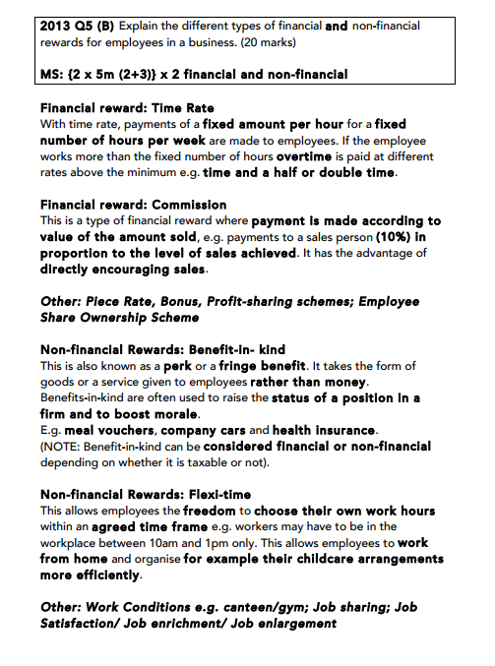

Monitoring Industrial Relations
This is a crucial part of the Human Resource Managers job. Industrial relations will affect the relationship between the employees and employers that can affect the overall performance of the business. Industrial relations can be good or bad.
Vs.
Positive Industrial Relations result in:
- Positive attitudes towards work
- High productivity
- Good atmosphere
- Job retention
- Less strikes and disruptions
Negative Industrial Relations result in:
- Poorly motivated workforce
- Inflexibility- unwillingness to change work practices to suit the firms changing needs
- Poor productivity
- Absenteeism and low job retention
- Strikes
Ways of promoting good employee/employer relations
Establish procedures for potential conflict: These procedures will exist to deal with conflict that may arise. They should be fair and worked out in advance
Management Training: Training managers on a continual basis is a great way of maintain positive employer/employee relations. On-going investment in training will help managers to keep the required skills up to date.
Value employees: Treat employees with dignity and respect. In addition the firm should respond to needs of workers by incorporating flexitime or job sharing schemes if possible.
Recognise Unions: Deal with unions fairly and honestly. Look at Ryanair.
Social Activities: Like staff activities to boost team morale.
Benefits of Good Industrial Relations Practices
- Motivated Employees
- High Productivity
- Low Staff Turnove/Absenteeism
- Satisfied customers due to quality of production and reliability of a firm and its workers.
- A good place to work

