Idea Generation Task 2
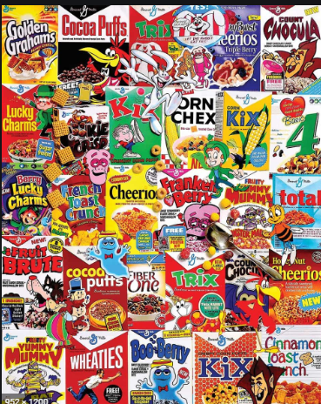
Students should bring in a cereal box and any necessary materials to class- teacher will provide paper, scissors, tape.
You have been selected along with other team members to design a new type of breakfast cereal for a brand that has seen struggling sales. Your manager has told you that the target market can be any group, but that it must be something that will appeal to people in 2023.
Your manager wants to see how well you and your group will work under pressure, and so has decided to only give you the success criteria for this new cereal just before the project begins.

Sample Success Criteria
Choose from:
- Must suit lifestyle choices in 2023
Or
- Must be suitable for children

Small prize for best cereal box, and also the best name.

