Identifying Business Opportunities

The Business Needs: Coming up with new ideas
When starting a new business, an entrepreneur will need an idea to start up their new business that stands out from what is already out there, or an existing business may also need to generate a new idea for business growth and development.
These ideas can come from either internally (inside the business), or externally (outside the business).

Internal vs External Ways of Generating Business Ideas
Internal
- Brainstorming:
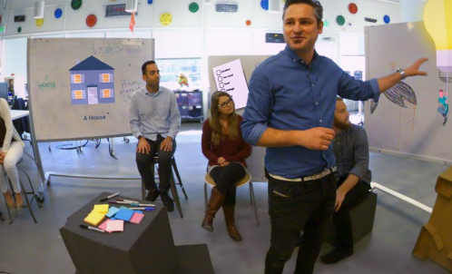
This involves people from different areas of the business who come together to generate a list of ideas on a given topic. Diverse ideas and approaches are encouraged, and will lead to creative suggestions. Once this list has been drawn up, it will then be shortlisted to move with the best ones.
Companies like Google could have regular meetings between different members of teams e.g. sales, IT development etc.. to brainstorm new ideas.
- Research and Development Department:
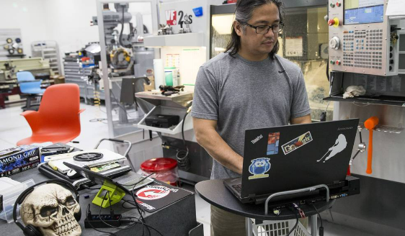
A business sets up a special department that is charged with carrying out investigative activities with the intention of making a discovery that can either lead to the development of new products or to the improvement of existing products.
Companies like Google spend billions each year on their R&D trying to come up with new products.
- Hobbies and Skills:
An entrepreneur may turn their own hobbies or skills into the best business opportunity. They themselves may come up with a more unique production technique or finish to an already existing product/service, or have a passion in a particular field and develop this passion into an idea.
Brian Lee set up Chopped in 2012 based on his interest in health and fitness.

Employee Suggestions (Intrapreneurship)
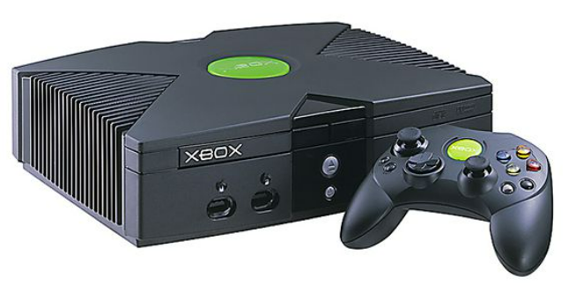
A business can get good ideas for new products and services from its employees. To encourage such intrapreneurship, the business can set up a formal employee suggestion scheme offering rewards for good ideas.
When some Microsoft workers saw the worldwide success of the Sony PlayStation, they thought of the idea of Microsoft developing its own games console. They worked on their idea, presented it to Bill Gates and this led to Microsoft launching the XBOX, which made a lot of money for the company.
Other internal: Staff suggestion box/ personal experiences
External
- Competitors:
A business could monitor close competitors and look at copying some of their product ideas, without copying them directly (patent)
Companies like Google constantly have to keep a close eye on the likes of Bing and Yahoo
- Trade Shows:
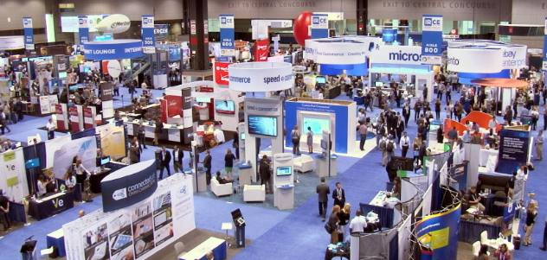
Business would regularly attend trade shows such as the Dublin Web Summit to inspire them to make a new product for the domestic market or search for gaps in the market
Companies like Google could travel to America to attend trade shows over there to see if there is an opportunities for an alliance on a new product etc…
- Customer Feedback
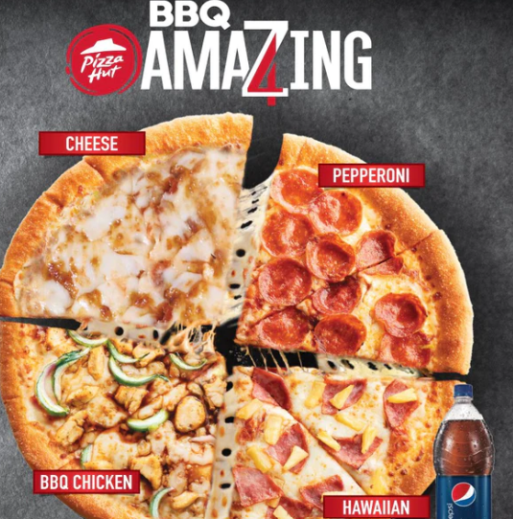
A business can survey its customers for their opinions about the business and its products. The customers can tell the business what new products or improvements to existing products they would like. This can give the business ideas for new products.
Pizza Hut observed customers in its restaurants. It noticed that although most families shared a pizza, each person usually wanted a different topping. This gave Pizza Hut the idea to launch its '4 for All' pizza (one pizza divided in four with four separate toppings) and sales went through the roof.
- Import Substitution
Entrepreneurs can establish a business by bringing out their own Irish version of a product that is currently brought into Ireland from abroad.
Joe Murphy saw that most crisps sold in Ireland were made in the UK, so he set up his own crisp business in 1954, called Tayto.

Other External Ways: Family/Friends, Media, Business Alliances
Market Research
Market Research is the process of gathering and analysing information on order to identify the needs of customers.
- Market research can save the business money in the long run
Market research can help the business to establish whether there is a demand for its product. By finding out in advance that consumers do not like the product idea, the business can avoid wasting money making a product that no-one will want to buy. Product ideas that get an unfavourable reaction in consumer surveys are not developed further.
GAP tried to change its logo in 2010. Within a week, they had changed it back to the original. Customer backlash prompted them to maintain their brand identity. The company lost a lot of money because they did not conduct market research.
- It reduces the risk of failure for the product and the business.
Market research reduces the risk of a product failing. It gives a business a deeper understanding of its customers – what motivates them, what price they are willing to pay for the product and what improvements they would like to see made. Because the product is made in response to feedback from consumers, it is more likely to satisfy their needs and wants and therefore more likely to sell well.
Before it was launched in Dublin, the radio station Spin 103.8 conducted research into what its target market of young people liked most and least about radio. Most young people disliked advertisements and DJs talking too much.
3. It helps a business to identify new markets.
Market research can help a business to discover the kind of products and services that customers would like but which are currently not on sale. It can use this information to make such products and thereby increase its sales and profits.
4. It helps a business to identify threats.
Market research can help a business to identify potential threats and sources of competition to its business. It can develop strategies to defeat these threats and ensure the business continues to succeed. Failure to identify and react to changes in consumer preferences and the presence of competitors can cause successful businesses to lose market share. For example, finding out that a competitor’s prices (from its website) are much cheaper, the business can then adjust its own prices, to prevent consumers flocking to the competition.

Types of Market Research: Field v Desk
- Field Research
This is going out and asking the public information (going into the field). It is the gathering of information yourself and having direct contact with the customer. Examples include questionnaires, taste tests, direct observations, focus groups, mystery shoppers.
Examples of Field Research
1. Observation
Trained researchers watch customers in action and learn from how they behave and react in certain situations. They may look at how customers move around the shop and how they react to certain product displays in the store. Observation enables the business to see what customers are doing without interacting with them directly. This reduces the impact of bias on the results obtained.
Supervalu use observation and it has helped them to improve the layout of their stores and to maximize sales.
2. Focus Group
A focus group is when a business brings a small group of consumers together to discuss the business and its products. The aim is to capture feedback from the group about the ideas shown to them.
Participants are free to talk with other group members. One person’s contribution sparks contributions from others. Focus groups are used to collect qualitative data: facts, feelings and opinions. This type of information helps to develop new products that customers want. It also ensures that customers are satisfied with the service they have received.
Vodafone Ireland holds regular focus groups at which it listens to groups of volunteer Vodafone customers who tell it how they think Vodafone could serve them better.
3. Survey
A survey involves market researchers interviewing consumers directly. Consumers are asked a series of questions and the researcher records all the answers.
The aim of a survey is to find out what people think and how many share the same opinion. Surveys produce qualitative data (people’s opinions) and quantitative data (statistical facts and figures). A survey usually involves questioning a representative sample of the population.
For example, Lily O’Brien Chocolates includes a survey in the boxes of chocolates it sells, asking customers to rate each of the chocolates.
Advantages
- Designing its own research allows the business to address issues specific to its situation. It obtains the answers it needs to the questions it wants answered and from the consumers it is interested in. Therefore, the information will be precisely relevant to the business.
- When the business conducts its own field research, it owns that information and does not have to share it with anyone else. Therefore, it may find out things that its competitors do not yet know.
- When a business conducts its own field research, it has full control over the whole research process and methodology. Therefore, it is assured that the research will be conducted correctly and that the information obtained will be accurate.
- When a business conducts its own field research, it obtains immediate information about what is happening right now. Secondary data may have been collected some time ago. Therefore, field research provides more recent data and a more up-to-date picture of the market.
Disadvantages
- It costs a lot of money to conduct field research. Surveys may have to be compiled, printed and distributed. Interviewers have to be paid. Therefore, field research can involve a high cost for the business.
- To be done correctly, primary research requires the development and execution of a research plan. Going from the start-point of deciding to undertake a research project to the end-point to having results is often much longer than the time it takes to acquire secondary data. Therefore, field research can take a lot of time to complete.

- Desk research
This involves gathering data that someone else has already compiled and organised. The information already exists, so the business does not have to go out and collect it first-hand.
Examples of Desk Research
Internal Reports
A business can obtain information from its own sales reports and financial reports into matters such as what its most popular products are, which of its shops is the most successful and so on.
Brian Lee, founder of “Freshly Chopped” looks at the sales figures of every store every day. This helps him to establish how each outlet is performing and the popularity of each product.
Publications
Many organizations publish a whole range of information that businesspeople can buy or obtain free of charge. The Irish government publishes a whole range of information that businesspeople can buy or obtain free of charge: Census, the Household Budget Survey and various other statistical reports from the Central Statistics Office. The CSO conducts monthly, quarterly and annual surveys covering all sectors of the economy.
Centra decides where to locate its new supermarkets by using the Census findings to spot the towns with growing populations.
Internet
If a business needs market research information on any topic, it can type that topic into its online search engine and it will produce the information for the business.
Websites that businesses, organisations and individuals have created to promote their products and views. A business can discover a lot about its competitors from their websites – the products/services they offer, the prices they charge and so on.
Advantages of Desk Research
- Obtaining information from secondary sources usually costs a lot less money than conducting original field research. Many sources are free of charge, such as internal reports, Enterprise Ireland etc. Therefore, desk research can help the business to keep its costs down.
- Secondary data can be obtained more quickly than field research, particularly from online sources. This helps the business to get the information it needs more quickly and thus address marketing issues faster.
- There is lots of secondary data available that businesses can use to help them make effective decisions. Governments produce extensive amounts of data covering a wide spectrum of issues. The internet contains a huge amount of information that the business can easily search through.
- Desk research can often be the starting point for primary research. For instance, a new manager doing an analysis of the business’s competition, but who is not familiar with the competitors in the market, could access secondary sources to locate a list of potential competitors. It can also help the business to identify important issues that are not covered by secondary sources and that therefore need to be addressed by field research.
Disadvantages of Desk Research

- The business has no control over the accuracy or otherwise of the research. The person who conducted it out may have made mistakes or carried it out in a biased way. Therefore, it tends to be less accurate and less reliable than primary research.
- The secondary research may have been done some time ago and is therefore out of date. The market situation may have changed drastically since the research was conducted and therefore it is of little use to the business when making decisions about the current situation.
- Secondary research is often freely available. The business’s competitors can also access the same information. Therefore, it does not provide the business with any particular competitive advantage.

**The Product Development Process**
Note: You will generally be asked to complete this using a product or service of your choice, or differentiate between different stages as a short question
Step 1: Idea Generation
This involves the search for possible product ideas which the Company feels it will want. Many ideas must be generated to find a few that will be successful. The sources may be internal or external to the business and brainstorming is one technique which is often used. You can also use any of the other ideas that we discussed at the start of this chapter
Step 2: Product Screening
This involves selecting the product ideas which have the best potential for sales. The products that are selected at this stage have the greatest potential for development. However, care must be exercised not to reject products which if developed could be marketed successfully. Market research will be conducted to determine the response of customers, such as further SWOT Analysis
Step 3. Concept Development
This involves developing basic ideas into a detailed version of the new product. The emerging product should be capable of satisfying basic consumer needs. Questions such as its purpose, what it will look like etc… will be noted. The features of the product which make it different from other products on the market is called its unique selling point (USP). The Unique Selling Point is the feature of the product/service that sets it apart from the competition. It can be taste, price, image etc...
Step 4: Feasibility Study
This looks in detail at the product’s commercial feasibility. Can the product be produced at a cost and sold at a price, which will enable a profit to be made?
Consumer demand must be analysed through market research and the type of marketing mix for the product will be considered.
If the answer to your questions is no, the product idea is not developed further. There is no point wasting time, money and effort continuing with an idea that is neither practical nor profitable.
Step 5: Prototype Development.
A prototype is the first working model that the business makes of the new product. It is a sample or mock-up product made as an experiment to see whether the product idea actually works in practice and whether it would appeal to consumers. The prototype is tested to see how it works and is then refined to eliminate any bugs.
This process is repeated until the business is satisfied that it has the 'perfect' product. By ensuring the product is perfect before launching it, the business avoids wasting money on refunds and repairs from a major product recall on a faulty product.
Step 6: Test Marketing
The new product is released on the market on a small scale to the target market. Consumer reaction is compiled and any necessary changes to the marketing mix must be made. If the test marketing proves unsuccessful a decision to postpone the launch or abandon the project could be taken.
Step 7 Product Launch
Assuming the test marketing goes well the business will commence production and the advertising and promotional campaign will be implemented.

Evaluation
Although it is a lengthy and expensive process, The Product Development Process is definitely an essential one. The costs of launching a product that does not successfully go through these stages will far outweigh the costs involved in the process. It is not just a financial cost, as customers may also move to competitors if they are not satisfied with what you are offering.
Many products and services break down across the stages, either the idea itself does not become possible or it becomes too costly along the way. Still though, it is very necessary for successful businesses such as X.

Break Even Analysis
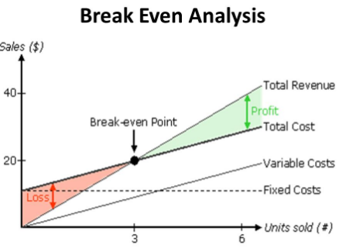
In order to survive businesses must at least break even, which means they need to generate enough income to cover all of their costs.
Break-even analysis is a financial tool that can be used by managers to determine the impact of costs and revenues on profitability. It will illustrate the number of products that must be sold in order to cover all the costs associated with production.
The Margin of Safety on a break even chart is also very important as this shows how much output or sales level can fall before a business reaches its break-even point. It is the quantity by which the product’s sales can fall before the firm starts to lose money on the product.
Calculating the Break-Even Point
In order to work out the break-even point a business will need to know its Fixed Costs, Variable Costs per unit, and its Selling Price.
Fixed Costs (FC): These are expenses that do not change as output changes. Examples include rent and insurance
Variable Costs (VC): These expenses will change as the level of output changes. Examples include wages, light and heat
Total Costs (FC): This is when you add all fixed and variable costs together
We use the following formula to calculate Break Even Point:
Fixed Costs
Divided by
(Selling Price- Variable Costs per Unit)

Be careful- there are limitations to Break Even Analysis: (Know 3/4)
- Break-even analysis assumes Fixed Costs are constant – FCs can vary as output changes
- It assumes that the business knows all its costs and can break them down into fixed and variable
- Variable costs may increase/decrease as output increases – business may be able to purchase larger amounts of raw materials at lower prices (economies of scale from bulk buying)
- Assumes that firm sells all its output – in times of low demand a firm may have difficulty in selling all its products
- Assumes a firm sells all its output at a single price -firms may offer discounts for bulk purchases/ may produce more than it can sell and may have to sell the surplus at a discounted price
- Ignores the effect that a change of price may have on sales-price increase fall in demand for the product and vice versa.
- Most businesses sell more than one product, so break-even becomes harder to calculate

