Income
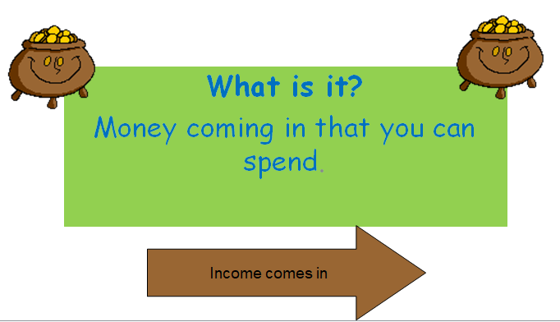

Do you have a student have any income?
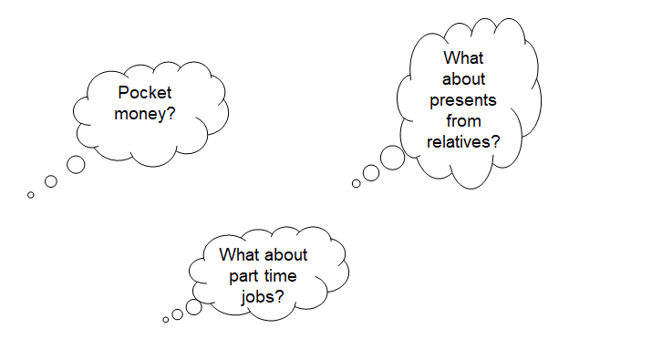
What income do employed people have?
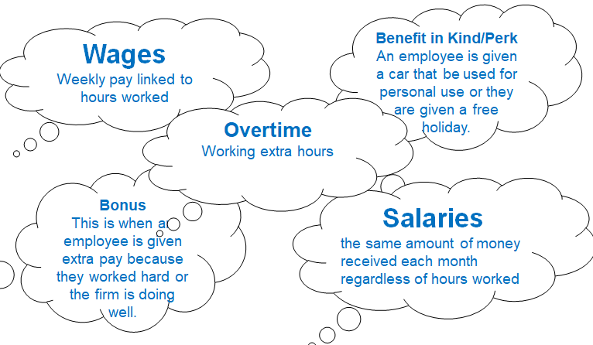
What income do unemployed people have?
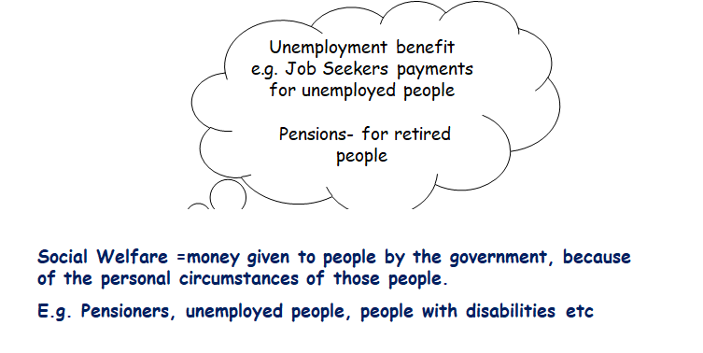The 3 types of Income
1. Regular Income
2. Irregular
3. Benefit in Kind/Perks
1. Regular Income
This is predictable amount of money received every week or month. In other words, you can rely on receiving this income.
- Wages/Salaries- Is payment received for work
- Pocket money
- Jobseekers Benefit- Payment made to the unemployed who are looking for work
- Pension- Money the government pay to retired people over 66 years of age
- Grant- Money received by a household or business that does not have to be paid back. An example would be a student grant for going to college
2. Irregular Income
This is unpredictable income in size and when you will receive it. In other words you cannot rely on it.
Overtime- Payment to employees for extra hours worked
Interest- for example, your money sitting in the bank earns interest
Bonus- For hitting a target- example goal scoring bonus on FIFA
Lottery Win
Loans- Given to you by financial institutions like the bank when needed
Dividend- A share of the profits from investing in a business
3. Benefit in Kind/Perks
These are non-cash sources of income given by an employer to an employee. Given to keep employees happy/motivated etc…
Examples: Company Cars, phones, gym memberships, free food at lunch, parking space
Activity: Based on what we have covered in class so far, can you match these types of income to their sources of income?
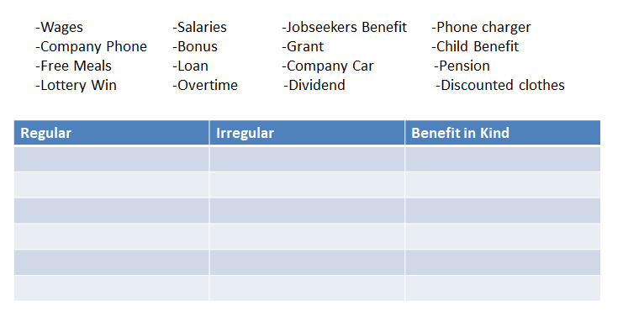
The Importance of Recording our Income
