- Insurance
Insurance is the protection against something that might happen, e.g. car insurance for car crash or house insurance for your house going on fire
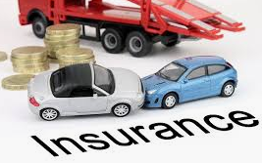
Assurance is protection against something that will happen, e.g. life assurance because you will die
The amount of money each person pays into this fund is known as the PREMIUM. (THIS IS THE PRICE PAID FOR INSURANCE).
The INSURANCE PREMIUM will depend on:
Risk
The greater the risk you are of claiming from the insurance company, the higher the premium you will be charged. The insurance company sometimes adds a loading for higher risk people and businesses. A loading is an extra charge added to the basic premium to cover such higher risks.
- Inexperienced drivers pay higher car insurance premiums than those who have been driving a long time, because inexperienced drivers are more likely to have an accident and claim from the insurance company.
- Smokers pay higher life assurance premiums than non-smokers because they have a higher risk of dying and claiming sooner.
- People who live in Dublin pay higher house insurance premiums than people who live outside Dublin because they are at a higher risk of claiming for the damage.
Value of the Item
- The more valuable the asset, the higher the insurance premium.
Claims
- The more the insurance company pays out in compensation claims, the higher the premiums they will charge to cover their costs.
- For example, insurance companies increased their house insurance premiums immediately following the very severe winter of 2010/11 when they had to pay out a lot of compensation for the damage the weather caused to people's homes.
- The rising cost of healthcare means that health insurance companies pay out more and more to hospitals and doctors for clients' medical bills. To cover these increased payouts, health insurance companies increase their premiums almost every year.
Profit
- The insurance company charges a premium that gives it a decent profit. The premiums collected must exceed the amount paid out in claims.
Government Tax
- The government adds tax to the premium charged by the insurance company, thus increasing the cost for the consumer.
Key Insurance Terms
It is important for a household or business to make sure that they get the best possible quote before paying their premium. As a result of this, many use an Insurance Broker, who sells insurance on behalf of many different insurance companies, and earn commission on the number of policies sold.
Some brokers are only tied to one insurance company, and so these would be called Insurance Agents.
The Actuary is the name given to the person who calculates the Premiums and issues Quotes. They use analysis and statistics such as location, age, etc... before issuing a quote to the insured person.
The Assessor is the name given to the person who calculates the compensation to be paid. A Loss Adjuster may be used if the insured person is unhappy with the amount of compensation and they can look to adjust it.
Insurance Forms
Insurance Proposal Form, which is the application form for insurance. You must be completely truthful when filling this out or your insurance will be void.
Once this has been received by the insurance company, you will receive your Policy document, which will state what is insured and the circumstances for making a claim. A person needs to fill in a Claim Form when making a claim.
The insured person must however be aware of Policy Excess, which states that the insured person would have to pay an excess amount before making a claim. The higher the excess, the lower the premium.
FIVE PRINCIPLES OF INSURANCE
Sometimes, people can make fraudulent claims for insurance. To prevent this from happening, the insurance industry has rules, known as the 5 Principles of Insurance
These principles are:
1. Utmost Good Faith (truth)
2. Insurable Interest (benefit)
3. Indemnity (no profit)
4. Contribution (split)
5. Subrogation (salvage rights)

1. Utmost Good Faith
This principle states that when the business/household is applying to the insurance company for insurance cover and is filling in the insurance proposal form, they must answer every question truthfully.
Furthermore, they must volunteer any material information, even if it is not asked for it. Material information is defined as any information that would affect the insurance company's decision whether to insure the business/household and, if so, what premium to charge it.
If the insurance company later finds out a person withheld material information, they will receive no compensation because they broke the rule.
Example: if you apply for health insurance and are a smoker, you must disclose this to the insurance company. Failure to do this may mean no copensation if you develop a related illness
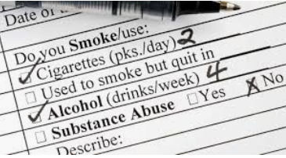

2. Insurable Interest: You are responsible for it. You benefit from its existence and suffer from its loss. I have an insurable interest on my own phone. I benefit from its existence and suffer from its loss. You have a legal relationship with the item that you are insuring.
Example: I would have insurable interest on my I-Phone and so can insure it and if it breaks I can claim.
3. Indemnity: The insured person cannot make a profit from insurance. You only get compensation for the value of the loss or damage suffered by the insured person. You must be put back into the original position before the loss occurred. (Relates to Average Clause also)
Example: If you insure this and it crashes, you are not entitled to a more expensive Ferrari as a replacement
This principle also covers over-insurance of a product or service. For example, if a business insures a factory for €100,000 even if the true market value is €80,000. The insurance company will only pay out the true market value because this is the value of what is lost.

4. Contribution
The insurance company will split the compensation if you insure with more than one company. This principle states that if you insure an asset with a number of insurance companies (say five), you will not receive five times the compensation. Instead, each will pay you a fraction of the compensation in the ratio of the amount you were insured with each as follows:
Example: If I fully insure my car with two insurance companies, they will both give me half in compensation. Otherwise I would have made a profit from insurance, which I cannot do as part of Indemnity.
5. Subrogation
Once the insurance company fully pays out to the insured person, then all savage rights pass to the insurance company
Example: If your car is written off as a result of a crash, your insurance company fully indemnifies you (put you back in original position before loss occurred). The insurance company now has the right to sell off scraps from the car as otherwise you would have made a profit
The insurance company can also look to sue a third party who caused the loss to occur. For e.g. if part of an aircraft falls off and damages a house, the company that insured the house can sue the airline to recover the money that the insurance company will pay to the householder.
AVERAGE CLAUSE
The average clause is a condition included in insurance policies that limits the value of a claim if you are under-insured.
If you insure your house for only two thirds of its value you will only receive two thirds of the value of any damage to the house.
To calculate the average clause it is a Sum Insured/True Value x Loss.
Example: Your house is worth €300,000 but you only insure it for €200,000 (i.e. 2/3 of its value)
A fire causes €60,000 worth of damage to it.
Sum Insured/True Value x Loss.
200,000/300,000 x 60,000
2/3 of 60,000 = 60,000 x 2 /3
Answer: 40,000
Average Clause Questions
- You have a house worth €200,000. You insure it for €100,000, believing that if there was an incident it would not cost that much. A fire causes €50,000 worth of damage. How much compensation will the insurance company pay out?

- You own a Ferrari car that is valued at €90,000. You only insure it for €72,000 believing that the car will never be written off and at best the damage will be slight. The car is involved in a crash causing €40,000 worth of damage. How much compensation will the insurance company pay out?

Sample Question
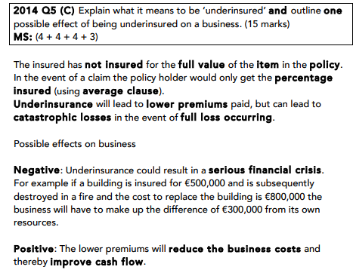
Risk Management for a Household or Business
Risk Management is the planned approach that a business must take to deal with potential risks that they are exposed to in everyday activities. The process involves identifying all possible risks, taking preventative action to reduce the risk of their occurrence, and putting in place measures to protect a business in the event of their occurrence.
The following are examples of Risk Management Strategies:
- Install security systems: Security risks can be reduced by installing alarms, CCTV cameras etc… These security systems will have a record of any instances and reduce the chances of theft etc..

- Training: Training individuals with the likes of CPR, fire training, fire alarms and procedures etc… can reduce the risk of illness or injury

- Insurance: Taking out insurance will transfer the financial risk to a company who will make a pay out in the case of a loss suffered. This is the protection against possible loss or injury that might happen

- Regular Inspections: Carrying out inspections and audits regularly can reduce the risk of incidents occurring. For a household it could be regular visits to the doctor, for a household it could be regular fire drills
5. Health and Safety: A Health and Safety Officer at a business should be appointed, and rules and procedures such as proper equipment, correct signs etc… should be visible. Think of the school with Covid 19
Life Insurance and Assurance
-There are different types including:
- Term Assurance- pays out a lump sum if the agreed person dies before the end of the term
- Whole Life Assurance- Pays a lump sum when the insured person dies
- Endowment Insurance- pays out a lump sum when the agreed person dies or reaches a certain age, but can be cashed in earlier. The longer this policy continues, the more money they will receive
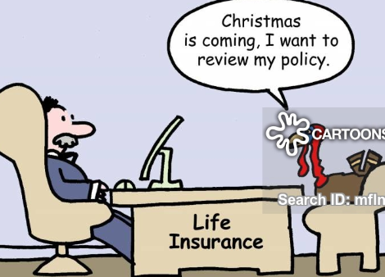
1. Term life assurance
Term life policies cover a named individual for a specific period of time and no compensation can be paid if the insured person lives beyond this date. A policy of this type might be taken out when undertaking a risky project or expedition. Term policies can also be used to cover the insured person’s life until such time as they have paid off a large debt like a mortgage. The policy can be timed to cease whenever the mortgage debt is paid off.
2. Whole life assurance
Whole life policies cover an individual until their death, provided premium payments are kept up to date. In effect this type of policy provides money to cover funeral expenses and to meet some of the financial needs of their next of kin.
3. Endowment life assurance
Endowment policies are designed to pay a lump sum after a specified term (on its ‘maturity’) or on earlier death. In a similar way to term policies, endowment life assurance policies are frequently tied in with the payment of mortgage debt. At the end of a specified time period, the endowment policy matures and the lump sum is used to pay off the mortgage. If the insured person dies before this maturity date, the life policy will also cover the outstanding mortgage debt.

Business and Household insurance
Importance of Business Insurance
Business Survival
Having insurance means that the business will not be ended by some catastrophe (if the factory burns down, for example). The insurance company will give the business owner the money to rebuild her business, so that she can start again.
Risk Management
Insurance helps a business to lower its risks. When taking out insurance the business must examine all the risks facing it (such as theft, fire, vandalism and so on). To lower the premium it has to pay, the business might take steps to reduce the chance of these risks occurring. For example, to reduce the risk of customers claiming injuries from falls in the shop on a rainy day, the business puts down mats and signs warning customers of the danger.
Improved Cash Flow
Paying a relatively small premium every year is a lot easier for a business to manage than having to pay out a large amount of money all in one go to pay for some unexpected crisis (such as replacing a stolen truck).
Insurance a business should have
1. Employee PRSI
This is a compulsory insurance that employers must pay to the government (paid through PAYE system). This contribution for each employee is to help the state provide a range of social welfare benefits to employees such as dental, optical, unemployment benefit,etc.
2. Fidelity Guarantee Insurance
This is insurance cover for the business that protects it against financial losses it might suffer as a result of dishonest and fraudulent activities committed by an employee who abuses his position of trust to steal from the business.
It covers the business for an employee stealing from it (taking company property) or embezzling money from it (for example, an accountant writing company cheques to a false 'supplier' account that he himself controls) or providing 'inside information' to others to help them steal from the business.
3. Public Liability Insurance
This insurance protects the business if any member of the public is injured or his property is damaged due to the business's negligence while he is on the business's premises. It also protects the business from such claims if the business visits a member of the public's house; for example, when a salesperson calls out to do a demonstration in the person's home. The insurance company will pay the compensation awarded to the member of the public.
4. Product Liability Insurance
This insurance protects a business that manufactures or sells a product to a customer that causes injury to him. The insurance company will pay the compensation to the customer. It covers damages caused by a manufacturing defect in the product (such as lead paint in toys), a design flaw and defective warnings or instructions about the product (claims that the product was not properly labelled or had insufficient warnings for the consumer to understand the risk).
For example, in 1992, Stella Liebeck sued McDonald's when she spilled the coffee she had bought in McDonald's and it burned her legs. She was awarded millions of dollars.
5. Employer's Liability Insurance
This insurance protects the business if an employee makes a claim because he was injured or made ill at work through the fault of his employer. The insurance company will pay the compensation to the employees.
6. Motor Insurance
- Third Party - The insurance company pays only for any damage caused to another person and his property by the business's vehicles and does not pay any compensation for damage to the business's vehicle.
- Third Party, Fire and Theft – The insurance company pays compensation for any damage or injury caused to a third party and his property and also if the business's vehicle is stolen or burned out. It will not pay any compensation for any other damage to the business's vehicle.
- Comprehensive - The insurance company pays compensation for any damage or injury caused to the business's vehicle and to the person driving and to any third party and his property. In other words, comprehensive insurance covers all risks.
7. Theft Insurance
The insurance company pays the business compensation for the value of am stock or other items that are stolen from the business.
8. Plate Glass Insurance
If the business's windows are damaged, the insurance company pays compensation to the business to get them fixed or replaced.
9. Buildings & Contents
The business insures the premises against damage to do with the premises by storms, flooding, subsidence or explosions.
10. Consequential Loss
This protects the firm employees against any loss of earnings due to the sudden/temporary ceasing of trading due to physical damage due to some event like flooding.
11. Cash Insurance/ Cash/Goods in transit
This is insurance against damage to goods in transport or for cash held on the premises or transferred to the bank.
Insurance a household should have
Insurance a household should have
1. Health Insurance
This insurance pays the private medical bills (such as bills for doctors, cost of staying in a private hospital, medicines and so on) of the family members if they become ill and require medical treatment.
In Ireland, under the law, a health insurance company must charge customers the same amount for a policy. They cannot charge older people more, for example. This is called 'community rating'.
2. Life Assurance
Life assurance protects the people who are financially dependent on the insured person, such as a spouse or civil partner and children. The insurance company pays a certain amount of compensation to the other members of the family when the insured person dies.
There are two main types of life assurance:
- Whole Life Policies: The insurance company pays out only when the insured person dies.
- Endowment Policies: The insurance company pays out at the earlier of two events - the death of the person or when he reaches a certain age that he nominated when he took out the policy.
3. House and Contents Insurance
The family takes out this kind of insurance to protect their home and all its contents. If their home is destroyed, the insurance company will pay to have it rebuilt. If their home is damaged, the insurance company will pay to have it repaired. If the contents of the house (furniture, TV and so on) are damaged or stolen, the insurance company pays the family compensation for the loss suffered
4. Motor Insurance
Motor insurance is compulsory by law. This means that if the family has a car it must get it insured. The insurance company will pay for the damage or injury caused by the family's car.
- Third Party
- Third Party, Fire and Theft
- Comprehensive
5. Mortgage Protection Insurance
If the family has a mortgage loan on their house, they should take out this insurance. If they cannot pay their monthly mortgage repayment due to ill health, redundancy or death, the insurance company will pay it for them until they can afford to pay it themselves again.
Similarities and Differences between household and business insurance
Similarities | Differences
Under Irish law, both businesses and households must take out motor insurance if they have a vehicle. It is an offence not to do so. They both must also display a valid insurance disc on the windscreen of the vehicle. | Different Risks  While households face risks, businesses face many more different types of risks. These include employees or members of the public getting injured on their premises and the products they sell injuring customers.  Businesses have to take out many more insurance policies that households don’t need, such as product liability insurance and employer's liability insurance.
Both a business and a household must fill in a proposal form when applying for insurance. They both must obey the principle of utmost good faith when doing so. | Different Premiums  Businesses tend to be bigger than households and own more valuable assets than households such as equipment and machinery.  They tend to pay much higher premiums than households because the greater the value of the item, the higher the premium chargeable.
Both make claims from the insurance company and both must fill in claim forms to do so.

- Taxation
We will look at
- Taxation in Ireland
- Household taxes
- How the system works.
- Calculating PAYE Tax Calculations.
- How taxes affect businesses and Households

Taxation in Ireland
Taxation is the process of the government collecting money from individuals and businesses to pay for public services.
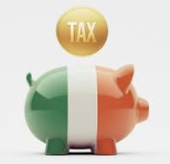
In Ireland, taxes are collected by the Revenue Commission on behalf of the government.
Revenue’s main aims are:
- Collect taxes
- Collect duties on Imports
- Provide information on tax issues
Taxes collected by the government can either be direct, (taxes on income),or indirect, (taxes on expenditure).
In Ireland, some taxes are progressive, meaning that there are higher rates for people on more income (e.g. PAYE), and some taxes are regressive, meaning everybody pays the same regardless of income levels (e.g. VAT).

Household taxes
PAYE: Employees pay income tax on their wages under the Pay as You Earn System. Under this system, the employer calculates the PAYE tax payable by the employee and deducts the PAYE tax from the employee’s gross wage and pays it over to the revenue for them. Progressive tax as more you earn/more you pay. Standard rate in Ireland is 20%, Higher rate is 40% (2022)
PRSI: Pay Related Social Insurance, direct tax on income, used to pay for social welfare etc… in economy, rate in 2022 is 4%
USC: Universal Social Tax, direct and progressive tax on income, brought in as emergency tax during recession to help pay government debt
Self- Assessment Income Tax: Tax paid by the self -employed.
VAT: This is Value Added Tax and is the tax on goods and services when a consumer buys goods. The tax is collected by the business and paid to the government. At present the standard tax rate is 23 % (2022).
Motor Tax: Compulsory tax on car ownership paid to local Authority. In Meath it is the motor tax office in Navan.
Excise Duties: Tax on certain products such as alcohol and tobacco.
DIRT: This is Deposit Interest Retention Tax. When someone earns interest on money in the bank, the account holder pays this tax on that interest. The rate of DIRT in Ireland in 2022 is 33%.
Capital Gains Tax: Tax if a person earns income from the sale of an asset such as shares or property (other than the home). Tax must be paid on the return of this investment (the difference between the original price you paid and the selling price). The rate of CGT in Ireland in 2022 is 33%.
Capital Acquisition Tax: Tax paid of gifts and inheritance. The amount of tax you pay depends on who gave you the gift or inheritance and how much it is worth. However not all gifts and inheritance are subject to this tax. Married couples do not pay tax on gifts and inheritances received by each other. The rate of CAT in Ireland in 2022 is 33%.
Customs/Import Duty- Tax on goods and services coming into the country

**PAYE System- 2019 onwards**
Every person in Ireland pays tax on their income when working. In Ireland the PAYS rates are 20% and 40% and it is a progressive tax.
The amount people pay depends on individual circumstances such as whether they are married, single, disability etc… and this can reduce their tax in the form of tax credits.
The PAYE Modernisation System
In the past, employers in Ireland had to deal with many forms such as the Form P60/P45 relating to employment. This created millions of paperwork and forms across Ireland, as well as an increase in the number of people working in more than one job.
To reflect this, the Revenue Commission have introduced PAYE Modernisation.
From January 1st 2019, the system operates as follows:
1. Starting Employment
A worker will register with the Revenue Commissioners using their PPS number, create an online account, and enter their employer’s details. The Revenue Commission then assigns the individual the correct tax bands and tax credits, which is known as Revenue Payroll Notification.
This information contained in the RPN is then used by the employer to ensure the employee pays the correct rates of tax and is receiving the correct tax credits. If the employer does not have the correct PPS or RPN, they will be subject to emergency tax.
2, During Employment
At the end of the year, an employee’s statement will be available to them by logging in online. It will contain all details such as taxes paid and deductions for the year.
They can also view their information such as taxes paid at any time by regularly logging into their account throughout the year.
3. Ending Employment
When an employee leaves their job, the employer communicates this to the Revenue Commissioner. This information will then become available to:
- New employer
- Social Welfare Office
Benefits of PAYE Modernisation- Credit Edco
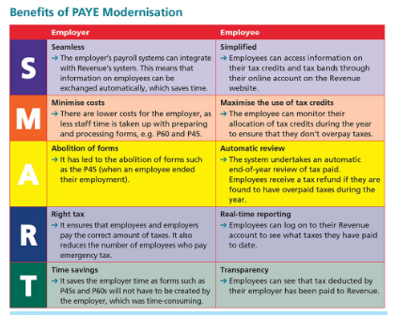

Calculating PAYE- We will be practicing questions in class.
Sample
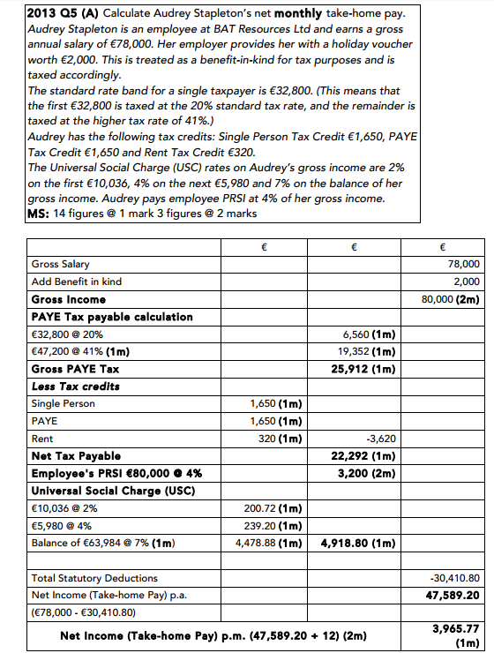
We will practice a number of tax working questions in class.

Types of Business Taxes
Corporation Tax: This is tax paid on profits of a business. Corporation tax in Ireland is presently charged at 12.5 % and it is one of the main reasons why we attract multinational companies to Ireland. Low tax rates attract these companies to set up in Ireland. This boosts our own economy as jobs are created.
The companies themselves are responsible for working out the amount of tax that they owe. They send their own tax bill to the revenue as well as their annual tax return, detailing their income and tax deductions. To stop companies cheating, they are subject to revenue audits by tax inspectors.
Value Added Tax: This is a tax businesses must add on to the price of goods and services they sell to the consumers. They collect the tax from the customer when they buy the products. Furthermore, when a business buys goods, they have to pay VAT to the supplier.
Firms act as VAT collectors for the government and at the end of every two month period they must pay over to the revenue commission the amount of VAT that they have collected on their sales, less the amount of VAT they have paid on their purchases. Detailed records must be kept to support VAT returns.
PAYE: Must operate this system in respect of the tax paid by the employees. They calculate it out of the income earned by the employees and pay it to the revenue commission. Detailed records must be kept.
Commercial Rates: Tax paid on the land/property owned by the business. They pay it to their local council every year. The amount paid is based on the value of the business premises. The money raised helps finance the local council’s activities (Such as roads, lighting and so on). The Government has used reductions in rates as a tax incentive to encourage the development of businesses in certain areas, in particular to encourage urban renewal.
Custom Duties: Taxes on goods imported by firms. These do not apply to imports from the European Union.
Capital Gains Tax: Similar to household, tax on money earned from sale of asset.
Motor Tax: Tax on vehicles, applies to business as well as household.
Self-Assessment Income Tax: Tax paid by the self-employed. They are responsible for calculating their own tax bill. They pay their income tax by the 31st of October each year. They must keep detailed records and can be subject to audits.
PRSI: Employers must pay a percentage of the employee’s wages as their contribution to the cost of this insurance. Employers see this as an additional tax on them which increases the cost of employing staff.
How Taxes Affect Households and Businesses
Household
Positive
-Taxation redistributes wealth into an economy that can be given to people out of work
-Money generated can be used to improve public infrastructure
Negative
-Reduces peoples disposable income
-Taxes such as VAT and Excise Duties increase the price of everyday goods and services
- Some taxes like VAT are regressive, which can reduce poorer peoples disposable income further

Business
Positive
- Corporation Tax in Ireland is relatively low compared to other countries around the world
- Tax breaks and tax incentives given to businesses can increase expansion opportunities
- Far less forms to fill out under new tax system which saves time and resources for a business
Negative
- Reduces profits of a business
- Higher rates of overtime discourage people from seeking overtime, e.g. teacher shortage correcting exams
- Employers have to pay PRSI for each employee which reduces their profits and increases their costs

