Enterprise and the Entrepreneur
An Entrepreneur is someone who spots a gap in the market, takes a risk, and sets up a business. They can either make a profit or a loss, depending on how successful their enterprise is. Eg. Mark Zuckerberg
Enterprise is a person or group being innovative/creative/using their initiative, while taking on a risk (personal/financial risk) in order to achieve a goal or make a profit.
E.g. Business Enterprise: Mark Zuckerburg taking the risk of setting up Facebook
So essentially, enterprise is the opportunity, and an entrepreneur is the person who takes the risk in setting this opportunity up.
Famous Entrepreneurs
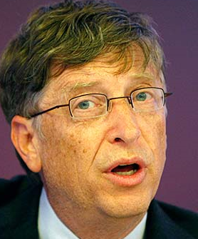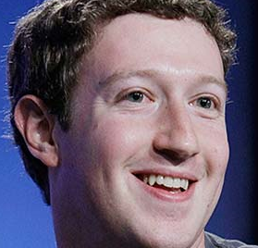
Steve Jobs-
Founder of Apple in 1976
Bill Gates-
Founder of Microsoft in 1975
Mark Zuckerberg
Founder of Facebook in 2004

Beyoncé Knowles Carter- Founder of shop.beyonce.com in 2012
Bobby Murphy/ Evan Spiegel- Founders of Snapchat in 2011

Oprah Winfrey- Founder of Harpo Productions in 1986

These above people are examples of an entrepreneurial talent for spotting a gap in the market and setting up an enterprise.
Types of Enterprises
Not all enterprises that are set up are set up to make money. Think about your local sport/culture club or charities. They were set up and sometimes have paid members but their goals are not to make profit, rather to help other people. These are known as Not for Profit Enterprises.
Public Sector Enterprises
These are enterprises set up by the government rather than an entrepreneur. They may be set up to provide essential services that would not be profitable to a private business. Example would be An Post or Fáilte Ireland Tourism Board.
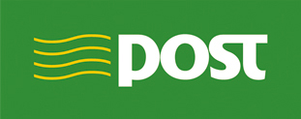

Commercial Enterprises
The most popular types of enterprises, these are goods and services set up to make a profit. Most are owned by entrepreneurs.
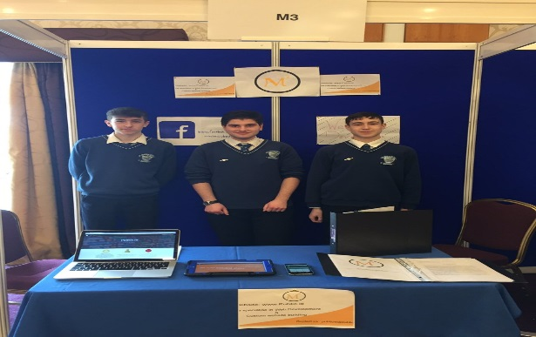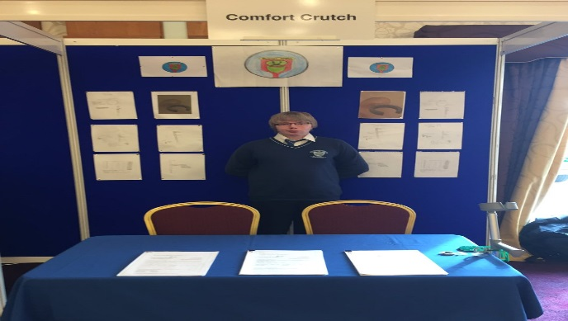
Why become an Entrepreneur?
People often decide to become an entrepreneur for the following reasons:
Income: Potential to make a profit and support yourself financially- to potentially earn more than an employee wage
Independence: Be your own boss, work for yourself and make all key business decisions
Challenge: Some people get bored easily and like to challenge themselves to be successful
Creativity: They have the ability to constantly come up with new ideas
Redundancy: They have been laid off from work and need a source of income for themselves
The Importance of Enterprise in an Economy
- Enterprise creates jobs for local people and gives higher standard of living and quality of life
- It increases the production of goods and services in an economy and creates competition which is good for consumers
- It creates new breed of entrepreneurs, acting as a role model for others
- Government can use taxes to spend on education, hospitals etc.
- Not for Profit Enterprises provide many socially desirable places like Sports Clubs and charities
- Creates the need for other service providers like banks and Building Societies

Characteristics and Skills of Enterprising People- Typical Exam Question- Always refer to question asked in Exam!!
The following are some of the most common characteristics associated with entrepreneurs:
- Creative
- Risk Taker
- Realistic
- Decisive
- Self-Confident
- Resilient
- Proactive

- Being Creative
This is the ability to come up with new ideas or new ways of doing things- ‘thinking outside the box’ to bring fresh ideas to the market
Example
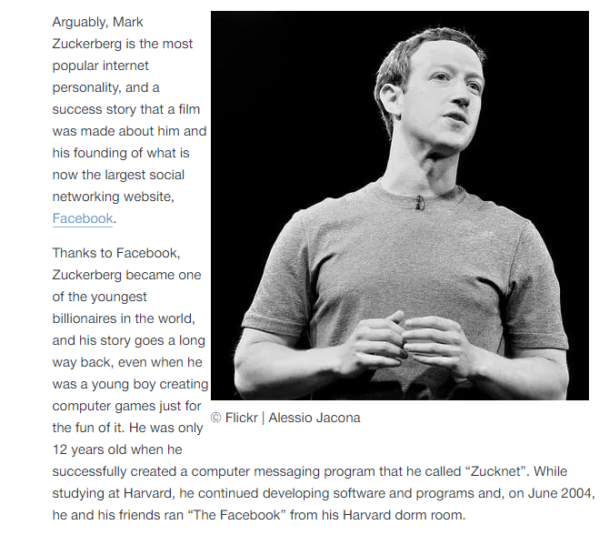
- Risk Taker
Entrepreneurs are generally people who are risk takers rather than risk avoiders/risk averse. They take both calculated personal and financial risks to bring a product to the market- but not simply just foolish ones. They are people who don’t simply wonder ‘what if’ and instead are positive about taking a chance in business

Example
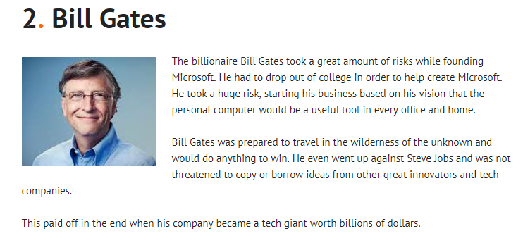

- Realistic
The entrepreneur will have good judgement and take a realistic view of what is possible. They are ambitious but will also have an honest view of their own capabilities and seek help and guidance when required.
Example
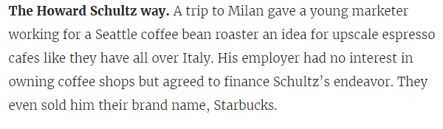
- Decisive
Decisions are made quickly and entrepreneurs take responsibility for any decisions that they make. They are able to adapt to circumstances that can change instantly and are flexible about this. Entrepreneurs who fail to move with the times and make key decisions are unlikely to be successful long term.
Example
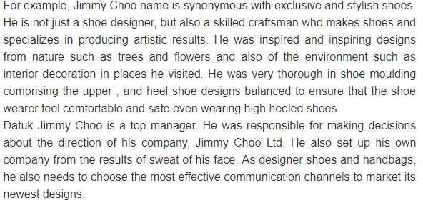
- Self-Confident
This is about having an inner belief in yourself and your idea. You see opportunities where other people see difficulties and your self- confidence makes you a problem solver rather than a problem finder. Self-confidence is concerned with how a person feels about their ability. You are not scared to explore un-chartered territories, take risk and take difficult decisions.
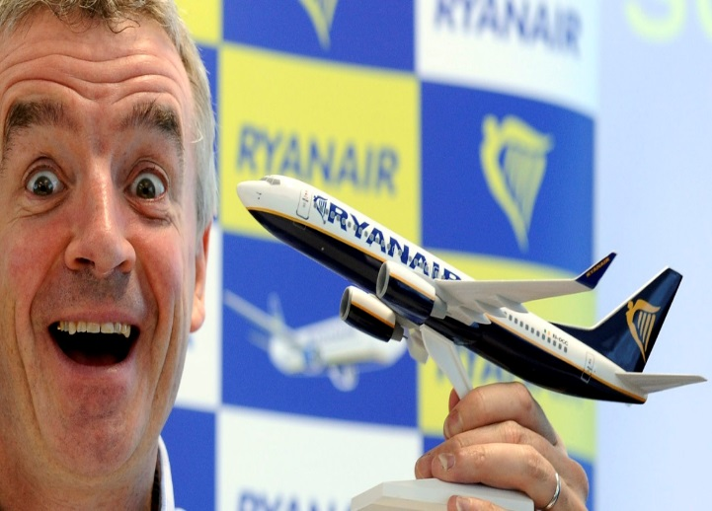
Michael O’Leary, regarded as one of the top entrepreneurs of the world, created the world’s first low-cost airline offering air travel around Europe and revolutionised air travel. He is someone who oozes confidence, and as a result is not afraid to make key decisions to evolve the Ryanair brand.
http://www.universitytimes.ie/2016/12/michael-oleary-on-how-ryanair-is-going-to-take-over-the-world/
- Resilient
The entrepreneur can take a knock and keep going. ‘If at first you don’t succeed, try and try again’. They are not willing to let a failed idea or a setback disrupt their motivation to succeed.
Example
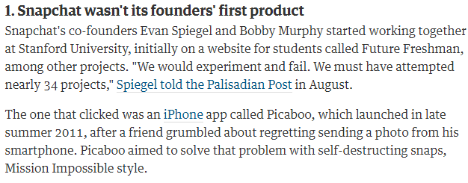
- Proactive
This is the ability to take action rather than simply wait for somebody else to do it. You will show initiative and want to bring your idea to the market, rather than simply wait for somebody else to come up with a solution to an issue or problem.

Skills of the Entrepreneur
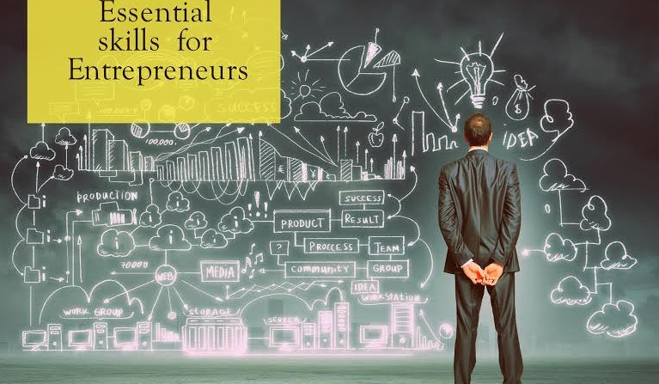
Inner control – taking control of your own situation, not wanting other to influence your life.
Planning & setting goals – setting both short & long-term goals. Bing future focused, plans must be drawn up to achieve these goals, i.e. SWOT analysis of a firm
Innovation – applying new ideas to situations where they have not been applied before. E.g. Brainstorming
Decision-making – an entrepreneur must be a good decision maker, choices must be considered, information must be analysed and then a (sometimes quick) decision is made. Failure to act can result in key business opportunities being missed
Human Relations – they must be able to manage people to achieve individual behaviour that will enhance the effectiveness of the business.
Reality perception – seeing things as they really are and being aware of employee’s and customer’s needs. There is little point in thinking that customers are satisfied with the firm’s products if they are dissatisfied.
Networking – working with other people and establishing contacts in the business community with people whose knowledge and expertise might prove useful
Ability to delegate: This allows the entrepreneur to pass some responsibility onto others and therefore reduce some of their own workload. This leaves the entrepreneur free to focus on more important tasks of the business while also ensuring the other jobs are getting done

Intrapreneurship
This refers to an existing employee who act as entrepreneurs inside a business. They come up with new ideas and solutions to problem that already exist. Most businesses like Facebook and Google encourage this amongst their staff.
Let’s examine one of the most famous examples of intrapreneurship- Ken Kutaragi and the Playstation.
https://youtu.be/Y0kpYoGJE0k
Other Examples of Intrapreneurship
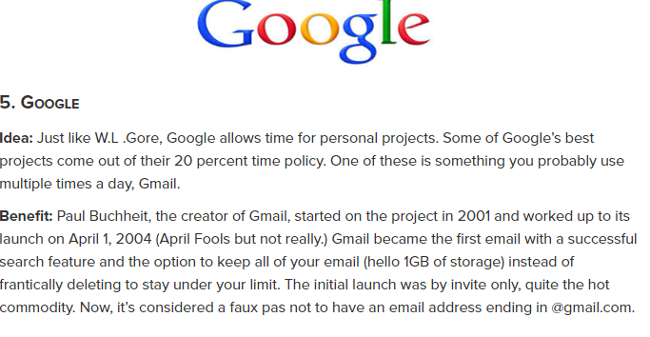
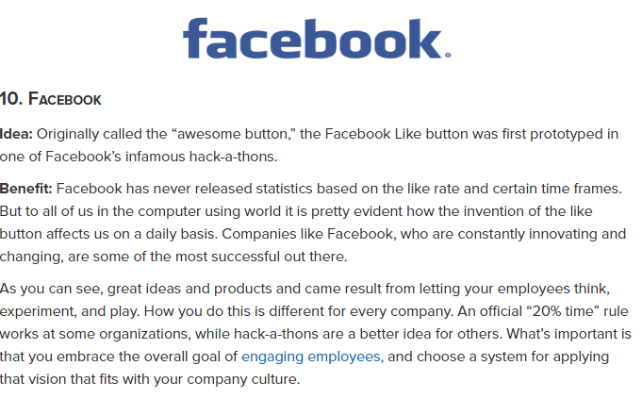
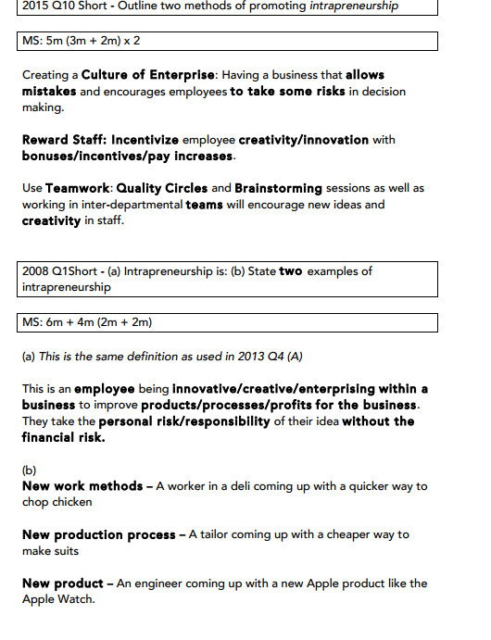
Ways to Promote Intrapreneurship
- Empowerment/employee participation encourages creativity as it allows employees greater freedom on how to do their job by placing real power, responsibility and authority in the hands of employees
- Create a culture within the organisation where it’s okay to make mistakes
- Financial rewards for effort and creativity. These rewards could involve a mixture of pay, incentives and benefits
- Teamwork encourages creativity among employees as it facilitates brain storming sessions as part of the product development process.
- Training program for employees and management, training them on the implementation of an intrapreneurial culture within a business

