In each of the following cases, use the income and taxation figures provided to calculate:
- PRSI Contribution
- PAYE Tax Due
- Net Pay

- Christy and Lara McGinn: Christy’s Salary is €24,000, Laura’s Salary is €28,600. PRSI is 6% of Gross Income, standard rate cut off point is €36,900, standard rate of tax is 20%, and higher rate is 40%. Tax credits combined are €3900

- Jennifer Cowley’s Gross Pay is €26,000. PRSI is 7%, standard rate cut off point is €29,000. Standard Rate Tax is 20%, higher rate tax is 40%. Tax Credits are €1900.

- Flann Geoghan’s Gross Income is €34,000. Standard rate cut off point is €36,000. Standard rate tax is 20%, higher rate tax is 40%. Tax Credits are €3680, PRSI is 6%.

- Oscar Hannon’s Gross Income is €28,200. PRSI is 7%. Standard rate cut off point is €25,400. Tax Credits are €2,200. Standard tax rate is 20%. Higher rate is 40%.

In each of the following cases, use the income and taxation figures provided to calculate:
- PRSI Contribution
- PAYE Tax Due
- Net Pay
- USC Rates

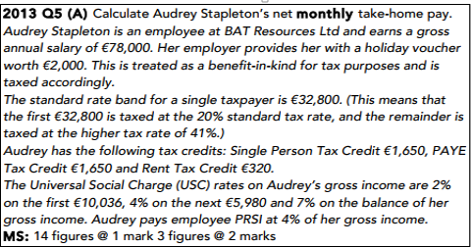

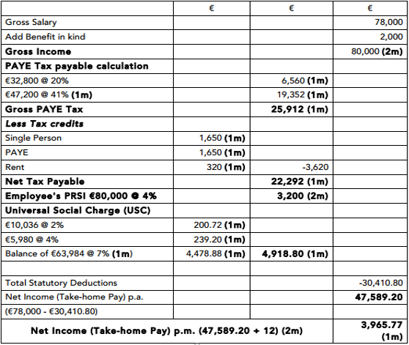

- Arthur Smith’s annual salary is €105,000. PAYE tax is paid as follows. First €45,000 at 20%. The balance at 40%. USC is 2% on the first €10,000, 4% on the next €10,000, 7% on the balance. The tax credit for the year are as follows: Married person credit €5000, Employee Credit €2000, Child Credit €3000, Age Credit €2000. PRSI is 0% on first €10,000, 4% on balance.

- Katie’s annual salary is €98,000. She also receives a holiday voucher worth €2000 that is treated as a benefit in kind for tax purposes. PAYE tax is paid as follows. First €35,000 at 20%. The balance at 40%. USC is 2% on the first €10,000, 4% on the next €10,000, 7% on the balance. The tax credit for the year are as follows: Employee Credit €1000, Child Credit €2000, Age Credit €1000. PRSI is 0% on first €10,000, 4% on balance.

