Management Skills 2: Communication
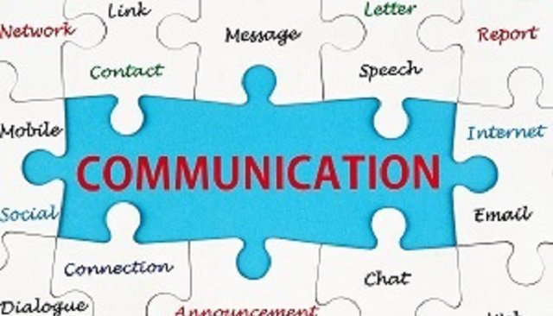
What is communication?
Communication is the transfer of information and ideas from one person to another with the aim that the receiver will understand, give feedback where necessary and act upon what they have been told.
Types of Communication
1. Internal- communication between people in the same business (a) upward (b) downward (c) horizontal (d) functional. (Methods include noticeboards, memos, email, minutes of meetings, telephone, informal chats)
2. External- communication between the business and the rest of the world. E.g. banks, government, suppliers, customers, accountants.
3. Formal – official channels of communication within a company e.g. routine meetings
4. Informal- communication occurs in all organisations and can be more casual. E.g. Gossip, social events outside work

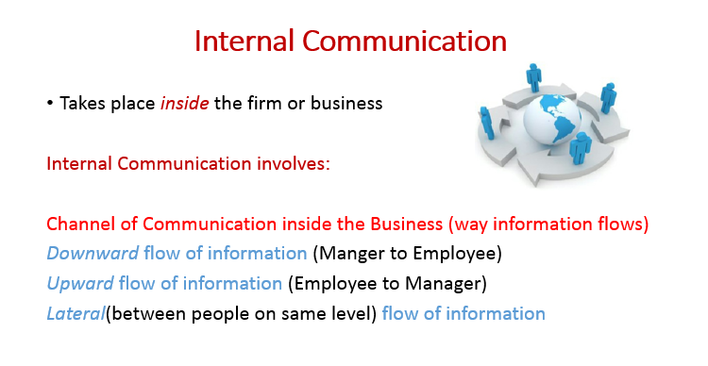
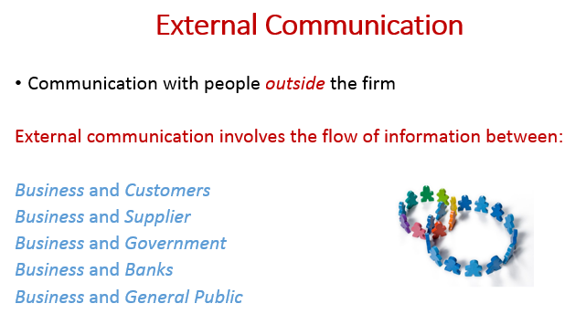
Importance of good communications:
• Upward (Feedback) - what is and isn’t working is identified quickly and avoids costly mistakes
• Downward (instructions) - gets work done
• Suppliers- having enough stock to meet demand/ avoids costly ordering errors
• Customers- will help them return
• Shareholders (confidence)
• Better industrial relations- issues dealt with quickly
*Factors of Effective Communication*
Appropriate Language/Clarity
If the language is too technical or too difficult (jargon)for the customers to understand then the message may be misinterpreted. The business needs to choose language appropriate to its audience. In the case of customers, short clear sentences and visual supports etc. may be suitable for product assembly e.g. flat packs.
Method used (Medium)
The medium chosen must be appropriate to the message been given. If the message is sensitive for the stakeholder e.g. terminating the employment contract of an employee, then a meeting would be more appropriate than a letter or an e-mail.
Cost
The expense of the communication process is a very important factor. A CEO communicating with his managers worldwide may choose to hold a virtual meeting to cut down on travel and subsistence costs.
Urgency/Speed/Destination
If a crucial piece of information has to be communicated instantly to a supplier, then a phone call, a text or e-mail may be appropriate rather than a posted letter e.g. to arrange a change in delivery times.
Feedback/Accuracy/Record
The business may be looking for feedback in order to take further action. Communication with the revenue commissioners may require regular correspondence and written records and in this case business letters and e-mail can provide formal evidence of the feedback process, eliminating misunderstandings

*Barriers to Effective Communication*
The language must be suited to the audience. Technical jargon or ‘buzzwords’ often have different meanings for different people. Suit the language used to the capabilities of the receiver of the message. Use technical jargon only when necessary
Wrong medium for the job in hand, i.e. the most appropriate for the transmission of the message. A medium that combine hearing and seeing may be best because people tend to remember more of the message if it is both seen and heard at the same time- e.g. bar chart for statistical data and figures
Check for Feedback. Failure to prepare for questions will lead to confusion, lack of credibility and loss of confidence
The receiver may not be in the best mood to receive the message so the timing of the delivery is often vital. The receiver must be receptive to the messages. You do not want to hold a staff briefing just before home time at the end of the day when everyone is ready to leave.
Speed and impatience cause lack of understanding, especially among groups. Deliver the message slowly and clearly. If the receiver gets tired, or loses interest, much of the message will be forgotten. Use visual and other methods e.g. charts, humour, to overcome the risk of wandering of attention or interest
Organisational Structure- Is there a clear chain of command and accountability, if there are too many levels, it may lead to messages not being transferred correctly
*Benefits of Effective Communication*
Productivity increases: Instructions are understood by all employees and deadlines are clearly communicated to employees resulting in an increase in productivity and fewer errors.
Better industrial relations: Clear communication and openness to listening to others mean that any dispute between stakeholders in a business can be resolved before it becomes a critical issue. Grievance procedures are available to all employees.
Intrapreneurship encouraged: New ideas flow easily and can be developed quickly in a business with effective communication.
Team Approach: In modern business a matrix structure is applied where employees work on projects in teams. For teams to be effective, members must be able to communicate clearly and objectively to each other.
Clear goals can be established: It is easier to plan with employees and agree individual targets for them. This will help to motivate the employees
Meetings as a form of Communication
Board Meetings
These are meetings of the board of directors and are usually held on a monthly basis. Progress and performance is discussed and tactical and strategic plans are formulated. Problem solving is a key function of board meetings
Annual General Meeting (AGM)
This is a meeting held once a year required by law and attended by the directors and shareholders of the company. The main functions of the AGM are to elect a board of directors, let the chairperson gives a report on company performance, and so they can declare a dividend for the year
Extraordinary General Meeting (EGM)
This is a meeting of the shareholders and company directors held to discuss a matter of urgency that cannot wait until the next AGM. There is no other matter discussed at this meeting. There could be an EGM if there was a takeover bid for the company or a major fire at the production plant
Ad Hoc meeting
A meeting that takes place at short notice to discuss a matter that requires attention and that has arisen unexpectedly. They aren’t organized in advance, only as the need dictates e.g. a sales meeting to address falling sales targets
Key Terms Associated with Meetings
Quorum: This is the minimum number of people who have to be present for a meeting to take place. If the quorum is not met, the meeting is postponed
Standing Orders: These are the rules for running a meeting, e.g. the time for each speaker
Point Order: When a person brings to attention that the standing order has been broken
Proxy: A person who represents a member of the meeting who cannot attend, they may vote in accordance with what the shareholder wishes
Procedures for Conducting Meetings
The Notice: Date, time, and place of the meeting
The Agenda: Topics to be discussed.
Sample Notice
Sample Agenda
2012- Q.4.
The Role of the Chairperson in a Meeting
- The chairperson draws up the notice and agenda with the secretary before the meeting
- The chairperson calls the meeting to order and opens the meeting only after ensuring the quorum is present
- The chairperson guides the discussion and manages time and contributions without any personal bias, allowing discussion only of matters on the agenda
- The chairperson organises vote taking and in the event of a tie they have the casting vote
- The chairperson closes the meeting at the end of discussions

The Role of the Secretary in a Meeting
- The secretary sends out the notice and agenda to all those who are entitled to attend. This should be sent out in plenty of time giving members or shareholders time to prepare for the meeting
- The secretary arranges a suitable venue ensuring that essential resources such as refreshments, audio-visual equipment and seating plans are in order
- The secretary assumes the role of minute’s secretary (a written account of what is discussed and decided). This involves reading the minutes of the previous meeting and having them approved and then signed by the chairperson. It also involves taking notes so that the minutes of the present meeting can be written up accurately later
- If the chairperson needs any help, for example counting votes, the secretary will assist

2004.- Draft up a typical agenda and minutes for an AGM of a limited company
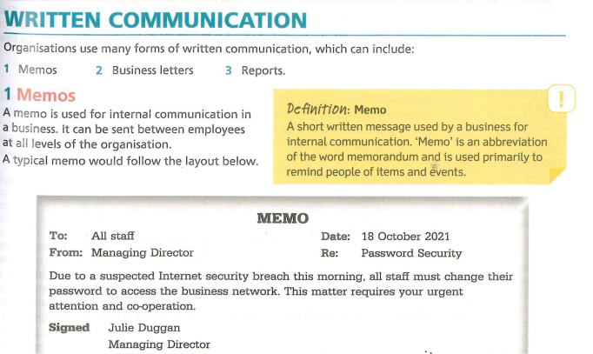

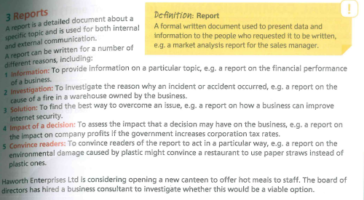
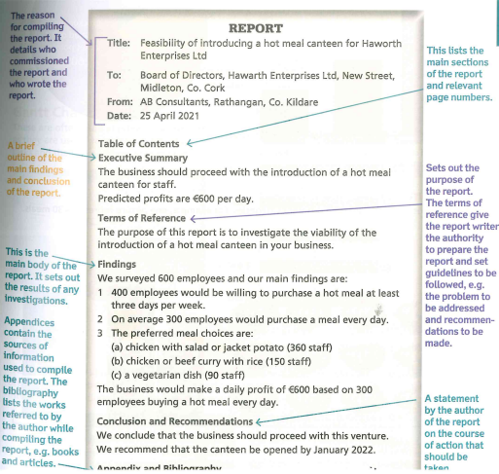
Information and ICT (Information and Communications Technology)
ICT refers to the growing range of technologies that are used to transfer information. For businesses the main ICT categories are computer based technologies such as Microsoft Programmes like Word and Excel, and digital communication technologies such as messenger services over the internet.
ICT has benefited companies hugely and has led to major growth in the Irish economy as information is now passed a lot quicker between businesses and their stakeholders.

Benefits of ICT in a Business
Speed: Communication is available quick and large volumes can be send rapidly using ICT. Example- sending a document via email rather than by post can get a response instantly
Lower Staff Costs: ICT can replace the need for people which can reduce costs- example self-service checkouts rather than tills in shops
Increase Sales: The use of the internet has enabled businesses to sell products around the world and grow rapidly
Access to larger markets: They also have been able to access target markets with information that may have been impossible otherwise
Challenges of ICT in Business
- Breakdowns- Many businesses invest heavily in ICT. Any breakdown can have massive implications for the business
- Viruses- Certain websites and systems can cause issues for customers and result is massive problems with sensitive information
- Security (Phishing) is an attempt to gain access to sensitive information from unsuspecting users. Many customers have fallen victim to these scams and as a result will not trust ICT
- Others not having up to date technology- ever-changing and the cost associated with this
- Can be expensive to purchase

Developments of ICT in Businesses
The Cloud
Cloud computing allows data to be stored in offsite servers which minimises the need for expensive hardware and onsite storage facilities. Example- Dropbox
Electronic Data Interchange
Electronic Data Interchange (EDI) is the electronic interchange of business information using a standardized format; a process which allows one company to send information to another company electronically rather than with paper.
These services greatly facilitate communication in a global market. Document transfer, automated stock ordering, details of trading figures etc. can be transmitted globally in a matter of seconds.

The Internet
The Internet is a global network of computers that allows people to share and transfer data instantly anywhere in world. Communication can be instantly received and faster decisions can be made.
Computer Aided Design
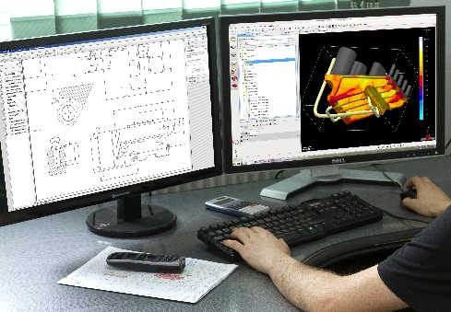
CAD had revolutionised the design process, making it much easier and faster to develop new products, and allowing companies to react quickly to customer requests and needs. Allows designs to be saved, changed and reworked without starting from scratch. A product designed in one country can be sent electronically to another country to be tweaked by local designers to make it better suited to local tastes.

Microsoft Office
Programmes such as Microsoft Word and Microsoft Excel have enabled businesses to create and edit documents that can be used to store important information online and this information can be easily edited. These documents are often used to present important information for the benefit of the business.
Social Media
Social Media platforms like Instagram and Snapchat allow businesses and their customers to share and access information globally at the click of a button. Businesses can reach mass audiences quite quickly and there a huge marketing benefits also.

Data Protection
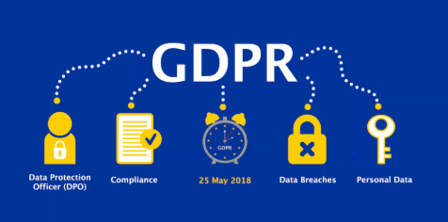
A new European Union-wide framework known as the General Data Protection Regulation (GDPR) came into force across the EU on 25 May 2018.
The GDPR strengthens your rights and gives you much more control over your personal data. It also imposes more obligations on companies who control and process your data. You have more rights under the GDPR about how your personal data is handled and processed. Data controllers and processors are required to comply with the Regulation.
Under the GDPR, your personal data is data that relates to or can identify you either by itself or together with other available information. Examples of personal data include your name, phone number, bank details and medical history.
You are a Data Subject when you are the person to whom the personal data relates. Data Controllers and Data Processors are organisations that collect or use your personal data.
As a data subject, you have the following rights:
Right to access data: If you believe a person or organisation is processing personal data about you, you can request that they tell you whether they are processing this data. If your data is being processed you will be able to request a copy of that data to be sent to you. The controller will be able to charge a reasonable administrative fee for this. Under the current legislation, the fee cannot be more than €6.35, and must be provided within one month
Your right to have your data rectified, restricted or erased: For example if the accuracy of the data is in question, or the data is no longer needed for the purpose it was collected, you have the right to the above
Your right to move or transfer your data: The GDPR introduces the right to data portability. This means that you can request and receive personal data that you have previously provided to a controller in a commonly used and machine-readable format. The right also means that you can request one controller to transfer your personal data to another controller
Your right to object to the use of your data: The right to object means that you have the right to object to the processing of your data at any time - for example, to prevent your data being used for marketing purposes, including profiling. The controller must stop processing your data unless they can show that there are legitimate grounds or legal reasons for such processing that override your interests
Your right to information about the protection of your data: Data controllers must have appropriate measures to comply with your rights and must provide information to you in a concise, transparent, intelligible and easily accessible form, using clear and plain language.
If a controller does not comply with a request from you, the controller must give you reasons for this and should inform you of your right to make a complaint to the supervisory authority. These rights will not apply where the data can no longer identify you.

Obligations of Data Controllers and Processors:
The obligation to design appropriate processing systems: For example, controllers should design their processes so that they collect only the data absolutely necessary for their purposes, and access to personal data should be limited to only those necessary for processing. Controllers may also temporarily anonymise personal data
The obligation to use processors that meet the requirements of the legislation: Where processing is to be carried out by a processor and not the controller, the controller must use only those processors who guarantee that their systems of processing meet the requirements of the Regulation
Examples of processors of his nature include payroll companies, accountants and market research companies, all of which could hold or process personal information on behalf of someone else. Cloud providers are also generally data processors
The obligation to keep records: Under the GDPR, any controller that has more than 250 employees, or that processes sensitive information, must keep a record of the processing activities under its responsibility, such as the purpose of data and erasure procedures. Processors must keep similar records. These records can be inspected by the Data Protection Commission on request
The obligation to keep data secure: The use of encryption passwords and back up data due to security risks.
The obligation to report data breaches: Under the GDPR, a controller must notify the Data Protection Commission of a personal data breach without delay where that breach is a likely to result in a risk to the rights and freedoms of the data subject. Notification should be made within 72 hours of the controller becoming aware of the breach. Data processors must notify the respective controllers if the processor becomes aware of a breach. The controller should also notify the data subject without delay
The obligation to carry out data protection impact assessments: Under the GDPR, when a controller intends to carry out high-risk processing they must first carry out a data protection impact assessment (DPIA). The Data Protection Commission will prescribe a list of the kind of processing operations that may be high risk
The obligation to appoint data protection officers (DPOs): Under the GDPR, data protection officers must be appointed by controllers and processors whose core activities consist of processing operations that require regular and systematic monitoring of data subjects on a large scale or of special categories of personal data or data relating to criminal convictions and offences.
Functions include:
- Must provide contact details to the Data Protection Commission
- Must be provided with appropriate resources to carry out their tasks and maintain their expert knowledge
- Must report directly to the highest level of management in their organisation
Enforcement and Supervision of GDPR
(Under the Data Protection Act 2018, the Data Protection Commission has replaced the Data Protection Commissioner.)
The Data Protection Commission will:
- Monitor and enforce the application of the GDPR
- Promote public awareness of the rules and rights around data processing
- Advise the Government on data protection issues
- Promote awareness among controllers and processors of their obligations
- Provide information to individuals about their data protection rights
- Maintain a list of processing operations requiring data protection impact assessment
The Data Protection Commission has the power to order any controller or processor to provide information that the authority requires to assess compliance with the Regulation. It may carry out investigations of controllers and processors in the form of data audits, including accessing the premises of a controller or processor. It can order a controller or processor to change their processes, comply with data subject requests. The Data Protection Commission can also issue warnings to controllers and processors and can ban processing as well as commence legal proceedings against a controller or processor.
European Data Protection Board
The GDPR will introduce a new European data protection supervisory authority. The European Data Protection Board (EDPB) will be responsible for ensuring the GDPR is applied consistently across The European Union. It will issue guidelines and recommendations on the application of the Regulation. It will also advise the EU Commission on the application of the Regulation and any updates that may be required.
The EDPB is made up of the head of one supervisory authority of each member state and a European Data Protection supervisor.
Penalties
Penalties apply to both controllers and processors who breach the Regulation. There are different penalties, depending on the seriousness of the breach.
Serious infringements
For the most serious infringements (for example, not having sufficient customer consent to process data or violating the core of privacy by design concepts) organisations can be fined up to 4% of their annual global turnover or €20 million, whichever is greater.
Each member state may introduce further fines legislation, which will be enforceable within that state only.
Lesser breaches
Under the GDPR, organisations in breach of the Regulation can be fined up to 2% of their annual global turnover or €10 million, whichever is greater, for lesser breaches. Some examples of lesser breaches include: not having records in order, not notifying the supervisory authority and data subject about a breach or not conducting an impact assessment.

