Marketing

Marketing
Marketing means identifying consumer’s requirements and identifying how to supply these requirements at a profit. It is finding out what a customer wants and making a product to satisfy these needs profitably
The Marketing Strategy
A marketing strategy is a plan of setting out how a business achieves its marketing objectives
The Marketing strategy will set out a map of marketing goals and how these goals will be achieved. It is usually developed with the different stages of planning in place, and should have both strategic and tactical plans in place
A business Marketing Strategy is outlined below

- Identifying your Target Market
A Target Market refers to all people who might buy a particular good or service. The Target Market will have something in common and are targeted by the advertisers
Example Target Market for Ed Sheeran tickets would be Pop Music Fans, soccer jerseys would be football fans, Dora the Explorer would be children, etc..
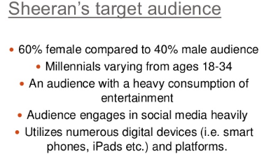

- Market Research
Once you have identified your target market, one of the most important tasks in business is to find out what products and services the consumer needs and wants. To do this they use Market Research, which is the collecting of information about a product and its market and then using that information to make business decisions.
This will give information for a business on important areas such as potential demand, consumer tastes, price sensitivity, competitors’ products, and feedback on existing products
Types of Market Research
Field Research
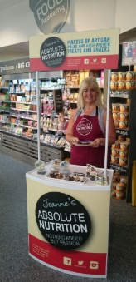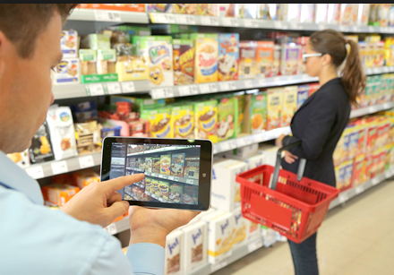
Field Research is primary research, and it involves going into the marketplace and gathering information by making direct contact with existing or potential customers.
Field Research can be expensive and time consuming, but it does allow a business the opportunity to design the questions they need answering themselves and also allows you to directly observe your target market.
Examples of Field Research include:
- Surveys
- Questionnaires
- Taste tests and free samples
- Focus Groups
- Direct Observations
Desk Research
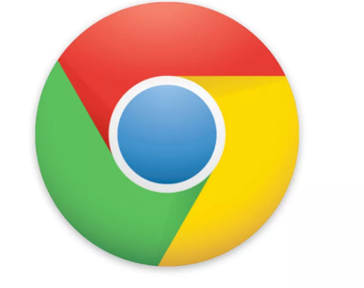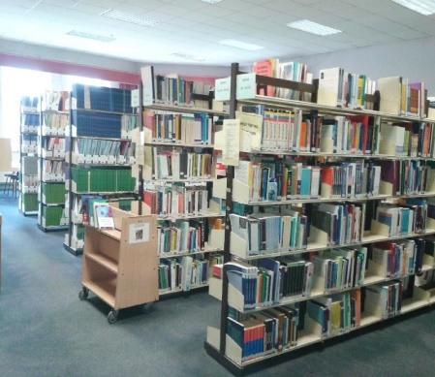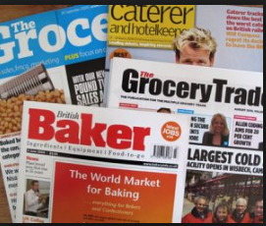
Desk Research is secondary research, where a business accesses information that has already been gathered. The information already exists, so the business does not have to go out to try and find it.
Desk research is relatively cheap, which keeps costs down as the data does not have to be collected. They must however be aware that data can go out of date quickly, and will have no guarantee to the accuracy of the research as there may have been mistakes in recording answers or leading questions
Examples of Desk Research include:
- The internet
- Central Statistics Office
- Trade Magazines
- Libraries
- Business Reports
Market Research Success
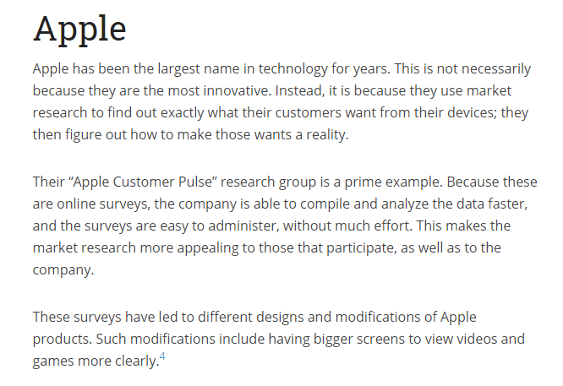
Market Research Failure
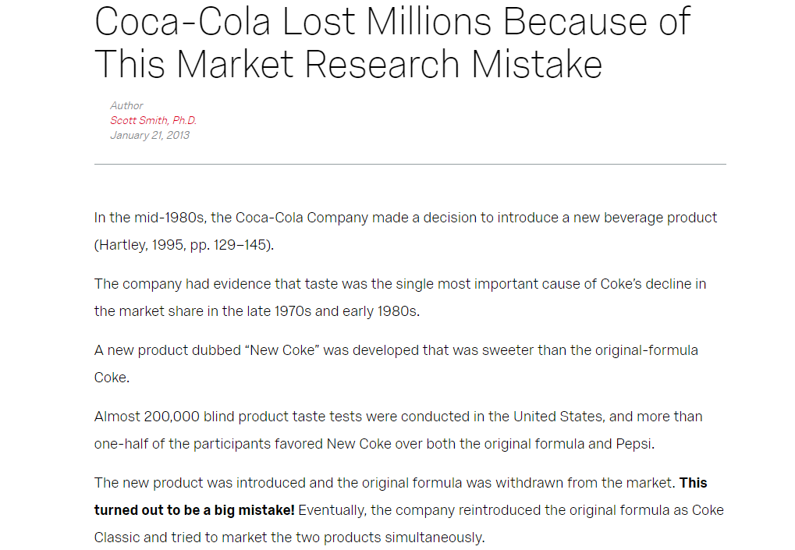
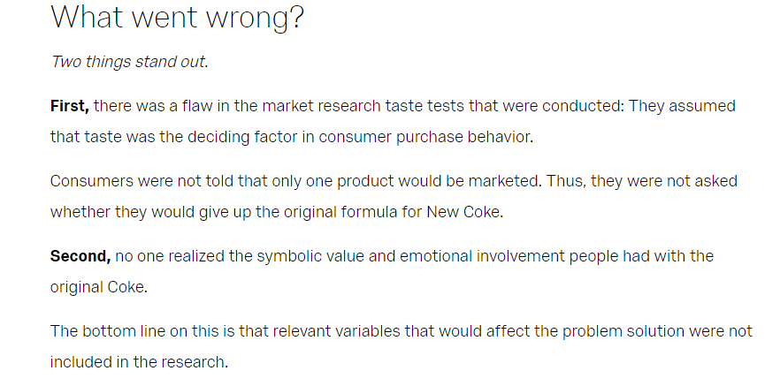

- Market Segmentation
Market segmentation involves dividing up the market into clearly identifiable sections which have common characteristics. It allows a firm to identify who their target market is.
It involves dividing a broad target market into subsets of consumers, businesses, or countries that have common needs and priorities, and then designing and implementing strategies to target them.
Reasons for Market Segmentation include:
- To focus the marketing strategy on the customers who are most likely to buy your products and services, saving time and financial resources
- A business will have the opportunity to build loyal relationships with its customer base and increase its potential for development of future products
- Advertising is better targeted: The selection of a certain segment will allow a business to better target advertising. This will increase the impact of advertising and lead to higher sales
- Prices can be accurately used to set the right image for the product if matched or targeted at the consumer’s income
- It can give a business a competitive advantage when trying to compete against larger brands in a particular market by strongly focusing on a particular segment
The most common ways of identifying a market would be through
- Geographic Segmentation: This is segmenting markets based on where a person is from, like country or county, urban v rural, climate, population growth etc… Think of radio stations like Spin 1038 or LMFM- they are segmented geographically based on where people are from and give local news about those areas. McDonalds change their menus depending on certain locations.

- Demographic Segmentation: This is segmenting markets based on characteristics, such as age, income, gender etc.. You are able to target demographics differently for the same or similar products. Think of Cadbury Chocolate Bars like Freddo, Dairy Milk, aimed at different demographics depending on income and interests, clothing brands segmenting their products based on gender

- Behavioural Segmentation: This is segmenting our brand loyal v infrequent users. Multipack offers can be offered to frequent users, while individual packets can also be purchased, like Manhattan Popcorn or baked beans. Dunnes Stores and Tesco often provide vouchers to loyal customers.

- Psychographic Segmentation: This market is divided into segments based on lifestyle, social status, beliefs, and attitudes. Think about luxury or fuel efficient cars, these items suit the lifestyle of their owners. These could be people who are more health conscious, e.g. salad menus, vegan options etc..
The market analysis may also highlight the existence of Niche Markets.
A niche market is a small market segment which a firm may specialise in supplying/Small specialist segments of a larger market.
Normally small firms enter niche markets because of the specialist nature / requirements of the market: the niche segment may be so small that the larger firms may not have the flexibility or desire to enter it. It is usually a small market segment that is not satisfied with the mainstream products in the market because they have different, more specialised needs and are even prepared to pay a higher price for the product.
Examples of products include Diamond rings/bridal shoes/first communion dresses/children’s’ clothing/ specialist transport-wheelchair..
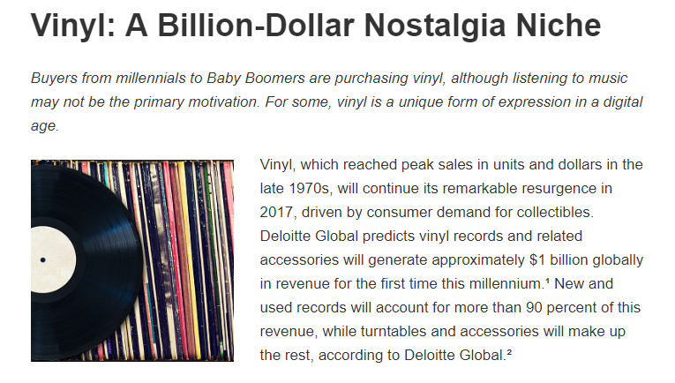
Implications of operating in a Niche Market
- Little or no competition/small market
Unlike in generalised marketing where market competition is stiff, niche marketers face less competition in the market as they deal with a specific product for a small market segment
- Less investment required
As they produce limited goods for the niche market they may require less investment.
- High cost base
The specialisation of products involves more expensive raw materials, highly skilled staff and job/batch production methods/personal service. The costs are very high for the business, therefore they must charge a higher price to customers.
- Less risk for the business/cost effective use of resources/more focused marketing
There may be fewer risks/costs for the business as the marketing is focused on a very small segment of the market.
4. Product Positioning
Product positioning means creating an image for the product in the minds of consumers in the target market. For example, what do you think when you consider Marks and Spencers v Aldi for food shopping?
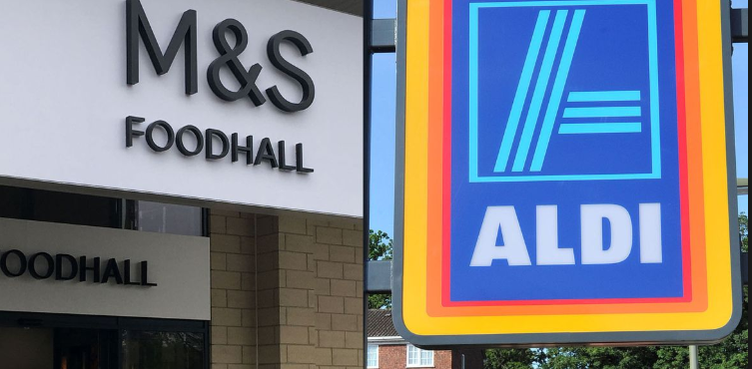
5. The Marketing Mix
The Marketing Mix consists of the 4 elements that a business can use to persuade consumers to buy their products. They are known in business as the 4 P’s, and they are:

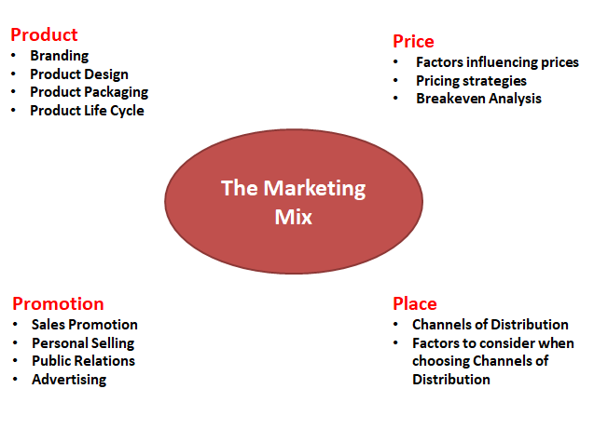
Product
A product can be an idea, a service or a good. Consumer products such as clothes and TV sets are products purchased to satisfy personal and family needs.
Among the issues to be considered concerning product include:
- Branding
- Product Design
- Product Packaging
- Product Life Cycle
Branding
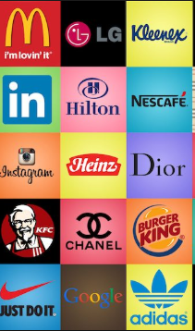
Branding involves the creation of a brand name (Coca Cola, McDonalds, Apple) which the company has the sole right to use. A business can register words, logos, letters and numbers to distinguish from competitors at the Irish Patents Office (e.g. Mr. Tayto).
Brands create a personality for a product, which allows consumers to develop a lifestyle relationship with the products they consume, and also helps the business stand out from their competitors
The Importance of Strong Branding
Brand Loyalty
A strong brand, which is associated with good quality, consistency etc. will develop a loyal customer base who will continue to buy the product even when prices increase e.g. many consumers buy Barry’s Tea and are averse to alternative brands, or Apple iPhone customers are extremely loyal to the brand and research shows most consumers upgrade to newer versions of the phone. e.g. upgrade from iPhone 12 to iPhone 13
Higher Prices can be charged
A strong brand is usually associated with high quality. If the brand builds a reputation for quality and consistency it allows them to charge higher prices than competitors. e.g. Rolex and Ferrari are businesses who charge a high price for the product based on the strength of their brand image. Apple charging higher prices than Samsung.
Brand recognition
A strong brand makes the product/service much easier to identify against competitor’s products/service e.g. Apple’s distinctive logo and branding are easily recognisable and draw consumer attention. Consumers can identify brands such as McDonalds.
Easier to launch new products
By having a strong brand a business can launch new products under its existing brand name. This allows the business the opportunity to build up market share e.g. Apple launched the iPod to great success, after which followed the iPhone and iPad. The strength of Nikes brand image has allowed the business to innovate and develop new products.
Aids advertising
It is easier for businesses with a strong brand to promote their products/services. A strong well recognised brand name or logo can easily be advertised in various formats e.g. Apple do not engage in direct advertising as their brand is so strong and visible all over the world that it does not require large scale promotion.
Own Brand Products
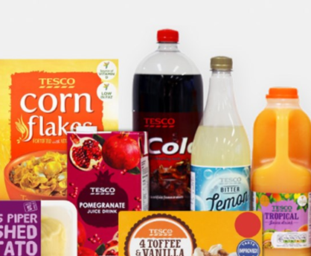
These are products sold by retailers under the retailer’s own name and logo to compete against existing products. Large multiples such as Tesco’s use own label brands e.g. Tesco Milk sold against Avonmore milk in Tescos. These products tend to be cheaper against the competitors.

Advantages of Own Brand Products
- Own Brand Products allow businesses to offer customers lower prices which in turn helps attract customers to do all their shopping in their store- this is known as a loss leader
- It gives retailers a competitive advantage against competition as their own brand products are not available anywhere else
- There is more bargaining power for the retailer- suppliers compete for limited shelf space as the retailer stocks their own products and so more discounts can be obtained
- Product Specification is allowed as the own brand retailer has influence in shape, colour, and content
Product Design
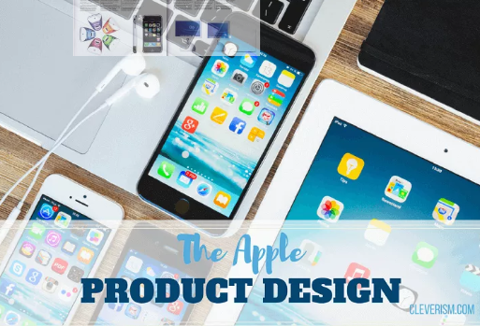
Product Design involves the creation of an attractive product which works. When designing a product, it must be able to do what it is set out to do, and also be aesthetically pleasing in terms of shape and colour etc... The success of Apple Computer's iMac can be attributed to its distinctive features and designs.
Particularly in today’s market where consumers are so self-aware, and with so much competition in the market place, making sure your product design suits the needs of consumers will increase sales and brand loyalty.
The product function and materials must also comply with The Sale of Goods and Supply of Services Act 1980
Product Packaging
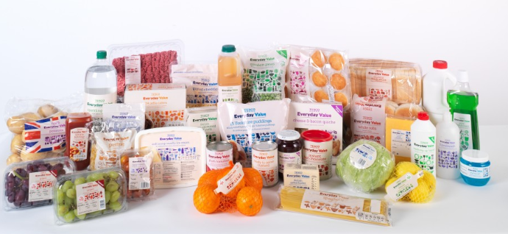
Product packaging serves many functions that are useful for a business:
- Protects the product during transit, storage and handling
- It also keeps the product fresh, preserving quality until it is used
- Packaging contains information on contents, ingredients, best before date…
- Products can be instantly recognisable due to the shape of the packaging
- Packaging draws attention through brands and logos, shape and colour
- Packaging can control the size and quantity of a product
- Packaging can increase brand loyalty and self-esteem/self-image for high end goods

Product Life Cycle
Product life cycle - This describes how the market for a product changes over time.
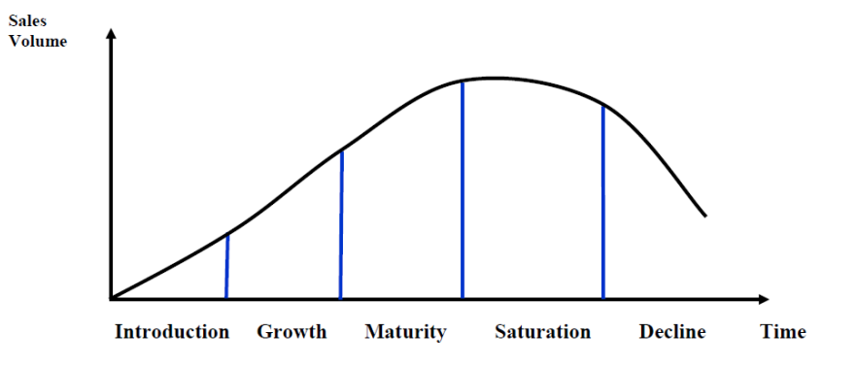
• Introduction-The product is launched onto the market. Sales may be low / costs of marketing the product will be high/Profits will be low if at all/Aim is to create product awareness. Most expensive stage with heavy drain on cash flow.
Example: Fidget Spinners are launched to the market for the first time
• Growth-Customer awareness of the product increases /sales are growing rapidly/Profits should start to rise/Aim is to maximise market share. Cash Flow improves as costs fall.
Example: There is a huge surge in demand for fidget spinners
• Maturity-Sales are at their peak and product is commonplace in the market/Profits are maximised / market share is defended. Cash flow is excellent but sales increase slows.
Example: Most people now own a fidget spinner
• Saturation- Sales are levelling off/Profits should be steady/Market will have been fully exploited. Planning needs to happen to prevent a decline/Extend the life cycle.
Example: New designs are created to try and keep sales high and extend life cycle
• Decline-Many competitors in the market and new products will cause a decline in sales/Profits decline/May cut prices to sell/May phase out weak products/May even be making a loss.
Example: CCPC bans fidget spinners due to being unsafe, product no longer sold in market
Extension Strategies to a Product Life Cycle
Update the Product
Businesses could update the product and launch it in new flavours or sizes or with different features. E.g. Coke launched different size bottles like the 1.25 litre to maintain sales
Change the Design
The business could improve the design of the product, tweaking a feature. This might attract new customers or previous customers may retry the product to find out what has improved. E.g. The I-phone 13 with additional camera features
Change The Pricing Strategy
Changing the selling price can increase sales. Price drops can increase demand as consumers look for value e.g. The FAI lowering match tickets to encourage fans to buy tickets to increase overall revenue
Offer Loyalty or Discount cards
Offering loyalty cards with points or discounts can be a way of retaining customers that may be tempted to go to competition. E.g. Dunnes Stores give €10 off your next shop when you spend €50.
Change channel of Distribution
Sell more products online to get access a global market or sell 24/7, partner up with sites like Groupon and offer discounts

Price
This is how much the customer will pay for the product/service.
Among the issues to be considered concerning price include:
- Factors influencing prices
- Pricing strategies
- Breakeven Analysis
Factors influencing Price
Demand: When demand is high, prices will be high. Think of tickets to an All Ireland Final or an Ed Sheeran gig
Production Costs: The price will have to be higher than the cost of producing the product, for example raw materials, expenses, wages etc.. While a business may initially try to sell below cost price to attract customers, it will not be sustainable in the long run
Competitors: Prices will generally need to be in line with what competitors are charging, unless they actively choose an alternative pricing strategy such as premium pricing
Consumers: The type of buyer and their expectations can decide the market- income levels, spending habits etc..
Type of good: Smokers generally are price loyal, but in supermarkets, everyday goods such as bread and milk will generally sell on what is the cheapest
Pricing Strategies
-High Price Strategies
Premium pricing:
Price is set at a high rate than competitors to reflect consumer’s perception of a superior product. It is ideal for small businesses that sell unique products and develop high-quality products. Product may have a unique selling point (USP) or a distinct competitive advantage. Examples would include new BMW, Rolex Watch etc…
Price skimming:
Often most effective in the early days of a product life cycle/very few close rivals/setting high prices during the introductory phase to maximise revenues/help cover R&D costs and lowering the prices as competitor products appear on the market
It cannot last for long as rival products will come on the market. Example would be the new I-Phone when it comes onto the market.
-Low Price Strategies
Penetration Pricing:
Undercut competitors to attract customers. Over time the business may increase their price. Example would be when Tesco came onto the phone market
Predatory Pricing:
This is setting lower prices to push competitors out of the market. It can lead to price wars which is good for the consumer. Example would be Ryanair who reduce prices on popular routes
-Other Pricing Strategies
Bundle pricing: Selling multiple products together at a lower price. Sky packages/Vodafone
Cost plus pricing (mark-up pricing): Price set to cover costs (production, marketing, distribution) and include a target/fixed percentage profit margin.
Tiered pricing: Customers can choose the price level that best fits their budget. They can purchase the basic model car or the luxury model. Can help a business capture a larger portion of the market
Price discrimination: Charging different prices to different market segments for the same product. Cinema tickets/airline tickets

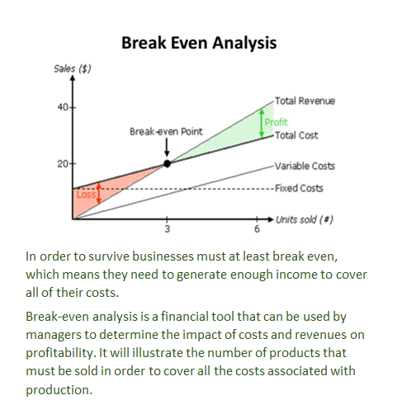
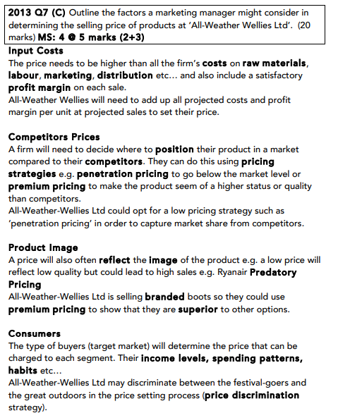
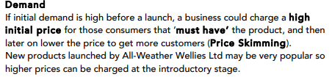

Place
This is about getting the final product to the consumer. It is important to choose a Channel of Distribution which is easily accessible to your target market
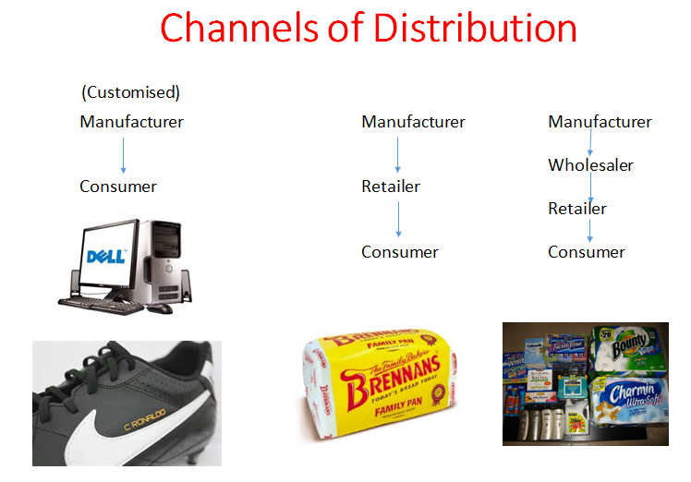
Factors to consider when choosing a Channel of Distribution:
Cost
More channels- more expense. Ryanair was motivated by cost factors when it cut travel agents out of its ticket sales distribution network.
Type of good/durability
What’s the shelf life? Fresh goods delivered directly to the retailer.
Market size
Cadburys distributes their products through wholesalers like Musgrave Group due to number of shops nationwide
Technological developments
Apps e.g. banking 365online for Bank of Ireland, less need for physical branches
The Wholesaler
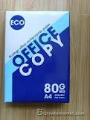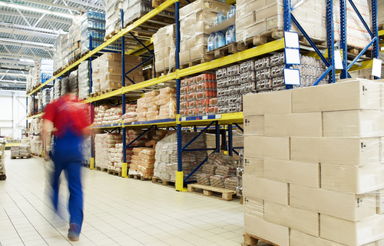
A wholesaler buys large quantities of goods from many manufacturers and sells them in smaller quantities to retailers. E.G. A school may need large stocks of paper, which it purchases directly through the wholesaler in order to receive a discount
Cash and carry wholesalers are different than general wholesalers as they act as supermarkets to retailers. Consumers are not permitted to shop in them. E.g. Musgraves.
2014 Question 7 B.
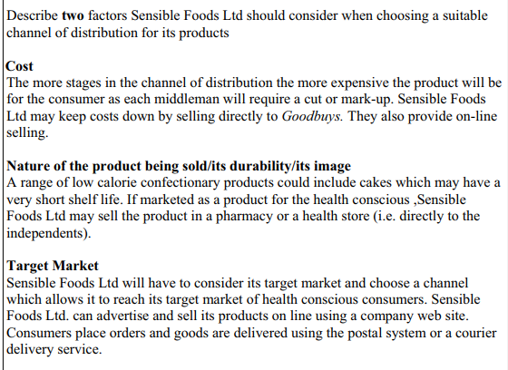
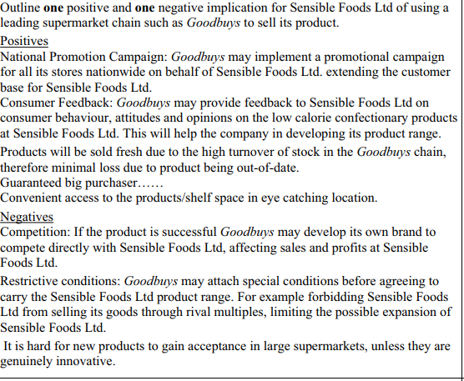

Promotion
This refers “to the method made by the business to communicate their product to the target market
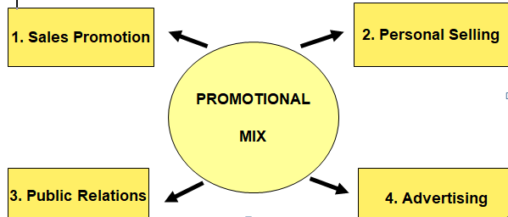
- Sales Promotion
Sales promotion is any initiative undertaken by an organisation to promote an increase in sales, usage or trial of a product or service
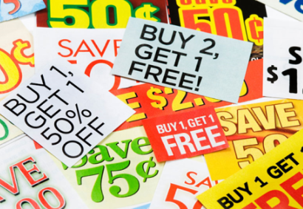

Examples of Sales Promotion
- Free gifts: e.g. Subway gave away a card with six spaces for stickers with each sandwich purchase. Once the card was full the consumer was given a free sandwich
- Merchandising: This is materials used to promote products in retail outlets, e.g. window displays, posters, and display stands. It is often placed at the point of sale where the customer buys the product
- Discounted codes: e.g. Budget airline such as EasyJet and Ryanair, e-mail their customers with the latest low-price deals once new flights are released, or additional destinations are announced
- Joint promotions between brands: For example fast food restaurants often run sales promotions where toys, relating to a specific movie release, are given away with promoted meals
- Free samples (aka. sampling) e.g. tasting of food and drink at sampling points in supermarkets. For example Red Bull (a caffeinated fizzy drink) was given away to potential consumers at supermarkets, in high streets and at petrol stations (by a promotions team).
- Vouchers and coupons: Often seen in newspapers and magazines
- Competitions and Prize Draws
- Special Offers: e.g. Buy one Get one Free
- Loyalty Cards

- Personal Selling
Personal selling is where businesses use people (the "sales force") to sell the product after meeting face-to-face with the customer. An example would be in stores such as PC World when buying a new computer or SMART TV.
The sellers promote the product through their attitude, appearance and specialist product knowledge. They aim to inform and encourage the customer to buy, or at least trial the product.
A good example of personal selling is found in department stores on the perfume and cosmetic counters. A customer can get advice on how to apply the product and can try different products. Products with relatively high prices, or with complex features, are often sold using personal selling.
- Public Relations
Public Relations refers to all activities e.g. press conferences/ sponsorship related to creating a good public image for the product or service amongst its stakeholders. Businesses often hire a Public Relations Officer (PRO) to protect and promote a positive image for the firm.
It aims to achieve favourable publicity and build a good corporate image for the business in the public eye in the long run.
Methods of PR
Publicity
Public Relations can take the form of press releases or press conferences where the media are given information about the company’s activities. The business can arrange photo shoots and provide pictures to media for them to use
Sponsorship
Businesses want to have people associate their brand with certain events or teams e.g. the Olympics.
They pay money so that their product name will be displayed by individuals, organisations or at particular events or stadia. It can be very effective at positioning a business (sponsoring of sports events or TV programmes).
e.g. 3arena in Dublin, Vodafone on the Irish Rugby Jersey
Newsletters
Sending newsletters – relevant information about the organisation or/and its products/services - directly to the target audience is also a common method to create and maintain a strong relationship with the public. Newsletters offering promotional products are also a common marketing strategy but PR specialists use it to share news and general information that may be of interest to the target audience rather than merely promoting products/services.
Blogging
To reach the online audience, PR specialists use the digital forms of press releases and newsletters but they also use a variety of other tools such as blogging and recently, microblogging. It allows them to create and maintain a relationship with the target audience as well as establish a two-way communication.
Social media marketing
Like its name suggests, it is used primarily by the marketing industry. Social media networks, however, are also utilised by a growing number of PR specialists to establish a direct communication with the public, consumers, investors and other target groups
- Advertising
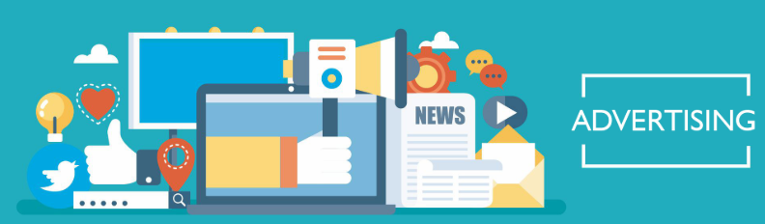
Advertising is when businesses communicate directly with consumers in an attempt to convince them to buy their products. The aim is to inform, persuade, remind, and compete while also trying to get as many customers as possible to buy your products/services.

Advertising Media
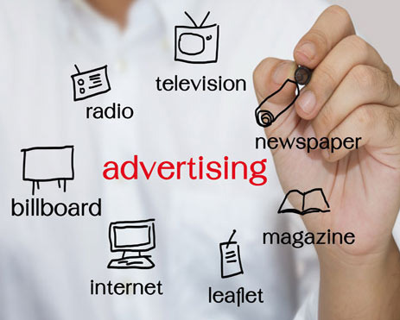
Note-In class we will form a class discussion on the advantages and disadvantages of each form for a business
Selecting an Advertising Medium
- When will the target audience see it- Example Dora the Explorer on tv during the morning
- Nature of the product – Example Washing Powder or cleaning products being seen to work
- The Message- Trade magazines for cars
- The Cost- Depending on size of the business, what is cost effective
- Stage of the Product Life Cycle

Guerrilla Marketing
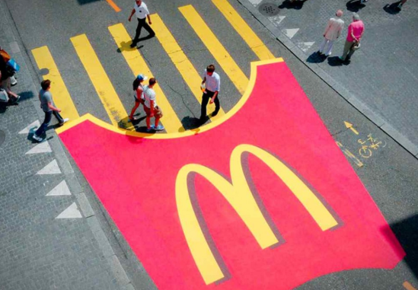
Guerrilla marketing is an advertisement strategy concept designed for businesses to promote their products or services in an unconventional way with little budget to spend. This involves high energy and imagination focusing on grasping the attention of the public at a more personal and memorable level.
2014 Question 7 A.
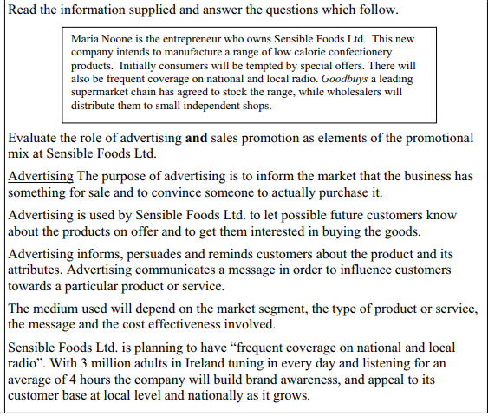
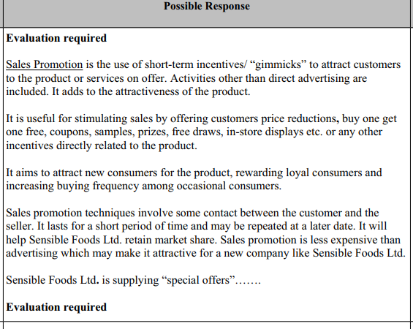
Protecting Consumers:
The CCPC- Illegal to make false claims about goods, services, prices
The Advertising Standards Authority of Ireland
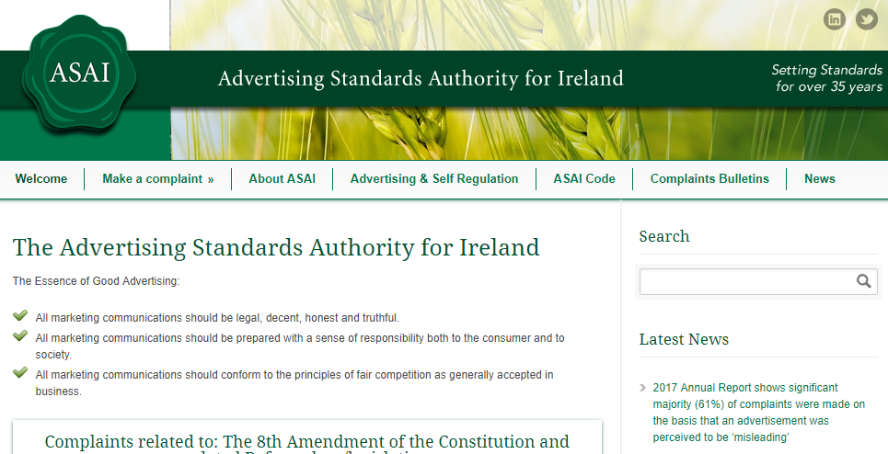
The Advertising Standards Authority of Ireland keeps an eye on the advertising industry to ensure that consumers are protected
Any member of the public can complain to the ASAI in writing. It will investigate the complaint and if it agrees with it, will ask the advertiser to take it down or change it