Marketing
Marketing means identifying consumer’s requirements and identifying how to supply these requirements at a profit. It is finding out what a customer wants and making a product to satisfy these needs profitably
The Marketing Strategy
A marketing strategy is a plan of setting out how a business achieves its marketing objectives
The Marketing strategy will set out a map of marketing goals and how these goals will be achieved. It is usually developed with the different stages of planning in place, and should have both strategic and tactical plans in place
A business Marketing Strategy is outlined below

- Identifying your Target Market
A Target Market refers to all people who might buy a particular good or service. The Target Market will have something in common and are targeted by the advertisers
Example Target Market for Ed Sheeran tickets would be Pop Music Fans, soccer jerseys would be football fans, Dora the Explorer would be children, etc..
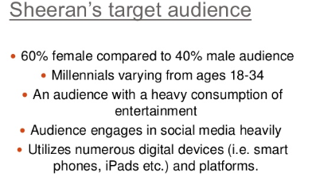

- Market Research
Once you have identified your target market, one of the most important tasks in business is to find out what products and services the consumer needs and wants. To do this they use Market Research, which is the collecting of information about a product and its market and then using that information to make business decisions.
This will give information for a business on important areas such as potential demand, consumer tastes, price sensitivity, competitors’ products, and feedback on existing products
Types of Market Research
Field Research
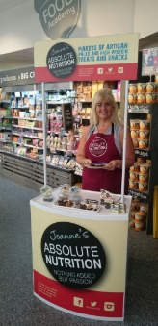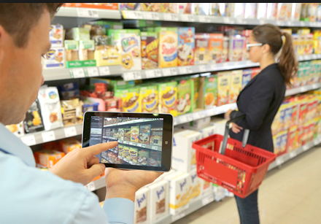
Field Research is primary research, and it involves going into the marketplace and gathering information by making direct contact with existing or potential customers.
Field Research can be expensive and time consuming, but it does allow a business the opportunity to design the questions they need answering themselves and also allows you to directly observe your target market.
Examples of Field Research include:
- Surveys
- Questionnaires
- Taste tests and free samples
- Focus Groups
- Direct Observations
Desk Research
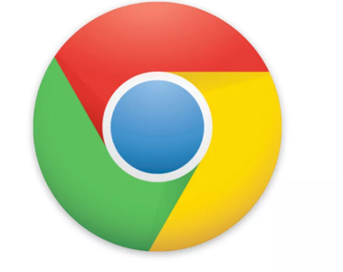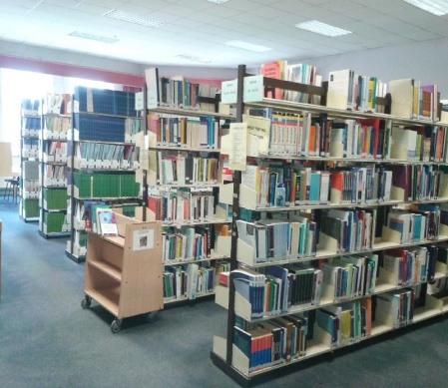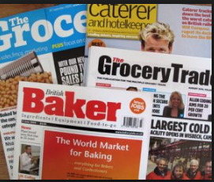
Desk Research is secondary research, where a business accesses information that has already been gathered. The information already exists, so the business does not have to go out to try and find it.
Desk research is relatively cheap, which keeps costs down as the data does not have to be collected. They must however be aware that data can go out of date quickly, and will have no guarantee to the accuracy of the research as there may have been mistakes in recording answers or leading questions
Examples of Desk Research include:
- The internet
- Central Statistics Office
- Trade Magazines
- Libraries
- Business Reports
Market Research Success
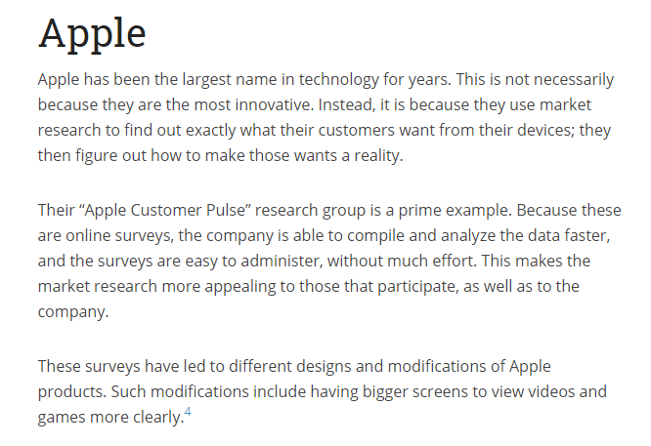
Market Research Failure
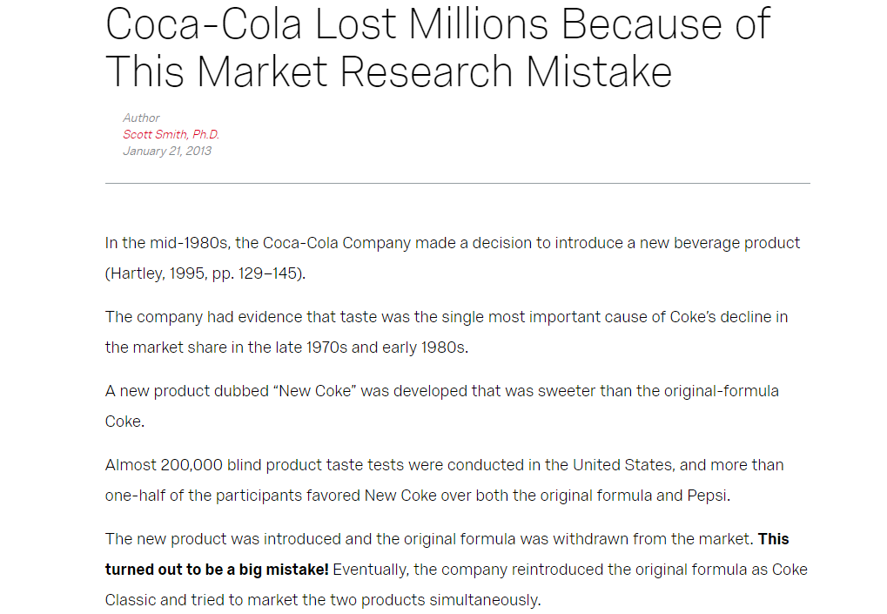
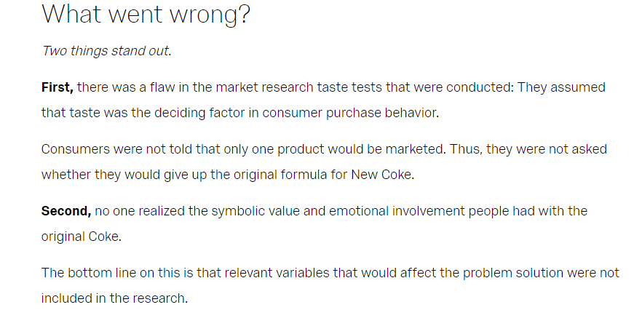

Market Segmentation
Market Analysis can show that your target market can be divided into smaller segments. Market Segmentation involves dividing up the market into clearly identifiable segments that have common characteristics. It allows a firm to identify which segment their target market is by dividing the market into groups of consumers with common needs and then designing and implementing strategies to target them
Reasons for Market Segmentation include:
- Different segments have different spending patterns and disposable income and so segmenting will ensure that different price strategies can be used for the different segments that exist
- Market segmentation helps lower marketing costs as money is not wasted on advertising to segments not interested in their products
- It can help smaller businesses succeed as they can enter a segment of the market that can be highly competitive and try to become an expert- example wedding shoes for the wedding market
The most common ways of identifying a market would be through
- Geographic Segmentation: This is segmenting markets based on where a person is from, like country or county, urban v rural, climate, population growth etc… Think of radio stations like Spin 1038 or LMFM- they are segmented geographically based on where people are from and give local news about those areas

- Demographic Segmentation: This is segmenting markets based on characteristics, such as age, income, gender etc.. You are able to target demographics differently for the same or similar products. Think of Cadbury Chocolate Bars like Freddo, Dairy Milk, aimed at different demographics

- Behavioural Segmentation: This is segmenting our brand loyal v infrequent users. Multipack offers can be offered to frequent users, while individual packets can also be purchased, like Manhattan Popcorn or baked beans

- Psychographic Segmentation: This market is divided into segments based on beliefs, attitudes, social status, and lifestyle. Think about luxury cars or expensive clothes
Sample McDonalds Market Segmentation
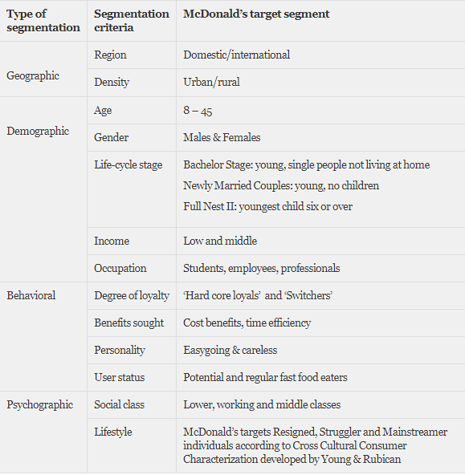
The Marketing Mix
The Marketing Mix consists of the 4 elements that a business can use to persuade consumers to buy their products. They are known in business as the 4 P’s, and they are:

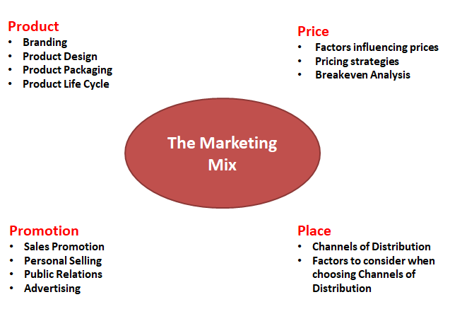
Product
A product can be an idea, a service or a good. Consumer products such as clothes and TV sets are products purchased to satisfy personal and family needs.
Among the issues to be considered concerning product include:
- Branding
- Product Design
- Product Packaging
- Product Life Cycle
Branding
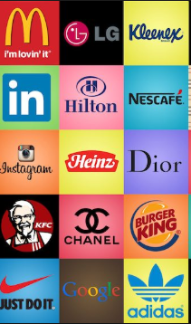
Branding involves the creation of a brand name (Coca Cola, McDonalds, Apple) which the company has the sole right to use. A business can register words, logos, letters and numbers to distinguish from competitors at the Irish Patents Office (e.g. Mr. Tayto).
Brands create a personality for a product, which allows consumers to develop a lifestyle relationship with the products they consume, and also helps the business stand out from their competitors
The Importance of Strong Branding
- Increase Sales
When consumers recognise a brand name, they are immediately drawn to it and it is easier for them to make up their mind to buy the product. Think about the amount of Starbucks there are all around the world- a strong brand name stands out from unknown competition to the buyer
2. Branding can help you win investment
A strong, well-known brand can help you to generate future business, and even increase your business’ value by giving you more leverage in your industry. This makes it a more appealing investment opportunity because of its firmly established place in the marketplace
3. Branding can help you win new customers
A good brand will make it easier for you to win referral business. Strong branding generally means there is a positive impression of your company among consumers, and they are likely to do business with you because of the familiarity and assumed dependability of using a name they can trust.
4. Branding can boost employee pride and satisfaction
When an employee works for a company with a well-respected brand, and they genuinely agree with what your brand stands for, they will be more satisfied with their job and have a higher degree of pride in the work that they do.
Branding your workplace and creating promotional merchandise for your employees to use can help to reinforce the strength of your brand and the values it stands for.
- Brand Loyalty
A well thought out brand will help you build trust with consumers, potential clients and suppliers.
People are more likely to do business with a company that has a polished and professional brand image and lead to brand loyalty and repeat customers
Own Brand Products
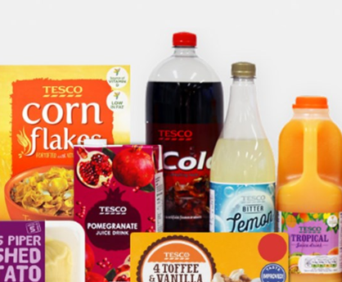
These are products sold by retailers under the retailer’s own name and logo to compete against existing products. Large multiples such as Tesco’s use own label brands e.g. Tesco Milk sold against Avonmore milk in Tescos. These products tend to be cheaper against the competitors.

Product Design
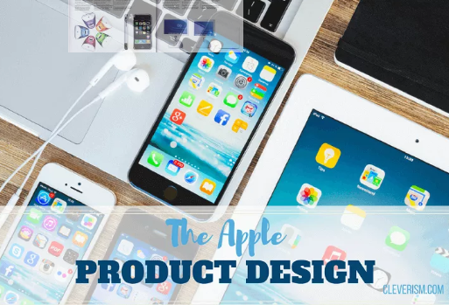
Product Design involves the creation of an attractive product which works. When designing a product, it must be able to do what it is set out to do, and also be aesthetically pleasing in terms of shape and colour etc... The success of Apple Computer's iMac can be attributed to its distinctive features and designs.
Particularly in today’s market where consumers are so self-aware, and with so much competition in the market place, making sure your product design suits the needs of consumers will increase sales and brand loyalty.
The product function and materials must also comply with The Sale of Goods and Supply of Services Act 1980
Product Packaging
Product packaging serves many functions that are useful for a business:
- Protects the product during transit, storage and handling
- It also keeps the product fresh, preserving quality until it is used
- Packaging contains information on contents, ingredients, best before date…
- Products can be instantly recognisable due to the shape of the packaging
- Packaging draws attention through brands and logos, shape and colour
- Packaging can control the size and quantity of a product
- Packaging can increase brand loyalty and self-esteem/self-image for high end goods

Product Life Cycle
Product life cycle - This describes how the market for a product changes over time.
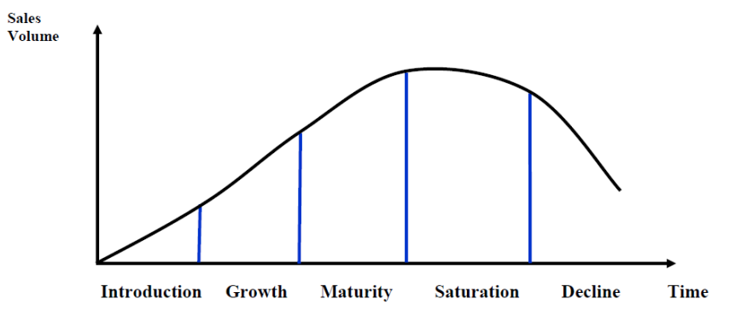
Price
This is how much the customer will pay for the product/service.
Factors influencing Price
Demand: When demand is high, prices will be high. Think of tickets to an All Ireland Final or an Ed Sheeran gig
Production Costs: The price will have to be higher than the cost of producing the product, for example raw materials, expenses, wages etc.. While a business may initially try to sell below cost price to attract customers, it will not be sustainable in the long run
Competitors: Prices will generally need to be in line with what competitors are charging, unless they actively choose an alternative pricing strategy such as premium pricing
Consumers: The type of buyer and their expectations can decide the market- income levels, spending habits etc..
Type of good: Smokers generally are price loyal, but in supermarkets, everyday goods such as bread and milk will generally sell on what is the cheapest
Pricing Strategies
-High Price Strategies
Premium pricing:
Price is set at a high rate than competitors to reflect consumer’s perception of a superior product. It is ideal for small businesses that sell unique products and develop high-quality products. Product may have a unique selling point (USP) or a distinct competitive advantage. Examples would include new BMW, Rolex Watch etc…
Price skimming:
Often most effective in the early days of a product life cycle/very few close rivals/setting high prices during the introductory phase to maximise revenues/help cover R&D costs and lowering the prices as competitor products appear on the market
It cannot last for long as rival products will come on the market. Example would be the new I-Phone when it comes onto the market.
-Low Price Strategies
Penetration Pricing:
Undercut competitors to attract customers. Over time the business may increase their price. Example would be when Tesco came onto the phone market
Predatory Pricing:
This is setting lower prices to push competitors out of the market. It can lead to price wars which is good for the consumer. Example would be Ryanair who reduce prices on popular routes
-Other Pricing Strategies
Bundle pricing: Selling multiple products together at a lower price. Sky packages/Vodafone
Cost plus pricing (mark-up pricing): Price set to cover costs (production, marketing, distribution) and include a target/fixed percentage profit margin.
Tiered pricing: Customers can choose the price level that best fits their budget. They can purchase the basic model car or the luxury model. Can help a business capture a larger portion of the market
Price discrimination: Charging different prices to different market segments for the same product. Cinema tickets/airline tickets
Place
This is about getting the final product to the consumer. It is important to choose a Channel of Distribution which is easily accessible to your target market
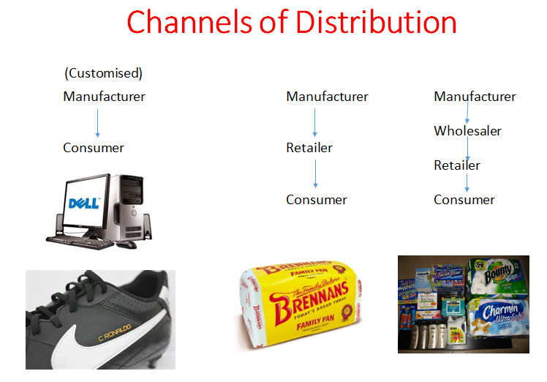Promotion
This refers “to the method made by the business to communicate their product to the target market
