People in Business and Business Relationships
Below are a list of just some of the important Business Stakeholders. These are the people who are affected by each decision that a business makes, and it is important that a business keeps the needs of their stakeholders in mind.
Stakeholders
A stakeholder is anyone effected by the day-day running of a business.

Who are the main stakeholders in business?
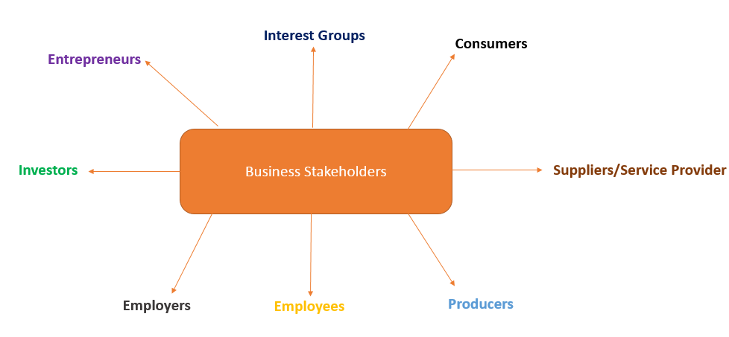

The role of the Entrepreneur
An Entrepreneur is someone who spots a gap in the market, takes a risk, and sets up a business. They can either make a profit or a loss, depending on how successful their enterprise is.
Famous examples of entrepreneurs in 2022 can be seen below:
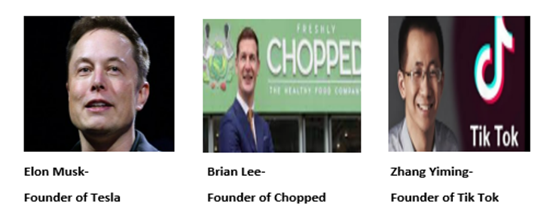
When an entrepreneur sets up a business they face 2 risks:
1. Personal Risk – The risk that if the business fails they will lose their confidence/ motivation to succeed or reputation in the market.
2. Financial Risk – The risk that if the business fails they will lose any capital they have invested.

The role of the Investors
These are the people who put money into a business in return for an investment payment in the future. The Dragons on Dragons Den would be typical examples of investors.
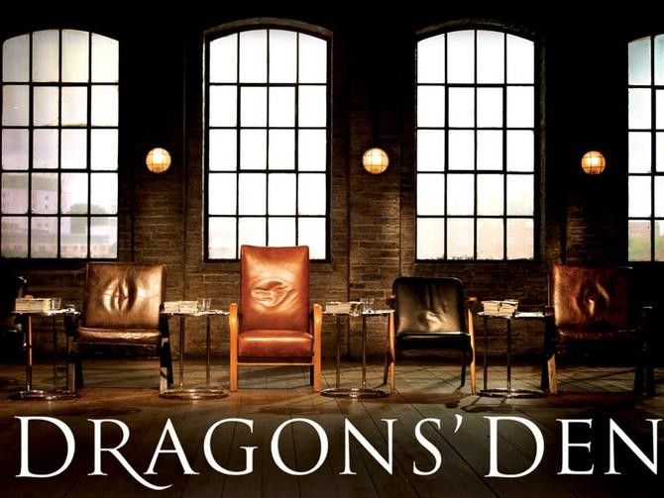
The investor lends money to the entrepreneur in 3 ways:
1. Debt Capital – The entrepreneur has to repay the investor all money they have received as well as paying them interest.
2. Equity Finance – The investor buys shares in the entrepreneur’s business. The investor is now known as a shareholder and owns a percentage of the business.
3. Grants- These are non-repayable sums of money from agencies such as Local Enterprise Offices (LEO’S). The capital does not have to be repaid as long as the conditions for the grant has been met- e.g., create 100 new jobs.

The role of the Employers
An employer is someone who hires employees to work for them. They usually look after the day-day activities of the business. An example of an employer would be the local Costa or Supervalu.
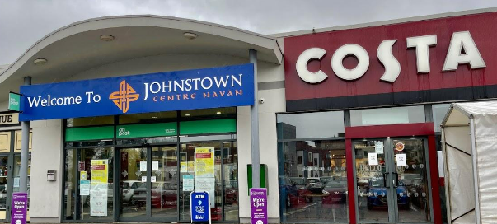
By law, employers must:
1. Provide employment contract
2. Provide proper working conditions
3. Pay agreed wages

The role of Employees
An employee is someone who brings their skills/expertise to a business in return for a wage/salary. An example of an employee would be your teachers who are working for LMETB.
By law, employees must:
1. Do an honest day’s work
2. Not break the terms and conditions in the contract employment
3. To accept and carry out reasonable instructions from management
The role of the Producers
A Producer is a business that manufactures goods for the market. They take raw materials and produce finished goods. Example Cadbury’s produce chocolate for the market.
The producer would not survive without the consumer. Therefor they must provide the consumer with good prices, good service and top-quality products. In competitive markets, if these are not provided by the producer, the consumer may choose alternative products/ go to the competition.
Producers can also work with each other- for example during Covid a number of fast food restaurants shared market research costs on the industry as people were not buying as many goods and services at that time.

The role of the Suppliers/Service Provider
These are the suppliers of raw materials and other support services to a business. Examples would be suppliers of wheat to a baker or a delivery service of products, or an external accountant to do your books.
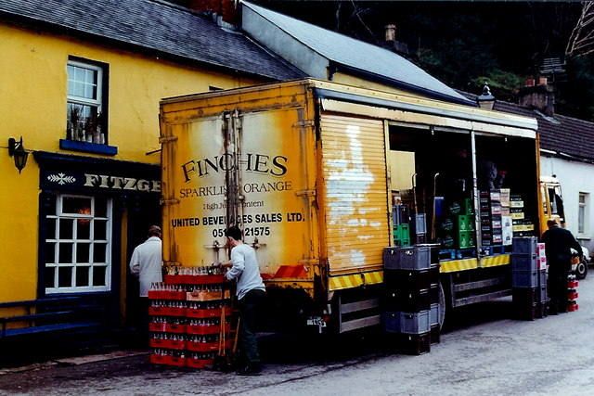
A supplier/service provider can save a business money/provide expertise they do not have in trying to do the job themselves.

The role of the CONSUMER
A consumer is somebody who buys a good for their own personal use- Example-buying a new pair of jeans for yourself in H&M .
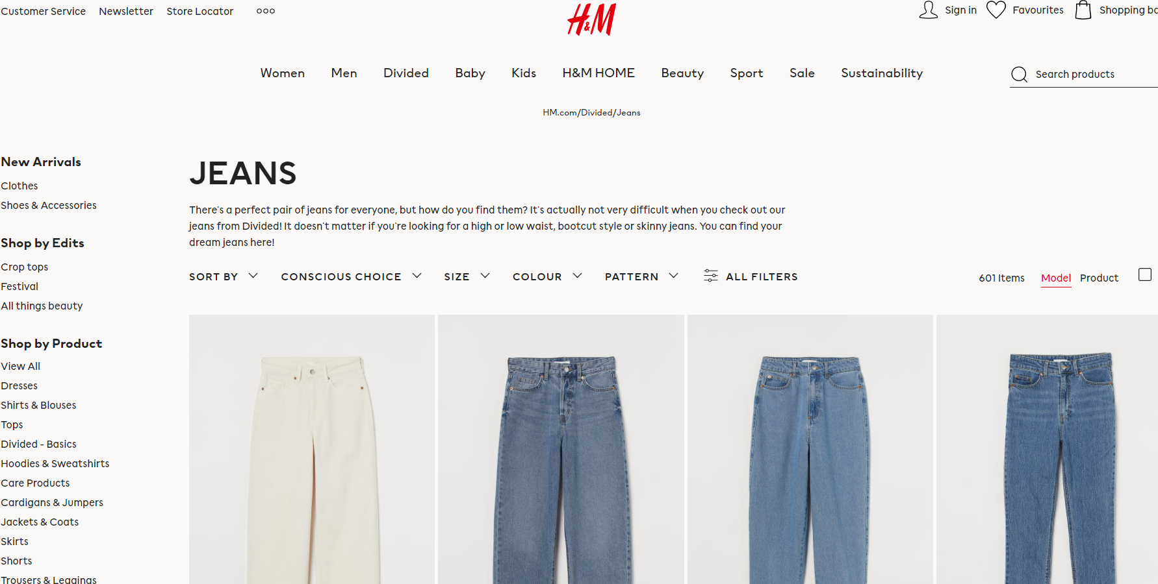
- Without the consumer there would be no market. They are the most important business stakeholder
- They look for good prices, good service and top-quality products
The role of the Interest Groups
Examples of Interest Groups:
1. The Irish Congress of Trade Unions (ICTU) fights for the rights of Irish workers.
2. Consumers Association of Ireland
3. Irish Farmers Association
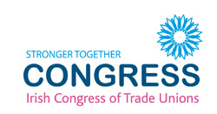
In order to get what they want they pressurise the government and businesses to change their practises. This is done through:
1. Lobbying
They lobby politicians through petitions, letters and protests. It is putting pressure on a stakeholder who have powers to make decisions
2. Boycotts
They organise boycotts & publicity campaigns against businesses who act in an unethical manner
Stakeholder Relationships
All stakeholders have different relationships with each other. The main ones are as follows:
1. Co-operative Relationship
2. Competitive Relationship

1. Co-operative Relationship
This involves both parties working towards shared goals and for mutual benefit. A cooperative relationship is a win-win situation.

Example:
A co-operative relationship may exist between investors and entrepreneurs. Investor wants the entrepreneur to be as successful as possible to get more money and therefore will help them in any way possible. An entrepreneur wants to be successful so that they can attract investment in the future and therefor works alongside the investor towards a shared goal.
A business that pays their staff very well may receive a high level of work rate and commitment to the job.
2. Competitive Relationship
This involves two or more rival parties. They both want to be successful but this is impossible. There is only one winner in a competitive relationship.
Example:
Rival producers compete with each other for consumers to choose their products. Example- Cadbury and Nestle both compete with customers for them to pick their brand of chocolate bar.
The shareholders of a business may only pay their employees minimum wage in order to keep money to invest in other parts of the business.
Questions
- On your I-Pad, take one of the above stakeholders and state why you think that particular stakeholder is important for a business.
- Write down some of the differences between stakeholders and shareholders.
- Describe examples of cooperative and competitive relationships that might exist between the following:
- Investor and Entrepreneur
- Two rival producers such as Cadburys and Nestle
- Employer and Employee
- Producer and Consumer

