People in Business
In this chapter, we will be examining the following:
- What is a business?
- Business Stakeholders
- Interest Groups
- Stakeholder Relationships
- Contract Law
What is a Business?
A business is an organisation that is set up to provide goods & services. Their goals can vary from for example a commercial business’s goal is to make a profit and increase their market share etc…
Business Stakeholders
A stakeholder is anyone effected by the day-day running of a business.

Who are the main stakeholders in business?
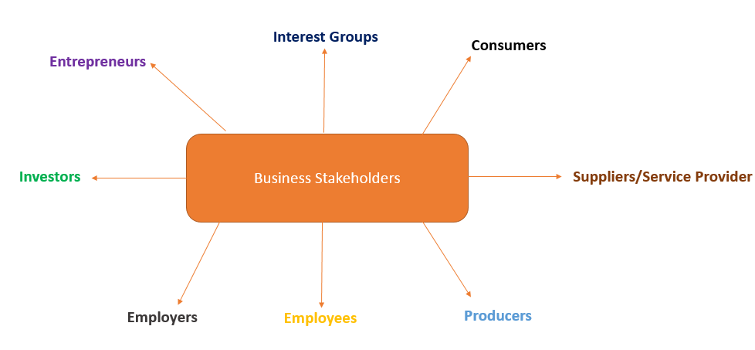

The role of the Entrepreneur
An Entrepreneur is someone who spots a gap in the market, takes a risk, and sets up a business. They can either make a profit or a loss, depending on how successful their enterprise is.
Famous examples of entrepreneurs in 2022 can be seen below:
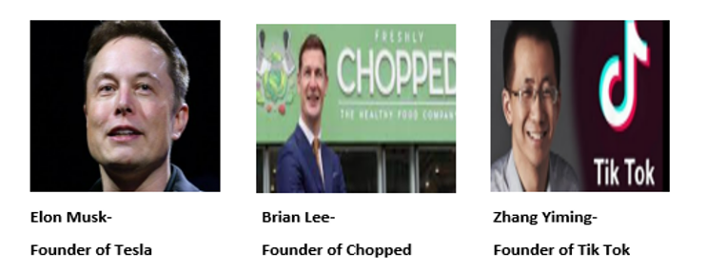
When an entrepreneur sets up a business they face 2 risks:
1. Personal Risk – The risk that if the business fails they will lose their confidence/ motivation to succeed or reputation in the market.
2. Financial Risk – The risk that if the business fails they will lose any capital they have invested.

The role of the Investors
These are the people who put money into a business in return for an investment payment in the future. The Dragons on Dragons Den would be typical examples of investors.
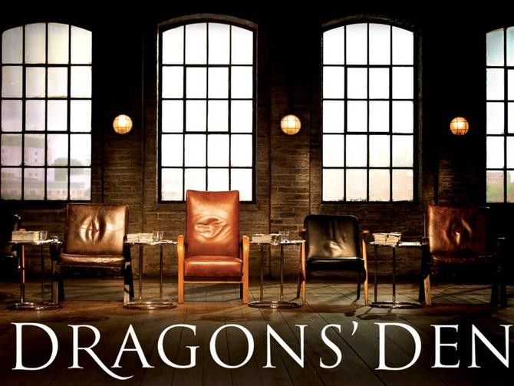
The investor lends money to the entrepreneur in 3 ways:
1. Debt Capital – The entrepreneur has to repay the investor all money they have received as well as paying them interest.
2. Equity Finance – The investor buys shares in the entrepreneur’s business. The investor is now known as a shareholder and owns a percentage of the business.
3. Grants- These are non-repayable sums of money from agencies such as Local Enterprise Offices (LEO’S). The capital does not have to be repaid as long as the conditions for the grant has been met- e.g., create 100 new jobs.

The role of the Employers
An employer is someone who hires employees to work for them. They usually look after the day-day activities of the business. An example of an employer would be the local Costa or Supervalu.
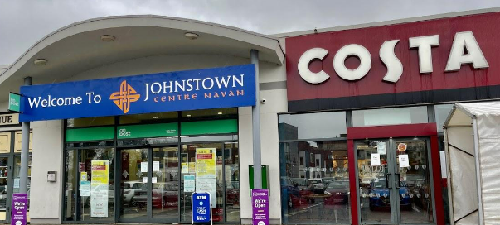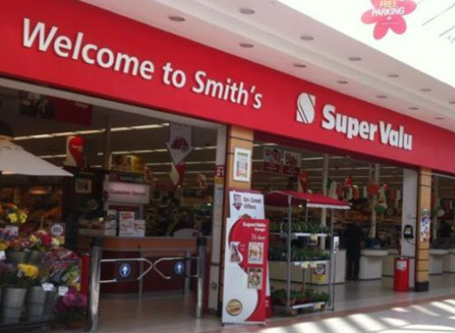
By law, employers must:
1. Provide employment contract
2. Provide proper working conditions
3. Pay agreed wages

The role of Employees
An employee is someone who brings their skills/expertise to a business in return for a wage/salary. An example of an employee would be your teachers who are working for LMETB.
By law, employees must:
1. Do an honest day’s work
2. Not break the terms and conditions in the contract employment
3. To accept and carry out reasonable instructions from management
The role of the Producers
A Producer is a business that manufactures goods for the market. They take raw materials and produce finished goods. Example Cadbury’s produce chocolate for the market.
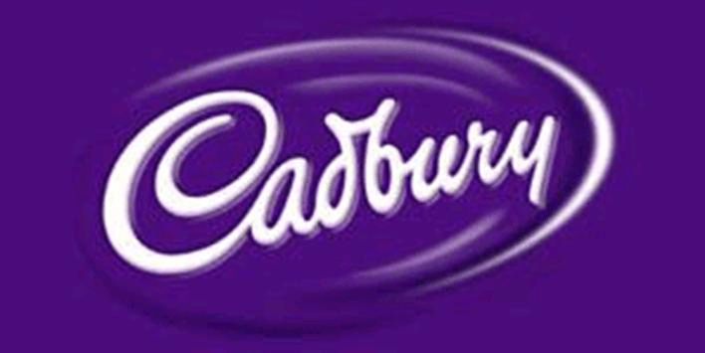
The producer would not survive without the consumer. Therefor they must provide the consumer with good prices, good service and top-quality products. In competitive markets, if these are not provided by the producer, the consumer may choose alternative products/ go to the competition.

The role of the Suppliers/Service Provider
These are the suppliers of raw materials and other support services to a business. Examples would be suppliers of wheat to a baker or a delivery service of products, or an external accountant to do your books.
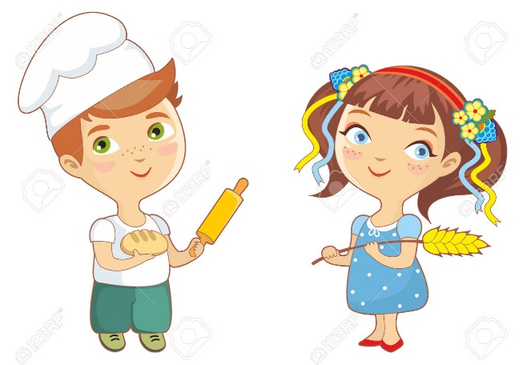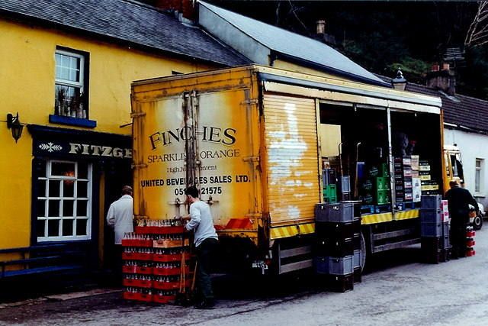
A supplier/service provider can save a business money/provide expertise they do not have in trying to do the job themselves.

The role of the CONSUMER
A consumer is somebody who buys a good for their own personal use- Example-buying a new pair of jeans for yourself in H&M .
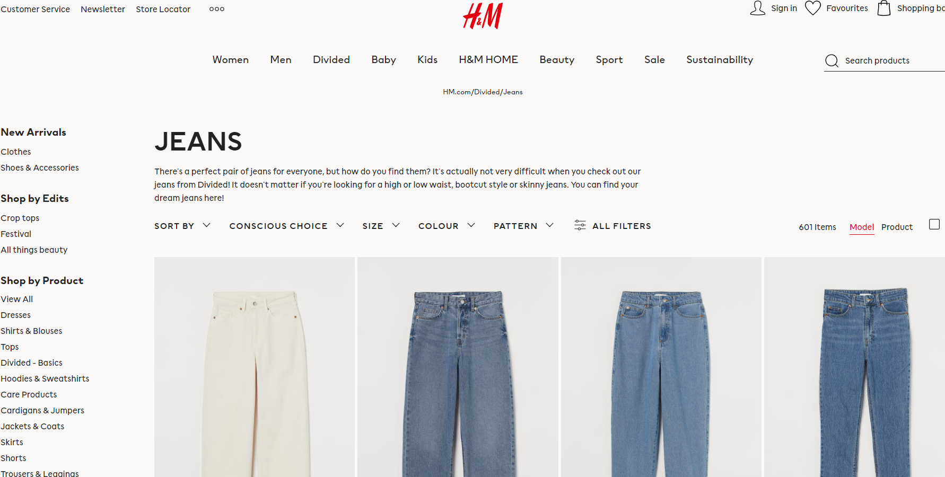
- Without the consumer there would be no market. They are the most important business stakeholder
- They look for good prices, good service and top-quality products

The role of the Interest Groups*
An interest group is a group of people who meet and campaign for a common goal, as they achieve more by working together (collective bargaining). They combine capital and resources to pressurise decision makers using strategies such as boycotting, lobbying, and running publicity campaigns.
By joining forces, they have more power, more money and more talents at their disposal and so are more likely to be listened to by the decision-makers.
In other words, in order to get what they want they pressurise the government and businesses to change their practises.
1. Lobbying
They lobby politicians through petitions, letters and protests. It is putting pressure on a stakeholder who have powers to make decisions
2. Boycotts
They organise boycotts & publicity campaigns against businesses who act in an unethical manner
Examples of Interest Groups:
Business Interest Groups represent the interests of businesses. They attempt to influence trade unions, the Irish Government, the EU and the wider society on issues relevant to the businesses like legislation, taxation, wages and conditions. They campaign/ lobby to get their way and influence decision makers by lobbying to meet their objectives They might also provide economic or strategic advice. For example: the IBEC (Irish Business and Employers Confederation)
Trade Associations are business interest groups that represent businesses involved in certain types of activities. For example: the Irish Farmers Association, which represents farmers and is very active in lobbying decision-makers at national, as well as EU level since farming is huge in Ireland.
Trade Unions are organizations that represent the interests of employees in a business on issues concerning pay or conditions of employment
Environmental and specialist interest groups represent the interests of members of society who want to prevent undesirable activities or to promote some cause they believe is important. For Example: Greenpeace represents those concerned about environmental issues.
- The Irish Congress of Trade Unions (ICTU) fights for the rights of Irish workers.
- CAI (Consumers Association of Ireland)- fight for rights of consumers
- IFA (Irish Farmers Association)- fight for rights of farmers
- IBEC (Irish Business and Employers Confederation) – Business Interest Group
- ISME (Irish Small and Medium Enterprises) – Business Interest Group
- SIMI (Society of the Irish Motor Industry) – Trade Association
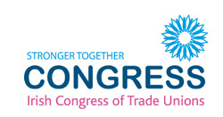

Stakeholder Relationships
All stakeholders have different relationships with each other. They are as follows:
1. **Cooperative Relationship**
2. **Competitive Relationship**
3. Dependent Relationship
4. Dynamic Relationship

1. Cooperative Relationship
A Co-operative Relationship is where both parties are working towards shared goals and for mutual benefit. A cooperative relationship is a win-win relationship for each stakeholder.
Example:
A co-operative relationship may exist between investors and entrepreneurs. Investor wants the entrepreneur to be as successful as possible to get more money and therefore will help them in any way possible. An entrepreneur wants to be successful so that they can attract investment in the future and therefor works alongside the investor towards a shared goal.
Other Cooperative examples between stakeholders
- Employees working together as a team to increase sales/ team goals
- A fair wage, which reflects work being done and qualifications and skills of employees, is offered by the employer and a fair day’s work is provided by the employee. The employer benefits from higher profits and increased motivation and the employee benefits with good pay and working conditions.
- Two businesses working together in market research- e.g. Renault and Volkswagen share the cost of a report into the cost of inflation in the car market
- All financial information provided by the manager to investor is accurate and up to date. The manager uses the investment appropriately. The investor will benefit from seeing that their investment is safe and the manager will find it easier to acquire the necessary finance to fund new projects.
- A co-operative situation would arise when the supplier provides good quality raw materials, components and finished goods to the purchasing manager who pays on time and offers a fair price.
- Producer charges a fair and reasonable price for a product/service and the consumer continues to use it. The Producer rewards their customers and treat them with respect, in return for brand loyalty.
- The supplier provides good quality raw materials, components, and finished goods to a business who, in turn, pays the suppliers on time and importantly offer a fair price to supplier
- Local business co-operates with local community when it reduces environmental waste and increase local employment

2. Competitive Relationship
A Competitive Relationship involves two or more rival parties. They both want to be successful but this is impossible. There is only one winner in a competitive relationship. It is known as a win-lose relationship.
Example:
Rival producers compete with each other for consumers to choose their products. Example- Cadbury and Nestle both compete with customers for them to pick their brand of chocolate bar.
The shareholders of a business may only pay their employees minimum wage in order to keep money to invest in other parts of the business.

Other Competitive Relationship examples between stakeholders
- Business is competitive with other firms for quality of goods, price, recruitment, customers, advertisements etc. (Aldi v Tesco)
- Employees battle with each other for promotion
- Employers versus employees in wage negotiations/working conditions
- Government and businesses at odds over tax rates such as VAT rates
- Two producers competing for sales/quality of service- e.g., to be the best in the market/ quality of products they offer (Renault v Volkswagen)
- Investors and entrepreneurs are competitive when an entrepreneur wants to expand the business but the investor wants a return on their investment
- Businesses and interest groups may clash over issues like environment, pay and working conditions, financial assistance
- Consumers and businesses clash over price/quality/service
- Interest Groups – e.g. Government v Trade Unions over increased wages in line with inflations
- Supplier and Purchasing manager compete over quality of goods/paying on time
- Consumers and Producers are sometimes in conflict because the consumer wants low/competitive prices and high quality while the producers want high prices and high profits

3. Dependent Relationship
This involves two or more parties that cannot achieve success on their own. The success of one party depends on the actions of the other party. If one fails so does the other.
Example: A dependent relationship exists between consumers and producers. If consumers stopped buying goods then there would be no demand for producers’ products and they would go bankrupt.

4. Dynamic Relationship
This is a relationship that is likely to change over time.
Example: Consumer and Producer
The relationship between both parties is good is goods are delivered on time and are I good condition. A bad relationship can result from goods arriving late and being in damaged

Typical Exam Question
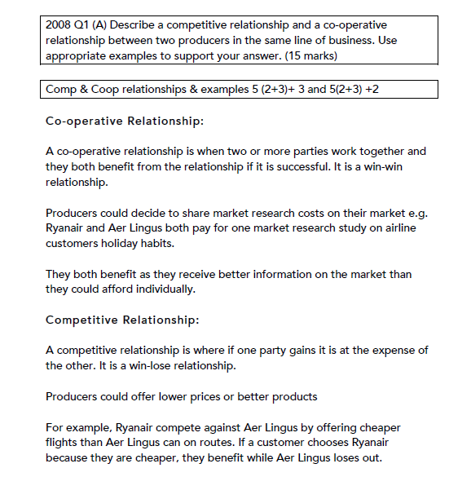
2015. 1. A.
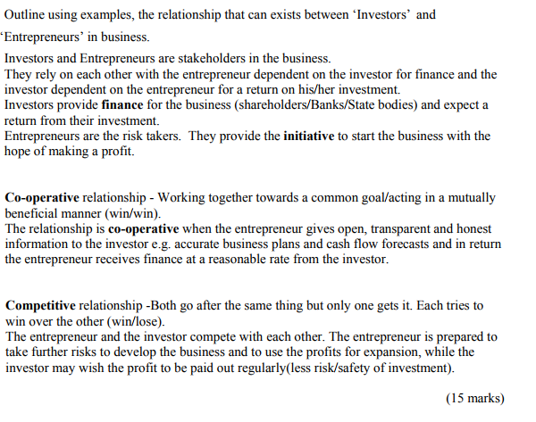

The Law of Contract
These must be learned off and in order- can be asked as Exam Question!!
Structure as you see them presented.
A Contract
This is a legally binding agreement made between parties who have the power to undertake such a contract when buying or selling goods or services.
This means that if one party breaks an agreement, a judge can order that party to pay compensation to the other party.
The following are the main elements of the contract:
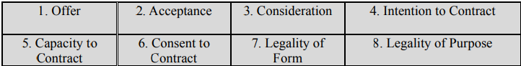
- Offer
This can be an offer to buy or sell a good or service. It can be made orally, in writing or by action.
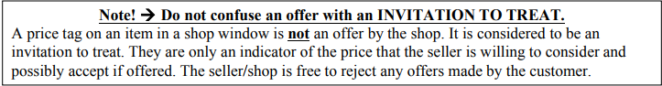
The offer must be made in a clear and final manner, and must be communicated by the offerer to the offeree so that the person receiving the offer can either accept or reject it
Example: Jim is selling his bike for €200. Lee offers Jim €200 for the bike.

The Termination of an Offer
This can occur in the following ways;
a) Revocation
If the offer is taken back (revoked) by the offerer prior to acceptance. Revocation cannot occur after acceptance- example if the price in the window is marked incorrectly
b) Lapse
The passage of time or the death of one of the parties may cause the offer to lapse and so cannot be accepted
c) Rejection
This may be expressed when notice of the rejection is given to the offer- example a bid for a house is rejected and the bid is withdrawn

2. Acceptance
Acceptance is when a party who receives an offer agrees to all the terms of the deal without any conditions.
• They can accept it by speaking, in writing or by conduct and it then becomes legally binding. The party who receives the offer must accept all the conditions exactly as the contract lays them out and cannot change them.
• To change any conditions is called a counter offer. A counter offer is considered as a new offer and also as an automatic rejection of the first offer.
Example: Jim is selling his bike for €200. Lee offers Jim €200 for the bike. Jim accepts the offer and there is a handshake. This is an agreement.

3. Consideration
Something of value moves between both parties. The acceptance of an offer must be accompanied by payment (cash, cheque, etc) moving in one direction and in goods or services moving in the other direction.
Example: In the bike deal Luke pays John €200 for the bike. This is consideration.
4. Intention to Contract
The parties signing or agreeing to a contract must know that they are entering a legal agreement which cannot be broken. There must be an intention by both parties to create a contract or legal agreement. They could end up in court if the contract is broken.
Example: If one company agrees that they will supply toilet rolls for a music festival, they are bound to supply the toilet roll on time.

5. Capacity to Contract
The parties to a contract must have the legal ability to make the contract.
The following do not have the capacity to contract:
- Those under 18- (although can for normal day-day items, e.g. food)
- Persons under the influence of alcohol or drugs
- Persons of unsound mind
- A bankrupt person
- Company directors without consent from other partners- this is known as acting Ultra Vires

6. Consent to Contract
All parties entering into a contract must do so on their own free will.
• One party cannot force another into a contract.
• Both parties must understand the conditions of the contract.
Example: You cannot be bullied (by threat or intimidation) into selling your own house

7. Legality of Form
This refers to the manner in which the contract is made- must be legal
  - Contracts can be made orally – simple contracts
  - Contracts may have to be written down due to their complexity- example would be for a house there must be a written contract for it to be legal

8. Legality of Purpose
For a contract to be valid it must be for a legal purpose
ie. it must comply to the laws of the land
Example: A judge will not reward damages to a person if their drug dealer failed to supply them the drugs they paid for.

Termination of the Contract

1. Agreement
The termination of a contract when all parties involved agree to cancel the contract before it is carried out. This happens when neither party benefit from the completion of a contract.
Example: A footballer has their contract cancelled by mutual consent.

2. Specific Performance
If both parties to the contract fulfil their contract obligations, the contract has been completely performed.
Example: U2 are paid €2,000,000 to perform at Croke Park. Upon full payment and completion of the concert the contract is terminated as both parties have fulfilled their obligations.

3. Frustration
A contract comes to an end if some unforeseen event occurs which makes it impossible to carry out the contract. Neither party is to blame.
Example: A U2 concert cancelled due to war breaking out in a country and it is impossible to fulfil the date.

4. Breach of Contract
If either parties fail to carry out their part of the agreement the contract will be terminated, this happens when they break a condition of the contract. This is known as a breach of contract.
Example: If Bono doesn’t show up the contract is in breach and they broke an essential condition of the contract.
Sample Exam Question
Breach of Condition v Breach of Warranty
A condition is an essential element which goes to the heart of the contract. Breach of conditions are effectively breaking the contract.
Example: U2 don’t show up for a Concert. This is a breach of condition. The contract is terminated and the concert organisers can sue U2.

Warranty
A warranty is a less important part of the agreement. A breach of warranty will often not break the contract. Breach of warranty generally results in a fine.
Example: U2 don’t show up for sound checks on the day of the concert. This is a breach of warranty. The contract is not terminated and the concert still goes ahead. U2 may be fined for this breach of warranty.
Remedies for Breach of Contract
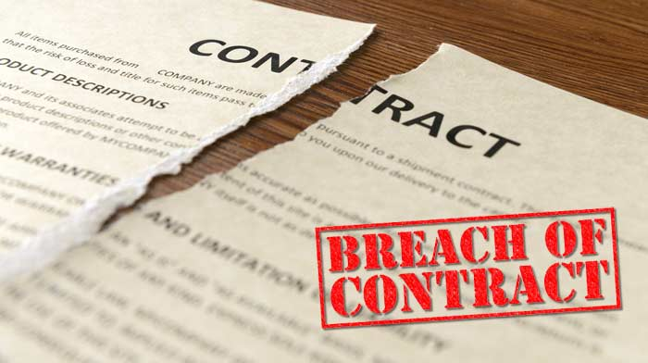

Breach of Contract is when any condition of a contract is broken.
1. Sue for Damages
The aggrieved party takes the other party to court. The aggrieved party receive financial compensation for the loss suffered because of the breach. This is known as suing for damages.
Example: The Concert organisers sue U2 for damages and loss of potential earnings through ticket and bar sales.

2. Specific Performance
This involves the judge ordering the contract to be carried out as had been agreed. If the contract is not carried out as agreed the aggrieved party may then sue for damages.
Example: U2 redo the concert at a later date.

3. Rescind the contract
The contract be cancelled. Both parties return to exactly the same position they were in before the contract started. This is a common remedy for contracts involving frustration.
Example: U2 repay the concert organisers the €2,000,000 and both parties go their separate way.

4. Agreement
Both parties agree to cancel the contract before it is carried out. Both parties agree to the contract being terminated and so the contract is annulled.
Example: A contract with a builder is terminated before work begins, it suits you and it suits the builder.

