Statement of Financial Position: Ratios
Stakeholders affected by a business performance
Management
They will want information to know how the business has performed over the year and to learn if any changes are needed. This will help make decisions if needed

Shareholders
They will want to know if the money that they have put into the business has been used wisely by the firm in order to generate profits and pay them a dividend

Banks
They want to know if the business is profitable enough to be able to make loan repayments and interest repayments

Trade Unions
They will keep an eye on the company’s profits because if they know the business is doing very well, they may look for wage increases

Suppliers
These are interested in a business’s accounts in order to assess the firm’s credit-worthiness

Employees
Will want to see if the firm is performing well for job security and promotion prospects

So why does a business need Ratios?
In the same way that a doctor examines a patient to find out what is wrong with him, a business must examine their accounts to make sure that it is in a healthy position.

In previous chapters we learned about Final Accounts for an organisation. In this chapter we learn about the ratios that can be used to assess performance.
There are 3 main Ratio Categories:
Profitability- Measures profits made by a business (3)
Liquidity- Ability to pay short term debts as they fall due (2)
Gearing-Looks at where the money comes from to run the business- the Financed By section. Having a lot of Debt Capital (Loans) can be a problem for a business as it must be repaid and has interest. (1)
You can see the key Ratio Headings and figures based on the 2022 Mock Question below:
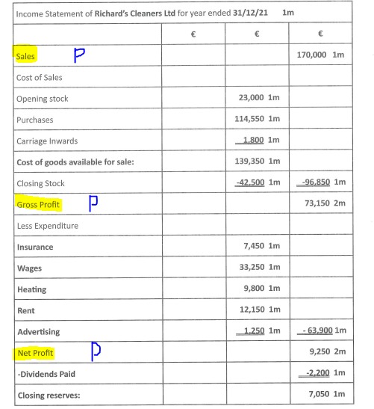
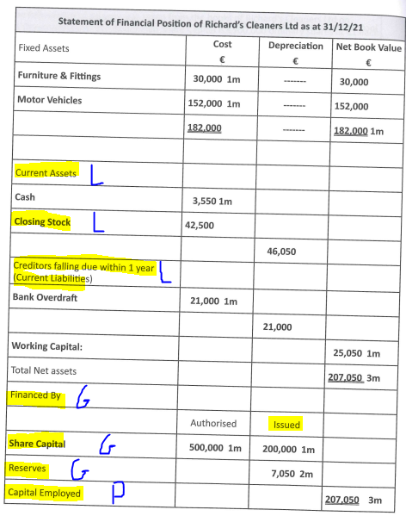
Note* 2022 did not contain a loan (Debt Capital)
- Profitability Ratios
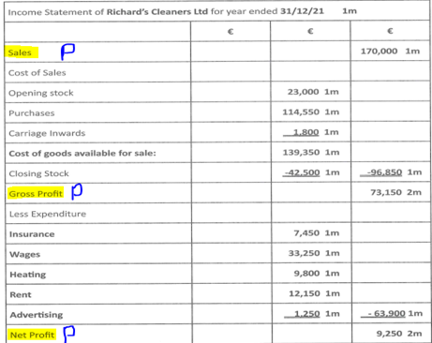

Ratio Number 1: Profitability
Profitability: This measures how successful the management of a business has been in making a profit
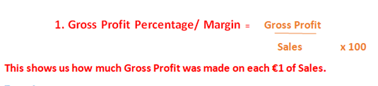
73, 150/ 170,000 x 100/1 = 43.03%

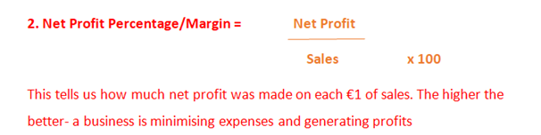
9,250/170,000 x 100/1 = 5.44%

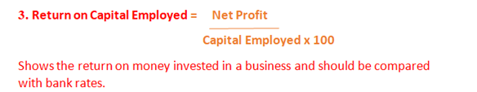
9,250/207,050 x 100/1 = 4.47%
(This should always be compared with the risk free option offered by banks)

Ratio 2: Liquidity
Liquidity: This is the ability of a company to pay off its debts as they fall due.
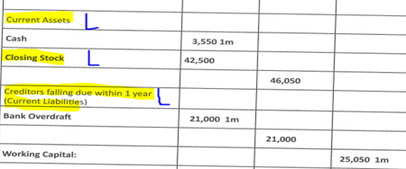
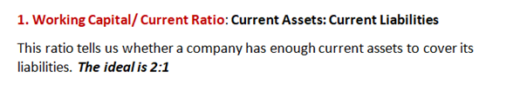
46,050:21,000
2.19:1

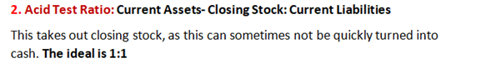
46,050-42,500: 21,000
3,550: 21,000
0.17:1
(Big problem, a lot of money tied up in closing stock, may be difficult to sell)

Ratio 3: Gearing
Gearing: This ratio measures the amount of debt equity (loans) in a business compared to Equity Capital (Issued share capital and Reserves)
The formula for the Debt: Equity Ratio is:
Long Term Loans: Issued Share Capital + Reserves
These figures can be found in the Financed By section in the Statement of Financial Position
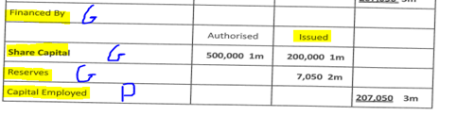
The ideal position is 1:1 or below.
Debt: Equity Capital =
Long Term Loans: Issued Share Capital + Reserves
0: 200,000 + 7,050
This company did not have any debt capital, therefore:
Debt/Equity Ratio is 0.

We will now put all of these ratios into practice and be in a position to make comments with practice questions in class.

