Ratio Notes/Questions Booklet
Ainm:
Please complete the following tables for the six ratios you have studied in Leaving Cert Business.
- Profitability
Ratio | Formula | Definition | Advice
Gross Profit Margin/Percentage |  | Gross Profit Margin shows the percentage of profit on all items sold before expenses are taken into account- it is the profit percentage from all trading (buying and selling)
Net Profit Margin/ Percentage |  | Net Profit Margin shows the overall percentage profit for the business after covering all costs, including expenses
Return on Investment/Return on Capital Employed |  | The Return on Investment/Return on Capital Employed measures the level of profit the business can generate from money invested in it.  (Always compare to the  risk free interest rates). | High  Low
- Liquidity
Ratio | Formula | Definition | Advice
Current Ratio |  | It compares current assets with current liabilities. The firm would want its current assets to be greater than its current liabilities.  Ideal Ratio: | If below ideal or worsening trend, they may need to solve this problem by sourcing cheaper suppliers or stop selling goods on credit.
Acid Test Ratio |  | Ratio that takes into account the fact that stock may not always be easily and quickly converted into cash.  Ideal Ratio: | If below ideal or acid test is worsening from last year than the trend indicates that the firm’s liquidity position is worsening, corrective action must be taken such as selling excess stock at a discount.
- Gearing
Ratio | Formula | Definition | Risk of High Gearing
Gearing Ratio |  | Examines the types of long-term finance or capital being used- what proportion of capital is made up of Long Term Loans and what proportion is made up of Retained earnings/Reserves and Ordinary/Issued Share Capital. | 1.  2.
Theory Questions
- Give three reasons why ratios are prepared:

- Explain why the following stakeholders may be interested in financial information.
Management
Shareholders
Banks
Trade Unions
Competitors
Suppliers
Employees
Government

- Give three limitations of Ratio Analysis:

Questions and Workings
- Profitability- Gross Profit Margin and Net Profit Margin
Ordinary Level
Sample Questions
Make sure to always show formulas workings

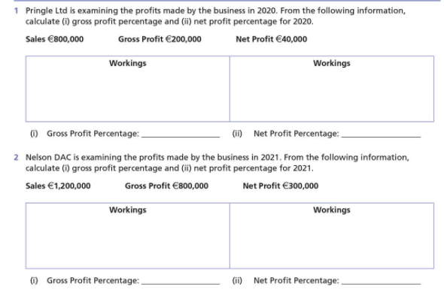
- Work out Gross Profit and Net Profit Percentage from the following figures presented in the year 2023.
Sales €400,000 Gross Profit €250,000 Net Profit €50,000
Workings | Workings

Higher Level
Sample Questions
*Gross Profit- Expenses = Net Profit*
Gross Profit Margin

In 2022 Value Ltd had a gross profit margin of 25%. Using the figures below calculate Value Ltd.’s gross profit margin for 2023.
Net Sales: €900,000
Expenses: €150,000
Net Profit: €150,000
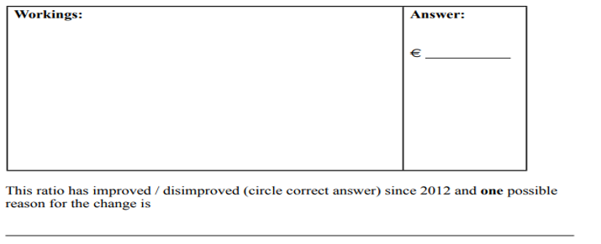
2022
B.
In 2022 Risk Ltd had a gross profit margin of 30%. Using the figures below calculate Risk Ltd.’s gross profit margin for 2023.
Net Sales: €800,000
Expenses: €50,000
Net Profit: €150,000
2022
2014 Mock
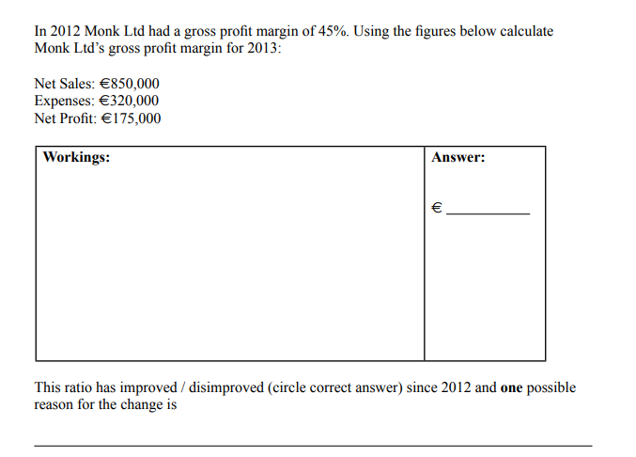

Net Profit Margin
2023 Mock
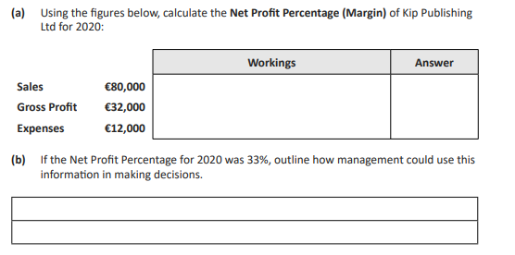

2015 LC
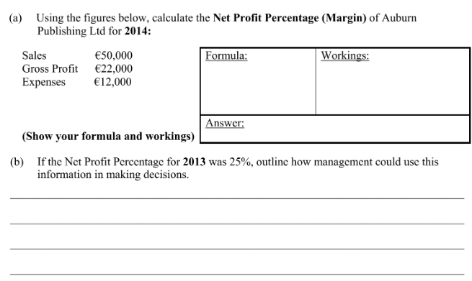
2017 Mock
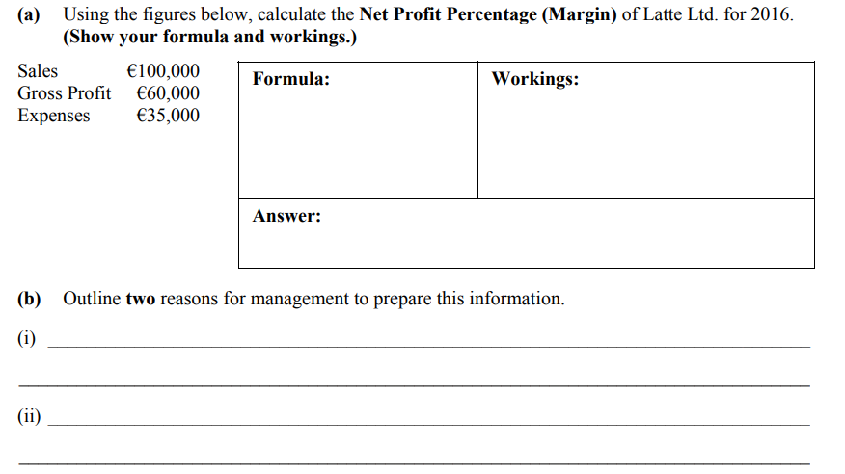
Profitability- Return on Investment/Return on Capital Employed
- The Return on Investment/Return on Capital Employed measures the level of profit the business can generate from money invested in it
- It is often compared with the interest rate on offer from the banks-typically 2-4%
- If it is less than interest rate that could be earned in bank investors may choose to take money back out of company
- Capital Employed is made up of the Gearing Ratio numbers added together-
Long Term Loans + Retained Earnings/Reserves + Issued/Ordinary Share Capital=
Capital Employed
2019 Mock
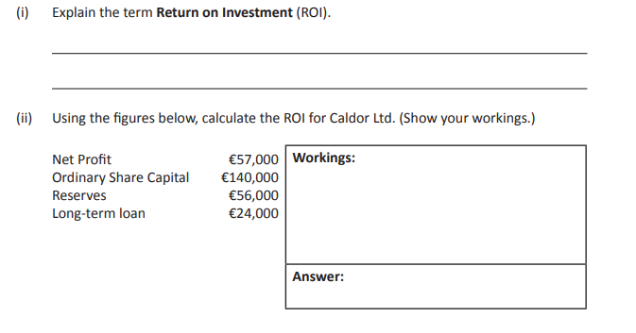
Sample Question
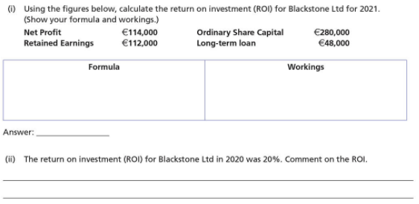
2021 LC
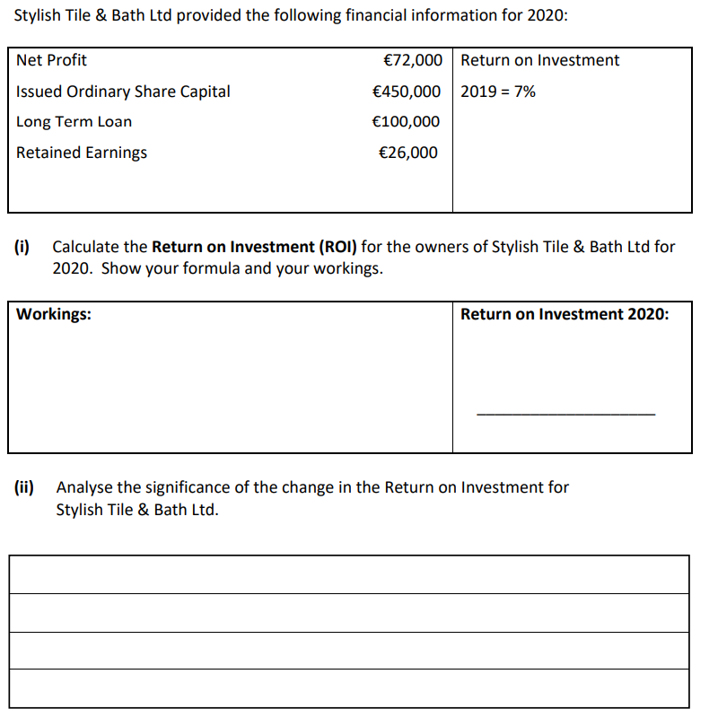
Profitability Ratio Long Questions: (OL)
- For Griffin Ltd, calculate both Gross Profit Margin and Net Profit Margin and comment on the trends.
The following figures have been taken from the Books of Griffin Ltd.
 | Year 1 € | Year 2 €
Sales | 230,000 | 276,000
Gross Profit | 138,000 | 151,800
Net Profit | 92,000 | 73,600
Answer
- Gross Profit Margin
Gross Profit Margin Formula =
Year 1 | Year 2
Answer: | Answer:

Gross Profit Margin- Comment on the trend
- Net Profit Margin
Net Profit Margin Formula =
Year 1 | Year 2
Answer: | Answer:

Net Profit Margin- Comment on the trend
- The following figures have been taken from the Books of Foynes Ltd. Work out the Return on Investment from the figures presented and comment on the trend. (OL)
 | Year 1 € | Year 2 €
Net Profit | 1,100,000 | 825,000
Capital Employed | 2,200,000 | 3,300,000

Answer
Return on Investment/Return on Capital Employed
Return on Investment/Return on Capital Employed Formula =
Year 1 | Year 2
Answer: | Answer:

Comment on the trend
- (HL)
- Using the figures below calculate the Net Profit Percentage for Auburn Publishing Ltd for 2014.
 | Year 1 €
Sales | 50,000
Gross Profit | 22,000
Net Profit | 12,000

Workings

Answer:

- If the Net Profit Percentage for 2013 was 25%, outline how management could use this information in making decisions.
Net Profit Margin- how can this information be used?
D. (HL)
(i) Explain the term Return on Investment.
(ii) Using the figures below, calculate the Return on Investment for Natural Options Ltd.
 | €
Net Profit | 57,000
Ordinary Share Capital | 140,000
Reserves | 56,000
Long Term Loan | 24,000

- Explain the term Return on Investment

Workings

Answer:

Liquidity Ratios
Definition- Can be asked to define the term ‘Liquidity’
The liquidity of a business is a measure of its ability to pay its short term debts (current liabilities) as they fall due for payment.
It should aim to have enough Current Assets (what they own with day-day value that they can convert into cash quickly) to cover Current Liabilities ( what they owe which value changes day-day).
Important to Note- Which are Current Assets and which are Current Liabilities
Current Assets | Current Liabilities
Closing Stock | Creditors
Debtors | Bank Overdraft
Cash
Bank

WHAT THE LIQUIDITY RATIOS TELL US ABOUT THE BUSINESS
1. Liquidity – This is the firm’s ability to repay back debts. If liquidity is too low the business will not be able to repay its debt on time and might go out of business
2. Insolvency – This occurs when the liabilities (Debt) is higher that the Assets. This means that the business can’t pay its debts back. This is very serious and can result in closure
3. Liquidation – is when a business is closed, and their assets are sold off. The money raise is used to pay the creditors
Working Capital- Importance in relation to Liquidity
Working Capital is the level of cash available for the day by day running of a business/ the level of cash available to run the business in the short run/It is used to pay current liabilities such as creditors, bank overdraft, accruals/ Working Capital is calculated by Current Assets- Current Liabilities.
PROBLEMS CAUSED BY INSUFFICIENT WORKING CAPITAL FOR A START-UP BUSINESS
- Objectives of the business cannot be achieved which affects the liquidity position
- Short term liabilities cannot be met on time
- Business opportunities like cash discount and trade discount cannot be availed as they do not have the ability to make these payments immediately- cash tied up
- The business may be overtrading
HOW TO MANAGE THE WORKING CAPITAL IN A BUSINESS
- Sell of slow-moving stock at a discount – this will result in the company getting cash
- Proper stock control – This will reduce the amount of money that the company has tied up in stock and free up storage
- Credit Control – Monitor which customers to give credit to and for how long. Effective credit control can reduce bad debts

Ratio 1: Current Ratio/Working Capital Ratio
Formula: Current Assets: Current Liabilities
It compares current assets with current liabilities by dividing the assets by the liabilities. The firm would want its current assets to be greater than its current liabilities.
The IDEAL figure should be 2:1.
If figure is close to 2 then the firm is liquid, able to pay debts as they fall due. If it below 2:1, they may need to solve this problem by sourcing cheaper suppliers or stop selling on credit.

Ratio 2: Acid Test Ratio
Formula: Current Assets- Closing Stock: Current Liabilities
Measures but takes into account the fact that stock may not always be easily and quickly liquidity converted into cash. Acid test does not include stock in current assets.
The ideal figure is 1:1
If acid test is close to 1:1, the firm is liquid. They should be able to pay short term debts as they fall due. If acid test is worsening from last year than the trend indicates that the firm’s liquidity position is worsening, corrective action must be taken such as selling excess stock at a discount.
Questions
Sample Question
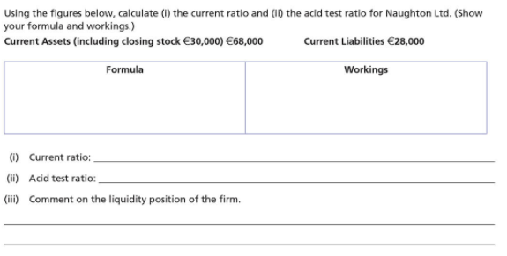

2023 LC
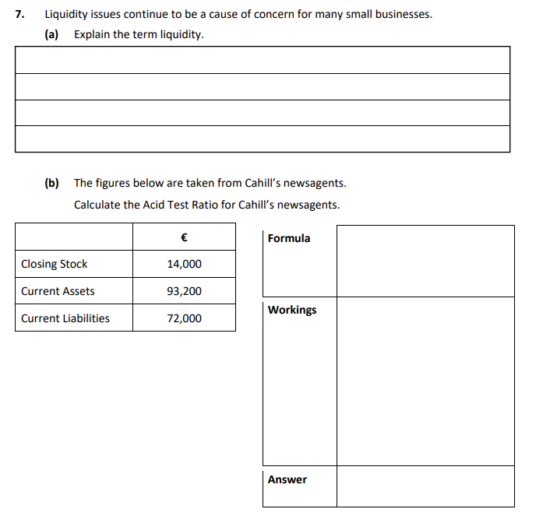
2015 Mock
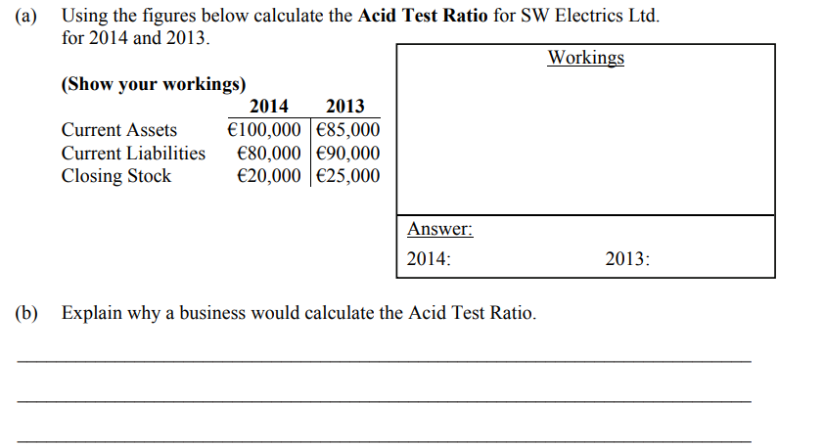
2020 Mock
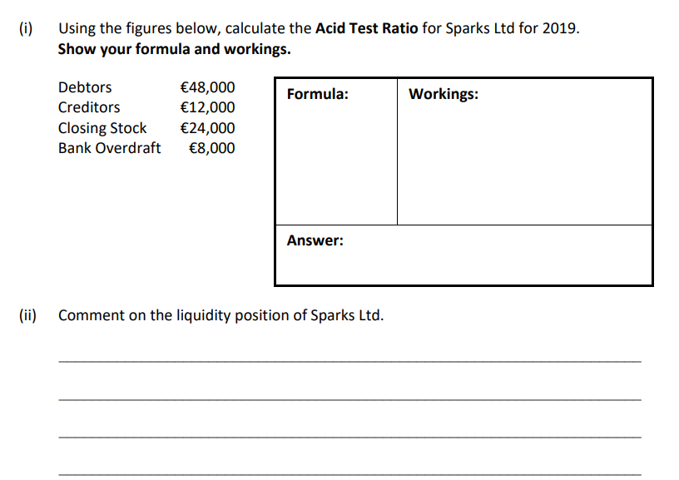
Liquidity Long Question
The following figures have been extracted from the books of Gibbons Ltd. Calculate both the Current Ratio and Acid Test Ratio for each year and comment on each trend.
 | Year 1 € | Year 2 €
Current Assets | 3,960,000 | 3,630,000
Current Liabilities | 2,760,000 | 2,415,000
Closing Stock | 879,000 | 1,242,000

Current Ratio: Formula-
Year 1 | Year 2
Answer: | Answer:

Current Ratio- Comment on the trend

Acid Test Ratio: Formula-
Year 1 | Year 2
Answer: | Answer:

Acid Test Ratio- Comment on the trend

Gearing Ratio
Debt/ Equity Ratio (Gearing Ratio)
Long Term Loans: Ordinary/Issued Share Capital + Retained Earnings/Reserves
(Note- NEVER, NEVER, NEVER USE AUTHORISED SHARE CAPITAL)
Examines how much long term debt the business is in
Higher than 50% or 1:1- business is highly geared- it has a lot of debt. You want it below 50% or 1:1. Typically in the exams now the answer is given as a ratio.
Too much debt is bad:
- A lot of interest to repay on loans
- Will reduce its ability to get more loans- seen as a risk by the bank
- Greater chance of going bankrupt- this money has to be repaid if a business fails
- May not be able to pay high return (dividend) to shareholders- they may not be attracted to your business or go elsewhere
- May need to use collateral to get loans
Answering the question:
- Always write formula
- Use numbers from question
- Show workings
Sample Short Question
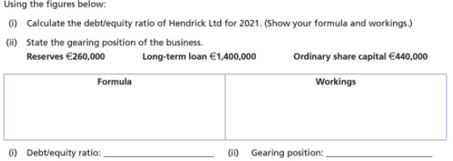

2006 Short Question
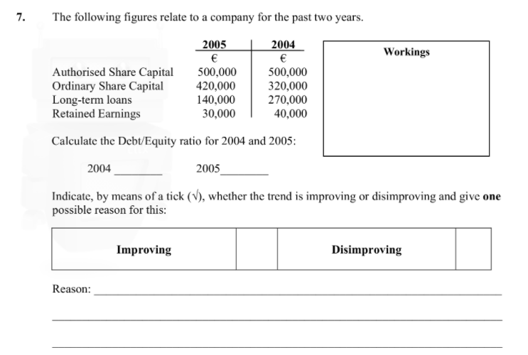
Extra Working Space for 2006 Question

2020 Mock
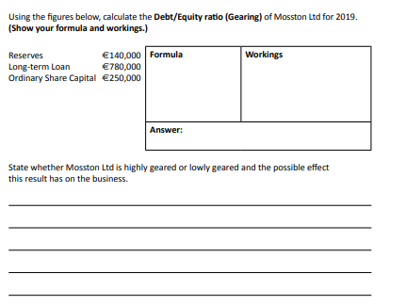
2023 Mock
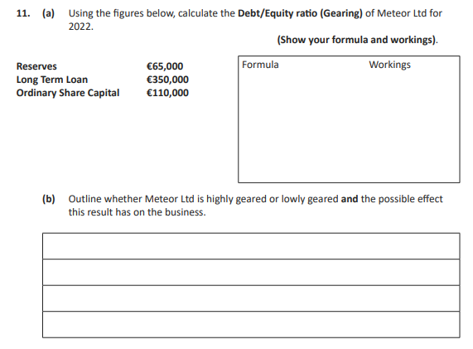
Long Questions
Sample Question
Calculate the Debt/Equity Ratio for Smiley Ltd using the figures below and comment on the trend
 | Year 1 | Year 2
Retained Earnings | 204,000 | 263,500
Equity (Ordinary) Share Capital | 1,190,000 | 1,190,000
Long Term Loans | 300,000 | 200,000

Debt/Equity Formula-
Year 1 | Year 2
Answer: | Answer:
Comment on the trend
2014 LC
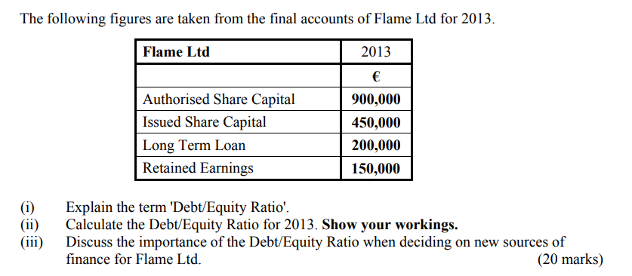
(i)
(ii)
Formula and Workings

Answer:

(iii)

