Starting a Business
Key issues for Business Start Ups
- The ownership structure that needs to be adapted
- The location of the business
- Finance
- The choice of production methods
- Developing a Business Plan

- Ownership Structure
Some of the most common business start-up structures include:
- Sole Trader
- Partnership
- Private Limited Company
- Franchise

The Sole Trader
The Sole Trader owns and runs their own business. The Sole Trader is the one who makes all decisions and provides the money in their business
This type of ownership model is typical in small retail and service sectors.
The owners have UNLIMITED LIABILITY!!!!
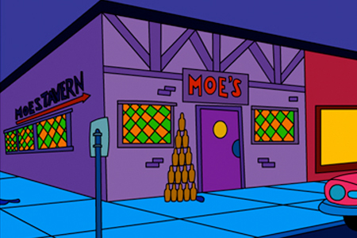

Partnership
A partnership is a business where between 2 and 20 people come together to set it up and share control of the business. The owners have UNLIMITED LIABILITY!!
A set of rules and responsibilities for the company are agreed and written down in a partnership deed
The Deed of Partnership will include:
- How profits are to be shared
- How capital will be provided
- Duties and tasks of each person within the partnership
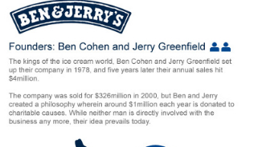

Private Limited Companies
This is formed when between 1 and 149 people put together money to start a new business. The people who put money in are called shareholders.
If the company makes a profit, shareholders receive a dividend. The dividend received depends on the amount of shares you invest. 1 share = 1 vote, the more shares, the more votes.
Shareholders have Limited Liability, and the words ltd come after the company name.

Franchise
Franchising is a business arrangement whereby one person (franchiser) sells the right to use their name, idea or business to others (franchisees) and allows them to set up an exact replica of that business.
A franchise is effectively a licence to produce and/or sell another well- known company’s products and use the company’s name in return for a fee
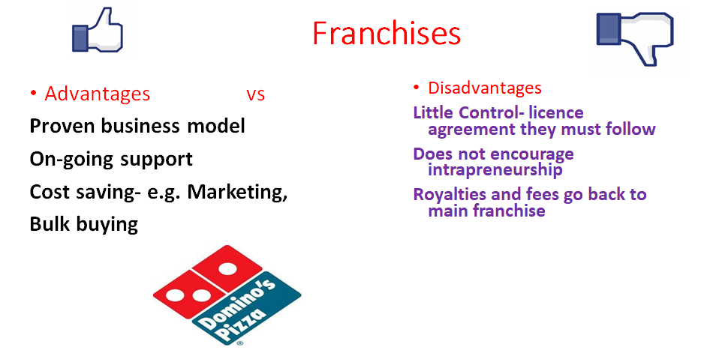

- Business Location
The location of the business will play a key role in both the visability and profitability of a business. The following factors are important when selecting business location:
- Accessability
Location is of utmost importance to businesses that sell goods or services directly to customers. The business needs to be accessable to its target market
For example, a book shop in Navan Town Centre is more likely to attract customers than a similar shop located in a less busy area.

- Competition
A business's location can affect the competition it faces from businesses that sell similar products and services.
A book shop could be very close to Eason’s, and so starting a business in an area with few direct competitors can increase the likelihood of attracting customers.
- Operating Expenses
The location of a business can influence the total cost of operation. Renting a storefront on a popular street shopping centre is likely to be more expensive than opening a store in a small commercial district in a residential area.
A business could be better off opening its doors in an area that is cheap, even if it results in fewer total sales`
- Availability of Workforce
Businesses that need skilled workers will have to locate to a place that s accessable for workers. Very often, businesses will locate close to transport links so the workers can reach the job on time.

- Sources of Finance
The entrepreneur has to decide where to get the money from
3 types:
- Short Term (0-1 years)
- Medium Term (1-5 years)
- Long Term (5 + years)
Short Term Finance | Medium Term Finance | Long Term Finance
Bank Overdraft | Medium Term Loan | Mortgage
Credit Card | Hire Purchase | Savings
Accrued Expenses | Leasing | Retained Earnings
Factoring |  | Equity Capital
Trade Credit |  | Grants
 |  | Debentures
 |  | Sale and Leaseback
 |  | Venture Capital

- Production Methods
If a new business is involved in manufacturing it will need to use one of the following Production Methods:
- Job Production
- Batch Production
- Flow Line Mass Production
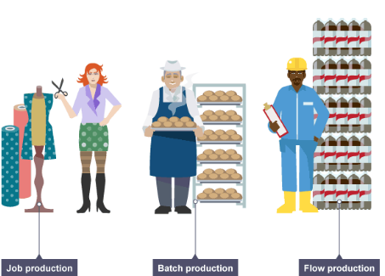
Job Production
This involves making products one at a time. Each product is both individual and unique, like a customised suit, wedding dress, or birthday cake. These products are generally made to order.
Job production use highly skilled workers to make the products, and is generally considered more expensive due to this fact as workers will generally command a higher wage, which can increase business costs. The raw materials and machinery can also be expensive, and this is usually reflected in the price charged to customers.

Batch Production
This involves making a limited number of production items in one go. The product is the same for all customers. Because it is the same, it can be made in batches, in advance, and ready for the customers when they need it.
These products are less expensive to make and pay employees than job production and machinery can be flexible as when one job ends, a business can shift to another. There is increased efficiency and less waste as goods are produced for stock and multiple items can be made at the same time.
A typical example would be cakes in a bakery or newspapers in a shop.

Mass Production
Mass Production is making the product continuously, 24/7/365. Therefore, you use mass prodcution for proucts that will be in high demand. The product is the same and made in advance, and the product is also the same for all customers.
Workers are generally unskilled assembly line workers with low pay and so morale may be low. Large capital investment may also be needed to purchase machinery.

- The Business Plan
A business plan is a written document prepared by the entrepreneur
about the business and its objectives (where it wants to go) and strategies in areas such as marketing (analysis and plan), ownership, production, finance and the identifying of opportunities.

The Main Sections of the Business Plan are as follows:

Nature of the Business: This is the idea behind the business, what the business will be about. It will set out the type of business as well as what its main intention will be

Ownership: This will outline the type of business it will be, e.g. Sole Trader/Franchise/Private Limited Company, the name of company directors and shareholders, as well as the skills and experience of these owners

Marketing Plan and Market Analysis: This contains the 4 P’s (Product, Price, Place, Promotion). It shows important information such as the branding of the product,how it will promote its product through advertising etc.., as well as its pricing strategy. The size of the market, the demographs such as age, gender, income levels, the different target markets. It also shows current competitors and segment preferences

Production Plan: This will give production details such as what machines, labour, and raw materials are needed to produce a product, as well as time and costs to do so also. Production targets and types of production (e.g. batch etc…) are also outlined

Financial Plan: The financial plan contains details of how the business will be financed, its ratio analysis, cash flow forecasts, and financial statements and projections that will show where its money comes from and also that the business will not run out of money as it begins trading

