The European Union

**The European Union and its member states**

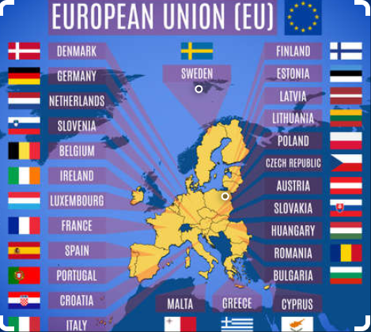

The European Union is a Trading Bloc of 27 countries operating in a single market meaning that there is free trade and movement of labour between the member states**. (Remember, a trading bloc is a group of countries who agree to form a trade area for a common market and remove trade barriers in doing so).**

Although each member is its own independent, sovereign country, they pool together to gain strength by numbers and give some control to EU institutions in order to support collective goals.

In June 2016, the UK voted to leave the EU and this is officially to come into effect early 2019.

**EU Institutions**

**The EU has established a number of institutions to look after the running of it. The most important are:**

* **The European Commission**
* **The European Parliament**
* **The Council of the European Union**
* **The European Court of Auditors**
* **Court of Justice of the European Union**
* **The European Investment Bank**

1. **The European Commission**

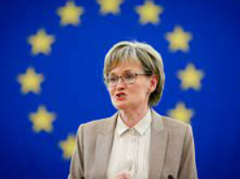 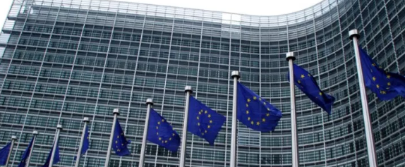

**The European Commission is the executive body responsible for the day-day management of the EU. It consists of one commissioner from each EU State and they are appointed by their own country’s government.**

**Each commissioner is in charge of a different area of responsibility within the EU, such as transport, the environment, education, health, agriculture and trade.**

**Weekly meetings of the Commissioners take place in the Brussels headquarters and in Strasbourg**

**Ireland’s present EU Commissioner is Mairead McGuinness serving as the European Commissioner for Financial Stability, Financial Services and the Capital Markets Union since October 2020.**

***(Phil Hogan served as European Commissioner for Agriculture and Rural Development but was infamously replaced due to the Golf gate scandal during Covid)***

***What does the Commission do?***

1. *Proposes new laws*

It consults experts, interest groups, and the public to identify new laws that are needed to protect the EU and its citizens. It proposed these laws to the European Parliament and the Council of the EU.

1. *Enforces EU Laws*

It enforces EU laws and can bring breaches of these laws to the Court of Justice of the European Union.

In June 2022 the EU Commission launched infringement proceedings against the UK for not complying with significant parts of the Protocol on Ireland / Northern Ireland and will consider taking the case to the Court of Justice of the European Union.

1. *Represents the EU internationally*

It represents all EU states when negotiating international agreements on behalf of the EU- e.g. Brexit

1. *Manages EU policies & allocates EU funding*

Sets EU spending priorities, together with the Council and Parliament and draws up annual budgets for approval by the Parliament and Council

Supervises how the money is spent, under scrutiny by the Court of Auditors. It makes the decision as to where the money is spent and what country gets what from the budget- including Ireland which is used for objectives such as improving infrastructure

1. **The European Parliament**



<https://www.europarl.europa.eu/ireland/en/your-meps>

**Members of the European Parliament are the only ones to be elected by the citizens of the EU. Elections are held every 5 years and the number of MEP’s (Members of the European Parliament) is roughly in proportion to a countries population. The EU Parliament meets in Strasburg and meets for 12 sessions 4 days a year.**

*The Main Functions of the European Parliament are:*

1. To debate and approve new European laws

The Parliament considers laws proposed by the Commission. The MEPs discuss the advantages and disadvantages of the law and suggest changes it makes to make it better

Under the co-decision principle, proposals rejected by the parliament cannot become law

2. To supervise the EU Commission

It supervises the work of the European Commission. The Commission must submit regular reports to the parliament.

The Parliament interviews all the candidates for the European Commission. It then votes on whether to accept the new Commission or not. The Commission cannot be appointed without Parliaments approval. Parliament also has the power to sack the entire Commission if it is unhappy with it

3. To represent EU citizens

MEPs are directly elected by citizens of the EU, therefore they must ensure that the EU acts in the best interest of these citizens.

4. To approve the EU budget

The Parliament had the power together with the Council of the EU to approve of or reject the entire EU budget. Therefore, it can influence how the EU spends its money

1. **Council of the European Union**

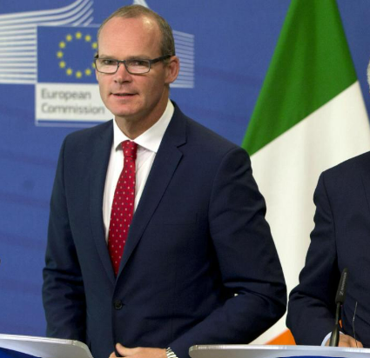

**The Council of the European Union along with the European Parliament make up the decision making body of the EU. The council consists of ministers from each EU member state, and the topic discussed determines which ministers will attend.**

**Example- when Brexit was discussed, Simon Coveney would attend as Minister for Foreign Affairs. The minster has the authority to vote on behalf of their member state on the topics discussed.**

**The presidency is held by each member state in turn, rotating every 6 months.**

*The Main Functions of the Council of The European Union are:*

*Negotiate and adapt EU Laws*

Working with the European Parliament, they can negotiate and adapt EU laws on behalf of the citizens of the EU.

*Approves the EU Budget*

Agrees the EU Budget with the European Parliament. It is approved in December and begins on January 1st.

*EU Common Policies*

It is responsible for creating common policies across the EU in areas such as aid and defence.

*International Agreements*

It gives the European Commission agreements to negotiate in agreements with non-EU member countries.

1. **The European Court of Auditors**

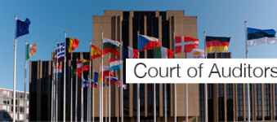

**The Court of Auditors checks EU funds are collected and used correctly, and help improve EU financial management. Its job is to check that EU funds, which come from EU taxpayers, are properly collected and that they are spend legally, economically (best value for money) and for the intended purpose.**

**The Court has one member from each EU country. It can audit any country or organisation that received EU funding to make sure that the money was not wasted and was spent for the purpose intended.**

**The court writes a report on its findings and this draws the attention of the Commission and the member states to any problems. It also produces an annual report for the European Parliament and the Council of the European Union.**

**It also conducts spot checks on any organisation or individual responsible for handling EU funds, including the European Commission or individual EU countries.**

1. **Court of Justice of the European Union**

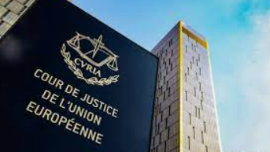

**The Court of Justice of the European Union (CJEU) interprets EU law to make sure it is applied in the same way in all EU countries, and settles legal disputes between national governments and EU institutions.**

**It can also, in certain circumstances, be used by individuals, companies or organisations to take action against an EU institution, if they feel it has somehow infringed their rights.**

***The functions of the Court of Justice are as follows:***

1. *Gives advice to member states*

The Court of Justice gives advice to member states’ national courts to help them understand EU laws and how they apply to their country

It makes sire that different countries do not give different rulings on the same issue

*2. Ensures compliance with EU legislation*

The Court of Justice makes sure that each country and institution in the EU obeys EU laws and does exactly what EU laws requires

It has the power to settle disputes between EU countries, EU institutions, citizens and businesses

1. *Strike Down EU Law*

The court of Justice can strike down and EU law that is illegal. If any of the member states or institutions of the EU believe that a particular EU law is illegal, they may ask the Court to annul it.

1. **European Investment Bank**

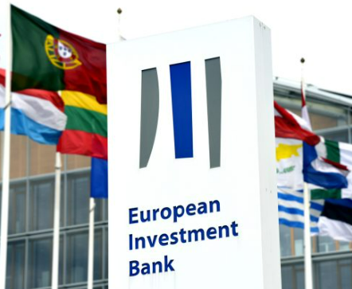

**The European Investment bank is jointly owned by the EU member states and operates in Luxemburg. It is responsible for providing funding to projects and helps to achieve the aims and objectives of the EU. It lends money across the EU as well as serving as a guarantor on projects which can encourage other investors to invest.**

**Decision Making in the EU- Sample Exam Question**

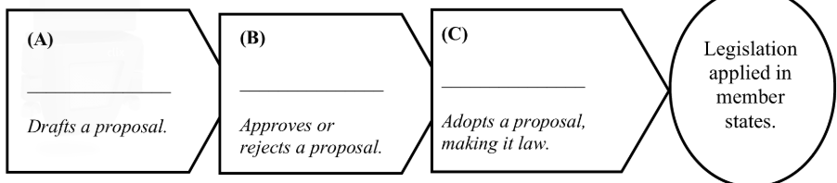

*(A)European (B) European (C) Council of EU Ministers*

*Commission Parliament*

*The European Commission is the executive body of the EU. It is the body responsible for proposing legislation etc. The commission thinks up ideas for new laws for the benefit of people in the EU and sends them to Parliament.*

*These proposals are then discussed in the European Parliament and amendments to legislation can be put forward. Advantages and disadvantages/amendments of proposals are discussed. It then sends its position to the Council of the European Union*

*Decisions are usually made by the Council of the European Union. It decides on legislation drafted by the European Commission and discussed by the European Parliament. It is the main decision making body of the EU etc.*

*Once legislation is passed by the Council of the European Union and Parliament, it is the Commission's responsibility to ensure it is implemented etc.*

***Regulations/Directives/Decisions etc.***

*Decisions/legislation can be adjudicated upon by the Court of Justice. The Court of Justice interprets EU law to make sure it is applied in the same way in all EU countries etc.*

**Interest Groups in EU Decision Making**

An interest group is a group with a common interest that come together to fight for a common objective. By joining forces, they look to achieve more than they could do alone and look to lobby decision makers to make decisions that may not have been achievable under one identity.

There are thousands of these special interest groups in the EU, including the Irish Farmers Association (IFA) and businesses such as Intel, IKEA, Ford etc.

The aim of these special interest groups is to pressurise EU decision-makers into making decisions that they want to achieve in their aims.

***Special interest groups will do the following to achieve their aims.***

*1. Lobby Members of the European Parliament (MEPs)*

Special interest groups will phone, write to and meet with MEPs to try persuade them to vote a certain way. They will send a petition to the European Parliament about an issue they feel strongly about in order to pressurise the MEPs into doing something about it

*2. Lobby the European Commission and individual commissioners*

Before it can think up ideas for new laws, the Commission had to be aware of problems in the EU that need to be solved. This is where special interest groups come into their own. They meet with the commissioners and make them aware if the particular issues they are concerned about and tell the commissioner what to do to sort it out

*3. Set up an office in Brussels*

Many EU decisions are made in Brussels, so special interest groups use their Brussels offices to lobby decision-makers on a regular basis. For example, IBEC and the IFA have offices in Brussels close to the Commission and the Parliament

**EU Directives**

EU Directives are laws that each EU member state must obey. It is up to a national government to decide how to achieve this directive, but it must be achieved by a given date.

For example, under EU Law it is illegal for an employee to work more than 48 hours in a week

**EU Regulations**

An EU regulation is a legal act which applies directly at the national level. This means that when a regulation is approved at the EU level and enters into force it becomes directly and immediately applicable within the countries of the EU. Countries do not need to create their own legislation to bring this EU legal act into force.

The GDPR that came into effect in May 2018 makes businesses more accountable for date privacy compliance and gives EU citizens extra rights and more control over their personal data

**EU Policies**

EU policies are major programmes that are designed to help specific categories of people in the EU.

There are EU policies for:

**1. EU farmers called the Common Agricultural Policy**

**2. EU Fishing industry called the Common Fisheries Policy**

**3. EU workers called the EU Social Charter**

**4. EU consumers called the Competition Policy**

**5. EU businesses called the Single European Market and the Euro**

**Common Agricultural Policy (CAP)**

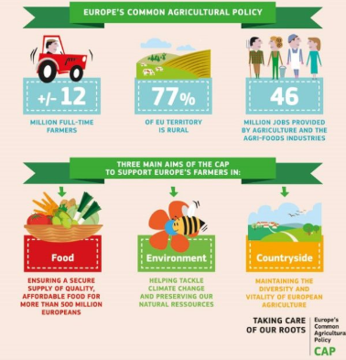

The CAP was established to give all farmers in the EU a decent standard of living. It currently accounts for 62% of the EU’s budget. It achieves this in a number of ways:

**The Common Agricultural Policy Promotes a fair standard of living for farmers**

The Common Agricultural Policy gives grants farmers under the single payment scheme. The EU makes these payments to farmers to help the viability of the farm business and to enhance food, safety and environmental standards.

**Free trade/No barriers or restrictions**

EU farmers are allowed to sell their produce to other EU member states without any barriers or restrictions. This allows Irish farmers to export to a large market.

**Improved Produce**

The CAP gives EU farmers grants to spend on improving their land and animals. This helps Irish farmers to produce/offer quality crops and rear quality animals, which helps increases sales and profitability.

**Protect Farmers from Competition**

The common agricultural policy adds tariffs to non-EU food imports to make them dearer. This will encourage consumers to buy more from farmers/producers within the European Union.

**The Common Fisheries Policy**

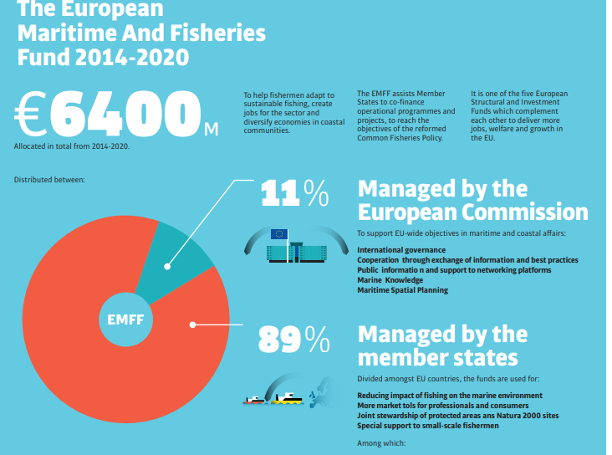

The CFP is a set of rules for managing European fishing fleets and for conserving fish stocks. Designed to manage a common resource, it gives all European fishing fleets equal access to EU waters and fishing grounds and allows fishermen to compete fairly. The CFP ensures the following:

* Access to Irish coastal waters is reserved for fishermen from local ports to a distance of 12 miles off-shore. This prevents foreign boats from over fishing the areas
* The EU is allowed to define where fishing is banned or restricted and all EU boats must be licensed to fish
* Conservation of Irish Fish Stocks: This policy is designed to protect fish stocks over-fishing
* Young fish catches are reduced, the mesh size of nets is regulated and limits applied to different fishing seasons
* Monitoring Fishing Activity: The responsibility to ensure that all rules are applied rests with each member state (Ireland in this case). The EU provides aid to Ireland for the purchase of fishery protection vessels and aircraft for the authorities

**EU Social Charter**

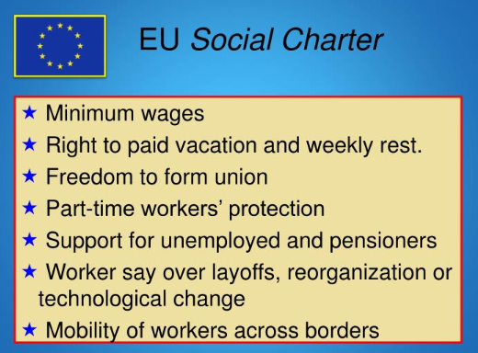

The **European Social Charter** is a Council of Europe treaty that guarantees fundamental social and economic rights as a counterpart to the European Convention on Human Rights, which refers to civil and political rights. It guarantees a broad range of everyday human rights related to employment, housing, health, education, social protection and welfare.

*It gives all EU workers the following rights:*

**1. Freedom of Movement**

EU citizens have freedom of movement. This means that they have the right to work in any EU country they want and be treated the same as nationals of that country.

**2. Fair Wage**

EU workers have the right to a fair wage that will give them and their families a decent standard of living. All EU countries must set a minimum wage.

**3. Maximum working hours**

EU workers can work only a maximum of 48 hours a week. They also have the right to public holidays and pay for four weeks paid annual holiday.

4. **Health and Safety**



**Competition Policy**

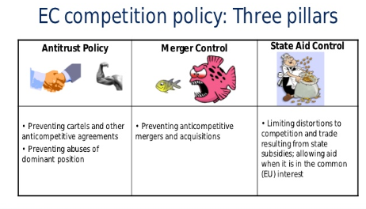

The EU Competition Policy is a set of rules intended to ensure free and fair competition between businesses in the EU. Its aim is to ensure that EU consumers get quality products at reasonable prices. It contains a number of rules.

1. Business cannot operate from cartels

A cartel is an illegal secret agreement between competitors in which they agree to restrict competition. The Competition Policy states that businesses cannot work together to take advantage of consumers by agreeing that that will all charge the same high price for their products.

2. Cannot increase prices

Businesses in a dominant position in the market cannot abuse their power by increasing prices.

3. No Monopoly Position

The EU competition policy ensures that Ireland’s state-owned enterprises cannot enjoy a monopoly position. This means that they cannot be the only business selling a particular product. They must be open to competition.

4. Permission for Mergers/Takeovers

EU competition policy prohibits mergers and takeovers that would reduce free competition. Any proposed merger or takeover must seek and obtain permission from the European Commission to go ahead. Permission is denied if the Commission believes that the merger would seriously damage competition.

**Single European Market and The Euro**

The single European Market is the world’s largest free trade area. There is free movement of Goods, Labour, and Capital in the EU.

(Within the single European Market there is the European Monetary Union which are the countries that use the euro as their currency- known as the Eurozone.)

Goods- Businesses can sell their products anywhere in the EU without restrictions or trade barriers

Labour- Workers are free to work, travel, and live anywhere in the EU

Capital- EU citizens and businesses can invest their capital anywhere in the EU

***Significance of SEM for Ireland***

1. **No barriers to trade**

Irish businesses can sell their products anywhere in the EU just as easily as they can sell them here. There are no barriers to trade between the countries

**2. Lucrative Contracts**

Irish businesses can bid for government contracts of other EU countries. National governments are not allowed to show favouritism to their own country’s businesses. They must choose the best quote they get from within the EU

**3. No customs checks/border controls**

The SEM has made trade within the EU easier. There are no customs checks or border controls anymore. This means that Irish goods are not physically inspected by government officials when they enter an EU country

**4. Attracts Transnational Companies**

Ireland’s membership of the SEM provides another opportunity for Irish businesses. Transnational companies come here to get free access to the EU market

**5. Free Movement of Capital**

The SEM allows for the free movement of capital. This means that EU citizens can invest their money anywhere in the EU. This makes it easier for Irish entrepreneurs to raise the capital they need to set up, run and expand

***Challenges of SEM for Ireland***

1. Increased Competition

The SEM has brought challenges for Irish businesses. In the same way that we can sell our products all over the EU other EU businesses can set up here and sell their products in Ireland. This increased competition may force some Irish businesses out of business if they cannot cope with the threat from big EU competitors.

1. Emigration

The free movement of labour means that EU citizens have the right to travel and work in any EU country they can get a job in. This could have a negative impact on Irish business because Irish people may decide to live and work elsewhere in the EU, leaving Irish businesses short of workers.

1. Brexit

Brexit has created huge uncertainty for Ireland’s economic future and may have huge consequences for Irish trade. Much of Ireland’s agricultural exports go to UK currently and if tariffs and quotas are placed on them Ireland will have to look at other markets

1. Extra Regulations

The EU places extra regulations on business which will increase business costs. Example: Mobile operator Three is raising its monthly prices by up to €5, blaming costs and new roaming regulations

1. Immigration:

Free movement of labour may cause overcrowding in large urban areas. This can push up house prices and led to congestion on roads

Exam Question 2018

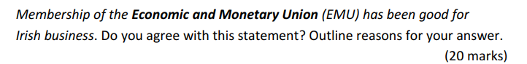

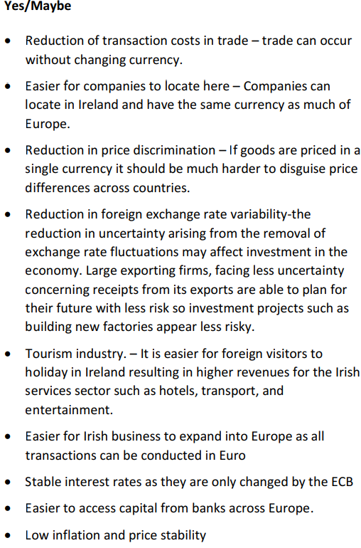

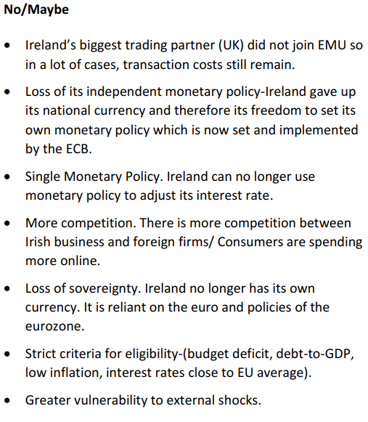

**Importance of EU Membership to Ireland** 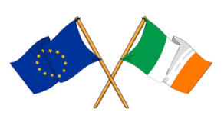

**The European Union is very important for Ireland. Our membership of the EU played a part in making Ireland the wealthy country it is today. The EU has helped Ireland in a number of ways.**

**1. Increased Profits**

The Single European Market provides Irish businesses with the opportunity to increase their profits by allowing them to sell their products and services freely to a market of over 440 million people across 27 countries.

**2. Grants**

The EU has given Ireland grants to improve its infrastructure, such as motorways, airports, ports and so on. This has helped Irish businesses to transport their products more quickly and cheaply.

**3. Transnational Companies**

Ireland’s membership of the Single European Market attracts transnational companies here, such as Dell and Intel. These transnational companies provide thousands of jobs in Ireland. They also buy materials from Irish businesses, which help to increase their sales and profits.

**4. EU Policies**

The EU Common Agricultural Policy (CAP) and the Common Fisheries Policy (CFP) have helped Ireland’s primary industries of agriculture and fishing by giving those who operate in these sectors a decent standard of living and by helping to modernise and improve these industries with grants.