The Wise Consumer
A CONSUMER is somebody who buys a good for their own personal use- Example-buying a new pair of trainers from JD Sports for your own use
A TRADER is somebody who buys goods and then resells them. Example- JD Sports selling trainers to a consumer
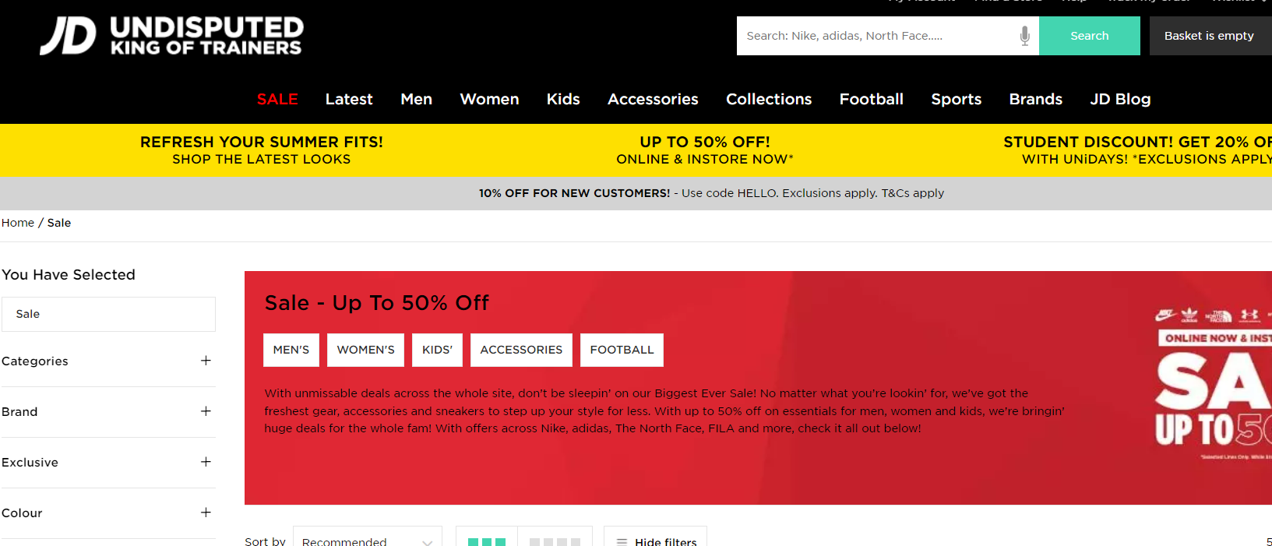

Task: Using your I-Pad- Find 5 more examples with pictures of items you would purchase for your own use as a consumer.
Before buying goods/services- as a consumer you should ask yourself the following questions:
- Do I need it: Is it really important?
- Can I afford it: How will it affect my budget?
- Is it value for money?
- Have you checked prices elsewhere?
- Don’t impulse buy
- Get a receipt as proof of purchase.
Do I really need it?
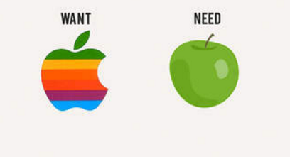
Think back to our needs and wants. Sometimes we can mix these up and it is really important as wise consumers that we remember this point.
Spending too much on our wants will mean that we may not have enough money to satisfy our needs and we may run into debt.
Can I afford it: How will it affect my budget?
If you decide to buy something you must know how much it is going to cost and stick to a budget for it. It is really important to not spend more than you can afford- if you spend more than you can afford you will run into debt.

Is it value for money?
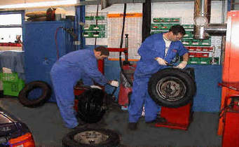
Think back to False Economies from our Expenditure Chapter. The wise consumer knows that just because an item is cheaper doesn’t mean it is better value for money.
Example
Chris needs a new set of tyres for his car. One set are €250 and will last 20,000 km. The more expensive set are €300 but will last 30,000 km. Which set should Chris buy and why?
Unit Pricing
The unit price is the price of the single amount of something. This is useful to calculate when you are shopping and comparing prices of items that come in different sizes.
The formula you use is:
Unit Price = $\frac{Price}{Quantity}$
Example 1
Boxes of Cookies come in the following packets:
- Small Box (500 grams) cost €3.00
- Medium Box (700 grams) cost €4.90
- Large Box (1kg) cost €5.50
Calculate which box is the best value for money.
Formula: $\frac{Price (cent)}{Quantity (grams)}$
Small Box = 300/500 = 0.6 = 6 cent per gram
Medium Box = 490/700 = 0.7 = 7 cent per gram
Large Box= 550/1000 = 0.55 = 5.5 cent per gram
The large box is best value for money
Example 2
Boxes of Cereal come in the following packets:
Small Box (250 grams) cost €2.50
Medium Box (300 grams) cost €3.00
Large Box (500kg) cost €4.00
Calculate which box is the best value for money.
Have you checked prices elsewhere?
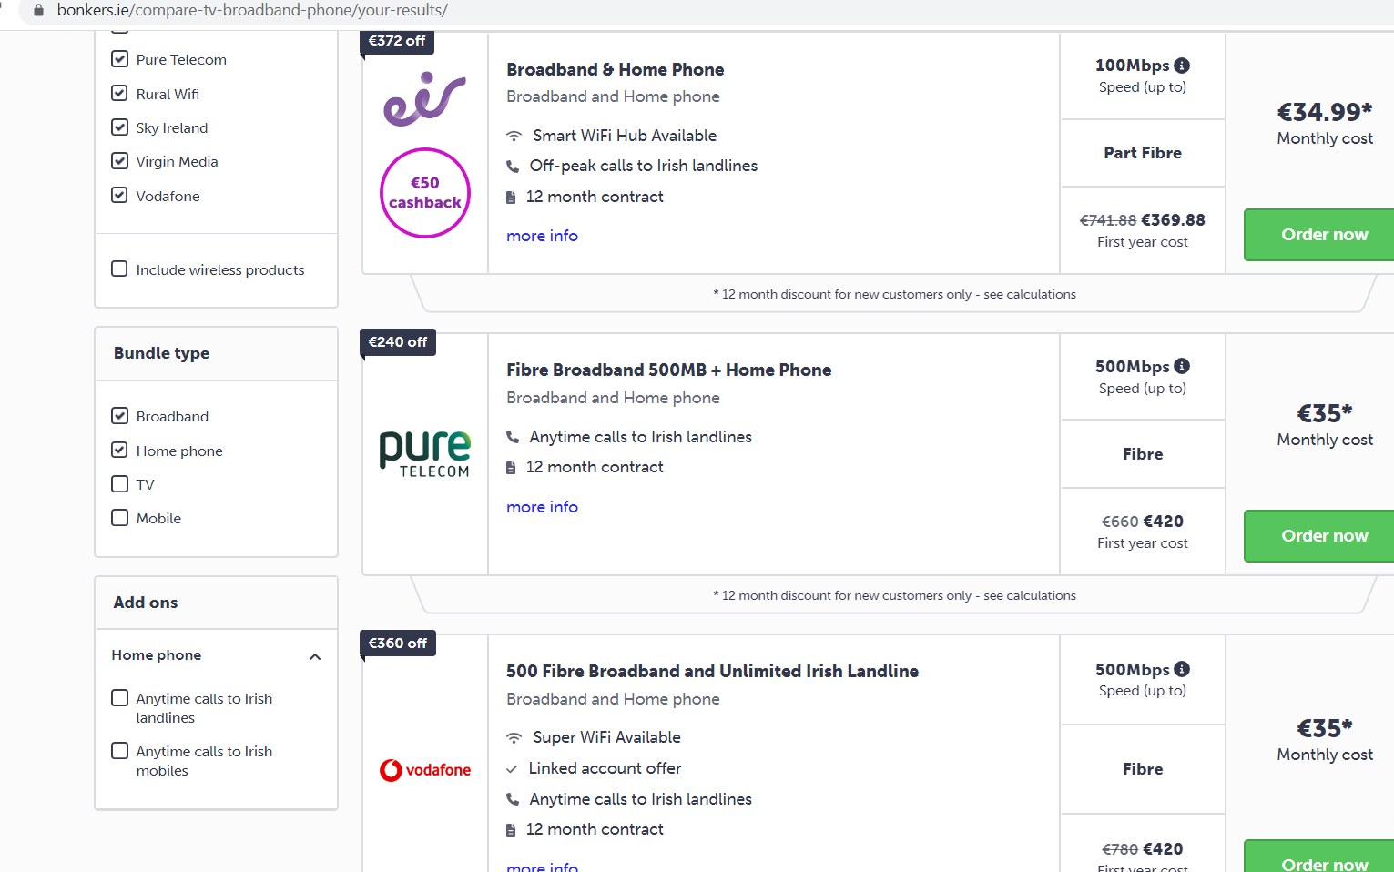
Comparison websites like www.bonkers.ie are great for consumers
Whenever we need to buy goods and services, it is important to make sure that we shop around and don’t just buy in the first shop we visit. You would be amazed with the amount of money you can save by shopping around.
This can mean looking at different brands, walking into different shops and shopping online to find the best value.
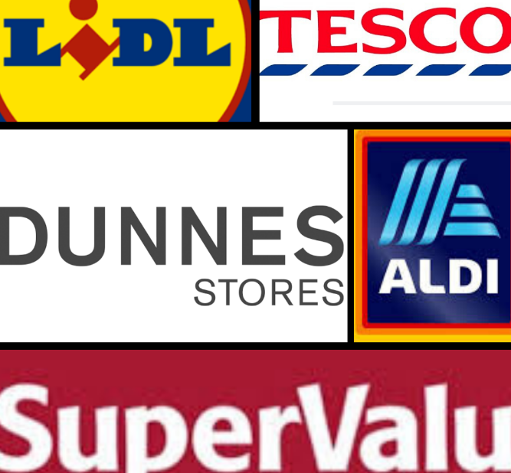
Some very expensive brands try to generate an exclusive image by getting people to spend a lot of money and choose their product over others. This is known as Conspicuous Consumption.
Think about the image people have when they wear expensive clothes. Businesses know people will choose their brand as the expensive brand will make them stand out over others and it appeals to people’s vanity.
The wise consumer is able to keep this in mind when buying products and services.
Don’t Impulse Buy
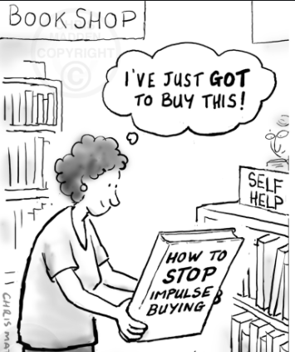
As we have seen in our Expenditure chapter, Impulse Buying is when we buy goods and services on the spur of the moment.
Shops deliberately place desirable goods close to the checkout in order to tempt us into making these purchases, and keep the most common goods such as bread and milk far away from each other in the hope we pick up other unplanned goods along the way
A wise consumer will be aware of this, and will also remember that just because something is on sale does not mean that we have to buy it
Shops will attempt to attract us to make impulse purchase with tactics such as:
- Loss Leaders: Attract customers into shop with low prices in the hope that they buy other profitable products- Example- €3 Chicken roll in the hope that you buy coke, sweets etc...as well
- Special Pricing: €9.99 sounds a lot better than €10. This sales tactic often fools people into buying goods and services that they would not normally buy for €10
- Below Cost Selling: Shops sell at a lower cost than they paid for it in the hope you will buy other things in store
Get a receipt as proof of purchase
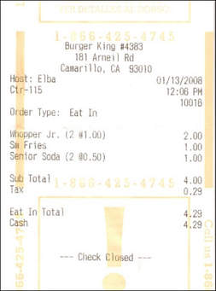
A receipt is a small piece of paper that you get after you have made a purchase and will contain:
- Name of the seller
- Date
- Description of the item purchased
- The price paid and change given
It is always good to keep a record of your receipts. If there was a problem with a good or service you bought your receipt would be your proof of purchase
Reviewing your receipts will help you monitor your spending and help prepare your personal accounts such as The Analysed Cash Book
Guarantees and Warranty
Guarantee: Promise from the manufacturer to offer a refund or replacement to consumers who have purchased faulty goods.
Warranty: Additional promise by a manufacturer or seller to repair damaged goods in a specified period of time.
Being smart shoppers online
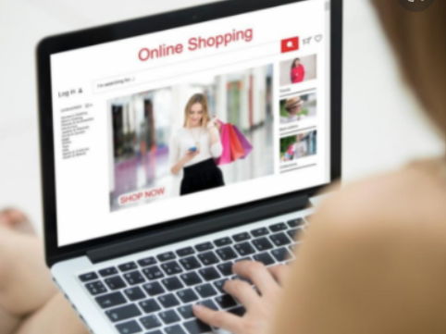
- Security: Use websites that you trust. Look for the padlock icon in the URL
- Research the website: Look at reviews, are the products of merchantable quality? do they offer returns for faulty products? -ask at home to review the website as well
- Secure Payment- make sure they have secure payment options- Try use PayPal where possible
- Indirect Charges: Be aware of delivery charges, taxes, that can be added onto the cost of the good for example if being bought outside the EU

