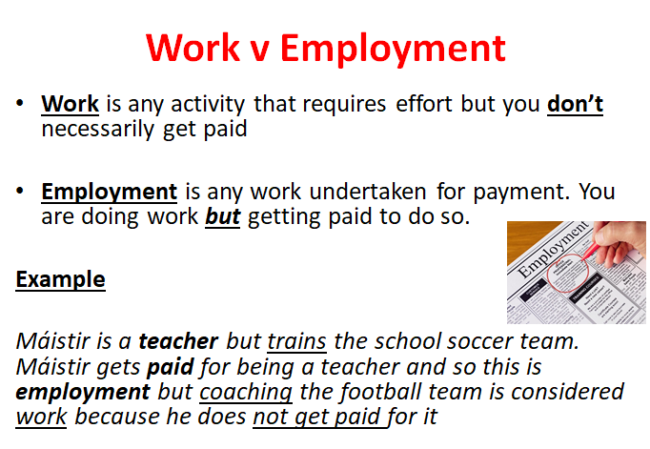
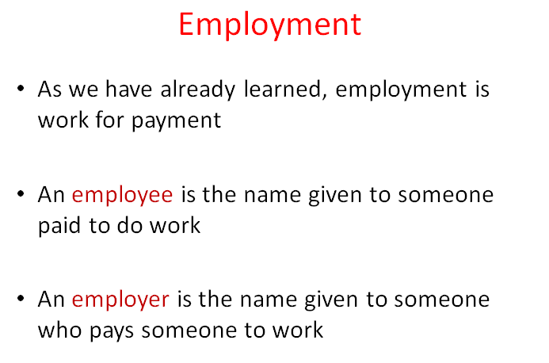

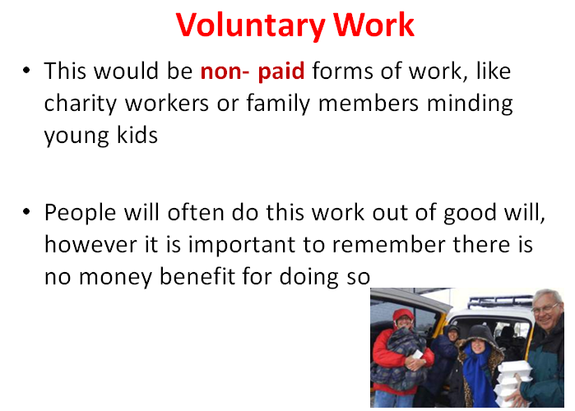
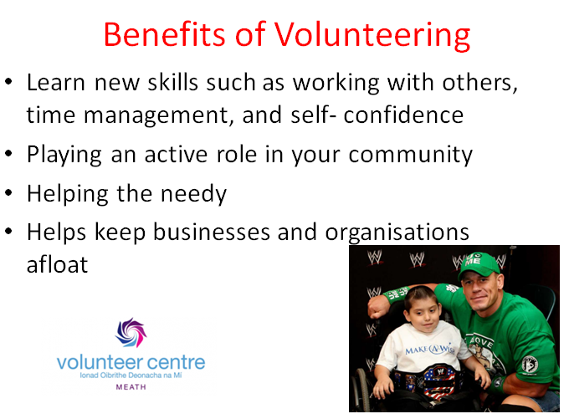
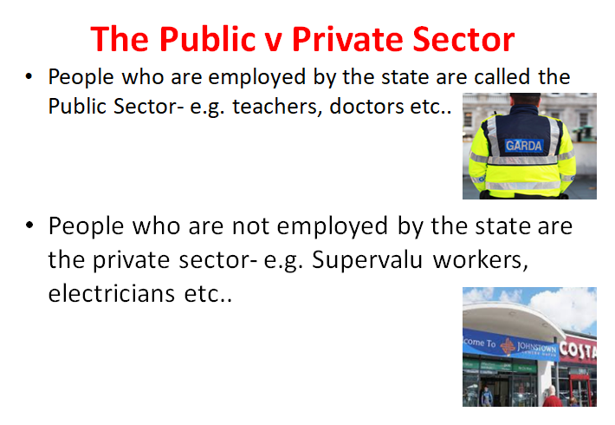
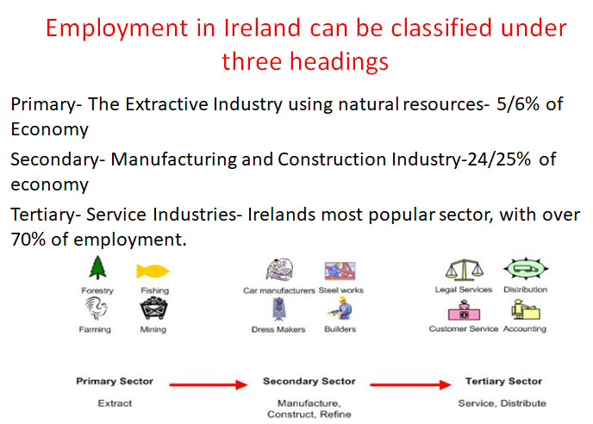

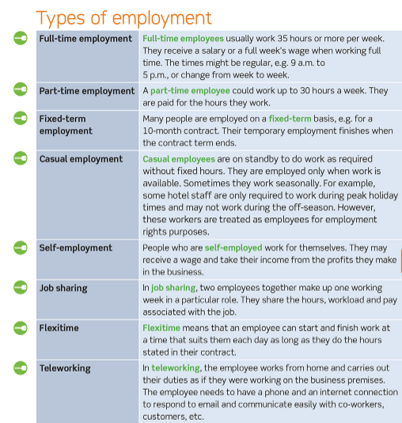

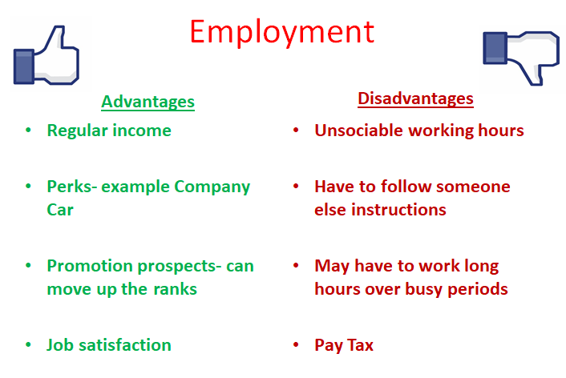
The Rights and Responsibilities of Employees and Employers
There is a detailed look below taken from your textbook of the Right and Responsibilities of employees and employers in in the workplace:
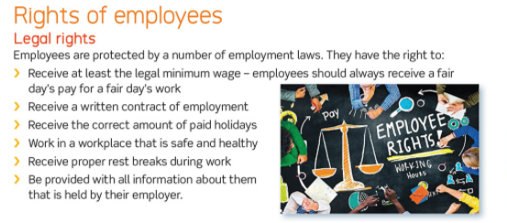
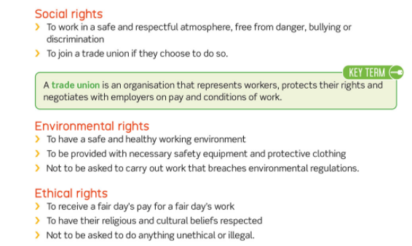
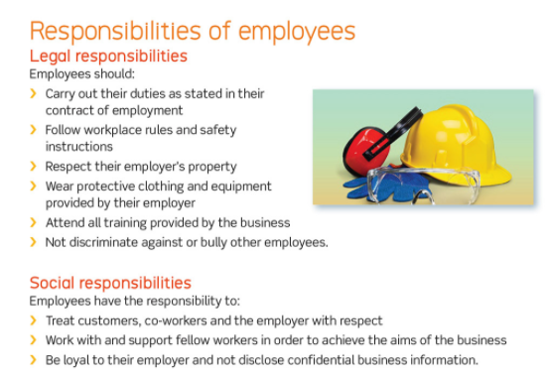
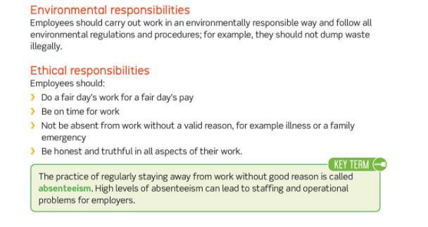
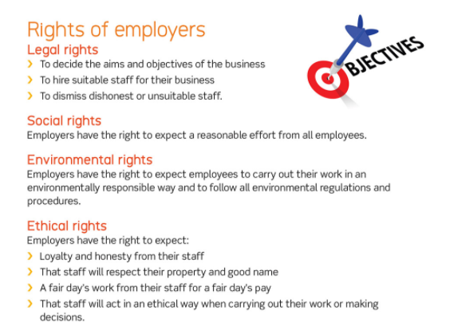
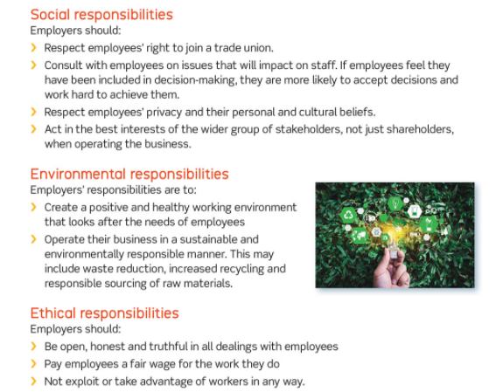
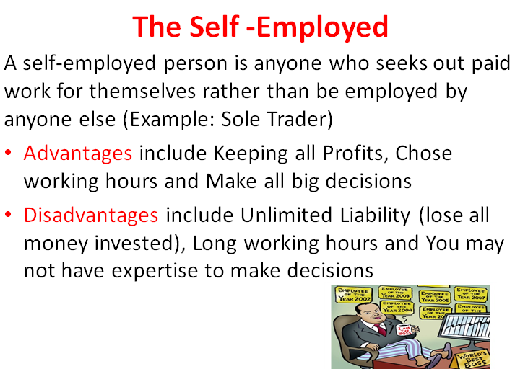
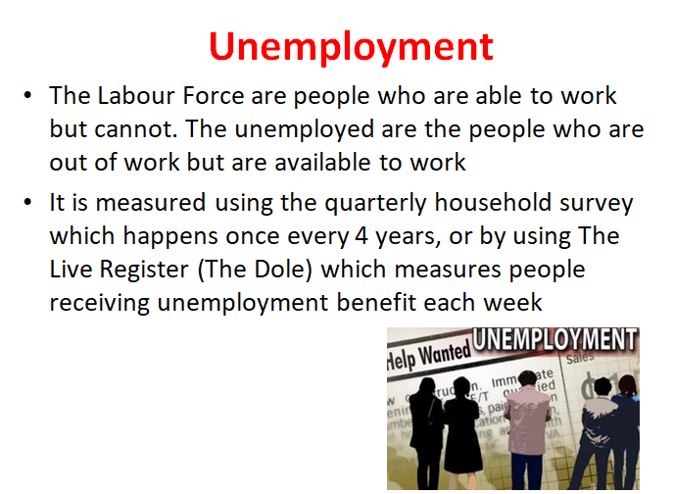
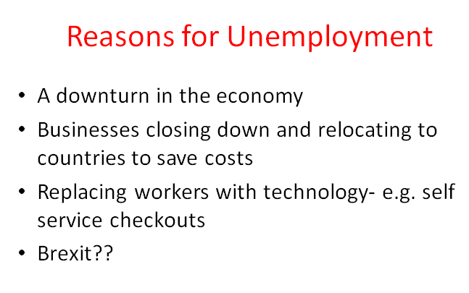
Task: Find out the unemployment rates in Ireland for the following years:
2005/2007/2010/2012/2015/2017//2019/2021/2022
Do you notice many changes in these figures? Why do you think this is the case?
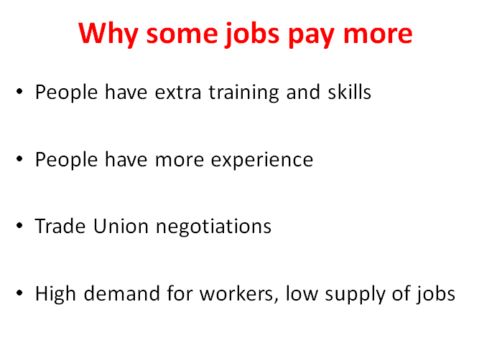

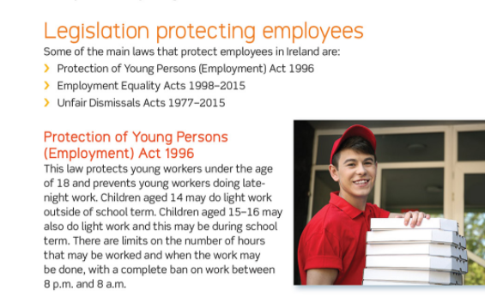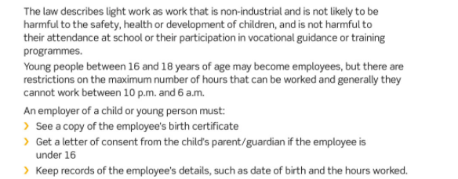
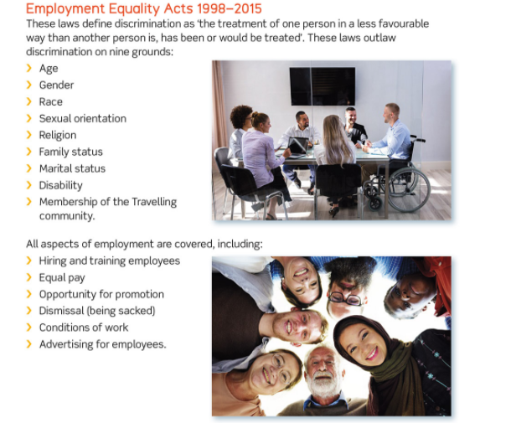
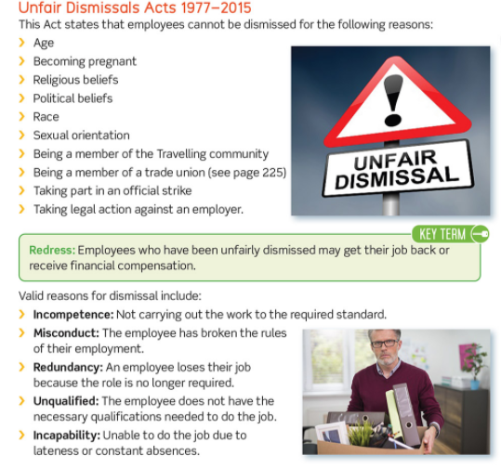

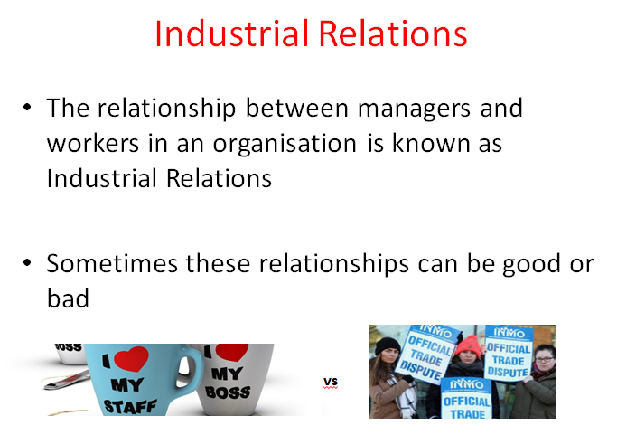
Trade Unions
Trade Unions are organisations that represent workers in their workplace. They are set up to protect workers in their disputes with management. Common Trade Unions include the Irish Congress of Trade Unions and SIPTU.
Máistir is a member of the Teachers Union of Ireland.
Shop Stewards
A shop steward is an elected member of staff to represent them and they work closely with the trade union in informing union members of any updates and organising votes if Industrial Action is to take place.
Reasons for Industrial Disputes
Some common reasons include:
- Pay
- Working Conditions
- Redundancy
- Discrimination
- Promotion
Types of Industrial Action
Illegal
- Unofficial Strike
- Lightning/Wildcat Strike
Unofficial Strike
An unofficial strike is one where employees don’t hold a secret vote and/or don’t give their employer 7 days’ notice. The trade union doesn’t recognise unofficial strikes and will not pay workers strike pay
https://www.independent.ie/irish-news/threat-of-unofficial-strikes-across-all-ci-companies-35488688.html
Lightning/ Wildcat Strike
This is a sudden strike where no prior notice has been given. Employees literally walk out of the job. This sort of a strike is illegal in Ireland
https://www.thejournal.ie/wildcat-strike-could-happen-again-3316941-Mar2017/
Legal
- Official Strike
- All out Strike
- Work to rule
- Overtime ban
- Token Stoppage
Official Strike
An official strike is legal in Ireland. First employees must hold a secret vote. If 51% of people want to go on strike they give their employer 7 days ‘notice. The trade union instructs employees to cease working. They will pay workers strike pay- This is linked to The Industrial Relations Act 1990, which is a law that protects workers in disputes with their employers.
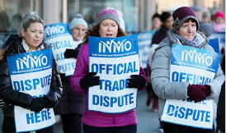
All-out Strike
This is where every single employee in the business goes on strike. For an all-out strike to be legal the workers must get the approval of the Irish Congress of Trade Unions
https://www.thejournal.ie/inmo-strike-4325520-Nov2018/
Work to rule
This is where workers do the least amount of work possible under the terms of their employment contracts. An overtime ban or go slow may be part of “working to rule”.
https://www.rte.ie/news/education/2018/0918/994521-lecturers-at-wit-and-it-carlow-set-to-take-action/
Token Stoppage
Workers temporarily stop work for a short period of time. This is an attempt to get the employer to listen to the workers and solve industrial disputes
https://www.irishtimes.com/news/ireland/irish-news/dublin-bus-staff-to-hold-three-48-hour-stoppages-in-september-1.2772899
Overtime Ban
This is when employees refuse to do any overtime for the employer.
https://www.irishtimes.com/news/health/psychiatric-nurses-begin-overtime-ban-over-pay-1.3777250

Solving Disputes
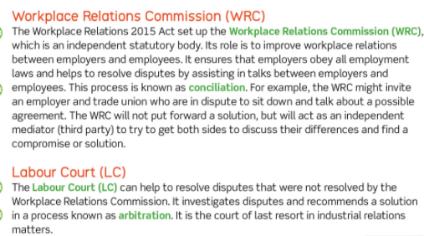
How the workplace is changing
Work from home- Due to Covid restrictions, more and more people are working from home. There is even talk of an initiative to allow workers to work from home if possible to do so moving forward.
https://www.irishtimes.com/news/social-affairs/employees-to-have-legal-right-to-request-home-working-says-varadkar-1.4459361
Improving technology- More and more jobs are becoming computerised, look at self-service checkouts in supermarkets. Also, more and more apps like Zoom, Teams, and social media allow workers to reach customers all over the world
Increasing competition- As markets are becoming more and more profitable, it will encourage more and more businesses to set up there. This will create more jobs in sectors like construction and manufacturing.
The effects of Covid and Brexit- Over the coming years, how exactly the workplace has been changed will be seen, but we can already see effects in consumer demand and business closures

