Working out Your Wages
€670
€1,000
Have you ever wondered how pay is calculated or if you get to keep all the money you earn? In this chapter we are going to look at the following in relation to working out your pay:
- How we calculate our pay
- The different types of pay
- The deductions that we pay from our wage slip
- Taxes: Statutory from the Wage Slip and other Consumer Taxes
- Non- Statutory Deductions

Before we begin, let’s remind ourselves of the differences between Wages and Salaries:
- A salary is a fixed payment to an employee and does not rely on hours worked
- A wage is payment made to an employee dependent on the hours worked
This means that the amount that with a salary you will get the same amount of money and it does not matter how many hours you do each day- for example a teacher- whereas a wage can be different each week- for example a sales assistant in a shop may do more hours at Christmas than usual.

How we calculate our pay
We will always use the following to calculate our Net Pay- which means the pay that we are left with:
Gross Pay- Deductions = Net Pay
Let’s first look at Gross Pay and how to calculate this
Basic Pay: This is the amount of pay an employee gets for a normal working week. If you are contracted for 20 hours in a week every week and get €10 per hour, your basic pay each week will be €200
Gross Pay: This is basic pay + any additional income such as overtime, bonuses, or commission for work done
Basic + Overtime/Commission/Bonuses = Gross Pay
Date |  | Week  Number | Employee’s  Name |  |  |  | Employee’s Number |  |  | Employee's PPS  Number
Gross Pay |  |  | Deductions |  |  |  |  |  | Total  Deductions
Basic | Overtime/  Commission  Bonus | Total  Gross  Pay | PAYE | PRSI | Union Subscription | Pension |  | Other
Net Pay

Methods of Payment
Time Rate: Being paid for each hour worked- money for each hour of your time. The more hours you work, the more you get paid
Piece Rate: Paid per unit produced- example €20 cent per block laid
Commission Rate is per units sold- think people who come door to door selling
Bonuses: Extra amount for hitting a target
Overtime: Working additional hours in a usual working week. You usually get a higher hourly rate for overtime.
Time Rate Example
Tom works 20 hours this week and gets paid €15 per hour. Therefore he will get for his time (20 x 15) €300 Gross Pay
Time Rate Practice: Find the Gross Wage for each question:

- Alice works 10 hours and gets paid €16 per hour
- Ciara works 20 hours and gets paid €16 per hour
- Paula works 30 hours and gets paid €14 per hour

Piece Rate Example

Mark gets paid €2 for each pizza he makes in a kitchen. He makes 30 pizzas today. Therefore he will earn (30 x 2) = €60 Gross Pay
Piece Rate Practice: Find the Gross Wage for each question:
- Andrew lays 100 bricks at €.50 per brick
- Cian lays 5 carpets at €50 per carpet
- Simon makes 120 scones at €.60 a scone
Commission Example
Jeremy works in a PC World selling electronics to customers. He earns a basic wage of €200 per week and an extra €20 for each computer he sells. This week he sold 6 computers.
Therefore his Gross Wage will be Basic Pay (€200) + Commission (6 x €20 = €120) = €320 Gross Wage
Commission Practice: Find the Gross Wage for each question:
- Shauna works for SSE Airtricity going door to door. She earns a basic wage of €100 per week and an extra €40 for each customer she gets to switch electricity provider. This week she made 3 sales.

- Martina works as a Sales Assistant in the Carphone Warehouse. She earns a basic wage of €150 per week and gets an extra €15 for each smartphone sold and €5 for every other type of phone. This week she sold 6 smart phones and 2 Nokias.

Bonus Example
Lisa earns €440 a week. Her employer gives her a Christmas bonus of €100 for the week for her hard work. Therefore she will earn (440 + 100) = €540 Gross Pay

Overtime Example- This one is a little trickier
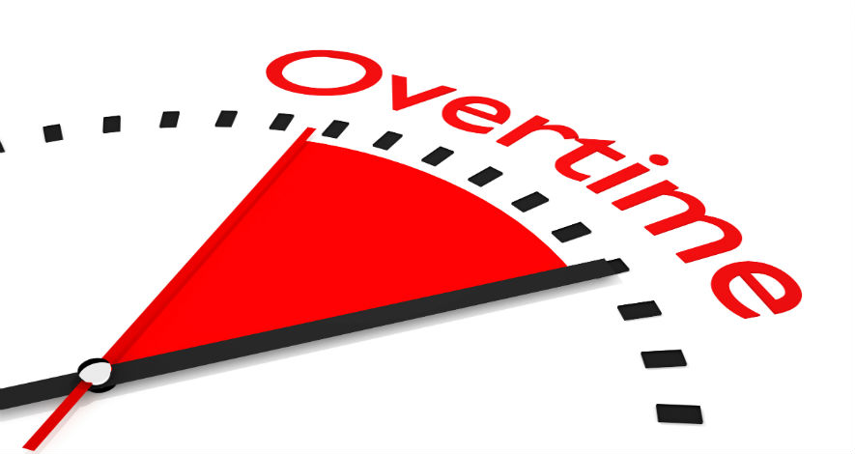
Karen works in a shop and gets paid a time rate of €10 per hour. She would usually work 40 hours a week. This week she worked 47 hours and gets paid time and a half for any overtime. Calculate her Gross Pay.
If we think back to our time rate practice, she would usually get €400 per week (40 x 10 = €400). This week however there is overtime of an additional 7 hours and this is paid at Time and a Half.
We know time = €10 per hour
So Time and a Half would be €10 + ½ of €10 which means €10 + €5 = €15
7 hours at €15 = €105 in overtime
So this week Karen would get her usual time (€400) + overtime (€105) = €505 Gross Pay

Overtime Practice: Find the Gross Wage for each question:
- Sarah works in a shop and is paid €20 per hour. Usually she works 30 hours but this week she worked 35. Overtime is paid at time and a half. Calculate her Gross Pay.
- Lucy works in a shop and is paid €20 per hour. Usually she works 30 hours but this week she worked 38. Overtime is paid at time and a half. Calculate her Gross Pay.
- Noel works in a shop and is paid €12 per hour. Usually he works 30 hours but this week he worked 38. Overtime is paid at time and a half. Calculate his Gross Pay.
The Deductions
Date |  | Week  Number | Employee’s  Name |  |  |  | Employee’s Number |  |  | Employee's PPS  Number
Gross Pay |  |  | Deductions |  |  |  |  |  | Total  Deductions
Basic | Overtime/  Commission  Bonus | Total  Gross  Pay | PAYE | PRSI | Union Subscription | Pension |  | Other
Net Pay

Most people do not receive all their Gross Pay as Net Pay and will have to pay deductions- some out of their wages, and others when they have their net pay. The following are the most common types of deductions:
- Tax
There are many different taxes people have to pay on their income, as well as their spending and on their personal assets.

The Revenue Commission is the State Agency responsible for collecting taxes on behalf of the government, and if you fail to pay correct taxes you can get a big fine and/or jail. They also look into cases of Tax Evasion and Tax Avoidance

Tax Evasion: Taxpayers illegally avoid paying full amount of tax they owe. They may lie on their tax returns such as claiming incorrect tax deductions or say they earned less than they really did. If found guilty they will be fined and could end up in jail as this is illegal.

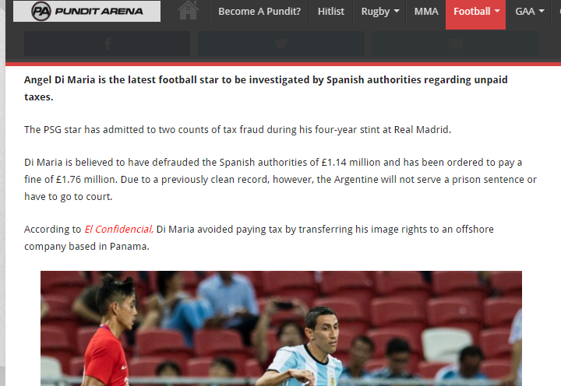
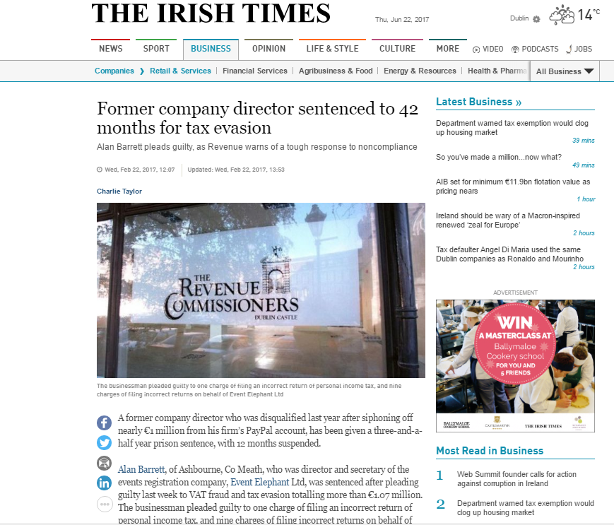

Tax Avoidance: Taxpayers take advantage of a tax system to legally reduce the amount of tax they pay.
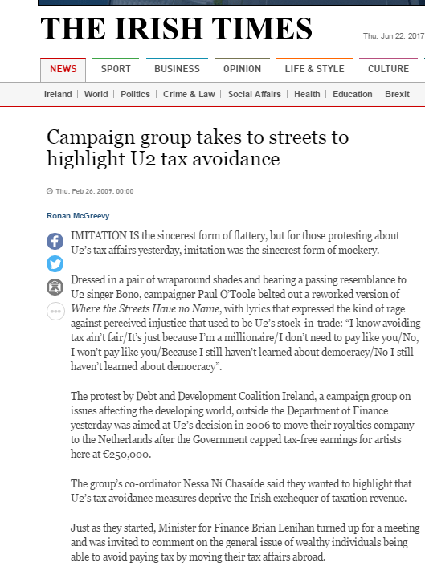

Taxes On Your Wage Slip
These are known as Statutory Taxes as they are compulsory and must be paid from your Wages/Salaries.
P.A.Y.E
- This is a tax you pay to the Government (Pay as You Earn). It is used to build roads, hospitals, schools etc. There more income you ear, the more PAYE you pay
P.R.S.I
- This is an Insurance you must pay to the Government (Pay Related Social Insurance). It is used to pay for Pensions, Jobseekers Benefit (Dole), Sick Pay, and Maternity Leave etc
USC (Universal Social Charge)
- Additional Tax Paid on Gross Income over €13,000 as of 2017
The above taxes are the only taxes that you would take from the wage slip to calculate Net Pay. There are however some other taxes on peoples other sources of income

Other Taxes on Sources of Income for the Consumer- Remember these are NOT in the Wage Slip
DIRT (Deposit Interest Retention Tax)
- This is a tax on the interest that your savings earn. We have seen this in the Saving Chapter section of the course

Capital Gains Tax

- If you sell an investment or shares, you have to pay tax on this income. Selling your own home, winning the lotto, or compensation payments are exempt from this tax

Capital Acquisition Tax
Tax is paid on receiving gifts/inheritance- the more you receive, the more you pay

Tax on Spending
VAT- Value Added Tax
- This is the tax placed on goods and services. The standard rate in Ireland is 23% in 2017.
Excise Duties
These are taxes on cigarettes, fuel, alcohol that we buy
Customs Duties
These are taxes on imports coming into a country. If you buy a good on E-Bay from another country, you will have to pay a customs duty tax on this

Tax on Our Assets
We have to pay tax on our Car. This is known as Motor Tax. In Ireland we also pay Property Tax on our home.

- Non-Statutory Deductions
A Non-Statutory Deduction are not compulsory and you can choose to deduct them from your wage slip. These will be things like:
- Charity Donation
- Trade Union Subscription
- Health Insurance
- Private Pension

