My Consumer Rights
Question
Have you ever saved up your money and bought something that you really wanted only for there to be something wrong with it when you went to use it?
There used to be very little protection for consumers (Caveat Emptor- Let the buyer beware), but now consumers have laws that look out for them.
Consumer Laws
Sale of Goods and Supply of Services Act 1980
When consumers buy goods from a retailer, both parties have entered into a contract. The following are the conditions to this contract:
For Goods:
Under this act, the buyer has the right to assume:
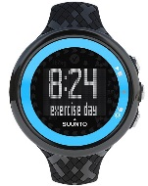
- Goods must be of merchantable quality: This means that the good must be of an acceptable standard, taking into account price and durability. Example: If you buy a watch it should not stop working after using it once.

- The goods are fit for purpose: This means that the good must do what you expect it to. Example: A freezer should freeze food 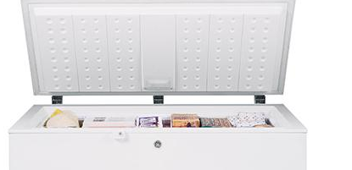

- Goods supplied as described: This means that the description of the good should match the packaging, catalogue, or description given by the sales person. Example: A silver I-phone X must be silver if selected by the consumer.

- Goods should match the sample: This means the sample shown to you by the seller should match the product purchased by the consumer. Example: A sample of curtain selected must match the sample delivered to the consumer.

For Services:
Under this act, the buyer has the right to assume:

- Parts should be of merchantable quality: This means that the parts supplied during a service are of merchantable quality. Example would be a door handle should open a door. This is a part of the overall good.
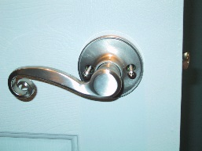
`
- Service must be carried out by suitably qualified people. This means that you have the right to assume that a person doing the work for you is qualified at their job. Example: Mechanic fixing your car, not your Business teacher.

- The service provider must take proper care and attention: When carrying out the work, a surgeon for example must take proper care when doing the procedure. If they do not, they would be legally liable. They cannot be watching Netflix while performing the procedure.

If a shop is in breach of this act, you are entitled to a REFUND/REPAIR/REPLACEMENT

Consumer Law 2
The Consumer Protection Act 2007
The Consumer Protection Act 2007 sets out the following rules about:
- Aggressive business practices
- Claims about prices
- Prohibited practices
- Price Controls
- Misleading Descriptions

- Aggressive business practices
A business cannot force or threaten a consumer to buy a good/service. Example: A restaurant owner or chef cannot harass you until you come into their restaurant.
- Claims about prices
This means the price of certain goods must be displayed in a particular way.
1. Goods sold must be final price inclusive of VAT etc..
2. Grocery stores selling Fruit must provide weighing scales.
3. If a special offer price is only available for a limited period this must be clearly stated. - Example while stocks last/ ‘Must End Friday’
A wise consumer will always shop around to get the best price. The Latin phrase Caveat Emptor meaning ‘let the buyer beware’ as the buyer alone is responsible for checking the quality and suitability of goods before a purchase is made.
- Prohibited practices
Certain practices are banned under this law:
1. Making false claims about cures for illnesses.
2. Offering free prizes when it costs money to claim these prizes.
3. Running competitions when the top prize is not available
4. Claiming a business is closing down when it is not
5. Ban of Pyramid Schemes
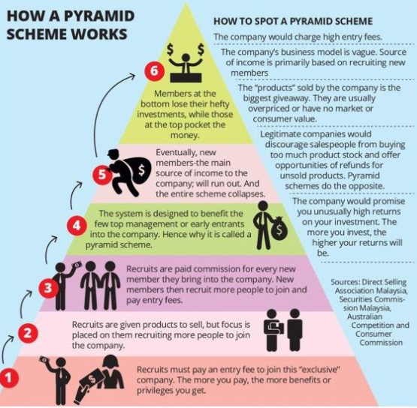
- Price Controls
In emergency situations the government can introduce a maximum price for a product. Example: Tickets for gigs cannot go over cost price to eliminate touting as a government policy.
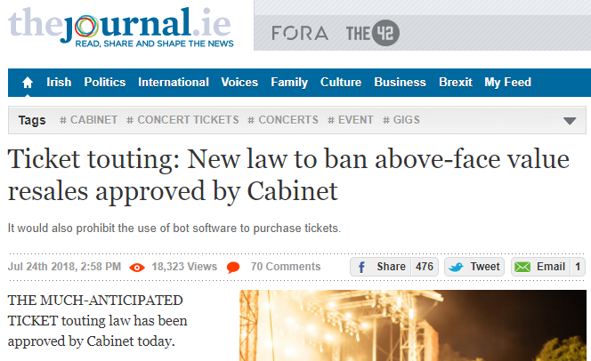

- Misleading Descriptions

Sellers cannot advertise in a way that deceives or misleads consumers.

1. About the product or service- the ingredients or materials used to make the good. A company saying their food is fat free when it’s not.
2. About usage/ history of 2nd hand goods. A car dealer changing the mileage on a car.
3. The country of origin of the good
4. The quantity or weight of the good
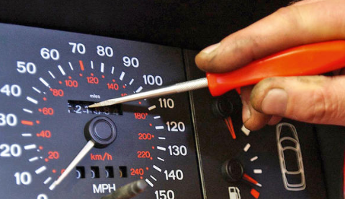

Law 3
Competition and Consumer Protection Commission
The CCPC is an independent body that enforces consumer protection and legislation in Ireland.
The CCPC operate the following functions:
- Inform consumer of their rights
- Investigate breaches of consumer laws
- Advise the Government
- Provide personal finance information and advice
- Enforce product safety regulations

- Inform consumers of their rights: The CCPC provide information to consumers via their website and helplines. They also run awareness campaigns. (www.ccpc.ie)
- Investigate breaches of consumer laws: The CCPC investigate breaches of consumer laws, and has the power to issue fines and prosecute traders. They also publish a list of these traders in breach online.
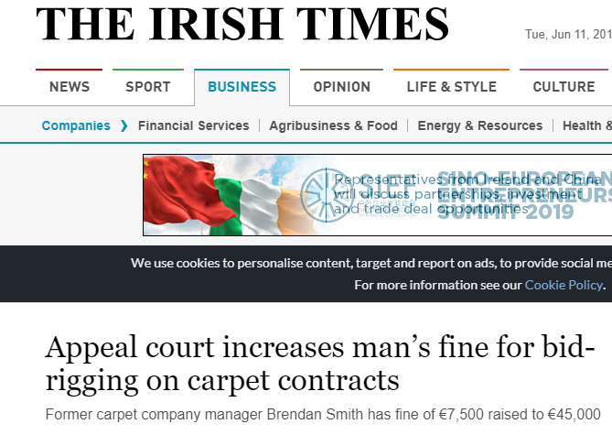
https://www.irishtimes.com/business/companies/appeal-court-increases-man-s-fine-for-bid-rigging-on-carpet-contracts-1.3537397
- Advise the Government: The CCPC conducts research and identify areas where consumers need greater protection. It then informs the government about the impact these new laws would have on Irish consumers.
http://www.mondaq.com/ireland/x/751336/international+trade+investment/The+CCPC+Recommends+Grocery+Regulator
- Personal Finance Information and Education: The CCPC provides financial information to consumers. They run campaigns and education programmes in offices and schools.
- Enforces Product Safety Regulation: The CCPC share information about dangerous goods and ensure producers and retailers obey product safety regulations.
Credit: EDCO
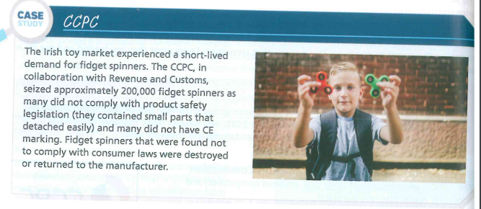

Buying Online- What are our Rights
Inside the EU
Under these rules, Irish shoppers have a 14 day cooling off period for buying goods online (Distance Selling), whereby the Irish consumer can cancel their order for any reason, including changing their mind. The seller will give a full refund once goods have been returned.
Irish people don’t also have to pay VAT as Ireland is part of the European Union
However, when you buy goods online you must follow the rules of the country you bought the item from- Irish law may not apply, it might be the law of the EU or the country from which you are purchasing from
Outside the EU
Be aware EU consumer rights do not apply
Be aware of VAT and customs duty that will have to be paid on goods coming into the country
Make sure the website you buy from has a good reputation- link to DML
Read all terms and conditions carefully

Making Complaints
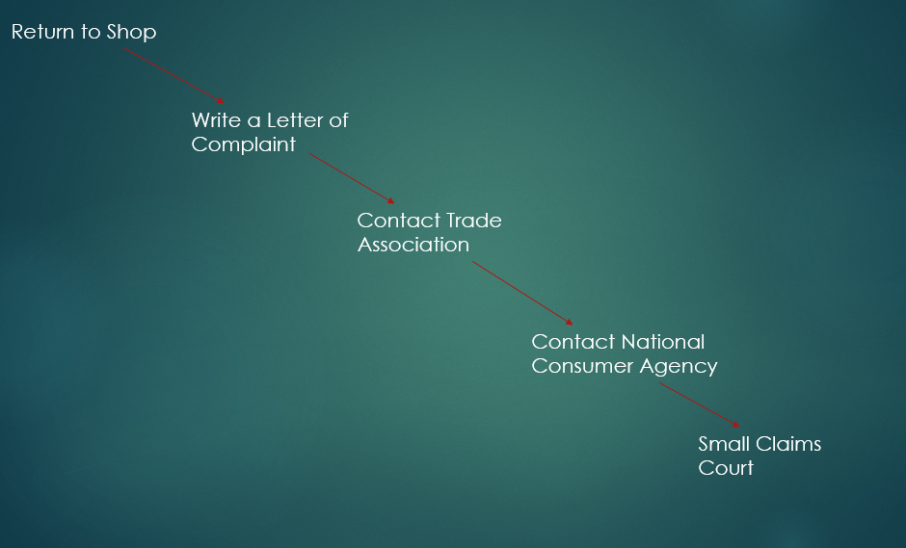
Letter of Complaint
Structure of Letter of Complaint
- Your Address
(Skip line)
(2) Date

(3) Company Address

(Skip line)
(4) Dear Sir/ Madam
(5) The Facts
(6) What’s your complaint?
(7) Your legal requirements: Note, this will always say ‘Under the Sale of Goods and Supply of Services Act 1980’...And is the only part not included in the question
(8) What you want done about it
(9) Sign off

Example
On 01/09/2014, Tom Jones, of 52 High Bridge Navan purchased a new fridge model XYZ from Fridge and Freezers Ltd, 24 Close Road, Dublin 15 for €600. After 2 weeks Tom found that the fridge would not close properly and the settings would always return to default. Tom was unhappy that the product was not fit for purpose or of merchantable quality and wanted either a refund or replacement immediately. Imagine you are Tom and write the letter of complaint dated September 20th 2014
- (Your Address)
52 High Bridge
Navan
Co. Meath
2. (Date)
20/09/2014
3. (Their address)
Fridge and Freezers Ltd
24 Close Road
Dublin 15
- (Salutation)
Dear Sir/Madam
5. On 01/09/2014 I bought a new fridge model XYZ from your store for €600. I enclose a copy of the reciept (the product purchased as given in the question).
6. (What went wrong- This is in the question).After two weeks I found that the fridge would not close properly and the settings would always return to default. 7. (Legal Requirements) The fridge is not of merchantable quality which is a legal requirement under the Sale of Goods and Supply of Services Act 1980.
8.(What you want done about it). I would like a refund or replacement product immediately.
9. (Sign off)
Regards
Tom Jones

Consumer Protection Organisations
Small Claims Court: Cheap, fast and easy way for consumers to solve disputes. No solicitors involved and deal with complaints regarding purchases or poor quality service. The maximum case can be worth €2000
Competition and Consumer Protection Commission:
The Competition and Consumer Protection Commission (CCPC) was set up by the government to promote fair competition between businesses and protect the interests of consumers by:
- Giving information and advice to the public
- Provide information and advice to businesses
- Enforce consumer laws
- Names and shames businesses that break these consumer laws
Trade Association: Represents firms that sell a particular product. Consumers can complain to these trade associations if they have a problem with a product. Example: - The Society of Irish Motor Industry
Consumers Association of Ireland: The Consumers Association of Ireland is a voluntary advice and information service for consumers that campaigns to improve consumer laws. They also print a magazine each month called Consumer Choice.
Ombudsman: The ombudsman is a representative of the people and will investigate complaints made by members of the public, e.g. The Financial Services ombudsman- who specialises in resolving claims against banks, insurance companies, credit unions, and other financial institutions
Advertising Standards Authority of Ireland: Promotes fair advertising and promotion. If you have a complaint about an advertisement you can contact them
The European Consumer Centre: The ECC gives Ireland and other EU member states free information and advice when buying and dealing with other EU countries.

